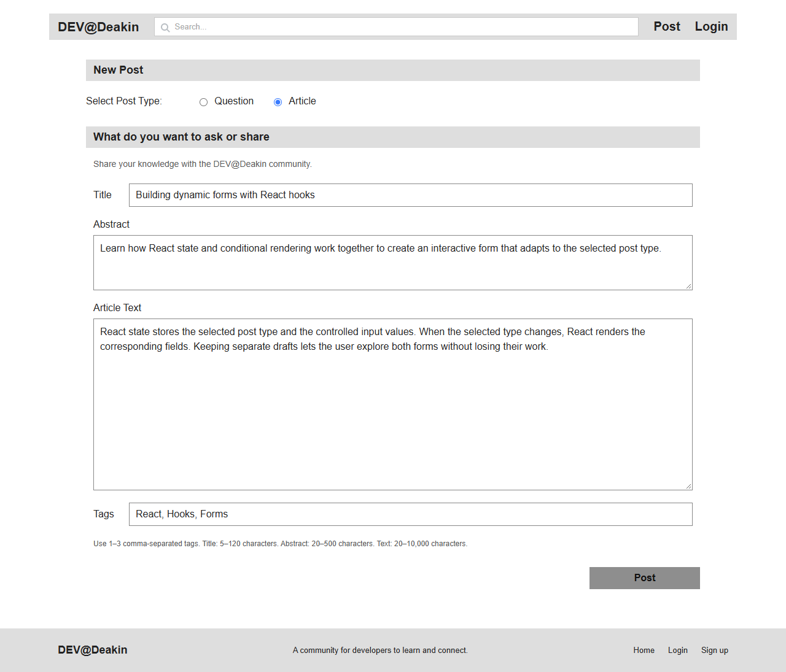
https://github.com/akashapple1107-rgb/SIT313-FullStack-

