SIT313 D1 Subscription Report
  - DEV@Deakin web platform
Name Aakash | Student ID [Insert student ID] | Date 27 October 2026

Introduction
Task D1 extends the existing DEV@Deakin platform with user sessions and subscription management. The implementation retains the original portfolio, teal interface, featured articles and tutorials, login and registration pages, newsletter and post form. Users can compare Free and Paid plans, log in, and complete a demonstration upgrade that is saved in Firestore.

Features implemented
- Registration and login. React forms send account details to Express. The backend validates the data, hashes passwords with bcrypt and stores user records in Firestore. New users start on the Free plan.
- Session management. A successful login returns a signed JWT with a one-hour expiry. React Context shares the current user across pages, while localStorage retains the token during a page refresh. Logout removes the token and clears the user state.
- Pricing page. A navigation link opens a comparison of Free and Paid plans. The page identifies the current plan and disables upgrading for visitors who are not logged in or users already on Paid.
- Upgrade modal. A popup collects a cardholder name, card number, expiry and security code. Frontend and backend validation check the required values, card checksum, expiry format and security-code length.
- Persistent upgrade. After validation, the backend updates the authenticated user to Paid in Firestore. The navigation badge and pricing page update immediately. Card details are neither stored nor charged.
- Saved posts and newsletter. Logged-in users can save validated questions and articles to Firestore with an authenticated author ID. The existing React-to-Express newsletter integration is retained.

Verification
The production build and 13 automated tests passed. Live checks confirmed demo registrations, login, the Free-to-Paid upgrade, persistence after refresh and a fresh login, and saved question and article records. Automated checks also covered invalid or expired tokens, invalid payment values, duplicate upgrades and service failures.
The displayed subscription prices, posting limits and premium benefits are illustrative. No real billing, premium access restrictions or upload limits are implemented for this demonstration.

Pricing page
The Free plan is shown at A$0 per month and the Paid plan at A$9 per month. A feature comparison appears below the cards. In the signed-out view, Upgrade Plan is disabled and a login link explains the next step.
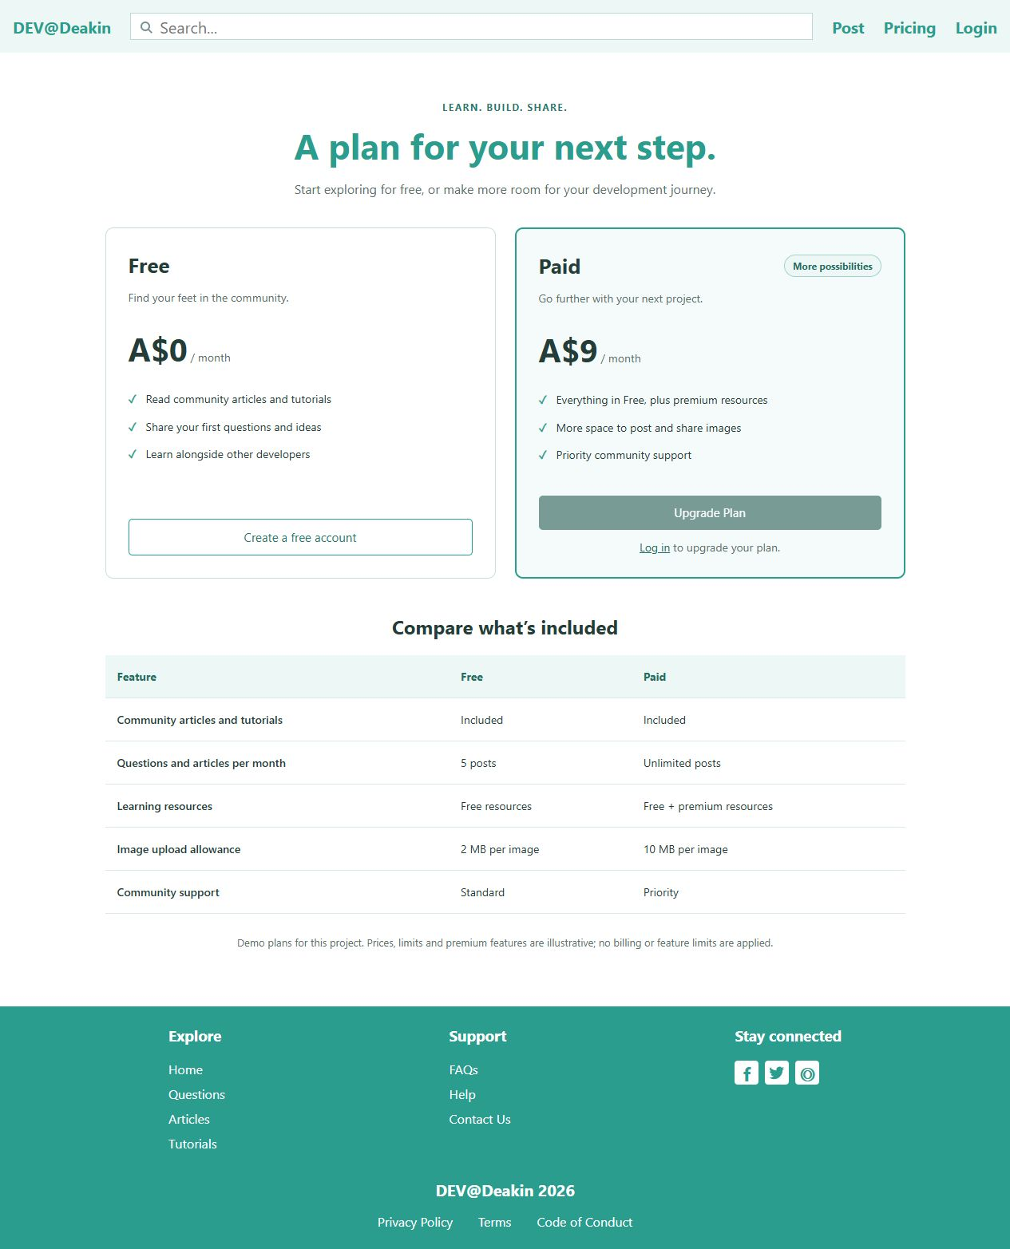
Figure 1 Pricing page with Free and Paid plans and the signed-out upgrade restriction

Upgrade plan
A logged-in Free user can open the modal and enter demonstration payment details. The example uses a test card, a future expiry date and a three-digit security code.
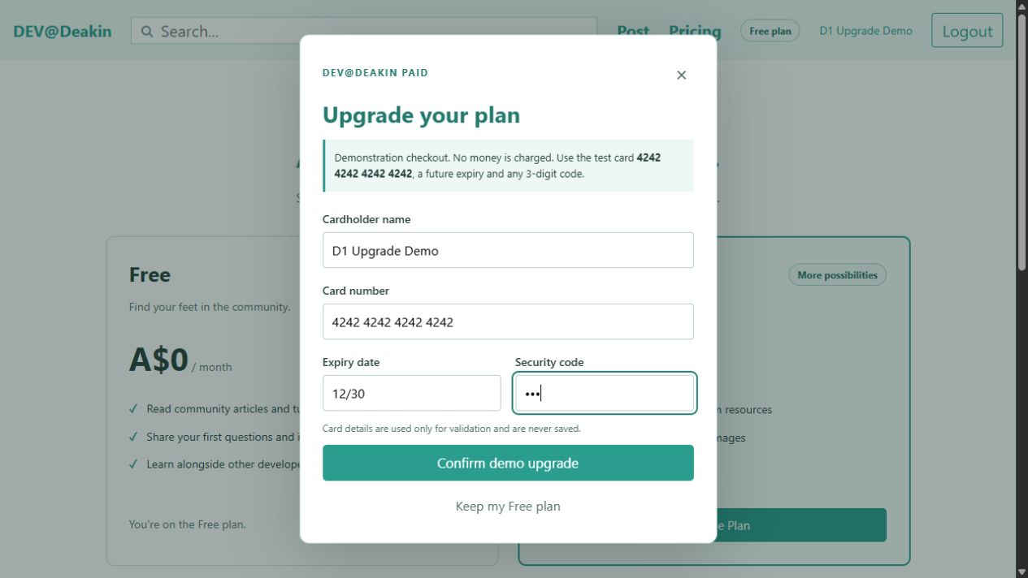
Figure 2 Upgrade modal showing test payment details before submission

Successful upgrade
After submission, the success message and Paid plan badge confirm the change. The account remains Paid after a page refresh and a fresh login, because the plan is read from Firestore.
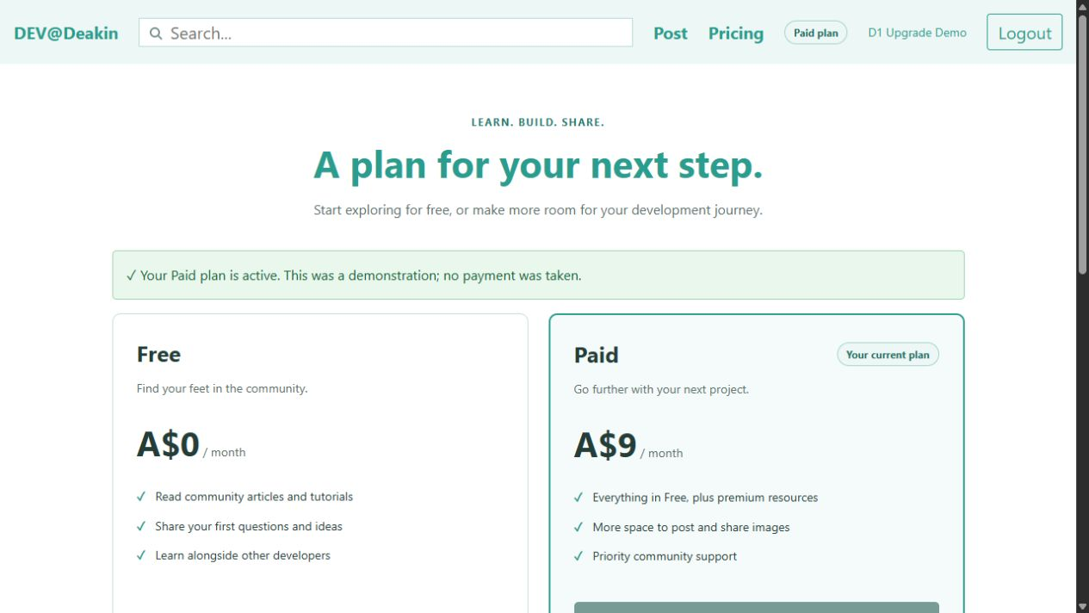
Figure 3 Successful upgrade for the D1 Upgrade Demo account

Firestore evidence
The following demonstration records are saved in the configured Firestore database. Add the corresponding console screenshots below before submitting the report.

Registered users
D1 Free Demo | d1.free.20261027@example.test | plan: free
D1 Upgrade Demo | d1.upgrade.20261027@example.test | plan: paid
Open the users collection and show the name, email, plan and createdAt fields. The upgraded record also contains upgradedAt. Passwords are stored as bcrypt hashes rather than plain text.
[Insert Firestore users screenshot showing the demo registrations and plan fields]

Saved posts
Question: How do React components share login state?
Article: Managing subscriptions in DEV@Deakin
Open the posts collection and show the title, type, authorId, authorName, tags and createdAt fields. Both records were submitted using the authenticated D1 Upgrade Demo account.
[Insert Firestore posts screenshot showing the saved question and article]

Submission links
GitLab repository [Insert Task D1 repository link]
Walkthrough video [Insert Panopto link for the 3 to 6 minute video]

