**A Software Requirement Specification(SRS) on**

***“PRISON MANAGEMENT SYSTEM”***



**DEPARTMENT OF COMPUTER SCIENCE AND ENGINEERING**

**SWAMI KESHVANAND INSTITUTE OF TECHNOLOGY, MANAGEMENT & GRAMOTHAN, JAIPUR.**

**2015-2016**

**SUBMITTED BY:**

AAYUSH SHARMA(12ESKCS003)

AKASH ARORA(12ESKCS009)

ALOK KUMAR(12ESKCS011)

KUMAR ADITYA(12ESKCS062)

**TABLE OF CONTENTS**

1. Introduction
   1. Purpose
   2. Scope
   3. Abbreviations
   4. References
   5. Technologies to be used
   6. System Requirements
2. Overall Description
   1. Use Case Model Survey
   2. ER Diagram
   3. Data Dictionary
3. Specific Requirements
   1. Use-Case Reports
   2. Supplementary Requirements
4. Test Cases
5. Project Screen-Shots
6. Bibliography& References
7. Further scope and further enhancement of the project
8. **Introduction**

**Purpose :**

* 1. Developing an online prison management system that is a collection of registers and reports for the effective management of prisons. It is a mobile application exclusively for administrators in the prison. Gives a clear idea of the Prison and its details and information about the prisoners. Used to keep a feedback of each prisoner by administrators. This application will save time and effort of administrators in maintaining records of prisoners.
  2. **Scope:**

✓There should be a login page for the administrators of the prison.

✓There must be a provision for adding new prisoners to the records.

✓There must be a provision for adding new jailors(multiple administrators).

✓It should be able to display the details of all the prisoners.

✓It should maintain the list of prisoners eligible for parole.

✓Alerts must be shown when a login or a detail filled is inappropriate.

✓Local notifications must be displayed to the user.

* 1. **Abbreviations:**

Admin- Administrator

HTTP- HyperText Transfer Protocol.

* 1. **References:**

IEEE SRS Format.

* 1. **Technologies to be used:**

✓ FRONT END- Objective C

✓ BACK END- PARSE(SERVER SIDE)

✓ SERVER- PARSE(CLOUD DATABASE)

✓ OS- OS X MAVERICKS 10.9

**OBJECTIVE C**

✓ It is the main programming language used by Apple for the OS X and iOS .

✓ Objective-C is an object-oriented programming language.

✓ Used for application programming interfaces (APIs), Cocoa and Cocoa Touch.

✓ It consists of a rich set of functions manipulating files, strings, etc.

✓ It provides utilities like date formatting, data handling, error handling, etc.

.

**XCODE**

✓ Xcode is the primary tool used for the development of Mac and ios

applications.

✓ This is a free tool used for Writing code, Building, Testing (Unit test) and for

Distribution (Submitting to App Store

✓ Xcode tools help the developer with designing the user interface and writing

the codes. It allows users to build UI for their applications.

**PARSE**

✓ Parse in a cloud application platform and a Backend provider.

✓ It reduces the task of server maintenance.

✓ It allows developers to instantly add push notifications, data storage and social

integration to their apps .

✓ It allows users to add a scalable and powerful backend in minutes and launch a full-

featured mobile or web app in record time

1.6.**SYSTEM REQUIREMENTS**

**1.6.1. Hardware Requirements**

* Intel Pentium-IV Processor
* 4 GB RAM or higher
* 40 GB HDD or higher

**1.6.1. Software Requirement**

**✓** Operating system: OS X MAVERICKS 10.9

**✓** Software Development Kit (SDK): APPLE XCODE 5.1.1

**✓** Programming language: Objective C

**✓** Platform OS: Iphone Operating System (IOS)

* 1. **Use Case model Description:**

The use case consists of three users :

1. Police office(supervisor): He who is provided with read only access to the information related to the prisoners. After logging in his own account, a police officer will be able to view information of criminals. He can then view nominal role, case register, in-out register, duty register(feedback), release diary and he has to confirm the interview requests by the relatives of criminals.
2. Administrator: can be a Jail Administrator or a government official. Has a right to view data and also generation of various reports.
3. Data Manager: Deals with the addition or updation of the existing data.

**USE CASE DIAGRAM:**

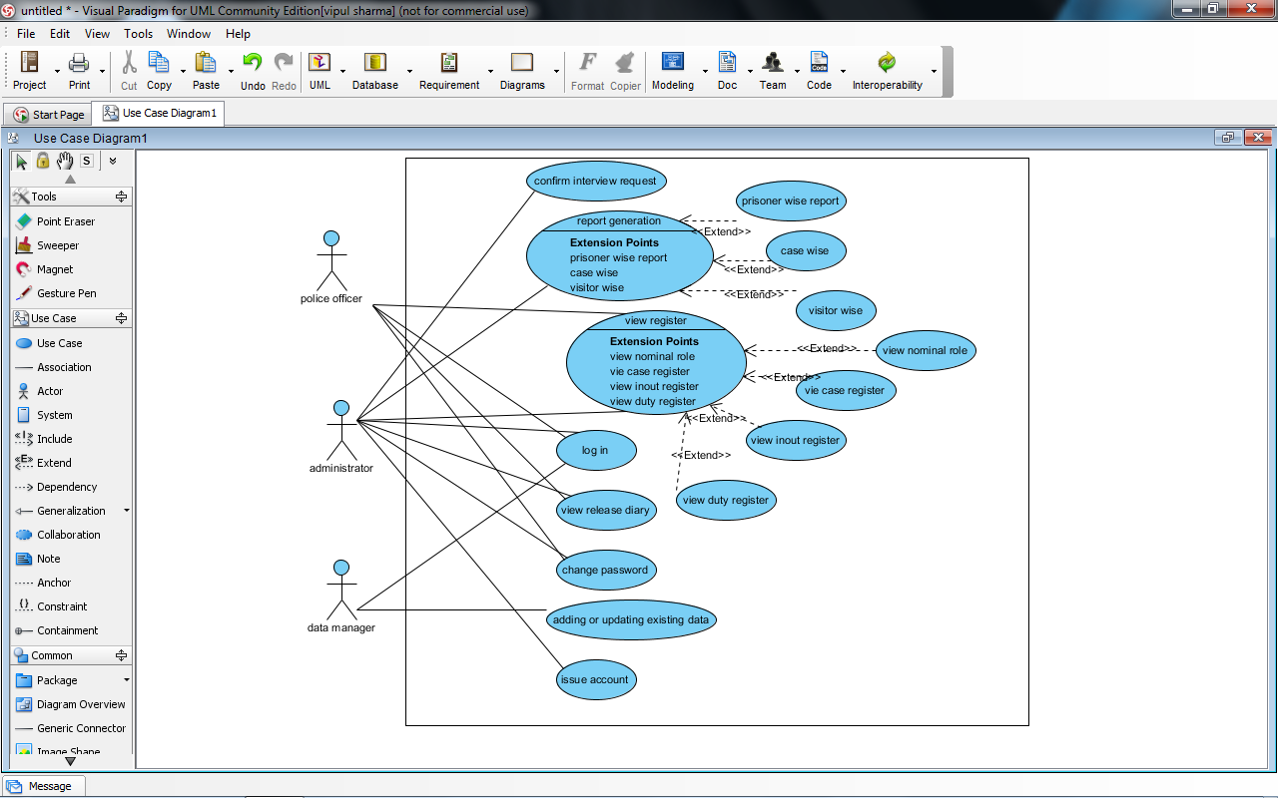

**DATA FLOW DIAGRAM**

***LEVEL 0 DFD***

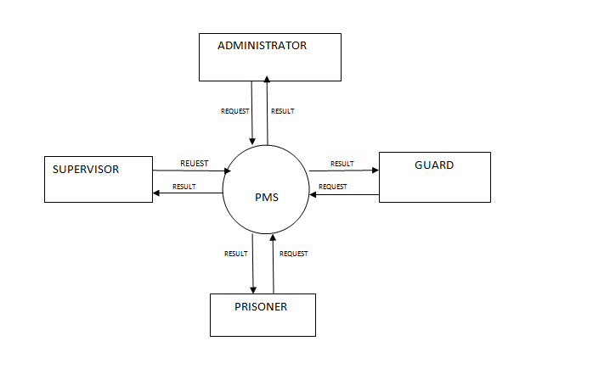

***LEVEL 1 DFD***

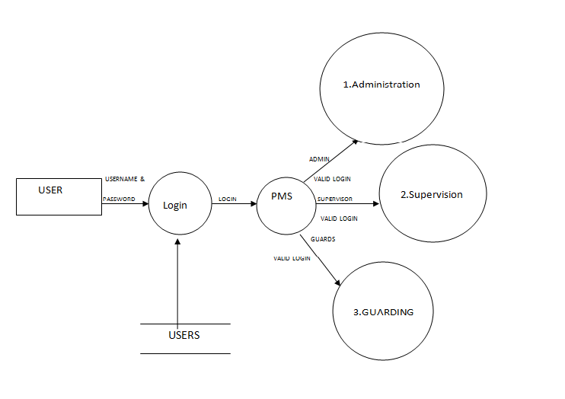

***LEVEL 2 DFD:ADMINISTRATOR***

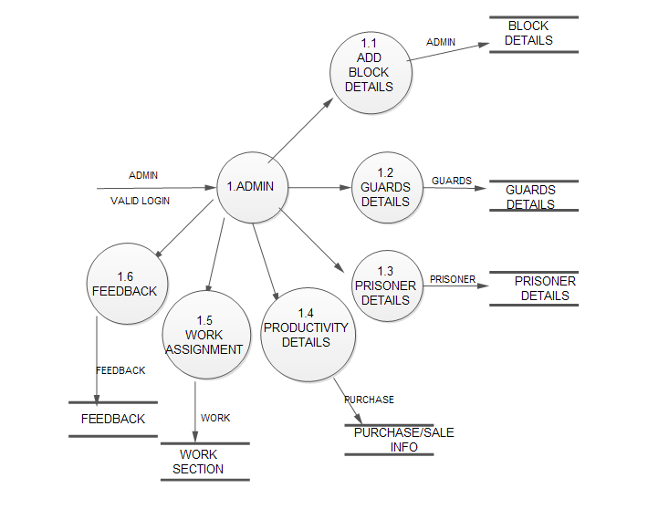

**Database Specification:**

1. Login Table:

|  |  |  |  |
| --- | --- | --- | --- |
| Serial Number | Field name | Type of field | Remark |
| 1 | Username | Varchar(15) | Primary key |
| 2 | Password | Number(10) | -- |

1. Nominal Roll Register:

|  |  |  |  |
| --- | --- | --- | --- |
| Serial number | Fieldname | Type of field | Remark |
| 1 | Prisoner id | Number(1000) | Primary key |
| 2 | Case id | Number(1000) | Foreign key |
| 3 | Name | Varchar(15) | No special characters allowed |
| 4 | Gender | Varchar(1) | M/F |
| 5 | Type | Varchar(15) | Duration specific/ life term |
| 6 | Duration of sentence | Number(100000) | No. of days |
| 7 | Height | Number(500) | In cms |
| 8 | Criminal Snaps | <img object> | -- |
| 9 | Status | Number(1) | 1.in jail  2.on parole  3.released  4. dead |

3. Case Register:

|  |  |  |  |
| --- | --- | --- | --- |
| Serial number | Field name | Type of variable | Remark |
| 1 | Case id | Number(1000) | Primary key |
| 2 | description | varchar(15) | Special characters not allowed |
| 3 | Type | Number(1) | 1.murder  2.theft  3.forgery  4.counterfeiting |

1. Parole Register:

|  |  |  |  |
| --- | --- | --- | --- |
| Serial number | Field name | Type of variable | Remarks |
| 1 | Prisoner id | Number(1000) | Primary key |
| 2 | Address of residence | Varchar(15) | Special keys not allowed |
| 3 | Entry date | Date | -- |
| 4 | Exit date | Date | -- |
| 5 | Remand frequency days | Number(1000) | Should visit jail for remand |
|  |  |  |  |
| 6 | Last remand visit status | Varchar(1) | -- |

**Specific Requirements:**

We describe the functional requirements by giving various use cases:

**3.1 Use case reports:**

1. **USE CASE RELATED TO LOGIN:**

Primary actor

All registered users having valid accounts  
1) Administrator  
2) Police Officer

3) Data Manager

Precondition

INTERNET connection is available and working at it's optimal level

Main scenario

1) Users Access the login Page

2) Provide User ID and Password.

3) Login Validity is checked

4) The user is shown their respective homepage.

Alternate scenario

1) The entered User ID or Password is not valid

2) The user is shown the error page.

**2. USE CASE RELATED TO REGISTRATION:**

Primary actor

Unregistered Police Officers

Precondition

none

Main scenario

1. The visitor accesses the registration page for new ID.  
2. He/she fills up the form and submits.  
3. The completeness of data is checked on client side.  
4. The Database is updated

Alternate scenario

1. The data completeness check fails and the user is prompted to

provide all details.

2. The database update fails.

**3. USE CASE RELATED TOVIEW REGISTERS:**

Primary actor

Administrator

Police Officer

Precondition :

1.Administrator or Police Officer should be logged in to his account

Main scenario

1. Retrieved the nominal roll register, case register, parole

register, in-out register from the data base.

2.Viewing of data.

Alternate scenario

1. Data retrieval process failed.

**4. USE CASE RELATED TO GENERATE REPORTS:**

Primary actor

Administrator

Precondition

1. Administrator should be logged in to his account

Main scenario

1. Retrieval of data prisoner-wise, case-wise or visitor-wise.  
   2. Form the retrieved data into printable format.  
   3. Print out the retrieved data.

Alternate scenario

1. Retrieval of data failed

2. Printing out of retrieved data failed

**5. USE CASE RELATED TO INTERVIEW CONFIRMATION:**

Primary actor

Administrator

Precondition

Administrator should be logged in to his account to access this option

Main scenario

1.Verification status is checked  
2. If OK then it is approved.  
3. The database is updated.

Alternate scenario

1. The interview request is not approved.

**6. USE CASE RELATED TO VIEWING OF RELEASE DIARY:**

Primary actor

1) Administrator

2) Police Officer

Precondition

1. User must be logged in

2. He/she has to be at his home page

Main scenario

1. Retrieved the release diary information from the data base.

2.Viewing of data.

Alternate scenario

1. retrieval of data failed.

**7. USE CASE RELATED TO CHANGE OF PASSWORD:**

Primary actor

1. Administrator
2. Police Officer

Precondition

1. The users should have registered an account with the system.

2. The users are logged into their account.

Main scenario

1. The System asks for the old password.  
2. The User provides his/her old password .  
3. After successful match the system asks to enter the new password.  
4. The Database is updated .

5. The Success page is shown.

Alternate scenario

1. The Old password doesn't match and the error page is shown.

2. The Database Update fails .

**3.2 Supplementary Requirements:**

Performance requirement:

1.Should run on 500 MHz, 256 MB machine.

2.90% of the responses should be within 2 sec.

Design Constraints:

1. Security: The files in which the information regarding  
Jailer ,Visitor, Prisoner should be secured against  
malicious deformations.

2. Fault Tolerance: Data should not become corrupted in case

of system crash .

**6. BIBLIOGRAPHY AND REFERENCES:**

**6. 1 BIBLIOGRAPHY:**

.

* Programming in objective c 2.0- Stephen Kochan.
* Beginning xcode-Matthew knott.
* Data Base Design-Korth
* Software Engineering-PressMan
  1. **REFERENCES:**

✓ [en.wikipedia.org](http://en.wikipedia.org)

✓ <http://www.stackoverflow.com>

✓ <http://www.developer.apple.com>

✓ [www.parse.com](http://www.parse.com/)

1. **Further Scope & Future Enhancement:**

The end product is a complete tool for online management of the prisons which is

efficient and saves the time and effort of the user. The users can simply rely on

the system as it ensures the safety of the data stored in it.

The second version of the project may include the record for a library, which will keep

the details of the books issued to prisoners.