**ST. XAVIER’S COLLEGE OF MANAGEMENT &**

**TECHNOLOGY**

**NAAC Accredited with B++ Grade (1st Cycle)**

Digha-Aashiyana Road, Digha, Patna-800011, Bihar

BACHELOR OF COMPUTER APPLICATION

SESSION-2020-2023

**USER-MANNUAL AMS**

**Attendance Management System**

Submitted to ARYABHATTA KNOWLEDGE UNIVERSITY

For the partial fulfillment for the award of the degree of Bachelor of computer

application (BCA)

Under the Guidance - **Mr. Prakash Upadhyay**

**Asst.prof., Dept. of Computer Science**

**BY:**

**Akash Kumar** [REG NO. 20303302010]

**Apurv Kumar** [REG NO. 20303302044]

**Archana Kumari** [REG NO. 20303302048]

**USER-MANNUAL INTERFACE**



**For source code scan this QR Code:-**

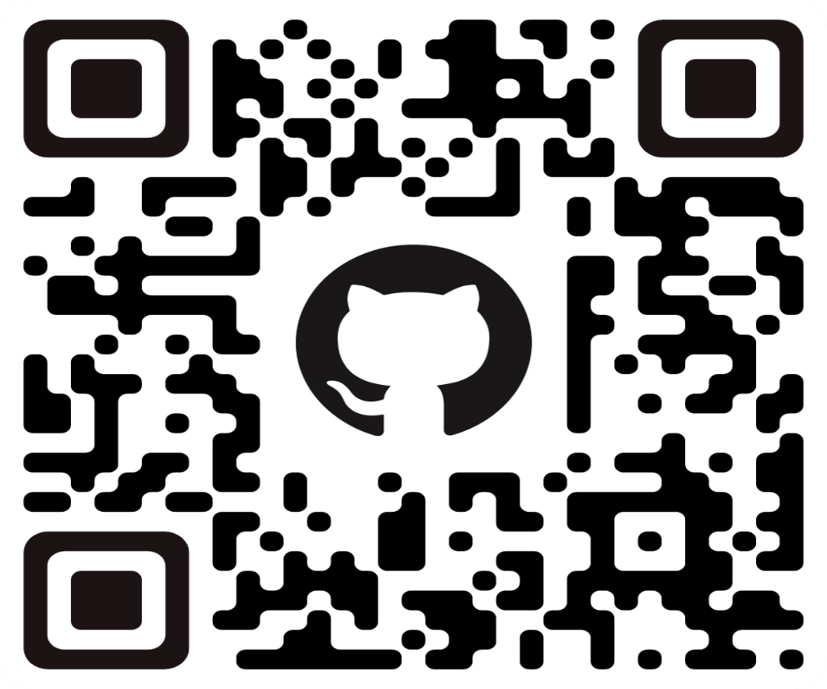

**After scanning the QR Code, this page is open-**

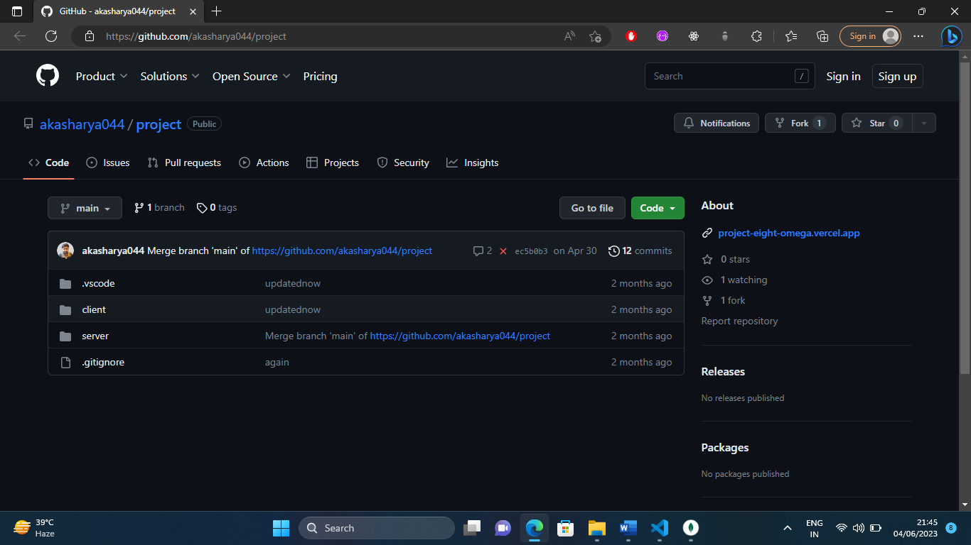

Click on code

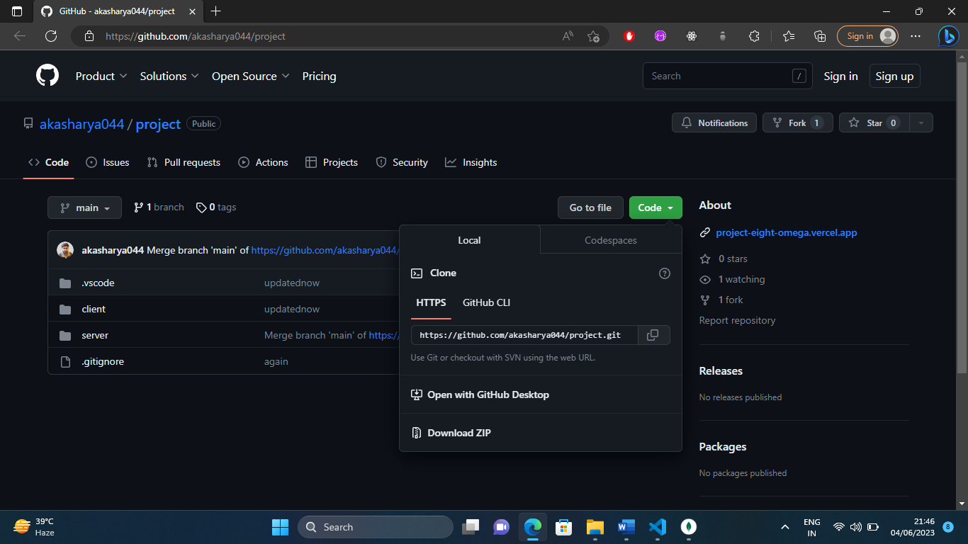

From here download the zip file.

* 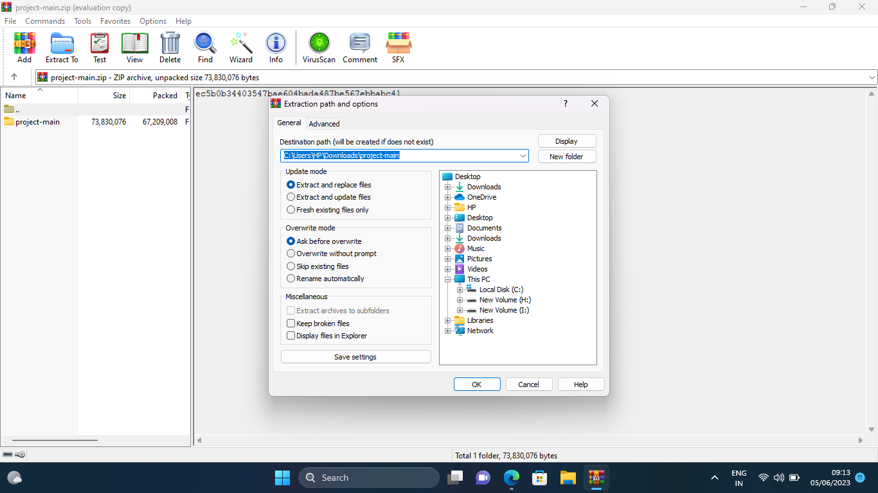After downloading the zip file, Extract the zip file.

Click on OK

* 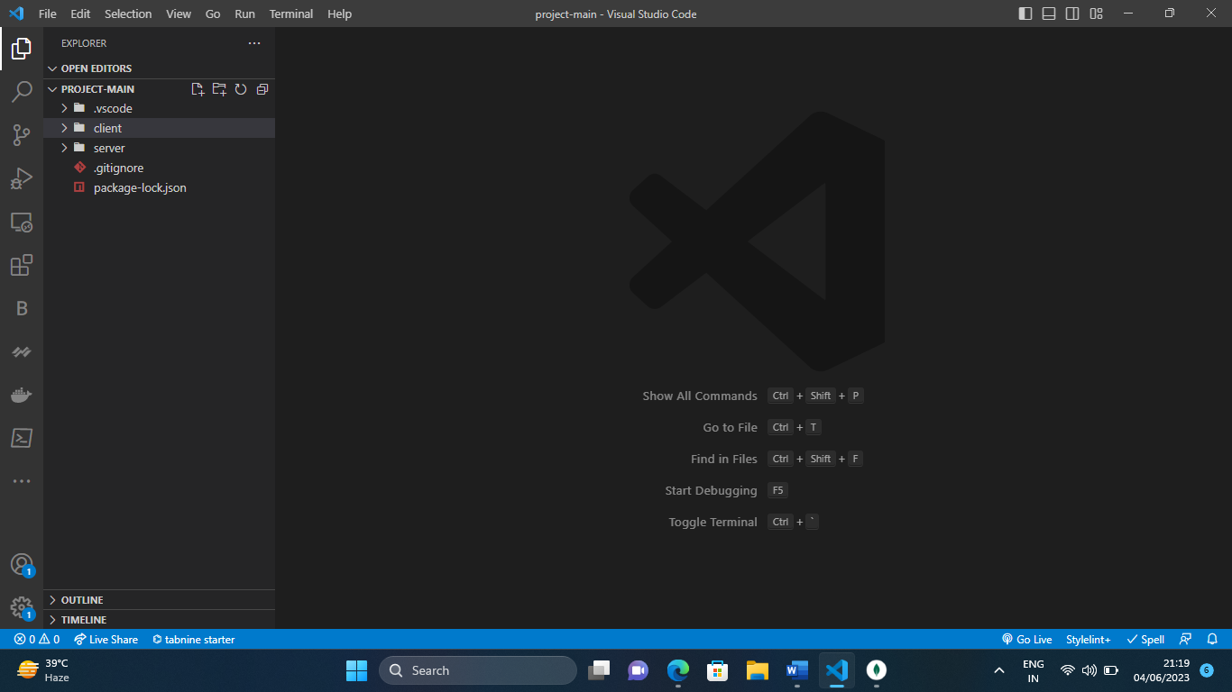Then open it in Visual Studio Code.
* To run this project, Install npm (npm i) and then after (npm start).

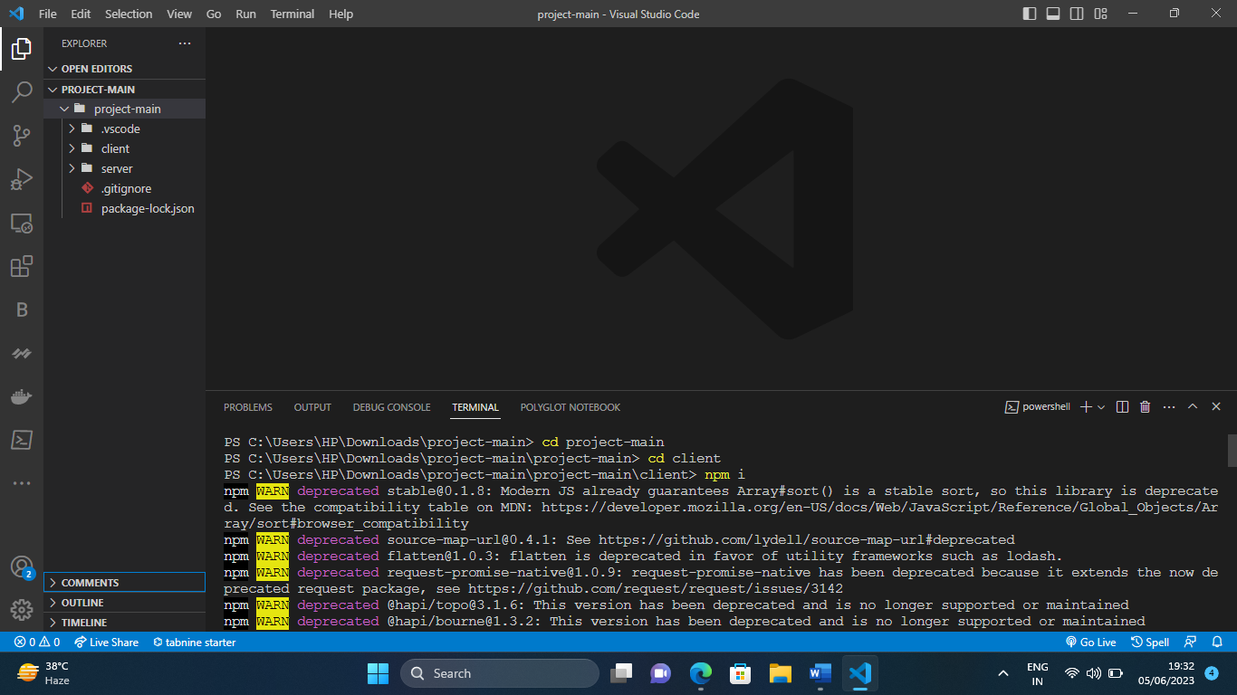

* **To connect with the database , install mongodb.**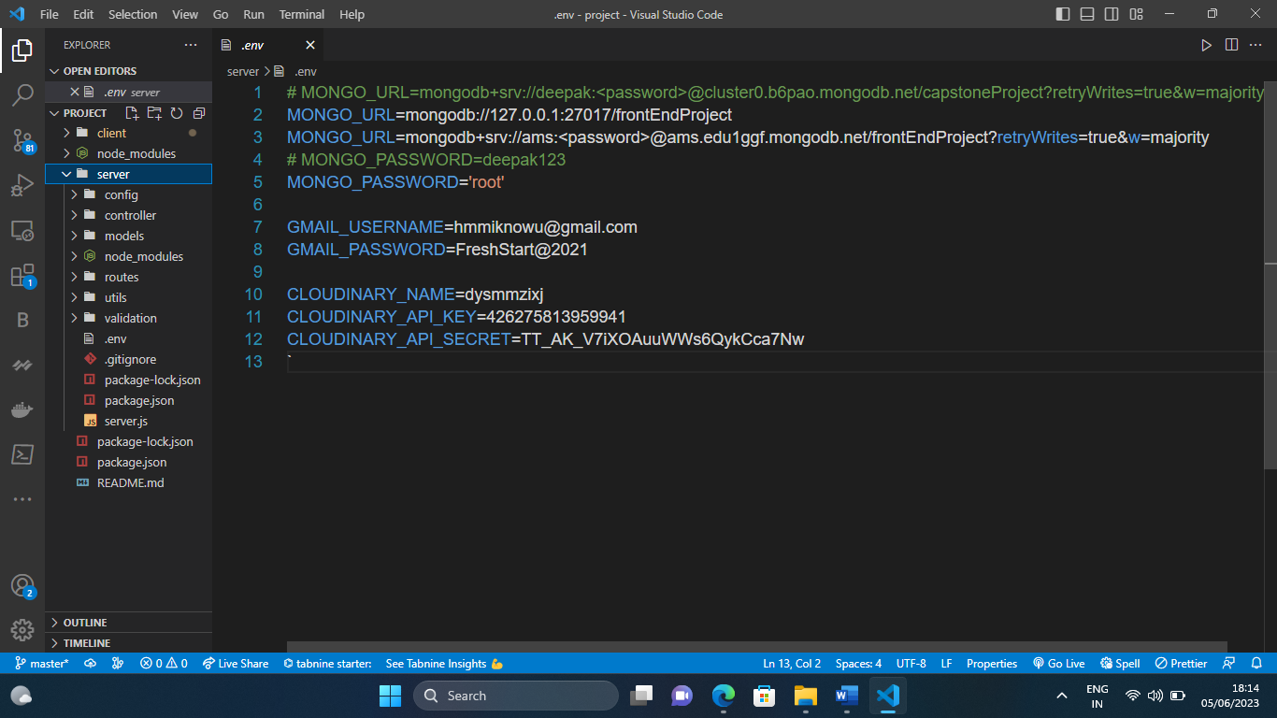

From this URL, you can connect with the database.

**Connect with the database:-**

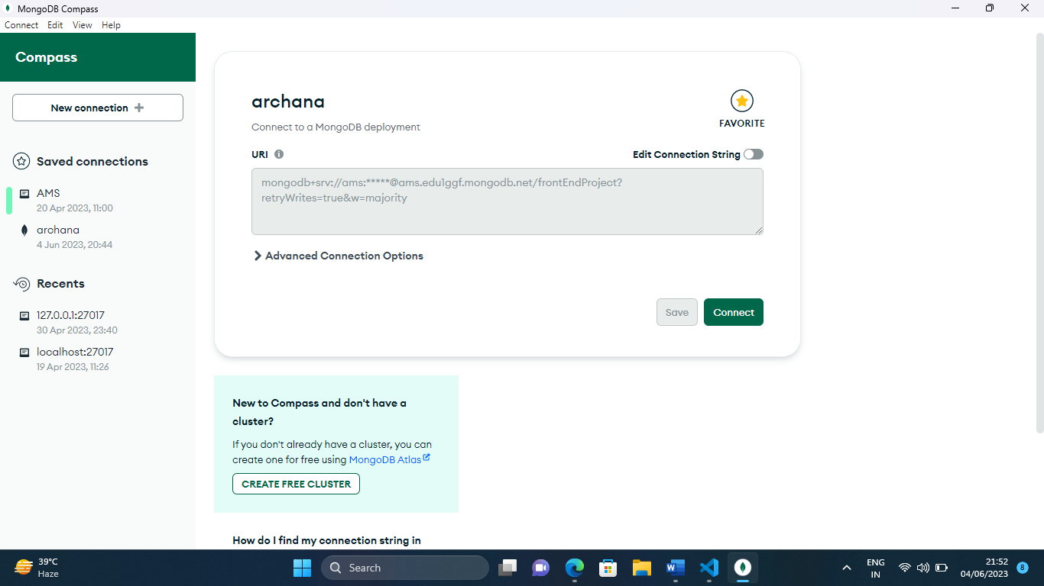

**Database is connected-**

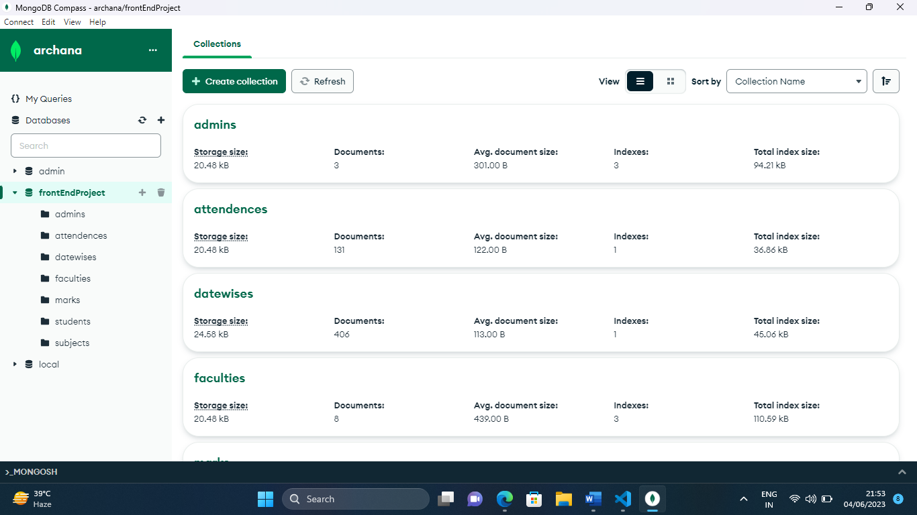

## Scan this QR Code or follow the Link-

## 

**After scanning the QR code or follow the link-**

**In Desktop , It look like this-**

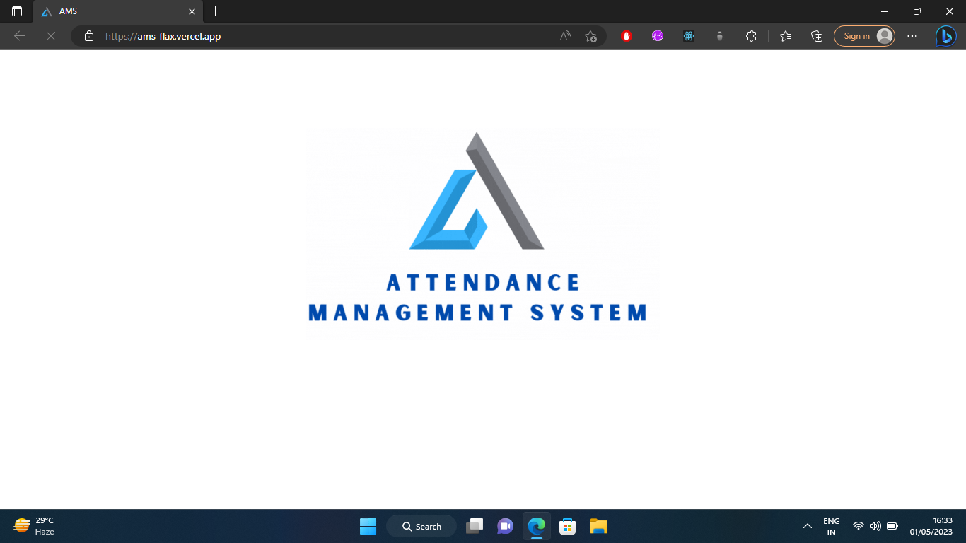

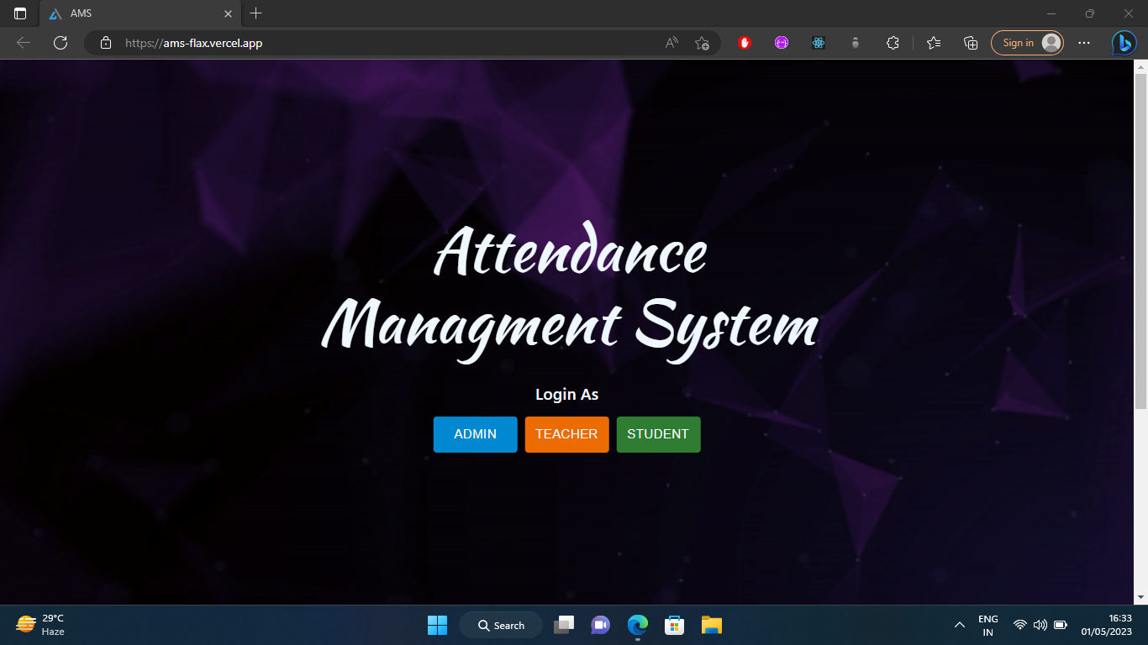 **Then after this-**

**Now you will select login as and then after enter your registration number and password-**

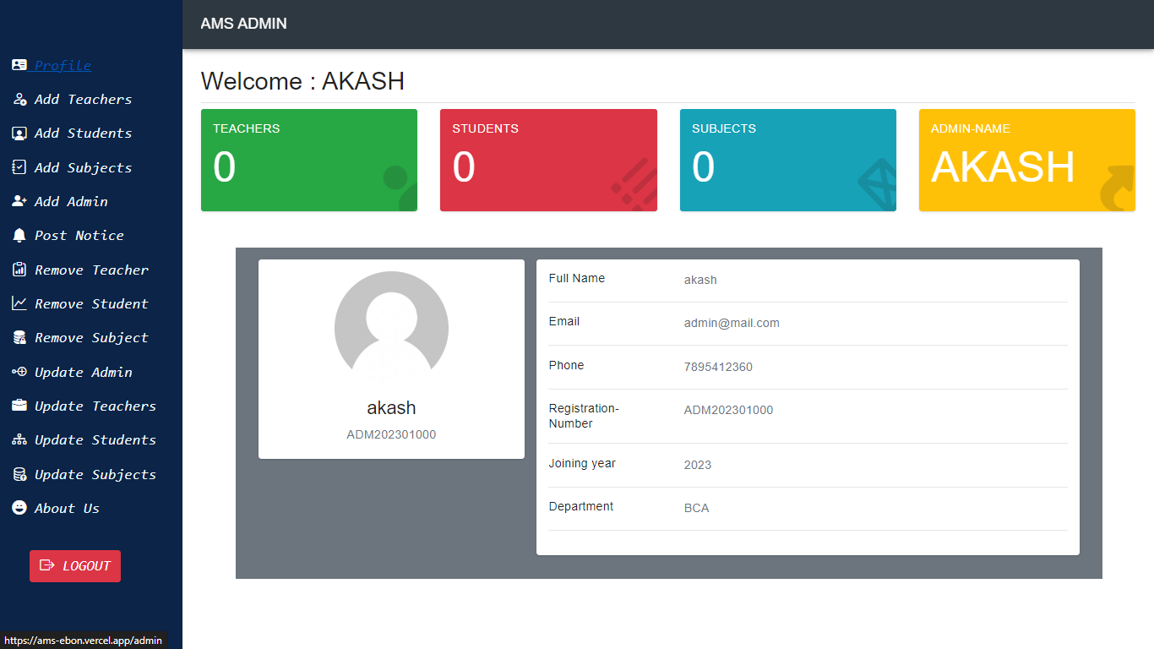 **After login as Admin, Admin Dashboard is open -**

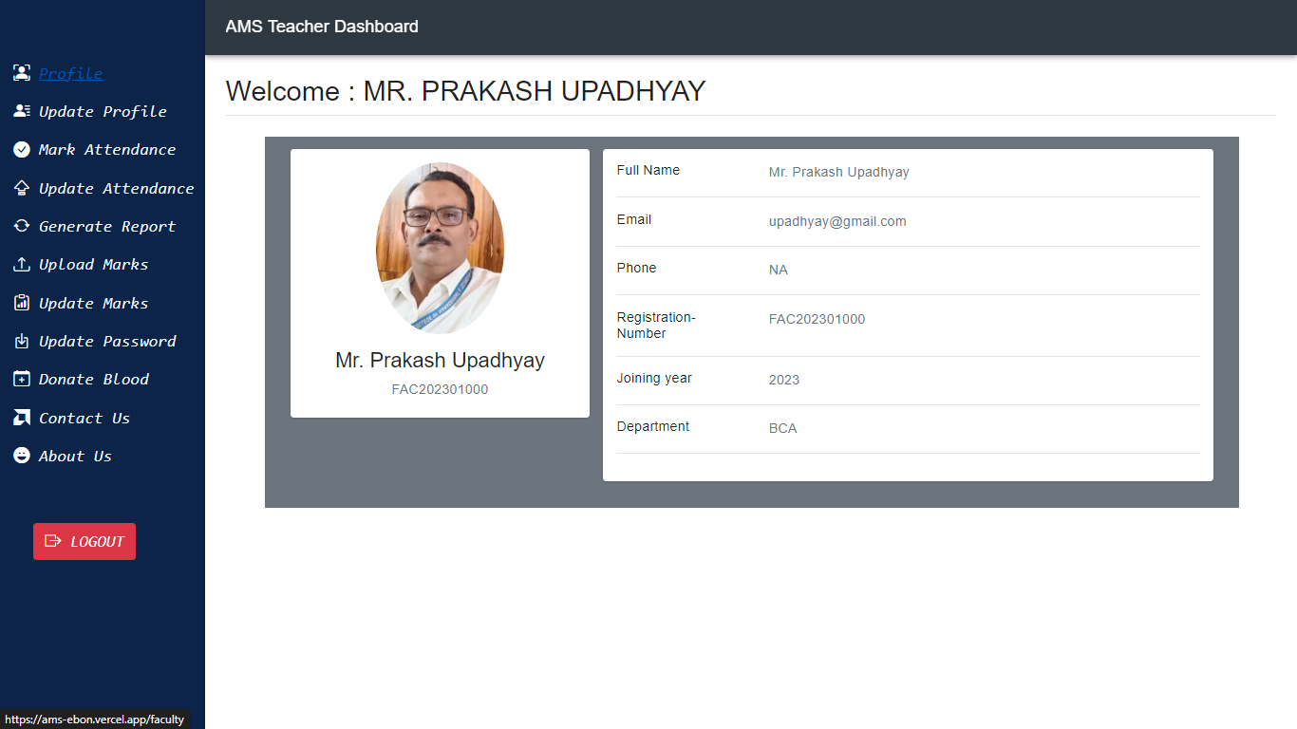 **After login as Teacher, Teacher Dashboard is open –**

**After login as Student, Student Dashboard is open –**

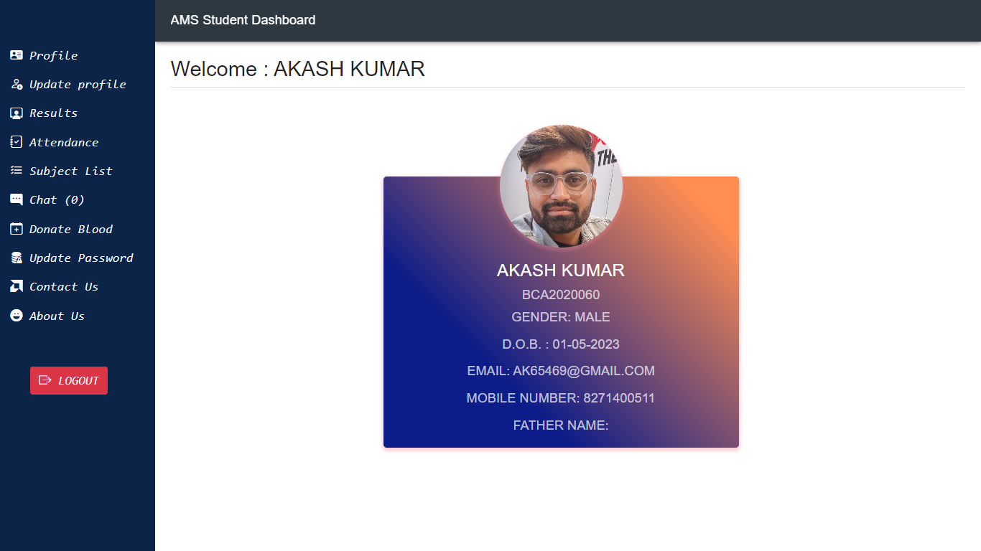

**In Mobile , It look like this –**

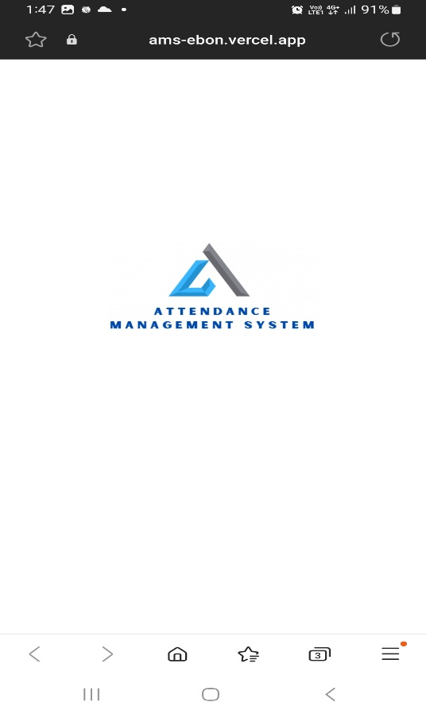

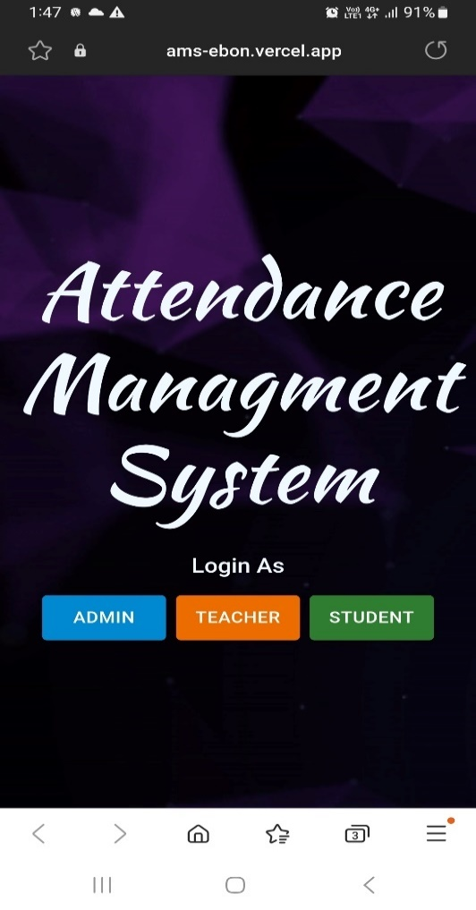

**After login as Admin, Admin Dashboard is open –**

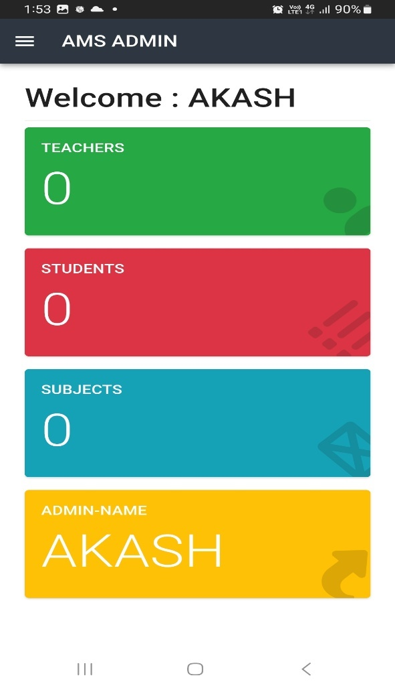

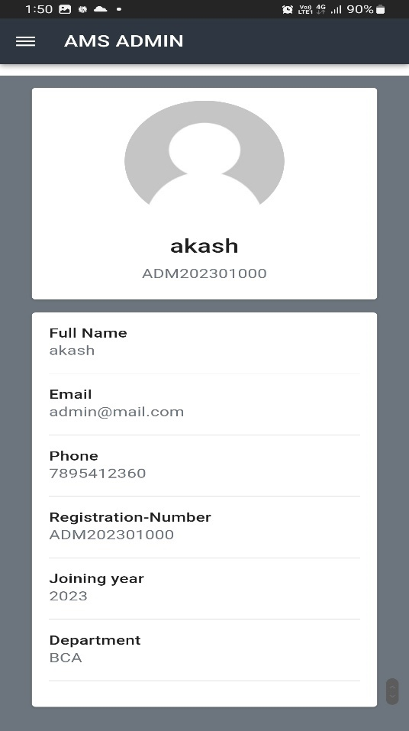

**After login as Teacher, Teacher Dashboard is open –**

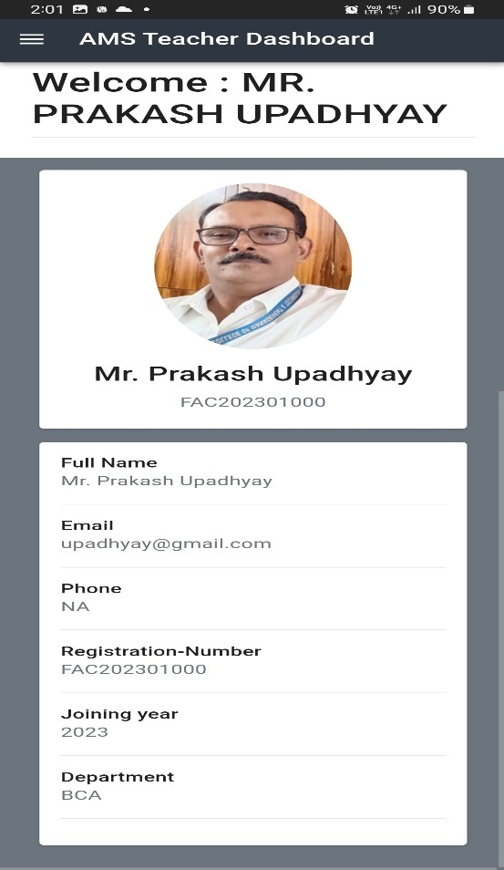

**After login as Student, Student Dashboard is open –**

