Customer Classification Model

A Pg. Diploma Project Report

Submitted by

**Prince Dubey (G23AI2014)**

Under the Supervision

Of

Prof. Sumit Kalra

Department of Artificial Intelligence

Indian Institute of Technology Jodhpur

Project and Code Description

**Objective**

The goal of this project is to cluster the customers based on their annual income and spending score which can include:

Purchase history

Demographics (age, income, etc.)

Using these clusters, businesses can: Personalize marketing campaigns Identify high-value customers Improve product recommendations

**Workflow**

The general workflow for the project is as follows:

*Data Collection:*

Collect customer data from internal databases or external sources.

*Data Preprocessing:*

Clean and prepare the data (handling missing values, scaling, etc.). Exploratory Data

*Analysis (EDA):*

Visualize and understand the key patterns in the data.

*Clustering:*

Apply clustering algorithm **K-Means** to group similar customers.

*Evaluation*:

We used evaluation metrics like the elbow method to assess the quality of the clusters.

*Reporting:*

Summarize findings and visualizations into a report that highlights insights and actionable recommendations.

*Technologies Used*

Programming Language: Python 3.9

Libraries:

Pandas, numpy for data manipulation

Scikit-learn for machine learning algorithms

Matplotlib, seaborne for data visualization

Flask for utilizing the trained model for future prediction.

Code snippet and screen shots

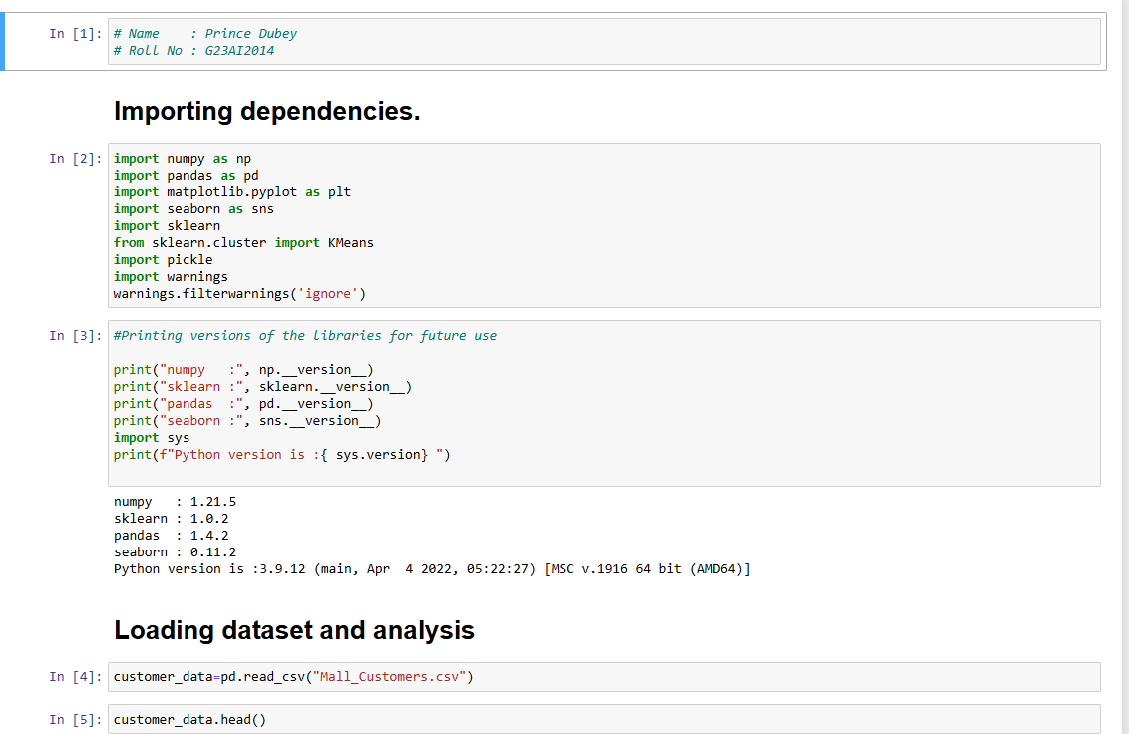

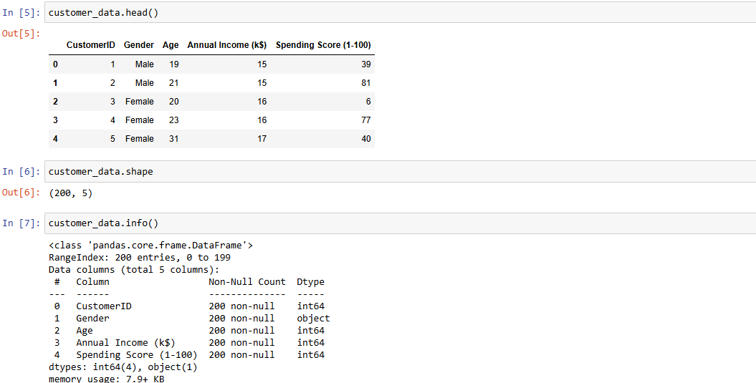

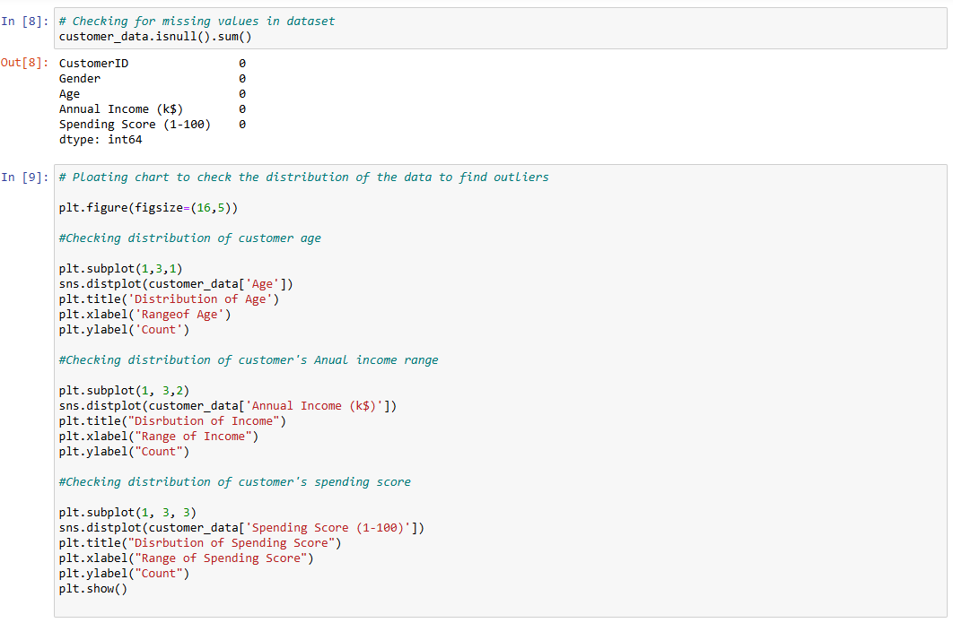

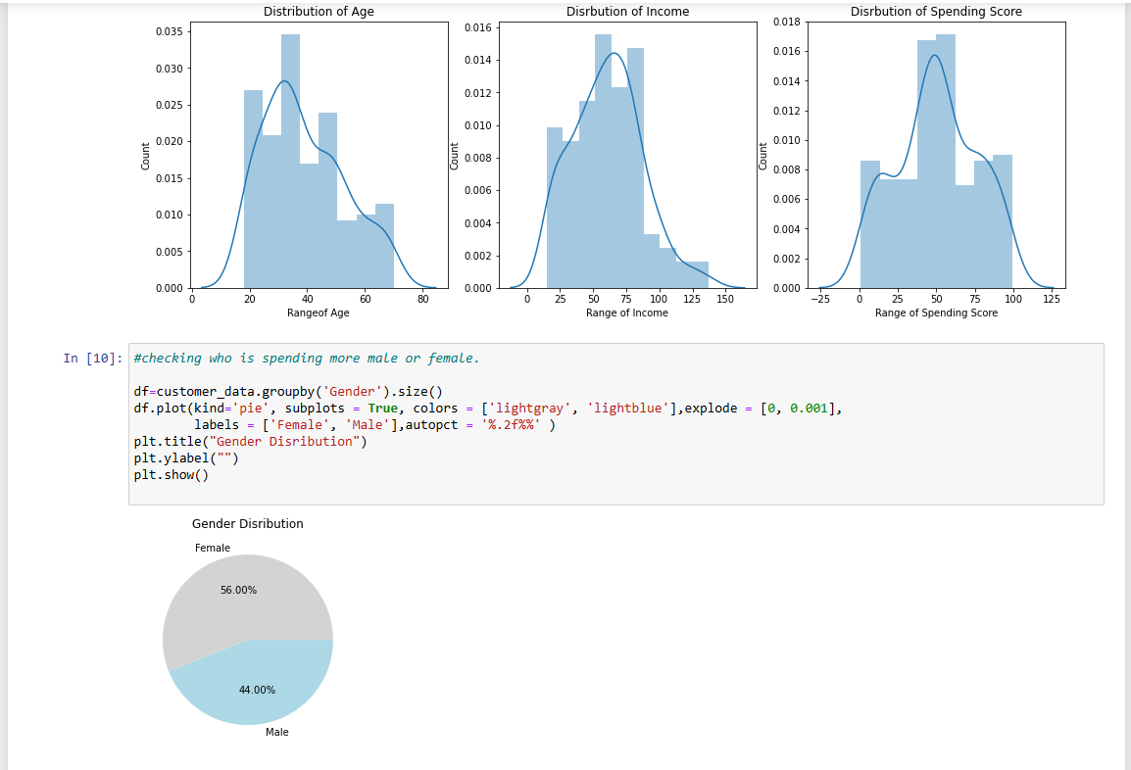

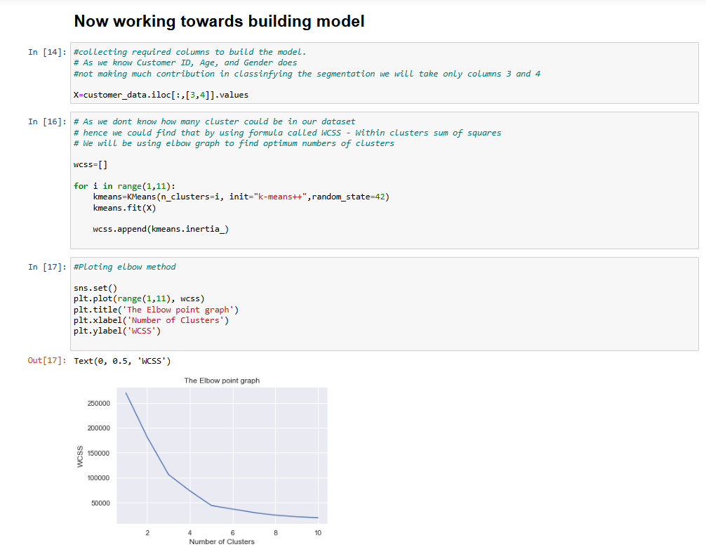

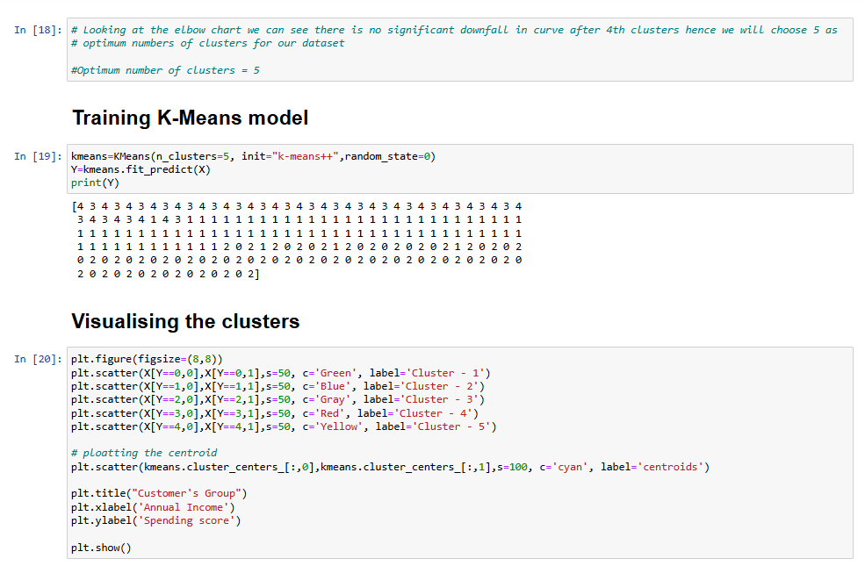

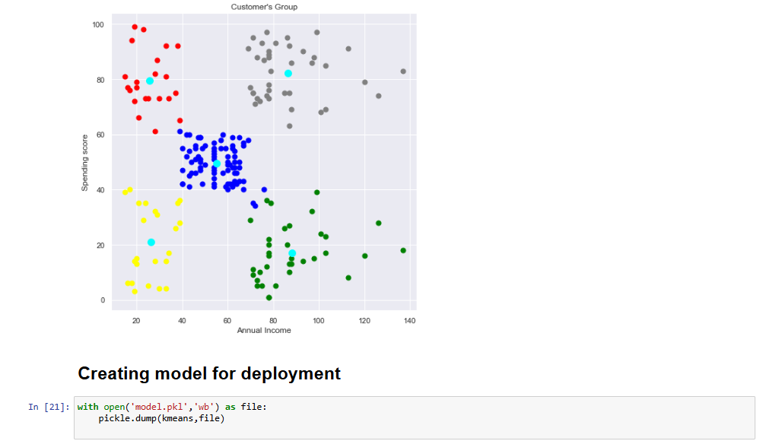

Code to call K-Mean clustering model.

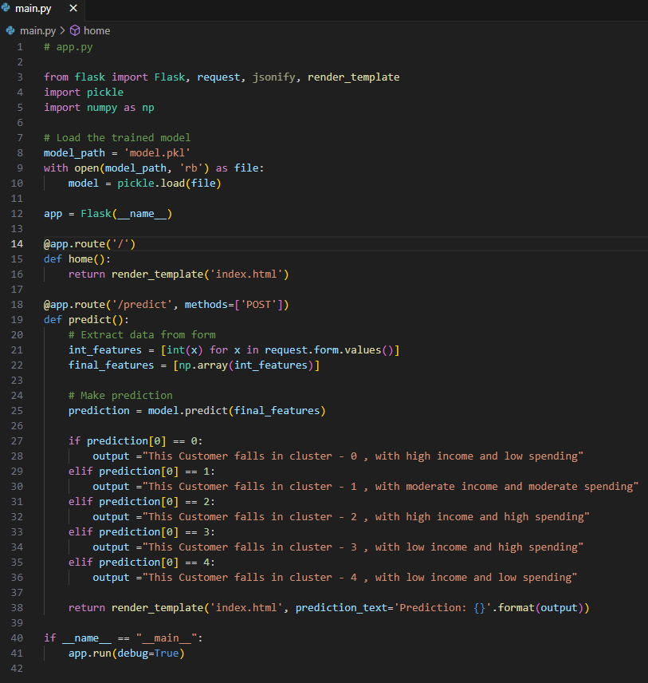

HTML script to create UI.

