TRAINING ANALYTICS PORTAL
WITH ML-BASED TRAINEE PERFORMANCE PREDICTION AND EARLY INTERVENTION
PROJECT SYNOPSIS
1. ABSTRACT
The Training Analytics Portal is a full-stack web application designed to centralize trainee performance data and provide individual and batch-level training insights. The system records session-level information such as assessment scores, categorized errors, time taken, completed modules, and related performance indicators. Role-based dashboards allow trainees to monitor progress while trainers can analyze batch trends and identify trainees who may require additional support.
The project incorporates a Machine Learning-based early-warning component that analyzes historical performance patterns to predict whether a trainee is likely to require additional trainer attention. The ML service is implemented separately using Python and FastAPI and communicates with the Node.js backend through an internal API. During the cold-start phase, when insufficient historical data exists for reliable temporal features, descriptive analytics and transparent rule-based indicators are used. The final ML target, features, and minimum data requirement will be established through exploratory data analysis and model validation.
2. INTRODUCTION
Training programs generate performance information through assessments, practice sessions, errors, completion records, and time-based measurements. When records are maintained manually across spreadsheets or separate files, identifying trends, comparing trainees, and detecting declining performance can become difficult. The proposed portal provides a centralized platform for recording, managing, visualizing, and analyzing training-session data. It combines full-stack development, relational database design, data visualization, and machine learning in a practical training analytics solution.
3. PROBLEM STATEMENT
Manual or spreadsheet-based training tracking can lead to fragmented session histories, limited visibility into individual progress, time-consuming batch comparisons, difficulty identifying repeated errors or declining performance, and a lack of automated indicators for trainees who may require additional attention. A centralized analytics platform is proposed to organize training data and provide timely, data-driven decision support to trainers.
4. OBJECTIVES
- Develop a centralized database for trainee, batch, session, and assessment information.
- Provide secure role-based access for trainers and trainees.
- Record session metrics including scores, errors, time taken, and modules.
- Provide individual and batch-level visual analytics.
- Identify performance trends through descriptive analytics.
- Develop an ML-based system to identify trainees likely to require additional trainer attention.
- Provide a rule-based fallback during the ML cold-start phase.
- Maintain a modular architecture supporting future predictive analytics.
5. SCOPE
The system covers authentication and role-based access, trainee and batch management, training-session recording, assessment score tracking, error categorization, time tracking, individual progress visualization, batch analytics, performance trends, ML-based attention prediction, cold-start handling, trainer attention indicators, and reporting/export.
The initial implementation excludes hardware/equipment telemetry, computer-vision CAD/STL analysis, LLM functionality, reinforcement learning, real-time IoT integration, mobile applications, and automated intervention delivery. These may be considered only as future extensions where appropriate.
7. MAJOR MODULES
1. Authentication and Authorization  2. User and Trainee Management  3. Batch Management  4. Training Session Management  5. Performance Analytics | 6. Trainee Dashboard  7. Trainer / Batch Dashboard  8. Machine Learning Prediction  9. Early-Warning Indicators  10. Reporting and Export
8. KEY FUNCTIONAL REQUIREMENTS
Authentication — Secure login, RBAC, JWT-based access.
User & Batch Management — Manage trainees, trainers, batches, and module assignments.
Session Tracking — Capture scores, categorized errors, time taken, and module information.
Dashboards — Individual trainee and aggregate trainer/batch views.
Visualizations — Score trends, error distributions, and progress charts.
ML Early-Warning — Predict trainees who may require additional attention from historical patterns.
Cold-Start Fallback — Use descriptive analytics and rule-based indicators when history is insufficient.
Reporting — Export selected performance and batch summaries.
9. TRAINEE & TRAINER DASHBOARDS
Trainee dashboard: total sessions, average/latest score, score trend, session history, error distribution, time trends, module-wise performance, and areas requiring improvement.
Trainer dashboard: batch average, score distribution, session completion, error distribution, module-wise performance, time statistics, declining/inconsistent performance indicators, and ML-based attention indicators.
10. MACHINE LEARNING COMPONENT
Prediction Objective: predicts whether a trainee is likely to require additional trainer attention based on historical performance patterns. The prediction is a decision-support indicator and does not replace trainer judgment.
Target Definition: finalized after inspecting available data — a possible formulation is “Requires Additional Attention: Yes/No,” depending on data, label availability, class distribution, feature quality, and validation results.
Candidate Features: recent scores, score trend, average score, error rate/frequency, time taken and its change, number of sessions, module-wise performance, and performance consistency.
Cold-Start Strategy: when a trainee lacks sufficient historical data for reliable temporal features (rolling averages, trend slopes), the system uses descriptive analytics and rule-based threshold indicators; ML inference activates once the minimum data requirement from EDA is met.
11. ML PIPELINE
Training Data → Validation & Cleaning → EDA → Feature Engineering → Target Definition → Train/Val/Test Split → Baseline Model → Model Comparison → Model Evaluation → Selected Model → FastAPI Inference → Trainer Dashboard
Candidate models include Logistic Regression, Random Forest, and XGBoost. The final model will be selected based on dataset characteristics and validation results rather than being predetermined.
12. SYSTEM ARCHITECTURE
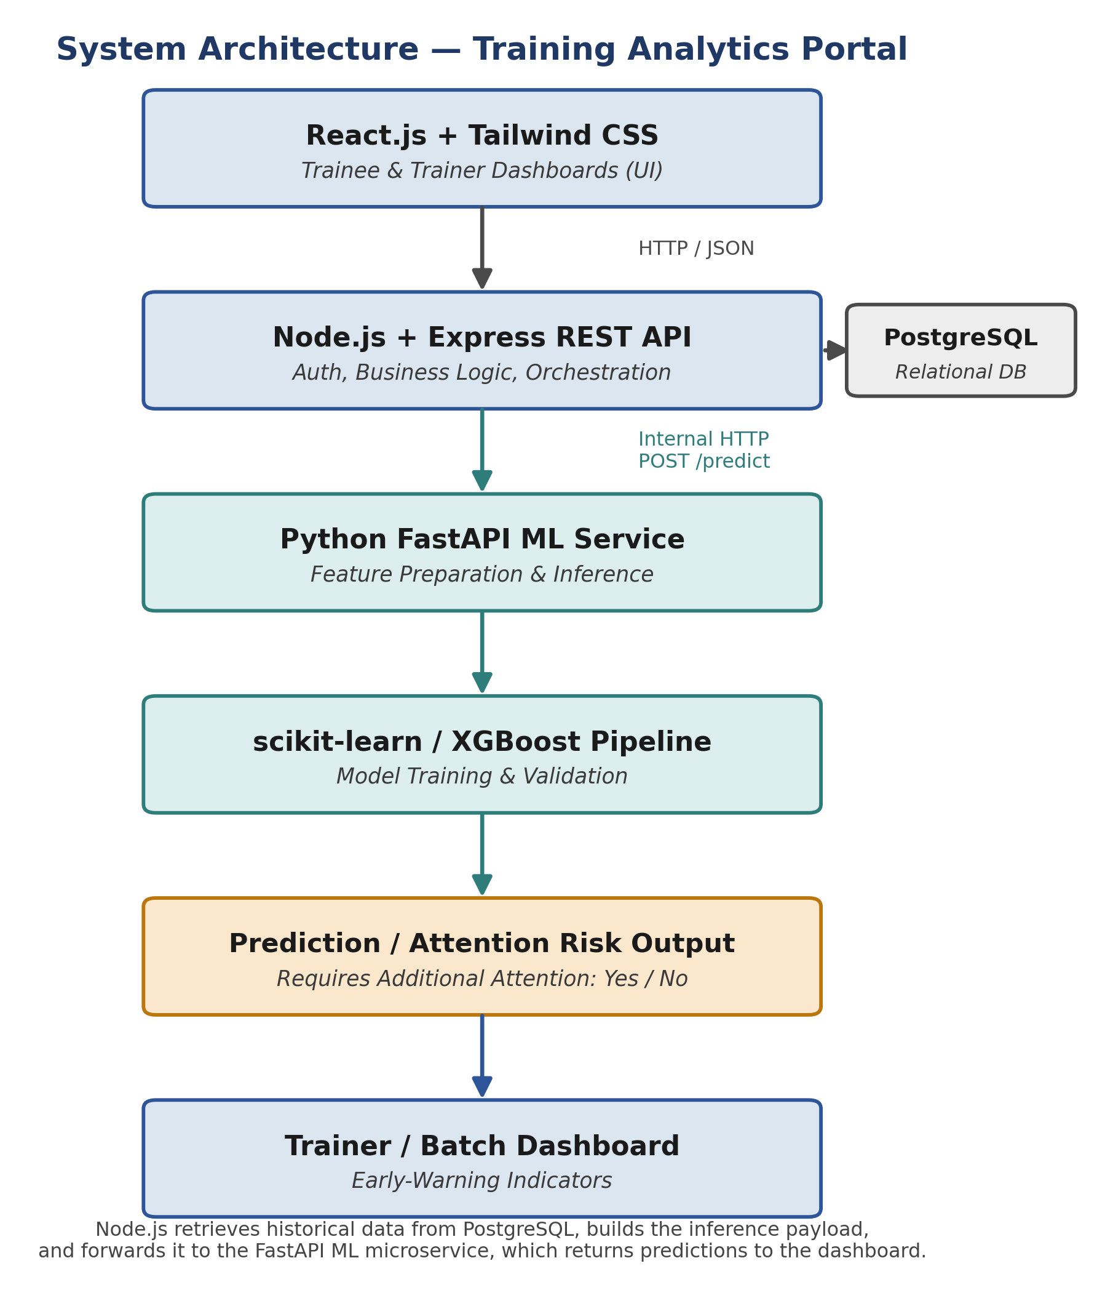
The ML component operates as an internal FastAPI microservice. Node.js retrieves required historical data from PostgreSQL, constructs the inference payload, and sends it to FastAPI. The ML service returns the prediction to Node.js, which exposes the result to the dashboard. Supporting feature contributions/importance may be returned where supported by the selected model.
13. DATA STRATEGY
The project will prioritize real and approved training data where available. EDA will examine trainees, batches, sessions, variables, missing/duplicate records, distributions, temporal coverage, class balance, and historical labels. If sufficient approved historical data is unavailable, synthetic/test data may be used to validate the application and ML pipeline, but it will be clearly identified and never presented as actual outcomes.
15. TECHNOLOGY STACK
Frontend — React.js, Tailwind CSS — trainee/trainer interfaces.
Visualization — Recharts / Chart.js — progress and trend charts.
Backend — Node.js, Express.js — REST APIs, authentication, business logic, DB orchestration.
ML Microservice — Python, FastAPI — feature preparation and inference.
Machine Learning — scikit-learn, XGBoost, pandas — model development, validation, inference.
Database — PostgreSQL — relational storage.
Security — JWT, bcrypt — authentication and password protection.
Version Control — Git, GitHub.
Deployment — Vercel and Render / equivalent cloud services.
16. DEVELOPMENT METHODOLOGY
Phase 1 — Requirements & Data Analysis: understand workflow, inspect data, perform EDA, define ML target.
Phase 2 — Database & Backend: PostgreSQL schema, authentication, APIs, validation and access control.
Phase 3 — Frontend: authentication, trainee dashboard, trainer dashboard, session interfaces.
Phase 4 — Analytics: score trends, error distributions, batch comparisons, progress statistics.
Phase 5 — Machine Learning: prepare data, engineer features, establish baseline, compare models, evaluate, build FastAPI service, integrate with Node.js.
Phase 6 — Integration & Deployment: testing, cold-start validation, ML validation, deployment, documentation.
17. MODEL EVALUATION
The ML model will not be evaluated using accuracy alone. Depending on the final target and class distribution, evaluation may include Precision, Recall, F1-score, Confusion Matrix, ROC-AUC where appropriate, Precision-Recall analysis, and cross-validation. Recall will receive particular attention because failing to identify a trainee who genuinely requires support may be more significant than generating an occasional false alert. No predetermined accuracy will be claimed before experimentation.
18. EXPECTED OUTCOME & FUTURE SCOPE
Expected outcome: a centralized trainee/session management platform, individual and batch analytics, score/error/time visualizations, an ML-based attention mechanism, transparent cold-start handling, and a modular web-plus-ML architecture suitable for demonstration and further development.
Future scope: LMS/assessment integration, notifications, additional predictive analytics, advanced recommendations, automated reports, equipment/application usage data where available, mobile access, and model monitoring/retraining pipelines, subject to requirements and suitable data.
19. CONCLUSION
The Training Analytics Portal combines full-stack engineering, database management, visualization, and machine learning into a practical training analytics solution. Its ML target, features, minimum historical-data requirement, and final model are determined through EDA and empirical validation rather than arbitrary assumptions. The Node.js and FastAPI separation provides a modular architecture, while the cold-start strategy keeps predictions responsible when historical information is limited. The project provides a realistic and defensible internship-level implementation with clear potential for future expansion.

