**UrecPlay**

**Recreation/Sporting Arena**

**CS6359.002 Project Iteration 2**

**Team:**

**(Group 2)**

**Members:**

**Akash Bharadwaj**

**Prathik Ganiga**

**Rohit**

**Vinay Potla**

**INTRODUCTION**

**Vision**

**UrecPlay** is a website that allows anyone to register and book slots in the sporting arena. A user who is registered on the site will be able to book slots. Once a user has made the booking, the website will send an email to the user, notifying them of their reservation. This registered users, once logged into the system can view their booking history. **UrecPlay** main purpose is to provide a smooth and convenient way for users to book the sporting arenas across the campus.

**Overview**

The functionalities provided by this application are as follows:

* Allow all the users set up an account, login, register and log out of the application.
* Allow admins to login, register an appointment and view details and manage their respective accounts.
* Allow admins to login, register, modify appointments and manage all accounts.
* Maintain Arena and User records.

**PROJECT SCOPE FOR ITERATION 2**

The following functionalities are included in this iteration

* Users should be able to book an arena for a particular time slot.
* Users should be able to view his booking history.
* Admins should be create new arenas.
* Admin should be able to delete existing arenas.

**DESIGN SPECIFICATIONS**

**Functional Requirements**

FR1 - All users should be provided with a login and registration facilities.

FR2 - All Users should be able to access only certain pages. Registered users can only view

the list of arenas whereas admin can see the push notification page.

FR3 - Admin should be able to send push notifications.

FR4 - All user should be able to view their booking history.

FR5 - All user should be able to make booking of the sporting arena.

FR6 - Admin user should be able to add an arena to the system.

FR7 - Admin user should be able to remove an arena from the system.

**Non-Functional Requirements**

NFR1- Application should be easy, intuitive and user friendly.

NFR2 - Application should be as secure as necessary.

NFR3 - Registrations should get updated in a timely fashion, and acknowledgements

should be provided.

**DOMAIN MODEL**

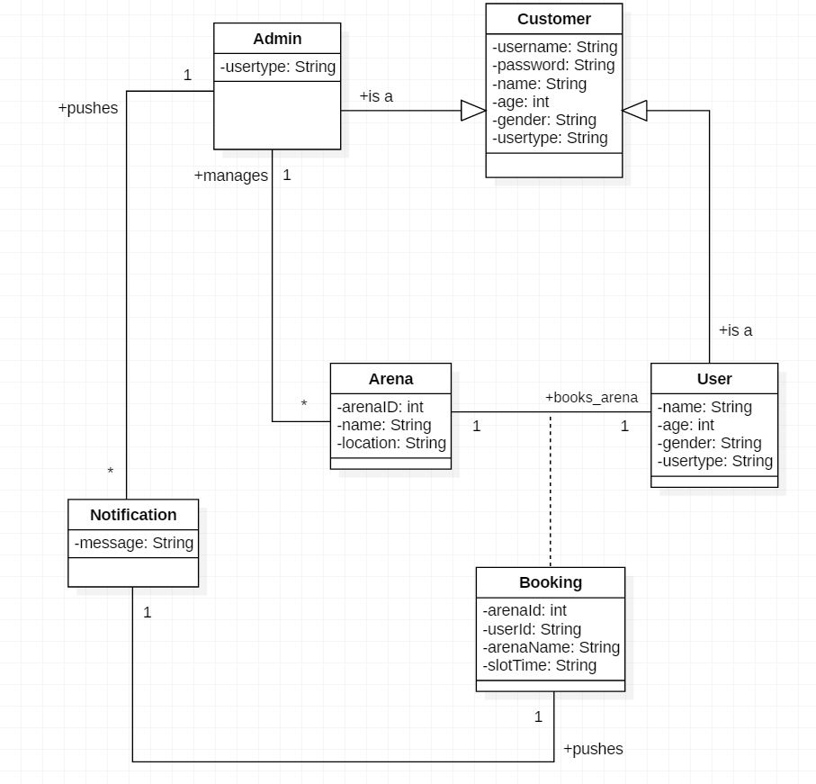

**CONSTRAINTS AND LIMITATIONS**

**Constraints**

* Time is a key constraint. Team members involved with implementing the application have busy schedules which must be factored into any plan.
* Organization is another constraint.

**Limitations**

* The application will not actually reserve a physical appointment for the users.
* Admin needs to correctly monitor the appointments for the arenas to be correctly updated.
* Notification will only be provided once the users is successful registered in the system.
* The application will most likely not support many concurrent users.

**USE CASE DIAGRAM**

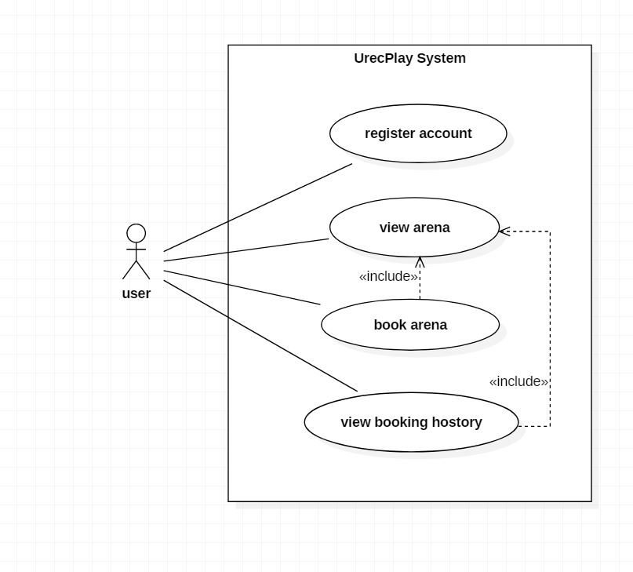

**Figure 1** - **User Use Case**

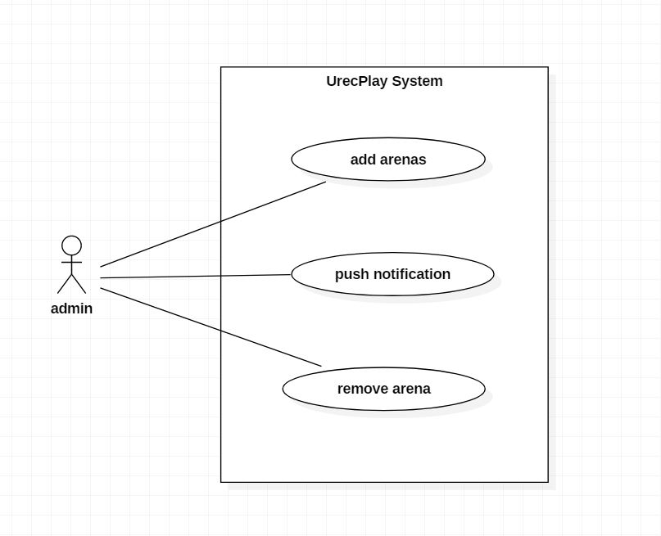

**Figure 2** – **Admin Use Case**

**CLASS DIAGRAM**

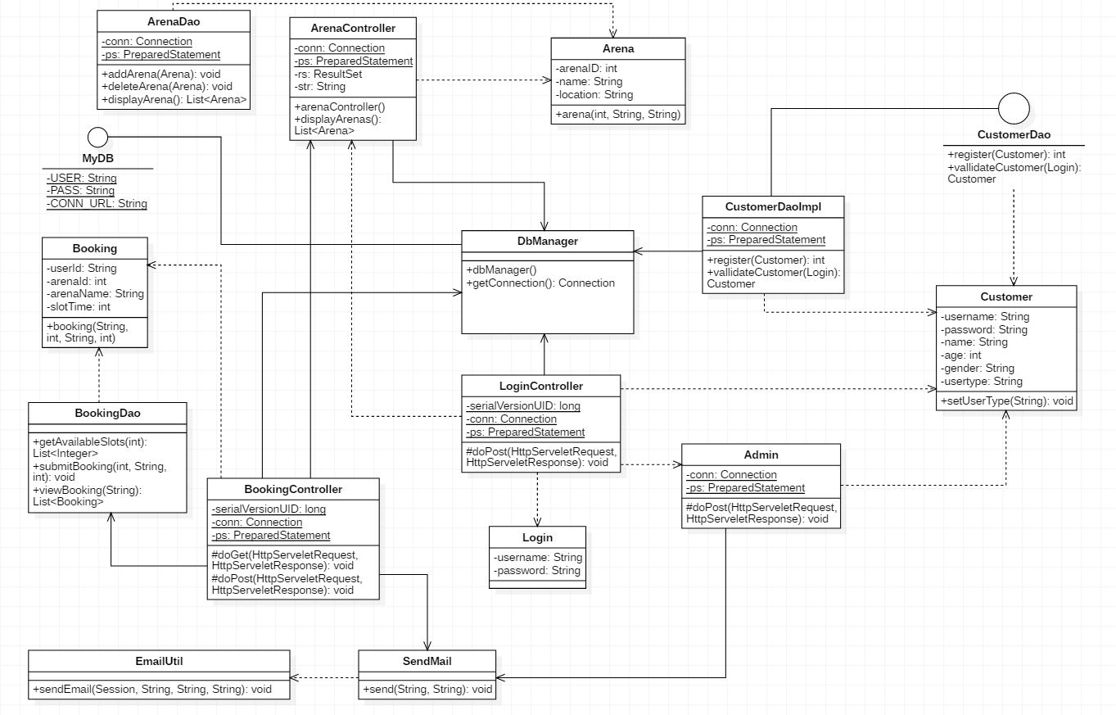

**FULLY DRESSED USE CASE TEXT**

|  |  |  |
| --- | --- | --- |
| Use-Case Number | **UC-01** | |
| **Use-Case Name** | **Registering a New User** | |
| Actor | User | |
| Description | This use case permits an user to register themselves in UrecPlay System. | |
| Precondition | The User must be at the Login Page and the System must be up. | |
| Post-condition | The User will be able to Register Themselves using the Register link. | |
| Basic course of Action | User Action | System Response |
| 1. TUCBW User Clicks on the registration link on the Login page.  3. The User Enters the necessary information in the Registration page and clicks on the register button.    5. TUCEW the user going to the welcome page and view the list of arenas. | 2. The System displays the Registration page for the User to enter details.  4a. The System will prompt a message on successful user registration. |
| Alternate course of Action | 4b.1 The System will prompt an error message if the re-entered password is incorrect.  4.b.2 The System will prompt an error message if the user is already registered in the system. | |

|  |  |  |
| --- | --- | --- |
| Use-Case Number | **UC-02** | |
| **Use-Case Name** | **View Sporting Arena** | |
| Actor | User | |
| Description | This use case lets the registered user of the system view a List of all available sporting arena. | |
| Precondition | User has to be logged in. | |
| Post-condition | The User will be able to view a list of all available sporting arenas in the System. | |
| Basic course of Action | User Action | System Response |
| 1. User searches for the required arena.    3a. TUCEW If there are matching arenas, the user views them.  3b. TUCEW if there are no matching arenas a message “No arenas found message is displayed”. | 2a. The System returns a list of all the Sporting Arena matching the users search. |

|  |  |  |
| --- | --- | --- |
| Use-Case Number | **UC-03** | |
| **Use-Case Name** | **Booking Arena** | |
| Actor | User | |
| Description | This use case lets the user to book an arena of his choice. | |
| Precondition | The user must be logged into the system. | |
| Post-condition | The User will have booked a slot for a particular arena. | |
| Basic course of Action | User Action | System Response |
| 1. User clicks the book button for the arena of their choice.    3a. The user selects a time slot and clicks book.  3b. The user sees an error message and has an option to go back to the home page.    5. TUCEW the user receives an email with the booking details.  User can see the available arenas and continue with booking again. | 2a. The System displays a page were the user can select the available time slots for the selected arena.  2b. If there are no available slots. Systems displays an error message.  4. The System will book the arena for the particular timeslot and sends a confirmation mail to the users email id. User is redirected to the home page. |

|  |  |  |
| --- | --- | --- |
| Use-Case Number | **UC-04** | |
| **Use-Case Name** | **View Booking History** | |
| Actor | User | |
| Description | This use case lets the registered user of the system view a List of all his booking histories. | |
| Precondition | User has to be logged in. | |
| Post-condition | The User will be able to view a list of all booking histories in the System. | |
| Basic course of Action | User Action | System Response |
| 1. User clicks on the Booking history button on the home screen.  3a.If there were previous booking histories, he views his booking history.  3b.If user had not previously booked arenas, he sees the message that there are no booking history. | 2a. If available the System returns a list of all the users Booking histories.  2b. If there are no booking history then the System returns a message saying no booking history. |

|  |  |  |
| --- | --- | --- |
| Use-Case Number | **UC-05** | |
| **Use-Case Name** | **Push Notification** | |
| Actor | Admin and User | |
| Description | This use case lets the admin send out email notification to all the registered user of the UrecPlay. | |
| Precondition | The admin must be logged into the system. | |
| Post-condition | The User will receive an email notification from the admin. | |
| Basic course of Action | User Action | System Response |
| 1. TUCBW the admin user logging into the system.    3. The admin user types a message for all the registered user of the system.    5. TUCEW the registered user of the System receiving an email notification message from the UrecPlay admin. | 2a. The System displays a page were the admin can enter the notification message.  4. The System will send a email notification message when the admin user presses **Submit**. |
| Alternate course of Action | 2b. The System displays an error message if the admin enters an incorrect password. | |

|  |  |  |
| --- | --- | --- |
| Use-Case Number | **UC-06** | |
| **Use-Case Name** | **Add Arena** | |
| Actor | Admin | |
| Description | This use case lets the admin add new arena to the UrecPlay application. | |
| Precondition | The UrecPlay application should be up and running. | |
| Post-condition | A success message is displayed once the arena is added to database. | |
| Basic course of Action | User Action | System Response |
| 1. TUCBW the admin user logging into the system.    3. The admin user enters the name and location of the arena to be added.    5. TUCEW the admin user sending an email notification message from the UrecPlay notification page. | 2a. The System displays a page where the admin can add new arena.  4a. The System will display a success message if the combination of name and location does not already exists.. |
| Alternate course of Action | 2b. The System displays an error message if the admin enters an incorrect password/username.  4b. The System will display an error message otherwise. | |

|  |  |  |
| --- | --- | --- |
| Use-Case Number | **UC-07** | |
| **Use-Case Name** | **Remove Arena** | |
| Actor | Admin | |
| Description | This use case lets the admin remove arena from the UrecPlay application. | |
| Precondition | The UrecPlay application should be up and running. | |
| Post-condition | A success message is displayed once the arena is added to database. | |
| Basic course of Action | User Action | System Response |
| 1. TUCBW the admin user logging into the system.    3. The admin user enters the name and location of the arena to be removed.    5. TUCEW the admin user sending an email notification message from the UrecPlay notification page. | 2a. The System displays a page where the admin can remove arena.  4a. The System will display a success message if the combination of name and location exists. |
| Alternate course of Action | 2b. The System displays an error message if the admin enters an incorrect password/username.  4b. The System will display an error message otherwise. | |

**SEQUENCE DIAGRAM**

User Sequence diagram

1. **View Arenas**

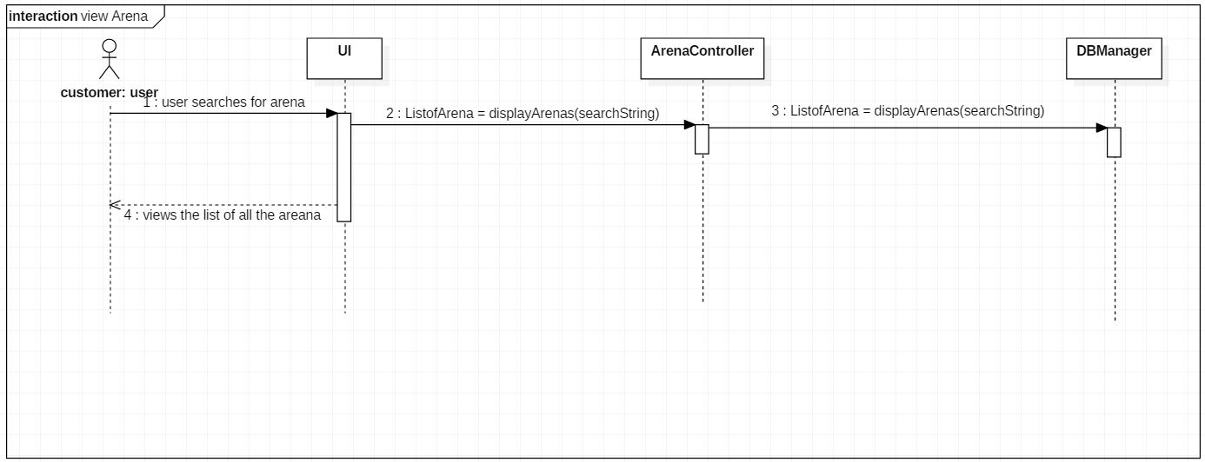

**2. Book Arenas**

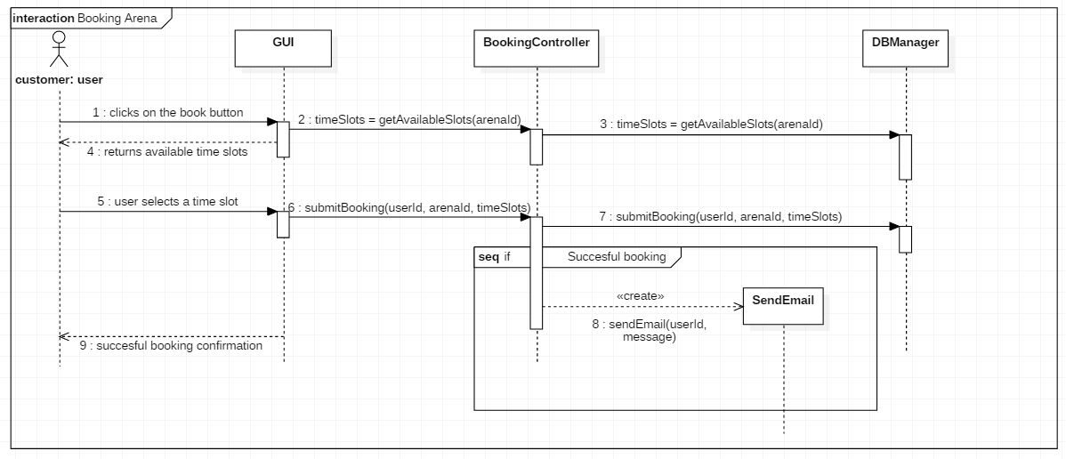

**3. View Booking History**

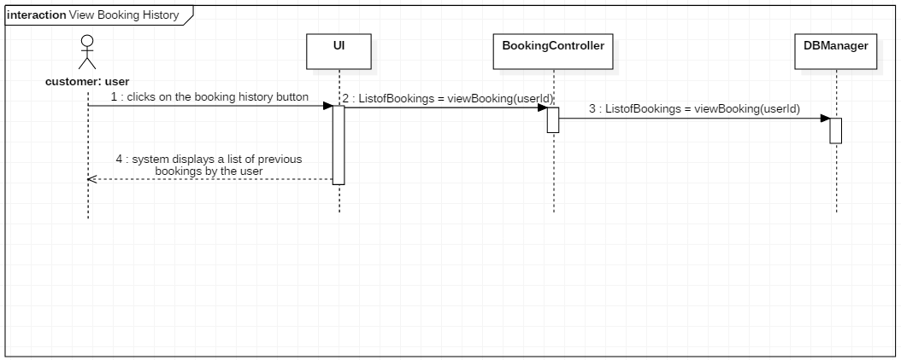

Admin Sequence Diagrams

1. **Add Arena**

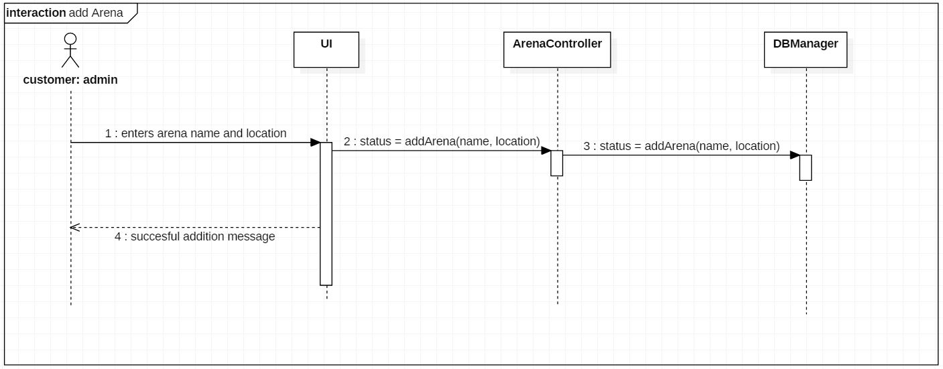

**2. Remove Arena**

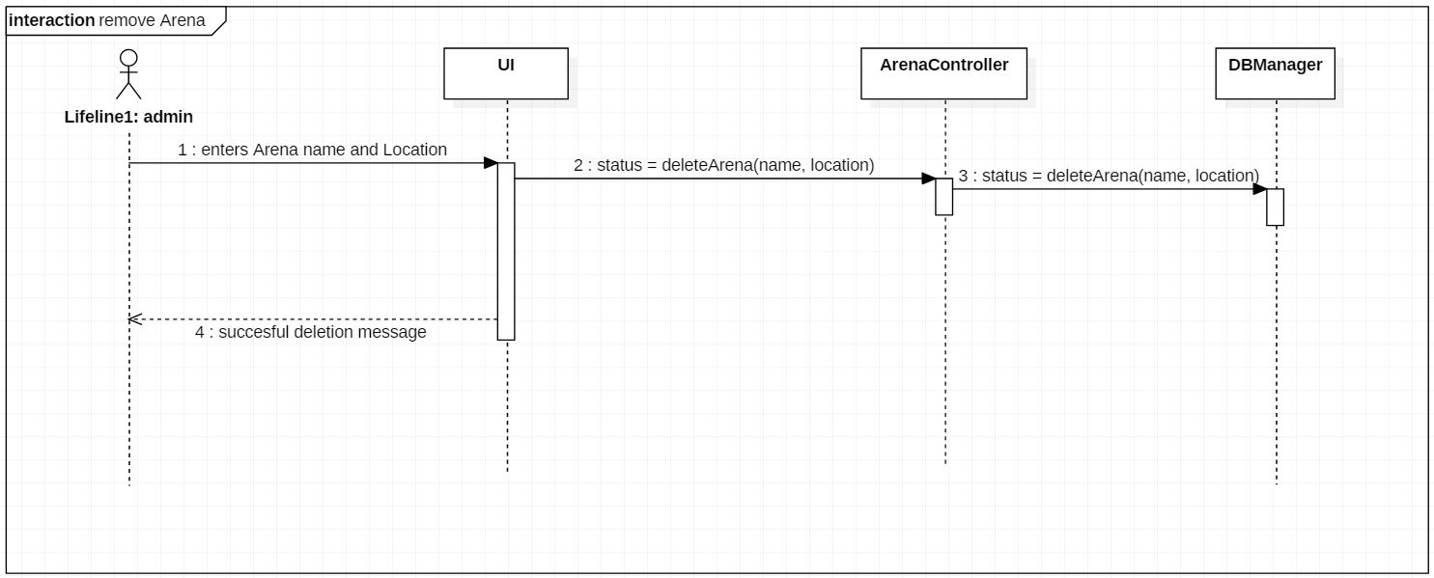

**SUPPLEMENTARY SPECIFICATION**

* Details should update in a timely fashion, and notifications should be sent within an acceptable time range.
* Developer will give a manual that explains how to use this program.
* The application should work on windows OS, Linux OS and Max OS

**TESTING**

Testing will be done on the system to check if the system can finish tasks according to the requirements stated earlier successfully and smoothly.

**Testing plan:**

The following activities and test cases are used to check the quality and to map the implementation with the requirements of the system.

**Unit Testing**

|  |  |  |  |  |
| --- | --- | --- | --- | --- |
| **S.No** | **Test Case** | **Test Case Description** | **Expected Output** | **Observed Output** |
| **TC1** | Admin Login | 1)Admin opens the application.  2)Admin logs in to the system by entering the admin userId and password.  3)Admin clicks on the login button. | The admin should be navigated to send notification screen. | The admin is navigated to send notification screen. |
| **TC2** | Send Notification | 1) Admin is on the send notification screen.  2)Admin enters the notification message in the text area provided.  3) Admin clicks on submit button. | 1)Success message(“Email Sent”) should be displayed.  2) Notification sent should be present in the sent folder of urec email account.  3)Notification should be present in the inbox of **stub accounts**. | Success message(“Email Sent”) is displayed.  2) Notification sent is present in the sent folder of urec email account.  3)Notification is present in the inbox of stub accounts. |
| **TC3** | User Login | 1)User opens the application.  2)User enters the userId and Password.  3)User clicks on login button. | The user should be navigated to “*Arenas to Book*” screen. | The user is navigated to “*Arenas to Book*” screen. |
| **TC4** | User Registration | 1)User opens the application.  2)User clicks on the registration link on the login screen.  3)User enters email-id, name, age, gender, password and clicks on register button. | “Registration done, please login” message should be displayed to confirm the success on the login screen. | “Registration done, please login” message is displayed to confirm the success on the login screen. |
| **TC5** | List arenas | 1)User successfully logins to the system. | “Hello-Name” and a table listing all the arenas to book should be displayed. | “Hello-Name” and a table listing all the arenas to book is displayed. |
| **TC6** | User/Admin Logout | 1)Admin/User opens the application and logs in.  2) Admin/User clicks on logout link. | User/Admin should be navigated to login screen. | User/Admin is navigated to login screen. |
| **TC7** | Login unsuccessful | 1)User/Admin opens the application.  2)User/Admin enters wrong userId and/or Password.  3)User/Admin clicks on login button. | User/Admin should be navigated to registration screen. | User/Admin is navigated to registration screen. |
| **TC8** | Registration Unsuccessful | 1)User opens the application.  2)User clicks on the registration link on the login screen.  3)User enters email-id (already registered), name, age, gender, password and clicks on register button. | User should be navigated to login screen with the “User Already Registered. Please Log in” message. | User is navigated to login screen with the “User Already Registered. Please Log in” message. |
| **TC9** | Book Arena | 1) User should click the on the arena he wants to book.  2) User should select a time slot from the available time slots shown. And click on book button. | User should be able to successfully book the arena for the particular time slot. And receive an email with booking details. | User is able to successfully book the arena for the particular timeslot.  User received an email with booking details. |
| **TC10** | View booking history successful | User clicks on the Booking History button to view his history. | User should be able to see the list of all his booking histories | User is able to see the list of all the booking histories. |
| **TC11** | View booking history unsuccessful | User clicks on the Booking History button to view his history when he has not booked any arena previously. | User should be able to see message that there are no booking available. | Users is able to see the message that there were no previous bookings. |
| **TC12** | Add arena successful | Admin enters the name and location of the arena to be added and clicks on add button. | Successful message “Arena Added Successfully” should be displayed. | Successful message “Arena Added Successfully” is displayed. |
| **TC13** | Remove arena successful | Admin enters the name and location of the arena to be removed and clicks on delete button. | Successful message “Arena Deleted Successfully” should be displayed. | Successful message “Arena Deleted Successfully” is displayed. |
| **TC14** | Add arena unsuccessful | Admin enters the name and location of the arena to be added and clicks on add button. | Unsuccessful message “Arena Add Unsuccessful” should be displayed. | Unsuccessful message “Arena Add Unsuccessful” is displayed. |
| **TC15** | Remove arena Unsuccessful | Admin enters the name and location of the arena to be removed and clicks on delete button. | Unsuccessful message “Arena Delete Unsuccessful” should be displayed. | Unsuccessful message “Arena Delete Unsuccessful” is displayed. |

**Traceability Matrix:**

|  |  |  |  |  |  |  |  |  |  |  |  |  |  |  |  |  |
| --- | --- | --- | --- | --- | --- | --- | --- | --- | --- | --- | --- | --- | --- | --- | --- | --- |
|  | **Priority** | TC1 | TC2 | TC3 | TC4 | TC5 | TC6 | TC7 | TC8 | TC9 | TC10 | TC11 | TC12 | TC13 | TC 14 | TC 15 |
| **Requirements** |  |  |  |  |  |  |  |  |  |  |  |  |  |  |  |  |
| UC01 | **1** | X |  | X | X |  | X | X | X |  |  |  |  |  |  |  |
| UC02 | **2** |  |  |  |  | X |  |  |  |  |  |  |  |  |  |  |
| UC03 | **3** |  |  |  |  |  |  |  |  | X |  |  |  |  |  |  |
| UC04 | **4** |  |  |  |  |  |  |  |  |  | X | X |  |  |  |  |
| UC05 | **5** |  | X |  |  |  |  |  |  |  |  |  |  |  |  |  |
| UC06 | **6** |  |  |  |  |  |  |  |  |  |  |  | X |  | X |  |
| UC07 | **7** |  |  |  |  |  |  |  |  |  |  |  |  | X |  | X |

. **PLAN FOR ITERATION III**

1. Implement arena booking functionality. System should check if there is an existing booking at the the slot selected. **R,V**
2. Implement functionality to send the confirmation Mail to the customer with booking details. **V,R**
3. Implement functionality that lets customer see their booking history. **P, A**
4. Implement functionality that allows customer to cancel their previous booking. **A, V**
5. Integrate newly implemented functionality with previous iterations functionality **P,A**
6. Test the whole system with newly implemented functionality. **P, V**

**GLOSSARY**

|  |  |  |  |
| --- | --- | --- | --- |
| **GLOSSARY** | | | |
| **REVISION HISTORY** | | | |
| **VERSION** | **DATE** | **DESCRIPTION** | **AUTHOR** |
| ITERATION - 2 | 7/10/2018 | First draft of glossary | GROUP2 |
| **DEFINITION** | | | |
| **Terms** | **Definition and Information** | | |
| User | Users are the main actors (superclass) in our design. Users can interact with the system and can perform transactions. Transaction refers to logging in and making arena reservations. | | |
| CustomerUser | Customer users (subclass of User) are the ones who decides to get serviced by the UrecPlay system. Customers can login to the system and book their reservations. They can only access information pertaining to their reservations only. | | |
| Admin Users | Admins (subclass of User) are the users who monitor and control the system. They can access, modify and update the arena details. | | |