Chinmaya Seva Samiti Trust’s



CHINMAYA P.U COLLEGE OF SCIENCE AND COMMERCE

College With A Difference

Accredited ‘A’ Grade by SAAC Committee

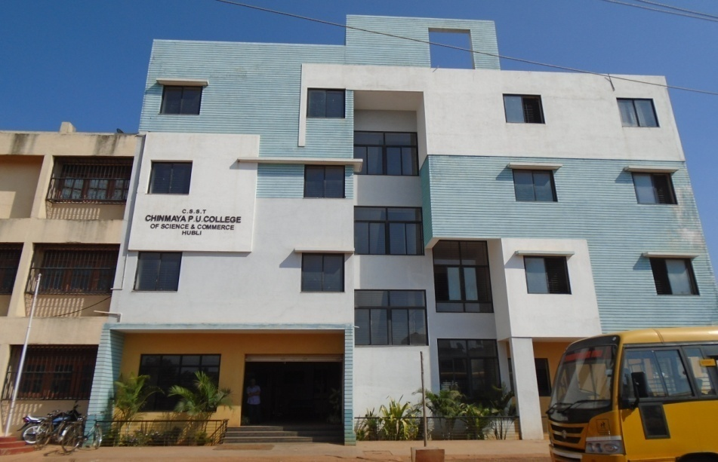

**MAYURI ESTATE, NAGASHETTY KOPPA, HUBLI 580023**

**Ph: 0836-2354374 Email:chinmayapuhbl@gmail.com**

**SUBJECTS OFFERED:**

**Science**- Physics, Chemistry, Mathematics,

Biology/Statistics/Computer Science

**Commerce**- Accountancy, Economics, Business Study,

Statistics, Computer Science

**“A vision not just for today but for future”**

**Our Vision**: To offer students a value based and holistic education, which power way for the integrated development of the physical, mental, intellectual and spiritual aspects of the personality, which is enriched by the knowledge of Indian culture, a feeling of patriotism and a universal outlook.

**Our Mission:**

Beginning in the classroom with exposure to new ideas, new ways of understanding and new ways of knowing, students embark on a journey of intellectual transformation.  Through a diverse living environment, where students live with people who are studying different topics, who come from different walks of life and have evolving identities, intellectual transformation is deepened and conditions for social transformation are created.  From this we hope that students will begin to fashion their lives by gaining a sense of what they want to do with their gifts and talents, assessing their values and interests, and learning how they can best serve the world.

The BEGINNING OF CHINMAYA

Chinmaya COLLEGE was started in the year 2005 at Hubbali with 40 students and now the tiny sapling has grown into a mighty tree of knowledge, with 435 students including COMMERCE as well as B.COM Degree. We have excellent infrastructure with up-to-date equipment, which enables effective teaching. Inspired Principals, dedicated teachers, supportive management and cooperative parents head these institutions. ‘Chinmaya college with a difference' for we have unique holistic vision programmes that create ‘students with a difference’.

**Inner transformation of individuals resulting in a happy world binding them through the Chinmaya Education Movement with 86 Vidyalayas, 7 Colleges and 1 International Residential school.**

Why Chinmaya?

* Holistic culture and Tradition
* Quality education

* Consistent results
* **Visionary Management**: To provide a clear vision, firm foundation of learning, strategic planning for growth and efficient management of resources.
* **Inspiring Principals:** To develop principle-centred principals who are inspired by the overall vision of Chinmaya Vidyalayas, and who step up as movers and shakers to lead their institution to nobler heights.
* **Dedicated Teachers:** To recognize and develop the crux of the institution by continuously motivating their love for knowledge, teachings, and children, so that they may effectively and lovingly, inculcate academics, skills, values and philosophy to the next generation.
* **Cooperative Parents:** To help parents be an ideal, hands-on, integral support base for their children, offering them extensive love, care, and joy, resulting in their healthy and integrated personality development.
* **Students with a Difference:** Students who learn, imbibe, and live the Chinmaya Vidyalaya vision of Knowledge, Spirit of Service, and Efficiency.
* The only Commerce college in Hubballi is to have on Integrated G-comm, Lab,

Tally-ERP 9,CPT Coaching for CA aspirant.

**Results and Achievements in academics.**

**SCIENCE Stream:**

**100% Result – 35 distinction, 65 first class, 05 second class.**

**I. Sudeep M with 97.66%**

**II. Srinivas M with 96.57%**

**III.Gourav S with 93.33%**

**COMMERCE Stream:**

**100% result – 35 distinction, 31 first class, 13 second class**

1. Runal Kothari with 94.33%.
2. Rutuja Devane with 94.33%.
3. Sushmita H with 93.16%

Jyoti Habib 93%

**JEE – MAINS QUALIFIED STUDENTS**

**1.** Swaroop P_JEE-MAINS-18, KVPY-1080, NSTSE-39(National Rank)

2. Srinivas M_NSTSE-1ST (State rank), KVPY-198, JEE-MAINS-181

3. Nishchal M

4. Sandesh Joshi

5. Harikishan H

6. Sudeep M

7. Srikant Tarrikeri

8. Anju Revanker

**CET Ranking**

1. Srinivas Mehrwade 15 Med-136 Engg.
2. Swaroop Pandit 191 Engg.
3. Nischal M 879 Engg.
4. Sandesh Joshi 395 Engg.
5. Sudeep M 1000Engg.
6. Sanat Patil 244 NATA
7. Gourav Singi 621 Med & 1986Engg.
8. Chaitra Revanakar NATA 280.
9. Jinesh Shah 444 NATA.