Index

1- Accessing the app online (Use deploy for offline access.)

2- logging in/signing up

3- Accessing Database

-ADDING

-EDIT

-DELETE

-SEARCHING

4.Editing your profile/changing password

1- Accessing the app online

link- cdc.pythonanywhere.com

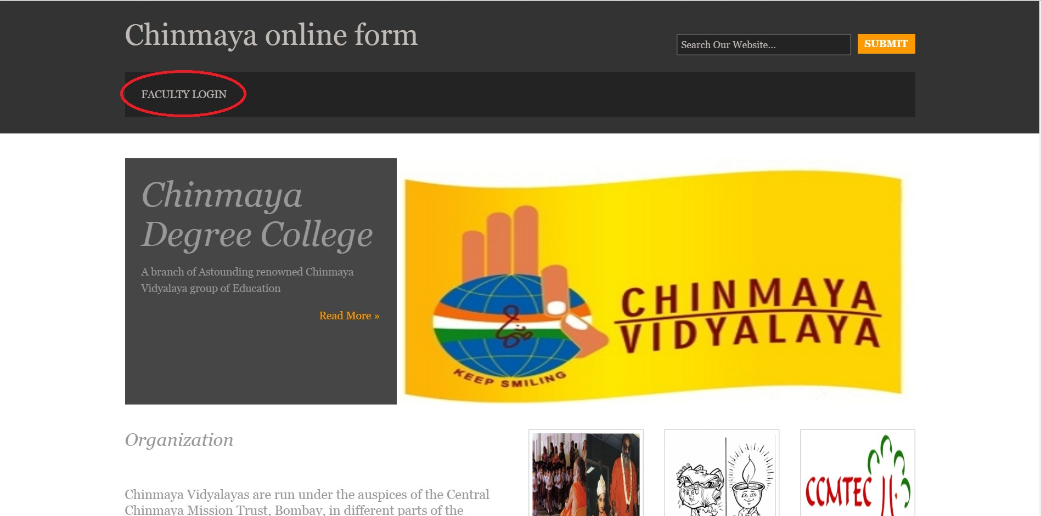

2- logging in/signing up

click on the "Faculty login " link on the left top of the home page.

You'll be asked with login / sign up prompt.

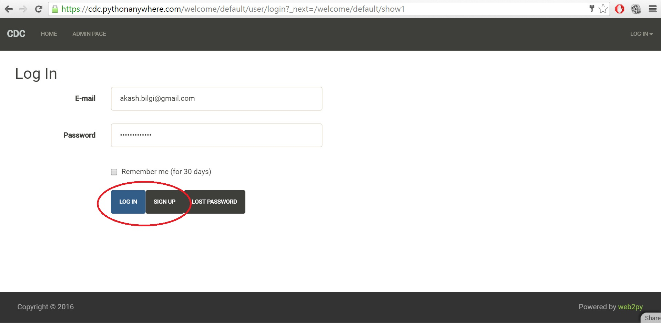

3- Accessing Database(Adding, Editing, Deleting, Searching)

-Only available to privileged user.

i. go to faculty login

ii. login with privileged credentials.

iii. You'll see this page.

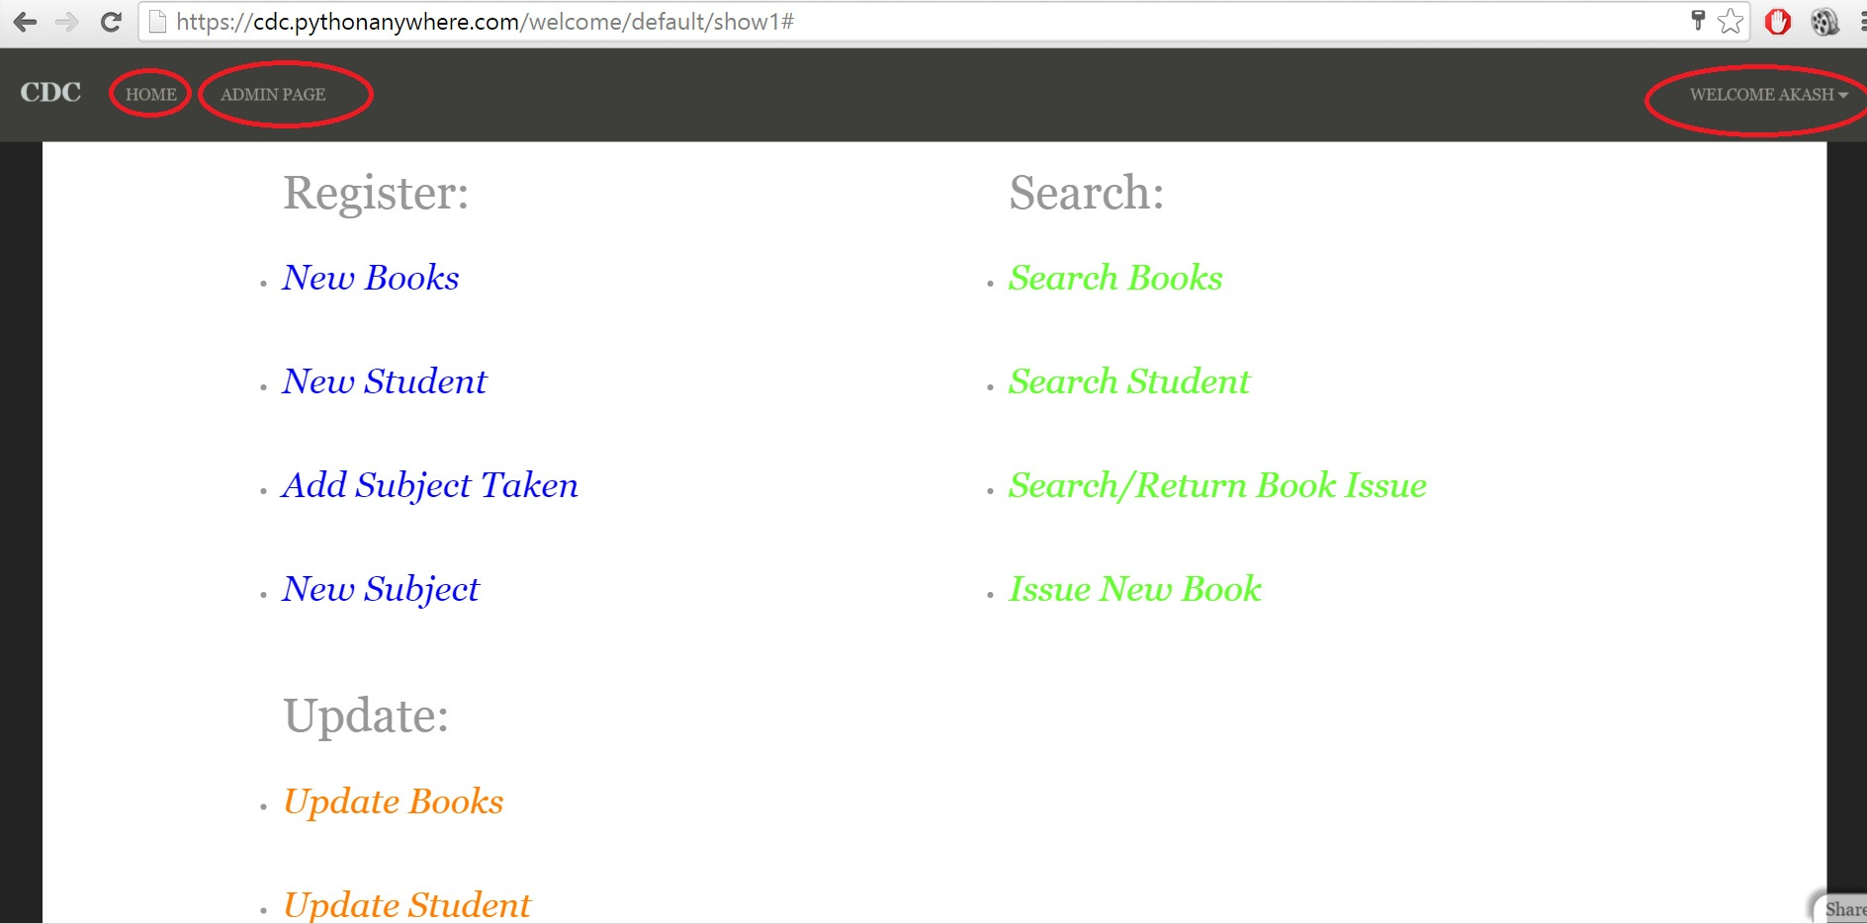

-click on home to go to home page

-click on admin page to come to this page at any moment.

3.1 Registering/Adding :

Click on the link of object you want to add/register(Ex: New books)

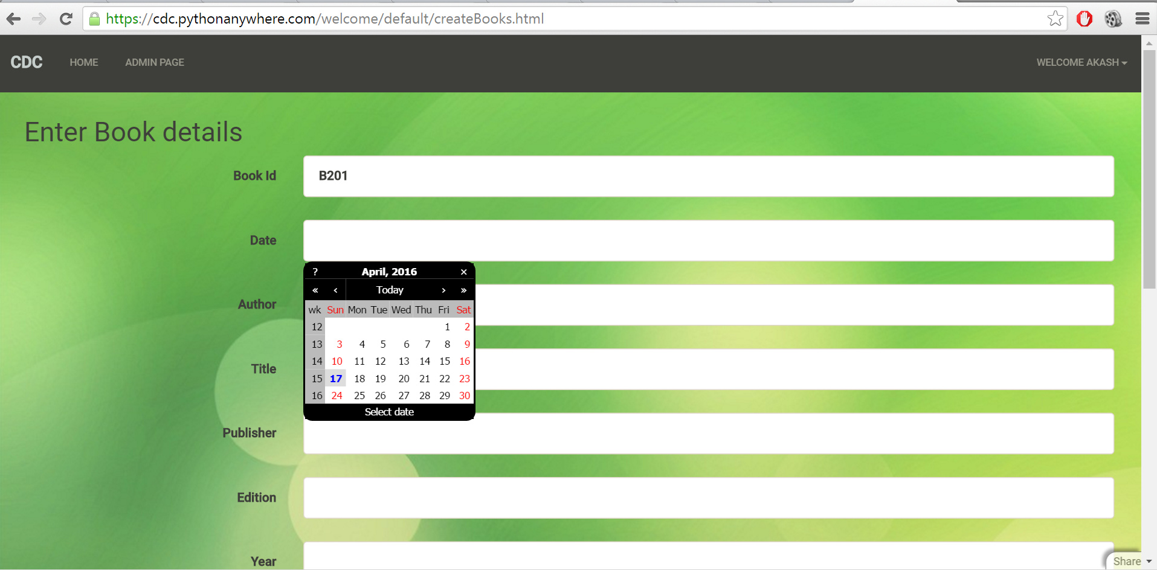

3.2 Searching

Click on the link of object you want to search.(Ex: Search student)

Search by UID.

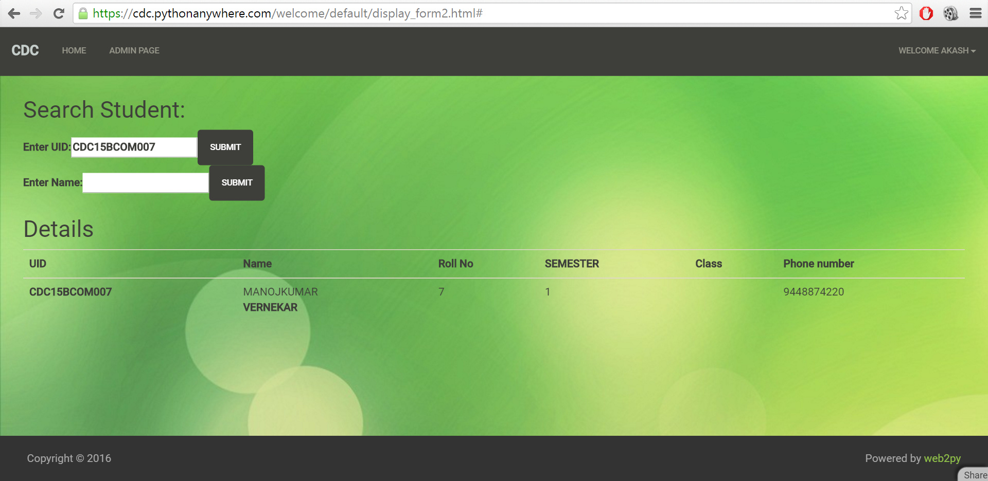

Search By First name:

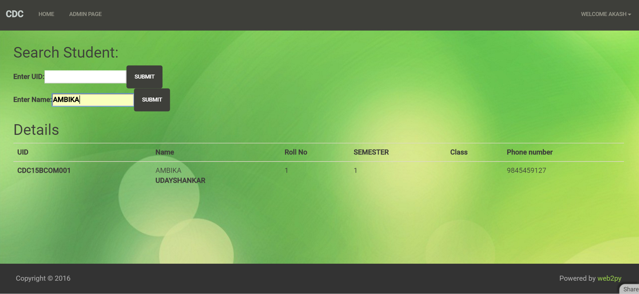

3.3 Update/Delete

Click on the link of object you want to update/delete.

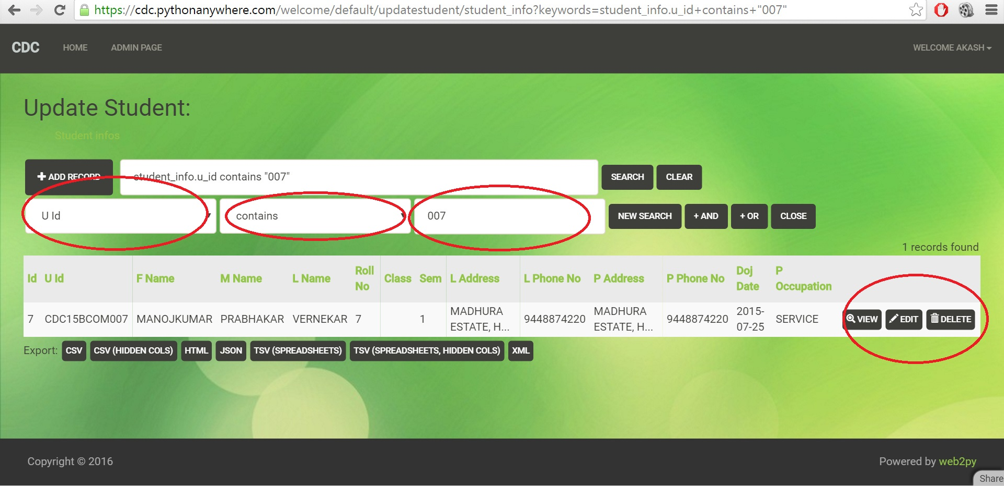

Editing : click on editYou’ll get prefilled form.

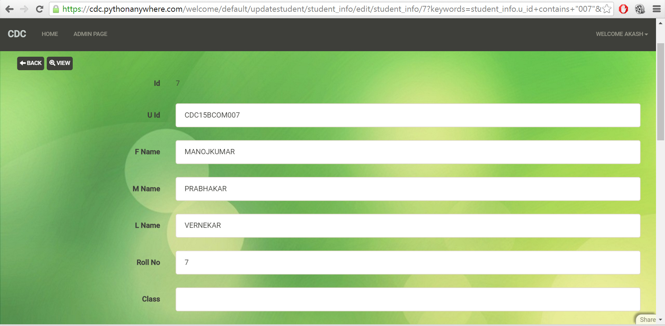

Delete: click on delete.

You’ll be prompted with confirmation.

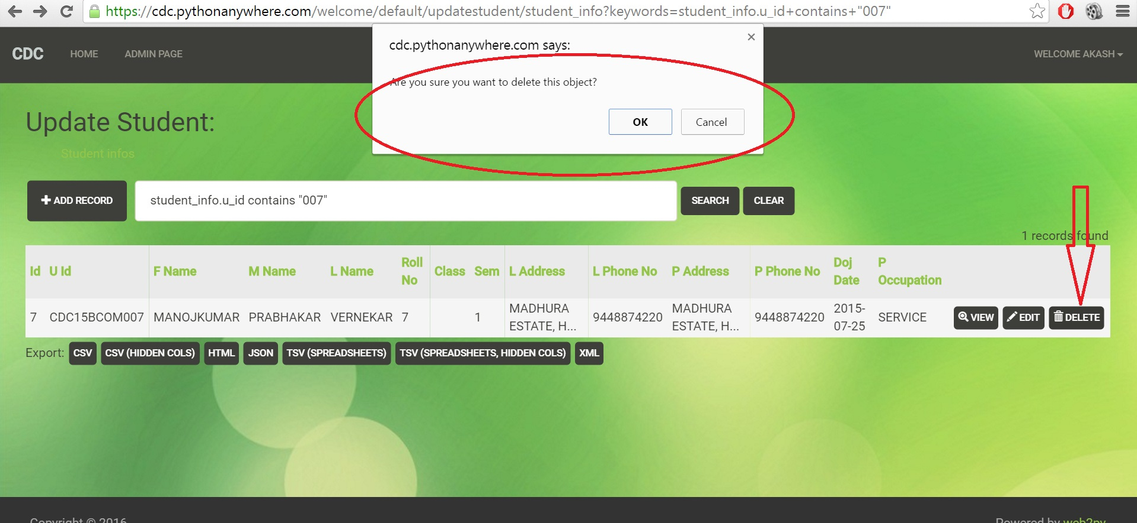

4.Editing your profile/changing password

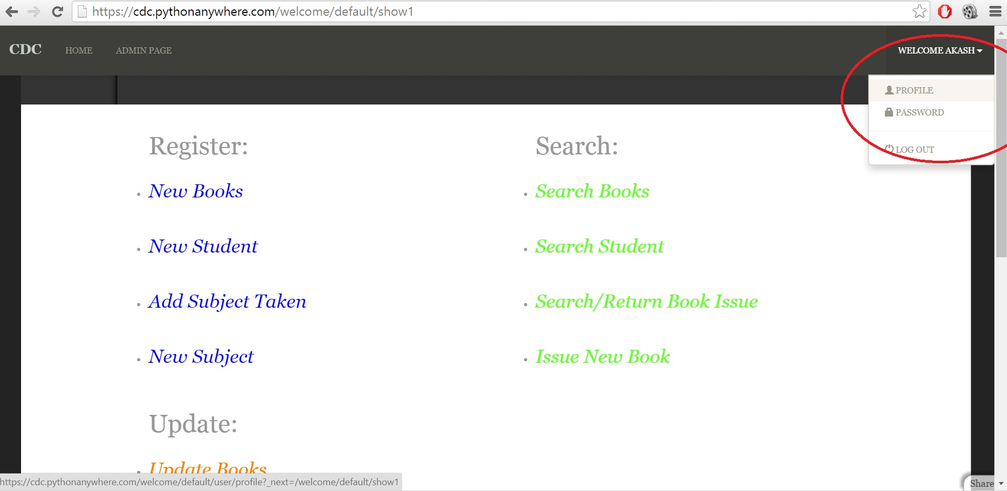

Editing: click on “PROFILE”

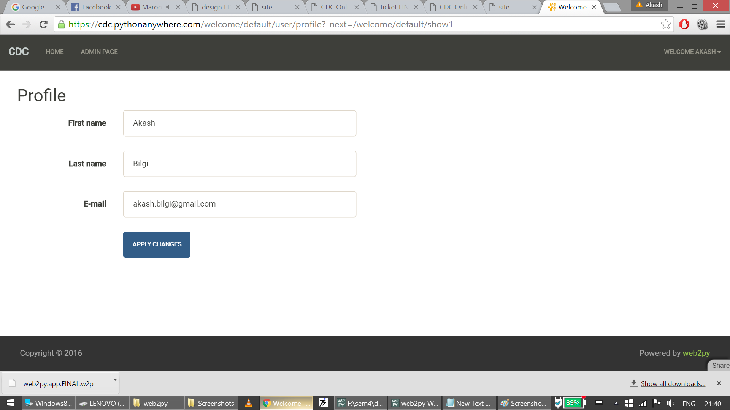

Changing password:click on “PASSWORD”

