Design Phase Report
Category: Application Development
Title: Database management application for student and library information
List of Team Members:
Akash Bilgi – 2bv14is007
Amrutha Alewoor – 2bv14is013
Ankita K R – 2bv14is017
Abhijit K – 2bv14is001
Team Leader: Akash Bilgi
Responsibilities: Abhijit- Back-end sql implementation
Akash- UI and web designing
Amrutha and Ankita- sql codes and data works
Requirements Specification:
To Build an application to provide details about students and details about books, information about students who borrowed books, etc in case of library management.
ER Design: [if there is a change in your earlier ER-design mention the changed model]
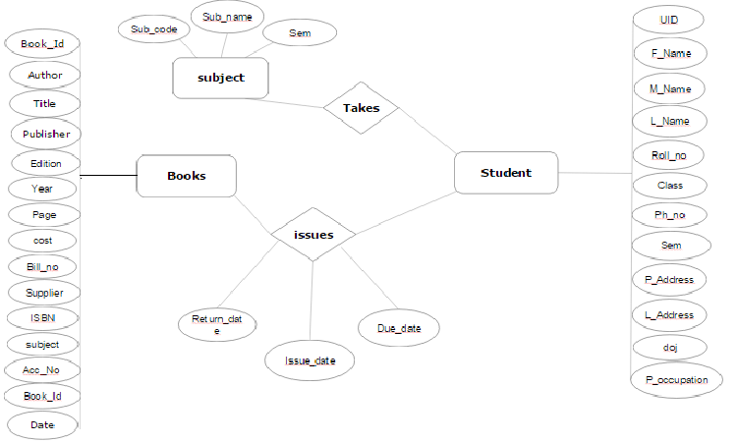
ER to Relation Mapping: [If there is a change in ER-design draw an ER to Relation Mapping]
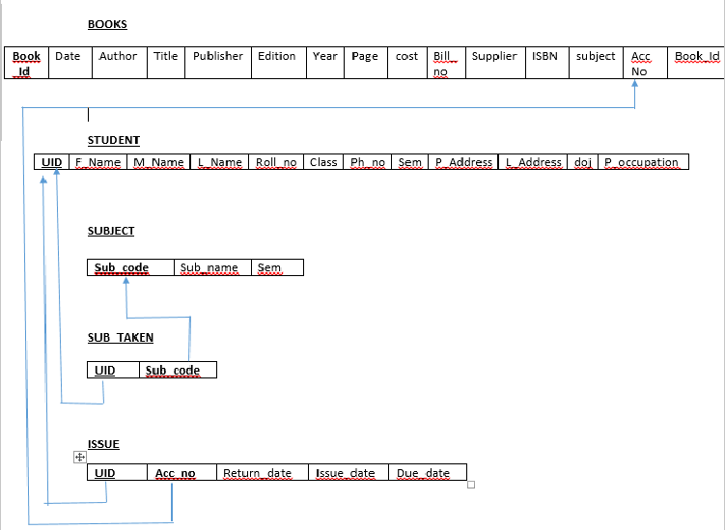
Data Dictionary: [If an new ER-to-Relation Mapping is formulated provide data dictionary]
Format for data dictionary is as follows:

Object (Entity) | Name (Attribute) | Type  (Data type) | Description | Primary Key | Foreign Key
BOOKS | ACC_NO,  AUTHOR  TITLE  PUBLISHER  EDITOR  DATE  YEAR & PAGE  SUPPLIER  COST  BILL NUM  CALL NO  SUBJECT  ISBN NO | INT  STRING  STRING  STRING  STRING  DATE  STRING  STRING  FLOAT  STRING  STRING  STRING  INTEGER | Accno of Book  Author of the book  Title of the book  Publisher of the Book  Editor of the book  Date of publication  Supplier name  Cost of the book  Bill number  Subject related to  ISBN | NO  NO  NO  NO  NO  NO  NO  NO  NO  NO  NO  NO  NO | YES  NO  NO  NO  NO  NO  NO  NO  NO  NO  NO  NO  NO
STUDENT | UID  F_NAME  M_NAME  L_NAME  ROLL_NO  CLASS  PH_NO  P_ADDR  L_ADDR  SEM  DOJ  OCCUPATION | STRING  STRING  STRING  STRING  INT  INT  INT  STRING  STRING  INT  DATE  STRING | Unique Identification number  First name of student  Middle name of student  Last name of student  Roll number of student  Division of a student  Phone number of a student  Permanent Address of a student  Local Address of a student  Semester of a student  Date of join  Occupation of father | Yes  No  No  No  No  No  No  No  No  No  No  No | No  No  No  No  No  No  No  No  No  No  No  No
SUBJECT | SUB_CODE  SUB_NAME  SEM  SUB CODE | STRING  STRING  INT  STRING | Code of a subject  Name of the subject  Sem where this subject is thought  Code of the subject | Yes  No  No  No | No  No  No  Yes
SUBJECT TAKEN | U_ID  SUB_CODE | STRING  STRING | Unique Identification number  Code of the subject taken | Yes  Yes | Yes  Yes
ISSUE | UID  ACC_NO  ISSUE_DATE  RETURN_DATE  DUE_DATE | STRING  INT  DATE  DATE  DATE | Unique Identification number  Accno of Book  Issue date of the book  Return date of the book  Due date of the book | Yes  Yes  No  No  No | No  No  No  No  No

Question 1: Normalization: Are all the relations in your chosen schema in 3NF? Are they in BCNF? Explain your answers. If any of your relations are not in BCNF, normalize them to BCNF. If you choose to normalize your relations only till 2NF or 3NF, explain your reasons (e.g., the amount of redundancy introduced is limited or some other valid reason).
Books relation is not in normalized form.
Book_id determines date,author,title,publisher,edition,year,page,cost,bill_no,supplier,isbn and subject.
Whereas, Acc_no and call_no determines itself.
Other relations are in normalized form.
Question 2: Choose the optimal normalized schema from Question 1 and justify why you think this is an optimal solution.
ANSWER FOR CHOICE AND JUSTIFICATION
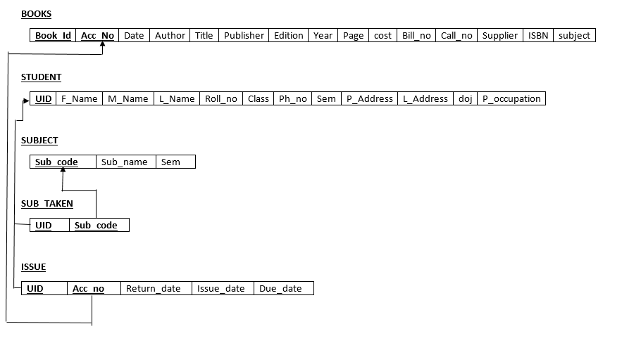

Question 3: UI design
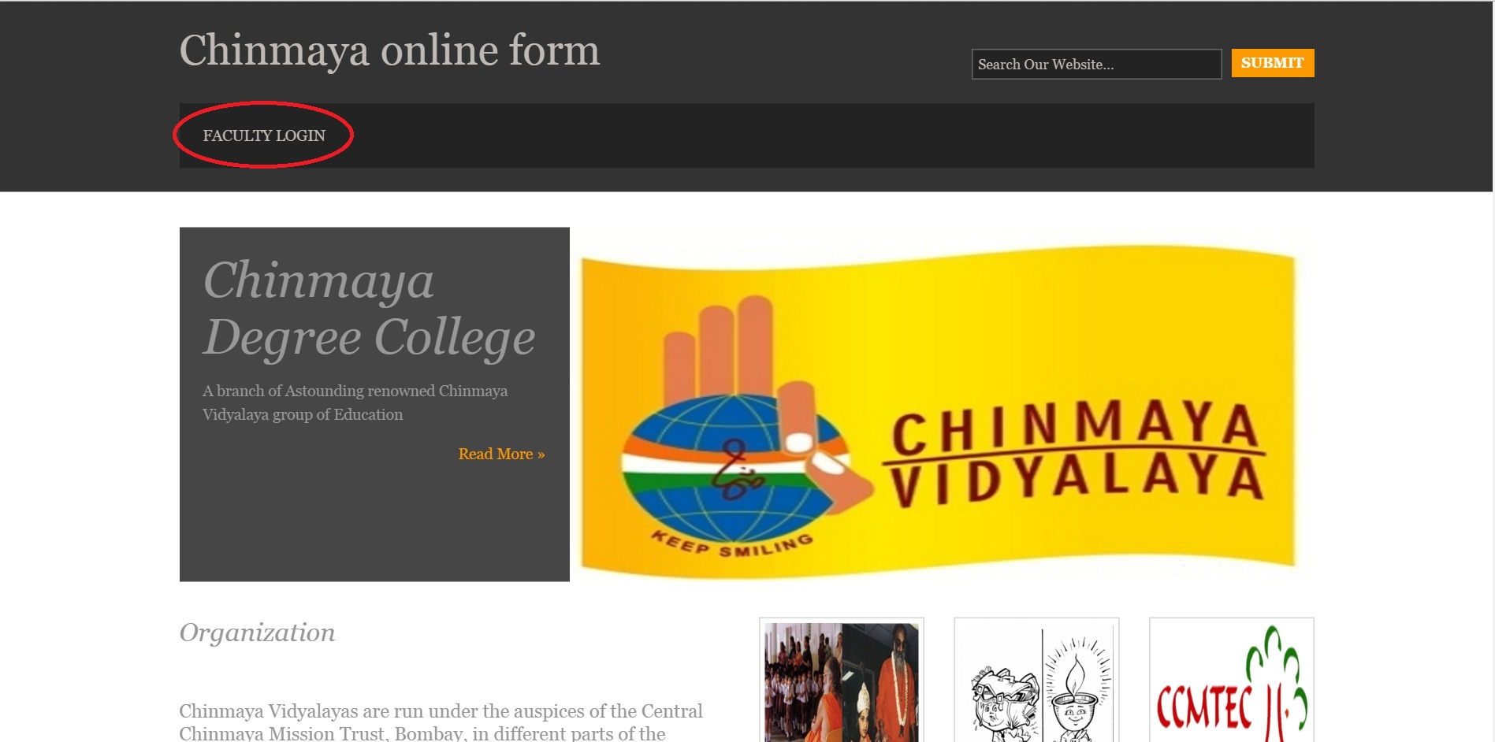
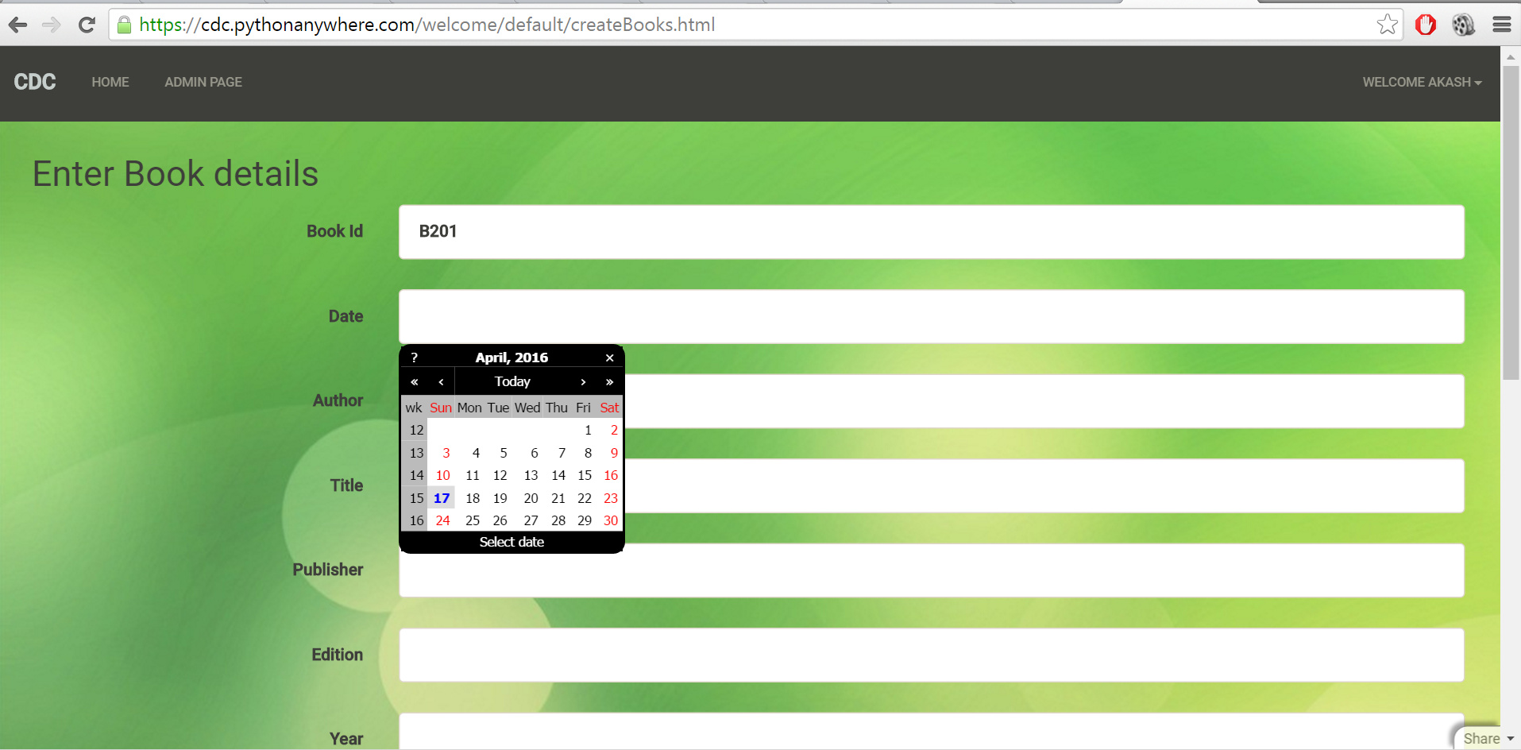
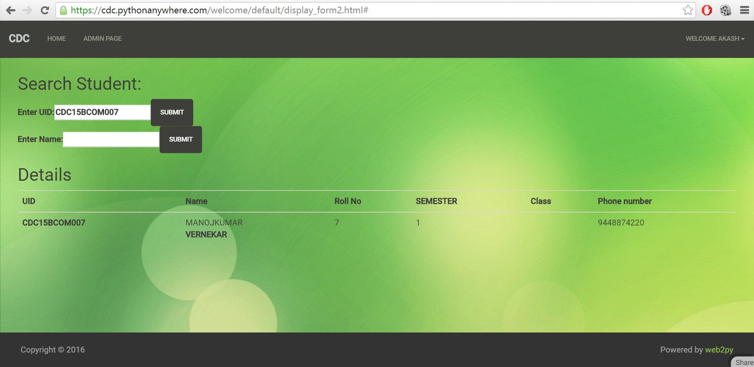
Question 4: Implemented requirements completed till date.
All the database have been created.
App has been uploaded (Available online 24x7)
GUI completed.
Admin security included.

References:
www.pythonanywhere.com
www.tinyurl.com
WEB2PY app
www.web2py.com/book
SmartDraw

Submission Date: 13 March 2016

