Proposal Phase Report
Category: Application Development

Title: Database management application for student and library management

List of Team Members: Ankita KR
Abhijit K
Akash B
Amrutha A

Team Leader: Akash B

Responsibilities: Collecting Dataset and requirements (Amrutha and Abhijit), ER diagram and other requirements (Akash and Ankita)
Problem Description: To build a database management application to access data of students and library information based on given dataset.
Requirements: To Build an application to provide details about students and details about books, information about students who borrowed books, etc in case of library management.

Question 1: From the problem description, identify the entities that need to be represented in the database, the attributes of each entity, the relationships between the entities, and the cardinality ratios of each relationship.
Entities: Student, book, Subject, Address, Parent.
Relationship: students issues / returns books, students takes subjects, address of students, students has parents.
Question 2: Draw an Entity-Relationship Diagram illustrating the information you have identified in Question 1.
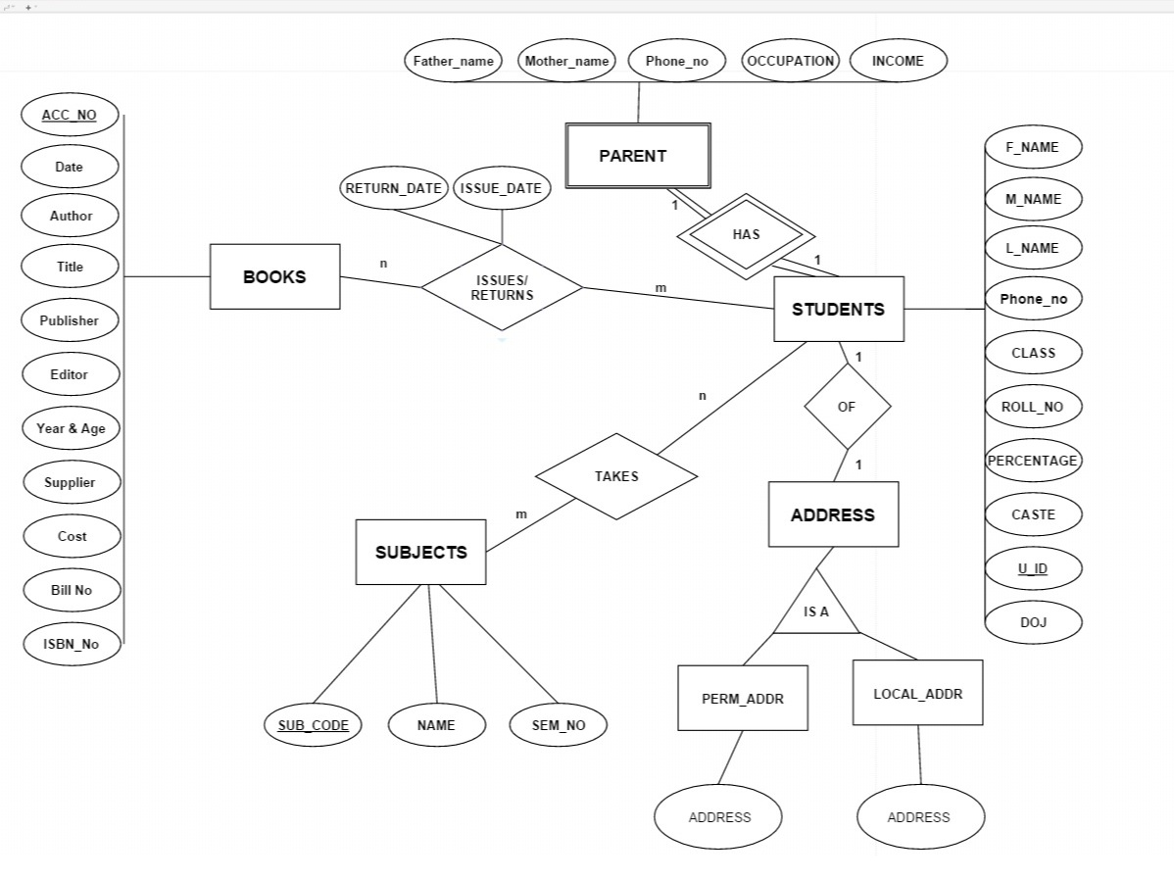

Question 3: Draw alternate Entity-Relationship Diagram illustrating the information you have identified in Question 1 that you think are most likely to occur.

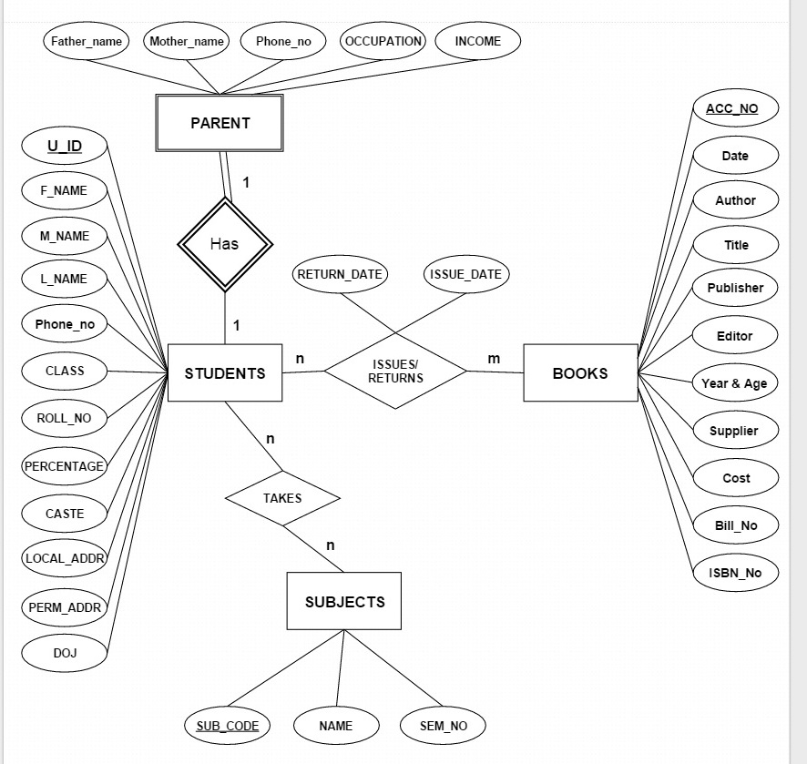

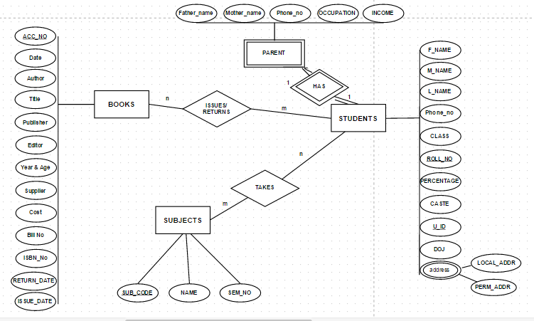

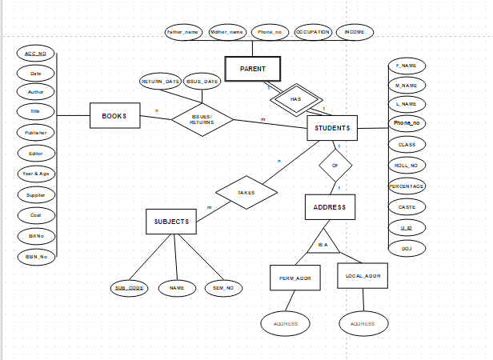

Question 4: Choose the optimal Entity-Relationship Diagram from the designs provided above and justify why you think this is an optimal solution for your identified problem specification.

Question 6: Draw an ER to Relation Mapping illustrating the information you have identified in Question 4.
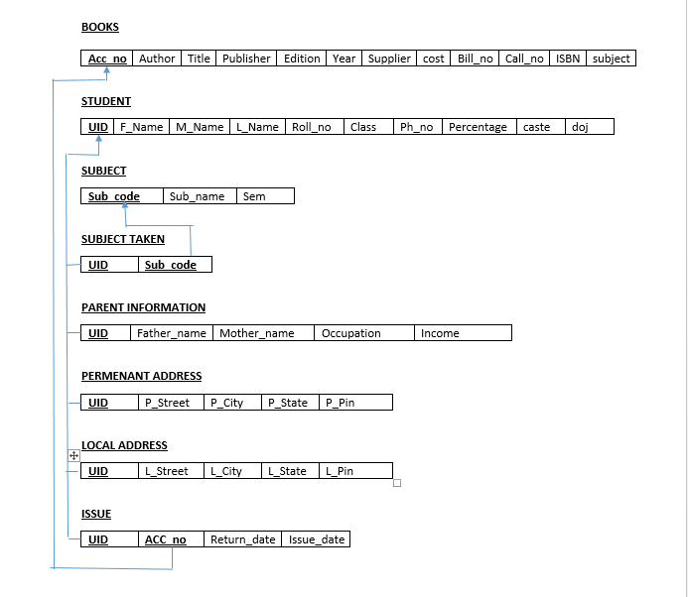

Question 7: Draw a Data Dictionary illustrating the information you have identified in Question 6.
DRAW YOUR DATA DICTONARY DIAGRAM HERE
Format for data dictionary is as follows:
Object (Entity) | Name (Attribute) | Type  (Data type) | Description | Primary Key | Foreign Key
BOOKS | ACC_NO,  AUTHOR  TITLE  PUBLISHER  EDITOR  DATE  YEAR & PAGE  SUPPLIER  COST  BILL NUM  CALL NO  SUBJECT  ISBN NO | INT  STRING  STRING  STRING  STRING  DATE  STRING  STRING  FLOAT  STRING  STRING  STRING  INTEGER | Accno of Book  Author of the book  Title of the book  Publisher of the Book  Editor of the book  Date of publication  Supplier name  Cost of the book  Bill number  Subject related to  ISBN | YES  NO  NO  NO  NO  NO  NO  NO  NO  NO  NO  NO  NO | NO  NO  NO  NO  NO  NO  NO  NO  NO  NO  NO  NO  NO
STUDENT | UID  F_NAME  M_NAME  L_NAME  ROLL_NO  CLASS  PH_NO  CASTE  PERCENTAGE  DOJ | STRING  STRING  STRING  STRING  INT  INT  INT  STRING  FLOAT  DATE | Unique Identification number  First name of student  Middke name of student  Last name of student  Roll number of student  Class/sem of a student  Phone number of a student  Caste of a student  Percentage of a student  Date of join | Yes  No  No  No  No  No  No  No  No  No | No  No  No  No  No  No  No  No  No  No
SUBJECT | SUB_CODE  SUB_NAME  SEM | STRING  STRING  INT | Code of a subject  Name of the subject  Sem where this subject is thought | Yes  No  No | No  No  No
PARENT INFORMATION | UID  FATHER_NAME  MOTHER_NAME  OCCUPATION  INCOME | STRING  STRING  STRING  STRING  FLOAT | Unique Identification number  Name of the father  Name of the mother  Occupation of father  Income of father | Yes  No  No  No  No | No  No  No  No  No
PERMANENT ADDRESS | UID  P_STREET  P_CITY  P_STATE  P_PIN | STRING  STRING  STRING  STRING  INT | Unique Identification number  Street of permanent address  City of permanent address  State of permanent address  Pin of permanent address | Yes  No  No  No  No | No  No  No  No  No
LOCAL ADDRESS | UID  P_STREET  P_CITY  P_STATE  P_PIN | STRING  STRING  STRING  STRING  INT | Unique Identification number  Street of local address  City of local address  State of local address  Pin of local address | Yes  No  No  No  No | No  No  No  No  No
ISSUE | UID  ACC_NO  ISSUE_DATE  RETURN_DATE | STRING  INT  DATE  DATE | Unique Identification number  Accno of Book  Issue date of the book  Return date of the book | Yes  Yes  No  No | No  No  No  No

References:
Smartdraw CI, www.draw.io
Cite all the reference documents, books, websites, design tools, etc adopted in your work.
[Note: Use design tools for drawing all diagram expected above]
Submission Date: 05-02-2016

