|  |  |
| --- | --- |
| College | Don Bosco Institute of Technology |
| Department | Computer Science and Engineering |
| Course: | Computer Science and Engineering |
| Student Name | AKASH BISHT |
| Mini Project Title | CONFERENCE REVIEW SYSTEM |
| Under Taken at | Don Bosco Institute of Technology |
| USN | 1DB17CS400 |
| Internal Guide | Mrs. Yashaswini B. M. |

SYNOPSIS

**OBJECTIVE**

The purpose of the system is to support the process of submission, evaluation and selection of papers for a conference.

**DESIGN**

ENTITIES

* AUTHOR
* PAPER
* REVIEWER
* REVIEW
* PC_CHAIR
* SELECTION

ATTRIBUTES

**AUTHORS:** {a_id, a_first_name, a_last_name, a_phone_no, a_email, a_pwd}

**PAPERS:** {paper_id, title, abstract, file_name, author_id}

**REVIEWERS:** {rvr_id, rvr_first_name, rvr_last_name, rvr_phone, rvr_email, rvr_pwd, rvr_interest, no_of_paper_assigned}

**REVIEWS:** {rv_id, clarity, relevance, technical_rate, rvr_id, paper_id}

**PC_CHAIR:** {pc_id, one_name, one_email, one_pwd, rv_id}

**SELECTION:** { pc_id_admin, rv_id, acceptance}

**SCHEMA DESCRIPTION**

**AUTHOR**

|  |  |  |  |  |  |
| --- | --- | --- | --- | --- | --- |
| a_id | a_first_name | a_last_name | a_phone_no | a_email | a_pwd |

**PAPER**

|  |  |  |  |  |
| --- | --- | --- | --- | --- |
| paper_id | title | abstract | file_name | author_id |

**REVIEWER**

|  |  |  |  |  |  |  |  |
| --- | --- | --- | --- | --- | --- | --- | --- |
| rvr_id | rvr_first_name | rvr_last_name | rvr_phone | rvr_email | rvr_pwd | rvr_interest | no_of_paper_assigned |

**REVIEW**

|  |  |  |  |  |  |
| --- | --- | --- | --- | --- | --- |
| rv_id | clarity | relevance | technical_rate | rvr_id | paper_id |

**PC_CHAIR**

|  |  |  |  |  |
| --- | --- | --- | --- | --- |
| pc_id | final_name | final_email | final_pwd | final_phone |

**SELECTION**

|  |  |  |
| --- | --- | --- |
| pc_id_admin | rv_id | acceptance |

**E-R DIAGRAM**

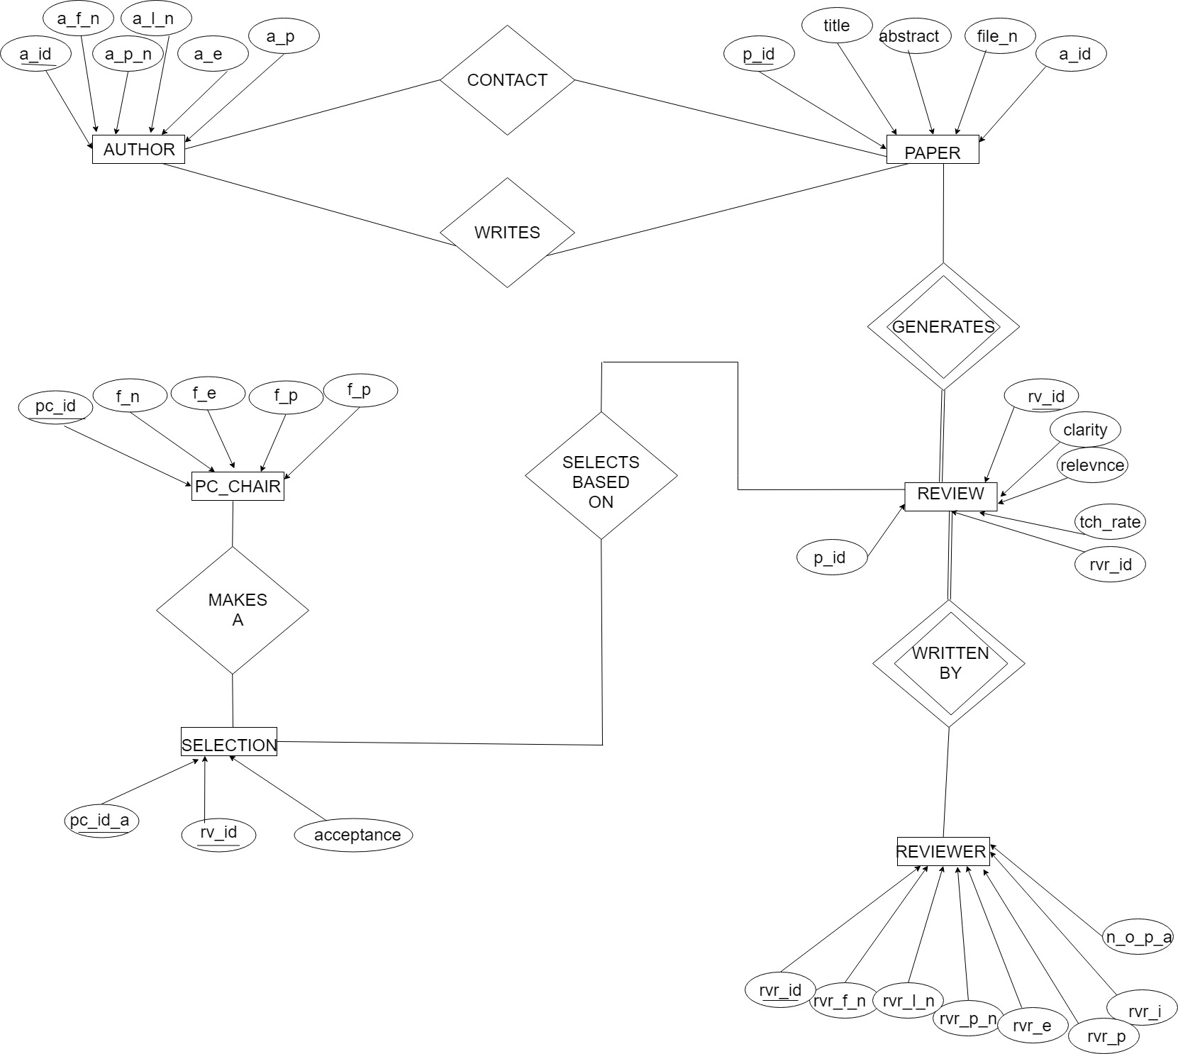

**PROCESS DESCRIPTION**

■ Authors of papers are uniquely identified by its own unique author id. First and last names are also recorded.

■ Each paper is assigned a unique identifier by the system and is described

by a title, abstract, and the name of the electronic file containing the paper.

■ A paper may have multiple authors, but one of the authors is designated as

the contact authors.

■ Reviewers of papers are uniquely identified by system generated unique id. Each reviewer’s

first name, last name, phone number, affiliation, and topics of interest

are also recorded.

■ Each paper is assigned between two and four reviewers. A reviewer rates

each paper assigned to him or her on a scale of 1 to 10 in four categories:

technical merit, readability, originality, and relevance to the conference.

Finally, each reviewer provides an overall recommendation regarding

each paper.

■ Each review contains two types of written comments: one to be seen by

the review committee only and the other as feedback to the author(s).

**SOFTWARE REQUIREMENTS**

**Front-end:** HTML, CSS, JAVASCRIPT

**Back-end:** SQL, PHP, XML, JAVA, PYTHON

**POSSIBLE OUTCOME**

This project Demonstrate the working of database and shows the implementation, analysis and the evaluation of the project developed for an application.