MGM UNIVERSITY
Jawaharlal Nehru Engineering College, Chh. Sambhajinagar
Computer Science & Engineering

Department Name: AI&DS
CA4: Integrating Deep Learning and Traditional Image Enhancement Techniques for Underwater Image Enhancement (Z. Shi, Y. Wang, Z. Zhou, W. Ren, IET Image Processing, vol. 16, pp. 3471–3484, 2022, doi:10.1049/ipr2.12544)
Name of students in a group: Akash Chaudhari Roll No: ________

Introduction:
Underwater images suffer from colour distortion, blur and low contrast because water absorbs light selectively by wavelength (red is absorbed fastest, blue travels farthest) and scatters it. This degrades every downstream task: marine biology surveys, underwater robotics, pipeline inspection and object detection.
The paper by Shi et al. starts from a statistical observation. For each image, the mean of each channel in the ground truth minus its mean in the underwater image is consistently positive for red (red is attenuated), negative for green (green is over-strengthened) and close to zero for blue. Based on this prior, the authors compensate the red and green channels differently: red with an attention-guided residual module that adds a gated compensation term, green with one that subtracts the excess. Contrast enhancement and deblurring then follow in a multi-scale CNN (MSCNN) that fuses two traditional enhancements, CLAHE and Gamma correction, using learned confidence maps.
Work done in this CA:
- Implemented the complete method from scratch in PyTorch (Rnet, Gnet, blue residual module, MSCNN with CLAHE and Gamma, and the L1 + SSIM + VGG-19 perceptual loss), following the equations and figures of the paper.
- Reproduced the paper's motivating statistical analysis (Fig. 1) and its post-enhancement counterpart (Fig. 11).
- Trained the network on the same UGAN synthetic dataset (4000 training / 100 test pairs) and evaluated it on synthetic (UGAN-100) and real (UIEB-90 with references, UIEB-Challenging-60 without) underwater images.
- Compared against four traditional enhancement algorithms and reproduced the ablation study (Table 4) and the loss-weight study (Table 5).
- Reported full-reference (PSNR, SSIM) and no-reference (UIQM, UCIQE, PCQI) underwater quality metrics, with visual results for every stage of the network.
Contribution of the paper:
- A prior that both the red and the green channel contribute to underwater colour distortion.
- Attention-guided (channel + spatial attention) residual modules that compensate red and green in different ways.
- A fusion of traditional techniques (CLAHE, Gamma correction) with a multi-scale CNN for contrast enhancement and deblurring.
Methods / Algorithms Used in paper and Comparative algorithm used by you
A. Method of the paper (implemented)
The input image I is split into its R, G and B channels, and each channel is corrected by its own module:
- Rnet (red compensation, Eq. 1): Irc = Ir + CAB(Ir) · SAB · (1 − Ir). CAB is channel attention (Global Average Pooling → FC → Sigmoid) and SAB is spatial attention (two 3×3 convolutions → Sigmoid, an H×W×1 map). The factor (1 − Ir) stops already-bright red pixels from being over-compensated. A long skip connection preserves data fidelity.
- Gnet (green compensation, Eq. 2): Iga = Ig − CAB(Ig) · SAB. Same structure as Rnet but without (1 − I); part of the over-strong green is subtracted.
- Blue residual enhancement: three residual blocks (conv–LeakyReLU–conv–LeakyReLU–conv + skip) refine the well-preserved blue channel.
- Contrast enhancement module Ce (MSCNN, Eq. 3): the colour-corrected image I1 is enhanced by CLAHE (I_CE) and by Gamma correction (I_GC). The top and bottom branches (3×3, 5×5, 7×7 convolutions) refine I_CE and I_GC into Z_CE and Z_GC. The middle branch (3×3, 5×5, 7×7, 1×1, 3×3, 5×5, 7×7 convolutions + Sigmoid) predicts the confidence maps W_CE and W_GC. Output: I_out = Z_CE · W_CE + Z_GC · W_GC.
- Loss (Eq. 8): L = λ1 (L1 + L_SSIM) + λ2 · L_per, with λ1 = 1 and λ2 = 0.1. L_SSIM uses grayscale images with an 11×11 window; L_per is the L1 distance between VGG-19 relu4_3 features.
The implemented network has 317,697 trainable parameters (about 1.3 MB), in line with the paper's emphasis on a light model.
Implementation and training settings
Setting | Value
Framework | PyTorch 2.8, kornia (differentiable-image library) for CLAHE
Optimiser | Adam, learning rate 2 × 10⁻⁴ (as in the paper)
Batch size / input size | 8 / 256 × 256 (as in the paper)
Training length | 15,364 iterations ≈ 30.73 epochs in 25 min (paper: 50 epochs)
Hardware | NVIDIA L40S (main model), NVIDIA A10G (ablations, λ sweep) on Modal
Feature width | 32 channels in every module
CLAHE / Gamma | clip limit 2.0, 8 × 8 tiles, per RGB channel / γ = 0.7
Precision | fp32 with TF32 (fp16 mixed precision made training unstable)

B. Comparative algorithms used by us
- CLAHE – contrast-limited adaptive histogram equalisation on the L channel of CIELab (clip 2.0, 8 × 8 tiles).
- Gamma correction – I^0.7, which brightens dark regions.
- Gray-world white balance – scales each channel so that the channel means become equal.
- Red-channel compensation + white balance (Ancuti et al., 2018) – Irc = Ir + (Īg − Īr)(1 − Ir) Ig followed by gray-world. It is the hand-crafted counterpart of Rnet.
- Ablation variants of the network – w/o Gnet, w/o Rnet, w/o Rnet + Gnet, and w/ Rnet + Gnet without the contrast module (Table 4 of the paper).
C. Evaluation metrics
- PSNR / SSIM (full-reference) – PSNR on RGB and on luminance (Y), SSIM on luminance – higher is better.
- NIQE (natural image quality evaluator, no reference) – lower is better.
- UIQM (colourfulness, sharpness and contrast; weights 0.0282 / 0.2953 / 3.5753) – higher is better.
- UCIQE (chroma, saturation and contrast; weights 0.4680 / 0.2745 / 0.2576) – higher is better.
- PCQI (patch-based contrast quality between the raw input and the enhanced image) – higher means more contrast gain.
Datasets Used:
Dataset | Source | Type | Images used | Purpose
UGAN (Fabbri et al., ICRA 2018) | Same dataset as the paper ('underwater_imagenet', EUVP/UGAN release) | Synthetic, CycleGAN-distorted, with ground truth | 6128 pairs → 4000 train / 100 test (seed 0) | Training; Table 1 and Table 4
UIEB (Li et al., IEEE TIP 2020) – test | Official UIEB release, seed-42 split | Real, with reference | 90 pairs | Real images with reference (Table 3)
UIEB – Challenging-60 | Official UIEB release | Real, no reference | 60 images | No-reference evaluation (Table 2)

All images are resized to 256 × 256. As in the paper, the network is trained only on the synthetic UGAN pairs; the UIEB images measure how well it generalises to real underwater scenes.

Result Analysis:
1. Images as an output for every stage
The figures below show the output of every stage of the network: input → I1 (after Rnet / Gnet / Bnet colour compensation) → I_CE (CLAHE of I1) → I_GC (Gamma of I1) → confidence maps W_CE and W_GC → final output.
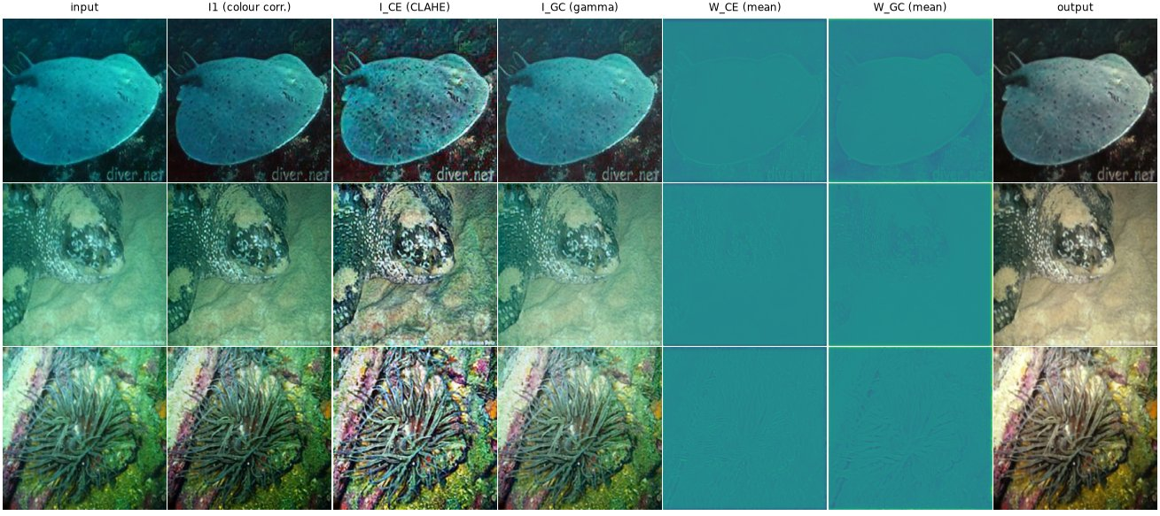
Figure 1: Output of every stage on UGAN test images (synthetic).
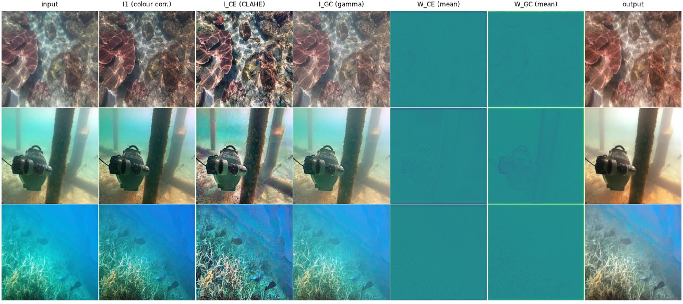
Figure 2: Output of every stage on real UIEB images.
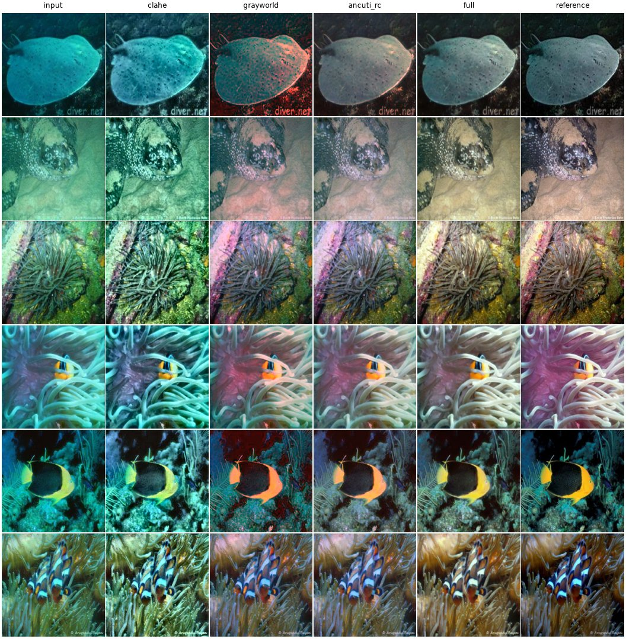
Figure 3: Visual comparison on the UGAN test set (columns: methods, last column: ground truth).
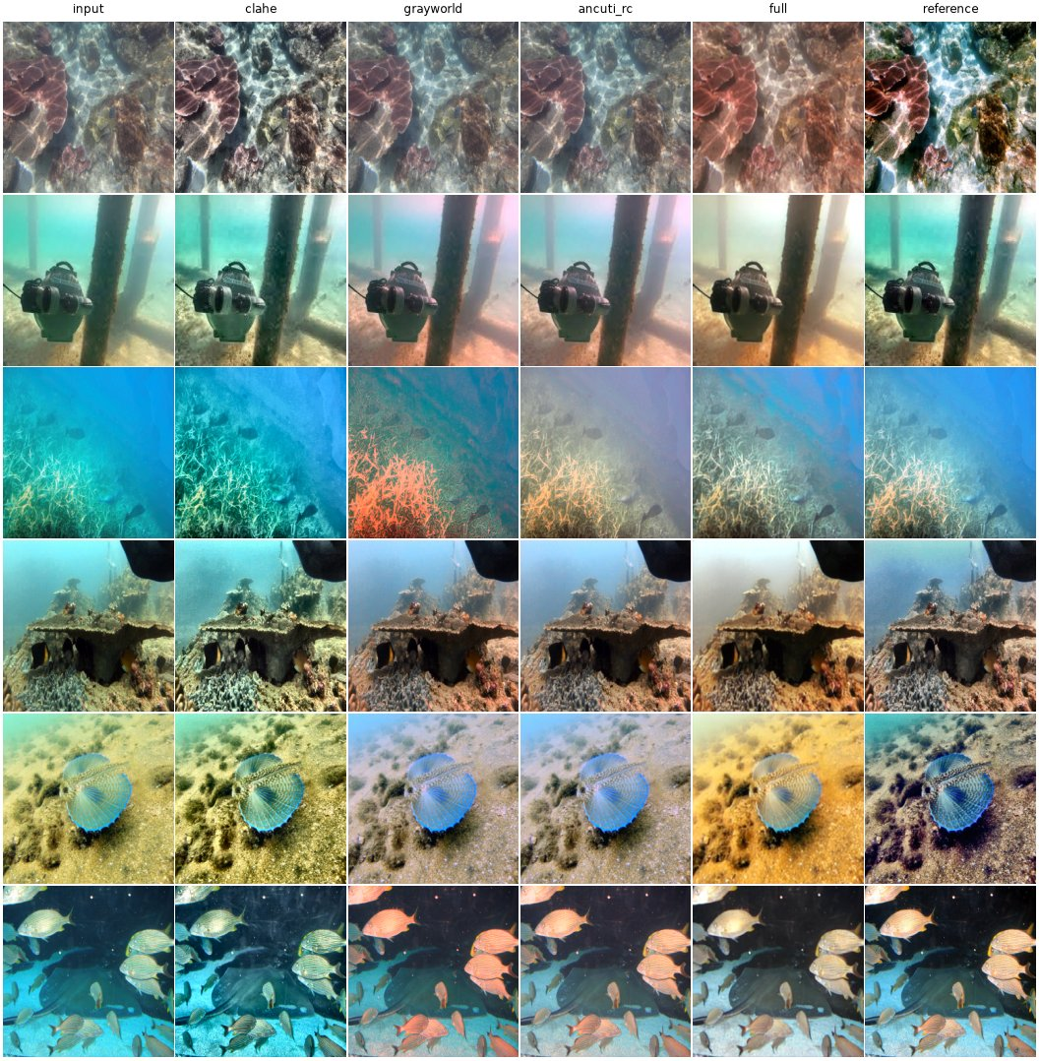
Figure 4: Visual comparison on real UIEB test images with reference.
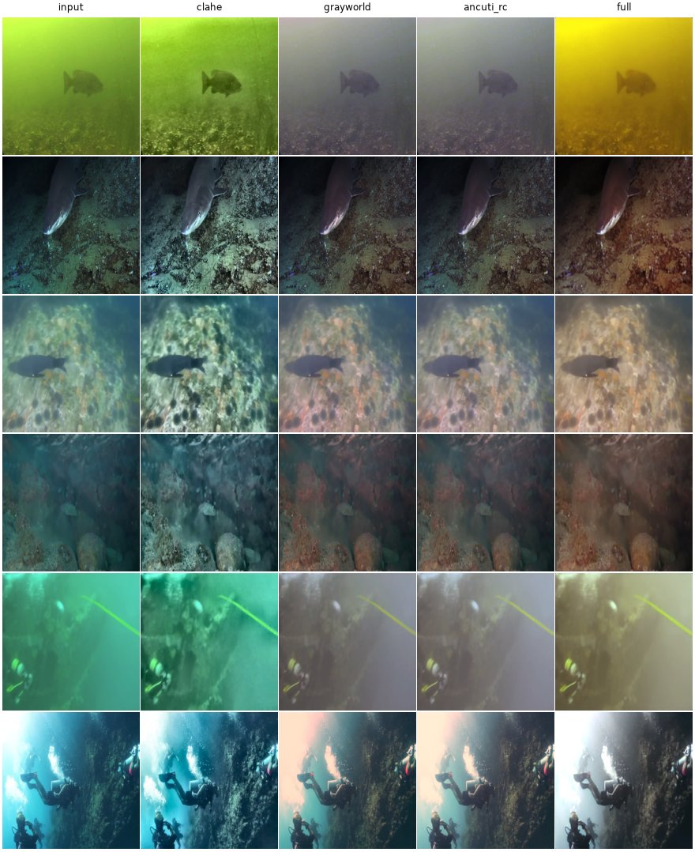
Figure 5: Visual comparison on UIEB-Challenging-60 (no reference available).
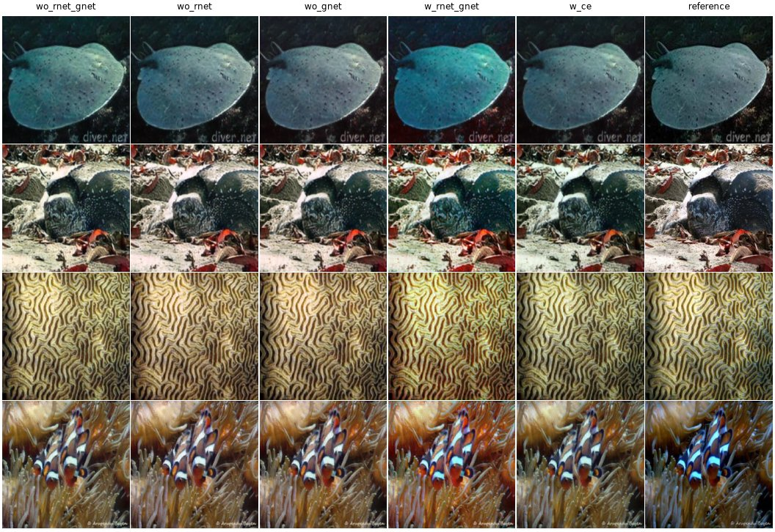
Figure 6: Visual ablation of the colour-correction and contrast modules.
2. Results in table format
Table 1 – Synthetic UGAN test set (100 images, full reference). Best result among the enhancement methods is in bold.
Method used | PSNR-RGB (dB) ↑ | PSNR-Y (dB) ↑ | SSIM ↑ | UIQM ↑ | UCIQE ↑ | PCQI ↑ | NIQE ↓
Raw input | 16.77 | 25.39 | 0.854 | 2.483 | 1.025 | 1.000 | 5.484
CLAHE | 14.85 | 19.40 | 0.740 | 2.302 | 0.879 | 1.224 | 5.457
Gamma correction (γ = 0.7) | 14.91 | 19.66 | 0.805 | 2.515 | 0.619 | 0.892 | 5.292
Gray-world white balance | 19.49 | 24.40 | 0.846 | 2.595 | 1.168 | 0.981 | 5.751
Red-channel compensation + WB (Ancuti) | 20.38 | 24.93 | 0.855 | 3.051 | 1.106 | 0.979 | 5.364
Proposed method (ours) | 23.63 | 26.38 | 0.884 | 3.025 | 1.629 | 0.972 | 7.223
PSNR-RGB is computed on all three colour channels; PSNR-Y and SSIM on the luminance channel, as the paper's text describes. The paper's input PSNR on this dataset (16.85 dB) matches our PSNR-RGB of the raw input, which suggests its PSNR values were computed on RGB.

Table 2 – UIEB-Challenging-60 (real, no reference).
Method used | UIQM ↑ | UCIQE ↑ | PCQI ↑ | NIQE ↓
Raw input | 2.048 | 0.987 | 1.000 | 7.582
CLAHE | 2.371 | 0.837 | 1.181 | 5.562
Gamma correction (γ = 0.7) | 2.109 | 0.614 | 0.903 | 7.330
Gray-world white balance | 2.082 | 1.105 | 0.978 | 7.381
Red-channel compensation + WB (Ancuti) | 2.233 | 1.051 | 0.990 | 7.241
Proposed method (ours) | 2.308 | 1.363 | 0.909 | 8.518

Table 3 – UIEB test set (90 real images with reference).
Method used | PSNR-RGB (dB) ↑ | PSNR-Y (dB) ↑ | SSIM ↑ | UIQM ↑ | UCIQE ↑ | PCQI ↑ | NIQE ↓
Raw input | 17.79 | 21.83 | 0.865 | 2.667 | 0.819 | 1.000 | 4.783
CLAHE | 18.04 | 21.66 | 0.912 | 2.725 | 0.769 | 1.227 | 4.363
Gamma correction (γ = 0.7) | 15.58 | 18.60 | 0.821 | 2.643 | 0.561 | 0.866 | 4.614
Gray-world white balance | 17.55 | 21.67 | 0.837 | 2.740 | 0.875 | 0.968 | 4.833
Red-channel compensation + WB (Ancuti) | 17.85 | 22.36 | 0.870 | 2.923 | 0.847 | 0.988 | 4.663
Proposed method (ours) | 17.57 | 21.58 | 0.818 | 2.886 | 1.058 | 0.852 | 6.258

Table 4 – Ablation study on UGAN-100. Every variant is trained for the same 4,000 iterations.
Method used | PSNR-RGB (dB) ↑ | PSNR-Y (dB) ↑ | SSIM ↑ | UIQM ↑ | UCIQE ↑
w/o Rnet + Gnet | 23.56 | 26.66 | 0.878 | 3.074 | 1.571
w/o Rnet | 23.47 | 26.55 | 0.877 | 3.080 | 1.808
w/o Gnet | 23.60 | 26.73 | 0.877 | 3.077 | 1.769
w/ Rnet + Gnet (no Ce) | 21.67 | 26.31 | 0.872 | 2.771 | 1.776
w/ Ce (full model) | 23.52 | 26.82 | 0.880 | 3.039 | 2.043

Table 5 – Loss weights λ1 / λ2 on UGAN-100 (each run 2000 iterations).
λ1 | λ2 | λ2 / λ1 | PSNR-RGB (dB) ↑ | PSNR-Y (dB) ↑ | SSIM ↑
0.1 | 0.1 | 1 | 23.24 | 26.20 | 0.873
0.1 | 1 | 10 | 23.13 | 26.32 | 0.865
0.1 | 10 | 100 | 21.90 | 24.62 | 0.848
1 | 0.1 | 0.1 | 23.42 | 26.34 | 0.875
1 | 1 | 1 | 23.33 | 26.33 | 0.874
1 | 10 | 10 | 23.17 | 26.31 | 0.864
10 | 0.1 | 0.01 | 23.33 | 26.31 | 0.876
10 | 1 | 0.1 | 23.42 | 26.36 | 0.875
10 | 10 | 1 | 23.31 | 26.27 | 0.874

Table 6 – Comparison with the values reported in the paper.
Quantity | Paper | Our implementation
UGAN test: input PSNR / SSIM | 16.85 / 0.692 | 16.77 (RGB), 25.39 (Y) / 0.854
UGAN test: proposed PSNR / SSIM | 25.67 / 0.891 | 23.63 (RGB), 26.38 (Y) / 0.884
UIEB (real, reference): proposed PSNR / SSIM | 24.89 / 0.837 | 17.57 (RGB), 21.58 (Y) / 0.818
PSNR gain over the raw input (UGAN, RGB) | +8.82 dB | +6.87 dB
Training length | 50 epochs (GTX 1650) | 30.73 epochs (25 min, L40S)
UIQM and UCIQE values are not directly comparable with the paper's absolute numbers, because implementations of these metrics differ in normalisation. The relative ranking of methods is what matters.
3. Charts and graphs based on the result
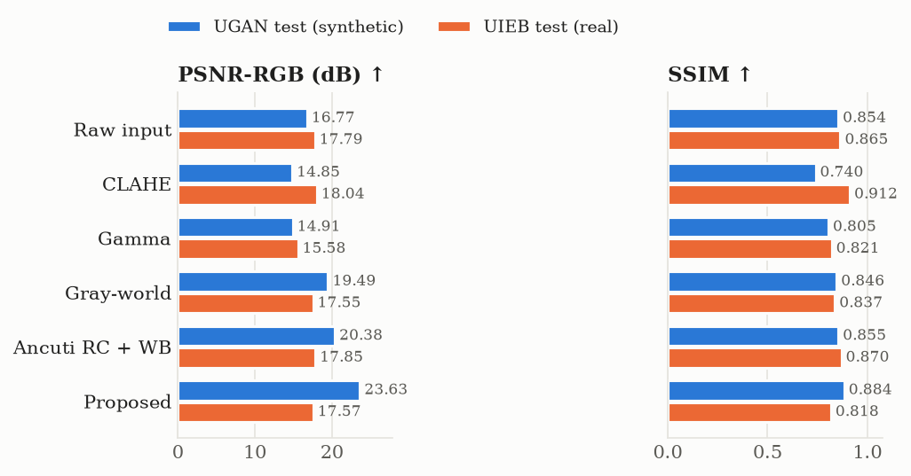
Figure 7: PSNR and SSIM of all methods on the synthetic and real test sets.
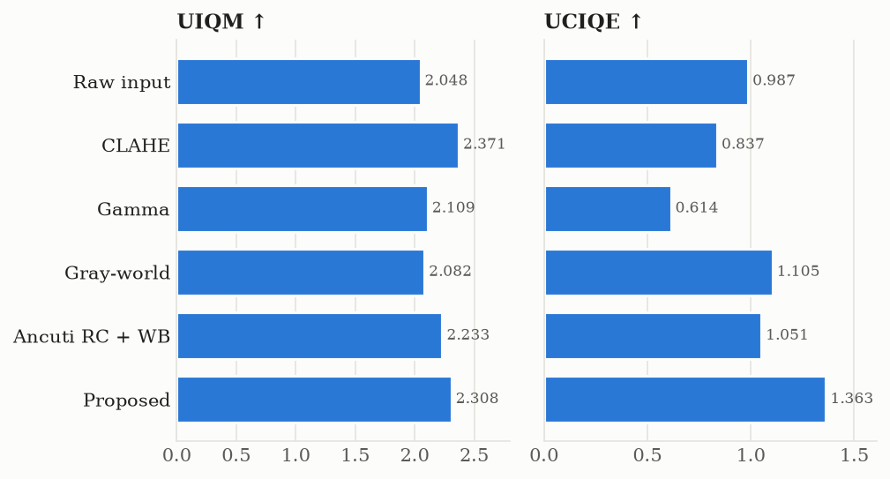
Figure 8: No-reference quality (UIQM, UCIQE) on UIEB-Challenging-60.
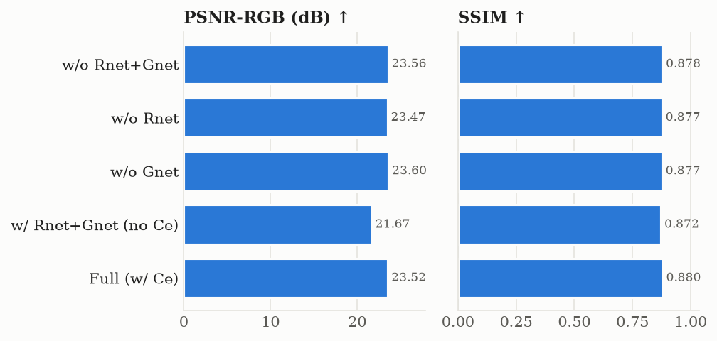
Figure 9: Ablation study – contribution of Rnet, Gnet and the contrast module.
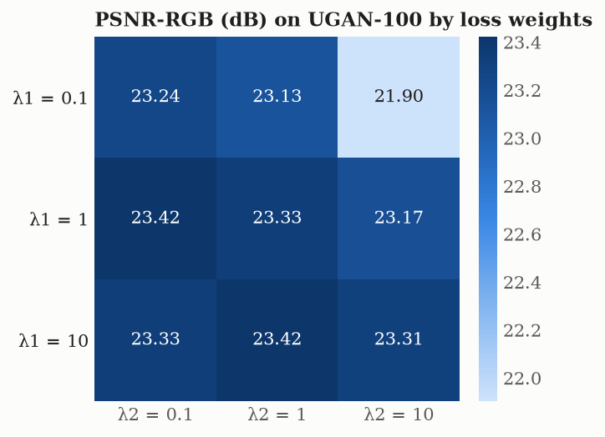
Figure 10: PSNR for each λ1 / λ2 combination (Table 5).
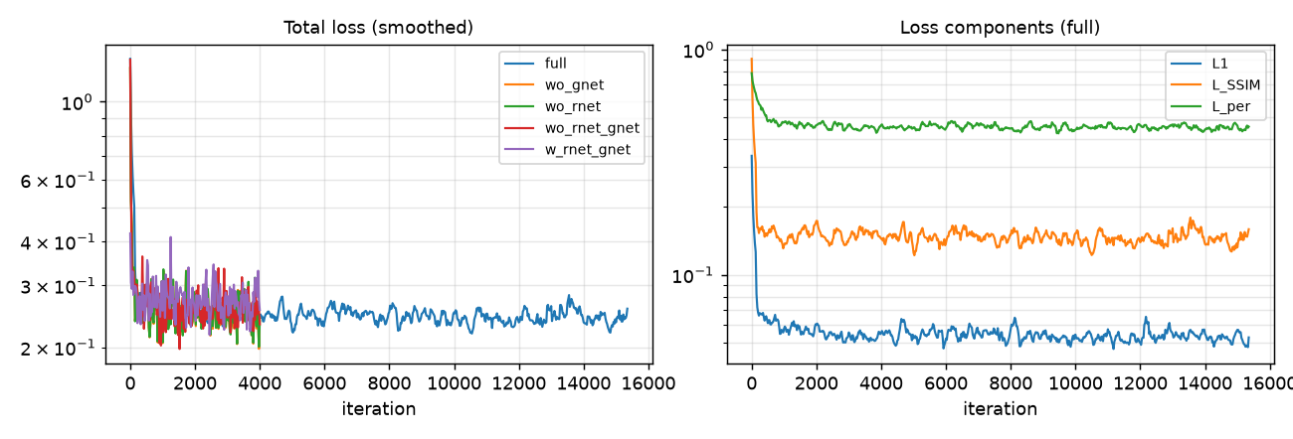
Figure 11: Training loss curves of the full model and the ablation variants.
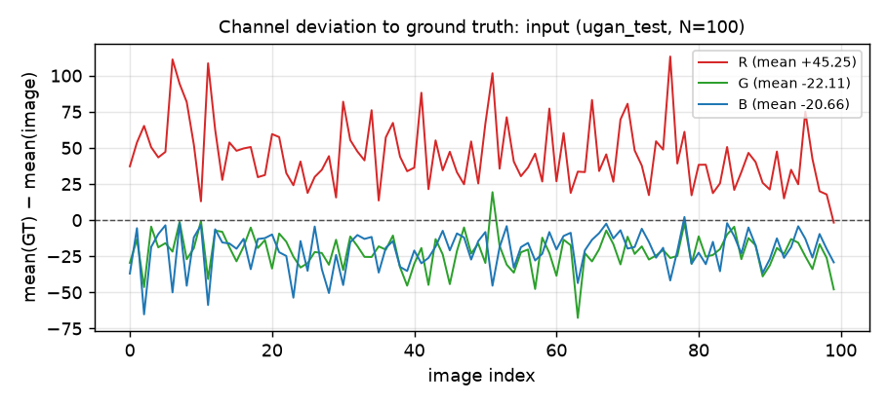
Figure 12: Per-image channel deviation mean(GT) − mean(input) on UGAN – reproduction of the paper's Fig. 1.
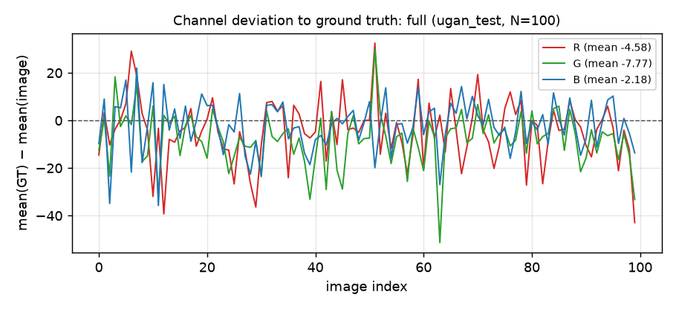
Figure 13: Channel deviation after enhancement – reproduction of the paper's Fig. 11.
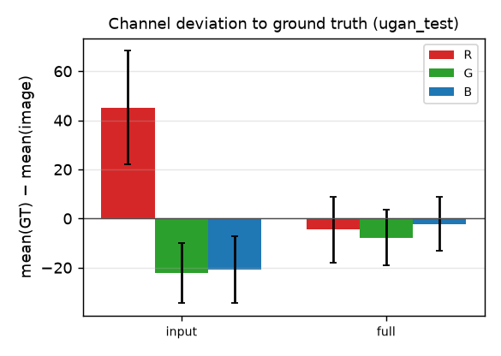
Figure 14: Mean ± std channel deviation before and after enhancement (UGAN).
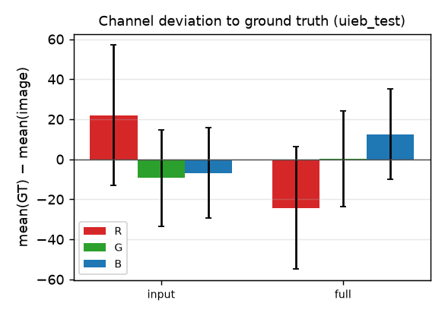
Figure 15: Mean ± std channel deviation before and after enhancement (real UIEB).
Observations
- The paper's colour prior is reproduced. On UGAN, mean(GT) − mean(input) is R +45.3, G −22.1, B −20.7 (0–255 scale): red is attenuated and green over-strengthened. Real UIEB images show the same pattern, weaker (R +22.0, G −9.4, B −6.9).
- After enhancement, the UGAN deviations shrink to R −4.6, G −7.8, B −2.2, close to zero, as in the paper's Fig. 11. The colour cast is largely removed.
- On the synthetic UGAN test set the proposed method is the best of the six methods on PSNR-RGB (23.63 dB, +6.86 dB over the raw input), PSNR-Y (26.38 dB), SSIM (0.884) and UCIQE. The paper reports 25.67 dB / 0.891 after 50 epochs; ours trained for 30.7 epochs (25 min). SSIM is within 0.007 of the paper; PSNR is about 2 dB lower.
- The paper's input PSNR (16.85 dB) matches our RGB PSNR of the raw input (16.77 dB), not the luminance PSNR (25.39 dB). The paper's PSNR values were therefore most likely computed on RGB.
- On real UIEB images with references the network trained only on synthetic UGAN data does not beat the raw input on PSNR / SSIM (17.57 dB / 0.818 against 17.79 dB / 0.865). The channel analysis explains why: it learned the strong red loss of the synthetic data and over-compensates red on real images (R deviation −24.3 after enhancement). CLAHE is the best full-reference method on real images.
- On UIEB-Challenging-60 the proposed method has the highest UCIQE (1.363) and the second-highest UIQM (2.308, after CLAHE). NIQE is worse than the input for the learned method. This metric was not designed for underwater scenes, and the paper reports values from a different implementation.
- Ablation at an equal 4000 iterations: removing the contrast-enhancement module (Ce) costs 1.85 dB PSNR-RGB (23.52 → 21.67 dB), so the MSCNN + CLAHE + Gamma fusion is the most important component. Removing Rnet, Gnet or both changes PSNR by less than 0.1 dB, so the roughly 3 dB contribution of the colour modules reported in Table 4 of the paper is not reproduced. A likely reason is that the multi-scale convolutions in Ce also learn the colour correction.
- Loss weights: with the Adam optimiser only the ratio λ2/λ1 matters, because scaling the whole loss does not change Adam's update. Pairs with the same ratio give almost the same PSNR-RGB: (1, 0.1) and (10, 1) both give 23.42 dB, and (0.1, 0.1), (1, 1) and (10, 10) give 23.24–23.33 dB. Only a very strong perceptual weight (λ2/λ1 = 100) hurts (21.90 dB). The paper's choice λ1 = 1, λ2 = 0.1 is among the best settings.
- The learned confidence maps W_CE and W_GC are almost uniform (Figures 1–2), so the network blends the CLAHE and Gamma branches nearly equally and does most of its adaptation in the Z_CE / Z_GC refinement branches.
- The model is light (317,697 parameters, 1.3 MB) and fast (about 9 ms per 256 × 256 image on an A10G GPU).
4. Conclusion
We implemented the underwater enhancement method of Shi et al. (IET Image Processing 2022) in full: attention-guided red and green channel compensation, blue residual enhancement, and a multi-scale CNN that fuses CLAHE and Gamma correction. We trained it on the paper's UGAN dataset with the paper's optimiser, batch size, image size and loss weights.
On synthetic underwater images the method clearly beats the traditional enhancement algorithms (CLAHE, Gamma, gray-world, Ancuti red-channel compensation). It raises PSNR-RGB from 16.77 to 23.63 dB and SSIM from 0.854 to 0.884, and it removes the red/green colour bias that motivates the paper. Its SSIM is almost identical to the paper's (0.884 vs 0.891); its PSNR is about 2 dB lower after 30.7 instead of 50 training epochs.
Two of the paper's claims are only partly reproduced. First, the network trained on synthetic data does not generalise to real UIEB photographs in full-reference terms, because it over-compensates the red channel. Second, at equal training length, the contrast-enhancement module accounts for most of the gain, while the separate red / green compensation modules add little. The loss-weight study shows that only the ratio λ2/λ1 matters, which explains why the paper's choice λ1 = 1, λ2 = 0.1 works well.
Future work: training on a mix of synthetic and real data (e.g. the 800 UIEB training pairs) to close the domain gap, longer training to reach the paper's 50 epochs, and a colour-constancy prior so the red compensation adapts to the actual attenuation of each image.
References
- Z. Shi, Y. Wang, Z. Zhou, W. Ren, “Integrating deep learning and traditional image enhancement techniques for underwater image enhancement,” IET Image Processing, 16(13), 3471–3484, 2022.
- C. Fabbri, M. J. Islam, J. Sattar, “Enhancing underwater imagery using generative adversarial networks,” ICRA, 2018.
- C. Li et al., “An underwater image enhancement benchmark dataset and beyond,” IEEE TIP, 29, 4376–4389, 2020.
- C. O. Ancuti, C. Ancuti, C. De Vleeschouwer, P. Bekaert, “Color balance and fusion for underwater image enhancement,” IEEE TIP, 27(1), 379–393, 2018.
- K. Panetta, C. Gao, S. Agaian, “Human-visual-system-inspired underwater image quality measures,” IEEE JOE, 41(3), 2016 (UIQM).
- M. Yang, A. Sowmya, “An underwater color image quality evaluation metric,” IEEE TIP, 24(12), 2015 (UCIQE).
- S. Wang et al., “A patch-structure representation method for quality assessment of contrast changed images,” IEEE SPL, 22(12), 2015 (PCQI).
- Code: https://github.com/akashch1013/Image-Enhancement-for-Underwater-Image

