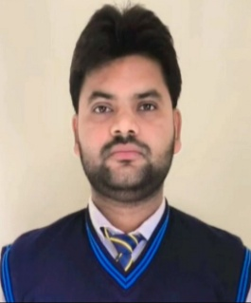

CURRICULUM VITAE
EHTARAMUL HAQUE
Add:-Lucknow (UP) India Phone:- +91.9795249738
+91.9793821849
E-mail:-gb1539936@gmail.com

Career Objective

Seeking an innovative and challenging career in a growing organization which gives an opportunity to utilize my skills & knowledge and provides me an opportunity for career growth.

Roles & Responsibilities

Closer

Relationship Management

Problem Solver

Communicator

Negotiation

Target Achievement

Customer Service

Training & Development

Education
- Diploma in Electrical from RITM Lucknow (UP)-2024 with 75%
- Bachelor of Arts, DDU Gorakhpur (UP)–2022
- ITI from Ganpati Niji ITI, Gorakhpur (UP)-2020-21 with 86%
- Intermediate from Gyanodaya Inter College Belwaniya,Kushinagar(UP)–2018 with 75.4%
- High School from Gyanodaya Inter College Belwaniya, Kushinagar (UP)–2016 with 76.5%

Certifications
- Certified in UPPCL summer training from Aug2023 – Sep2023

Hobbies

  - Playing Games, Books reading, listening Music.

  - Good Communication

Work Experience

- Hero Motor Corps (Sales) Padrauna Kushinagar(UP)- Jan 2022 to June 2022
- Lloyds Metals & Energy Ltd. (Hyderabad) from 3 Sep 2024 to till now.

Personal Details

Father’s Name = Akaramul Haque

Date of Birth = 8-apr-2001

Gender = Male

Marital Status = Single

Religion = Islam

Language = Hindi & English

Nationality = Indian

Permanent Address = Bulahwa, Chhitauni, Dist-

Kushinagar (UP), 274801.

Declarations

I solemnly hereby declare that all the above information is given by me is true and correct the best of my knowledge and belief.

Thank You! Ehtaramul Haque

