1. Introduction

Sustainable Development Goal 14 (SDG 14), "Life Below Water," represents a critical commitment by the United Nations to conserve and sustainably use oceans, seas, and marine resources. The ocean covers over 70% of Earth's surface and supports the livelihoods of more than 3 billion people who depend on marine and coastal biodiversity for food security and economic survival. However, this vital ecosystem faces an unprecedented crisis: ocean plastic pollution.

Ocean plastic pollution has emerged as one of the most pressing environmental challenges of the 21st century. Approximately 8 million metric tons of plastic waste enter the ocean annually, with projections suggesting that by 2050, the oceans may contain more plastic by weight than fish. This escalating crisis threatens marine biodiversity, disrupts ecosystem functions, contaminates the food chain, and poses severe risks to human health and economic stability.

The primary objectives of this analysis are to: (1) examine the multifaceted challenges of ocean plastic pollution, (2) understand its sources, pathways, and environmental impacts, (3) evaluate current mitigation strategies and their effectiveness, and (4) identify sustainable solutions aligned with SDG 14 targets. This case study contextualizes the global plastic crisis within the framework of marine conservation and sustainable development.

2. Methodology

This analysis employs a comprehensive mixed-methods approach combining qualitative and quantitative research techniques. Data sources include peer-reviewed scientific literature, reports from the United Nations Environment Programme (UNEP), World Bank assessments, and industry case studies on marine pollution.

The analytical framework integrates three complementary tools: (1) SWOT Analysis to evaluate Strengths, Weaknesses, Opportunities, and Threats related to ocean plastic management; (2) PESTLE Analysis(Political, Economic, Social, Technological, Legal, Environmental) to examine macro-level factors influencing marine plastic pollution; and (3) Systems Thinking to trace plastic pathways from source to ocean and identify intervention points.

The criteria for analysis include: environmental impact severity, socioeconomic implications, technological feasibility of solutions, and alignment with SDG 14 targets (specifically Target 14.1 on marine pollution reduction). Evidence is drawn from global datasets, case studies from high-pollution regions, and proven intervention models.

3. Case Study Overview

Ocean plastic pollution is a borderless, transnational crisis. Approximately 80% of marine plastic originates from land-based sources, with rivers serving as primary conduits transporting waste to the ocean. The top 10 rivers globally—predominantly in Asia and Africa—are responsible for 90% of riverine plastic discharge. These include the Yangtze River (China), Yellow River (China), Hai River (China), and Ganges River (India).

- Key Stakeholders:

- Governments and Policymakers:Responsible for legislation, enforcement, and international cooperation.
- Corporations and Industries: Producers of plastic goods, packaging manufacturers, and fisheries affected by pollution.
- Developing Nations: Disproportionately impacted due to inadequate waste management infrastructure.
- Scientific Community:Researchers documenting impacts and developing solutions.
- Civil Society and NGOs: Advocates for environmental protection and community mobilization.
- Consumers:End-users whose behavior drives plastic consumption patterns.

4. Analysis

4.1 Sources and Pathways of Ocean Plastic

Ocean plastic originates from two primary sources: macroplastics (visible items >5mm) and microplastics (particles <5mm). Single-use plastics—bags, bottles, packaging, and fishing gear—constitute 60% of ocean plastic debris. Industrial discharge, textile fibers from synthetic clothing, and tire wear particles account for significant portions of microplastic pollution.

The primary pathways include:

- River Systems: Transport 1.15–2.41 million metric tons annually to oceans.
- Coastal Mismanagement: Inadequate waste management in coastal communities.
- Marine Activities:Fishing industry losses, shipping waste, and offshore drilling operations.
- Atmospheric Transport: Microplastics suspended in air depositing in marine environments.

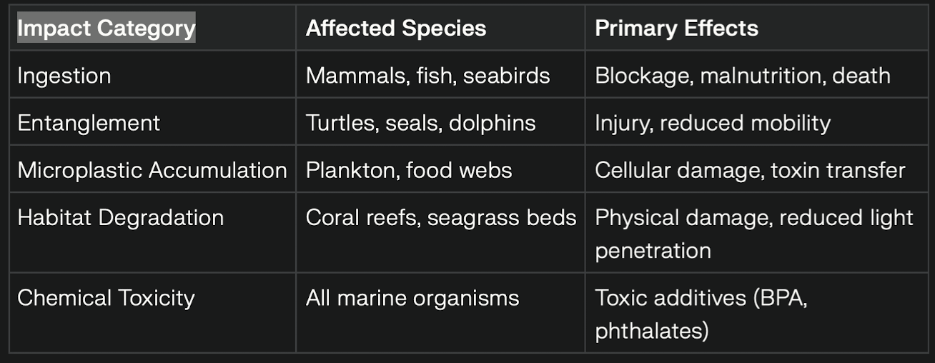
4.2 Environmental and Ecological Impacts
Over 1,000 marine species are affected by plastic pollution, with approximately 100,000 marine mammals and seabirds dying annually due to ingestion or entanglement. Microplastics have been detected in 90% of seabirds and 52% of marine turtles studied, with particles found in their tissues causing inflammation and reducing nutrient absorption.

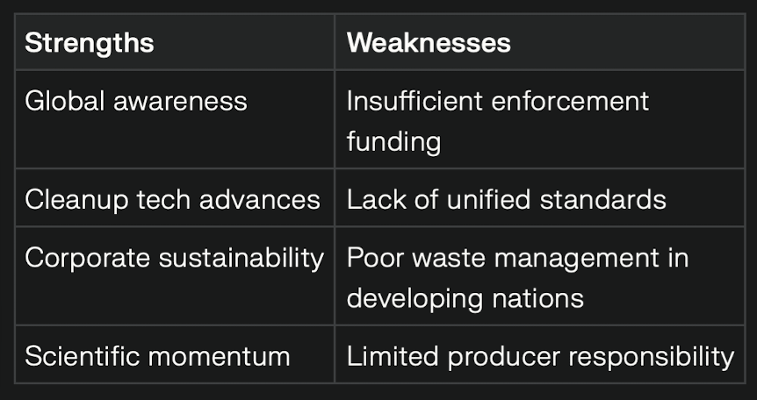
4.3 SWOT Analysis: Ocean Plastic Pollution Management

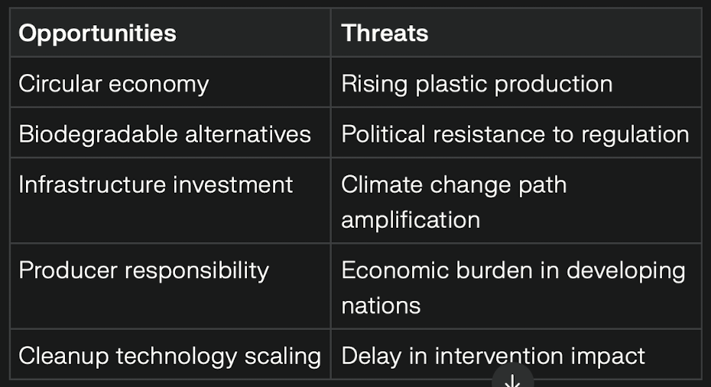

4.4 PESTLE Analysis: Macro-Level Factors

Political:International agreements like the Basel Convention and emerging UN Ocean Governance frameworks provide legislative foundations, yet enforcement remains weak. Geopolitical tensions hinder transnational cooperation on river plastic management.

Economic: The plastics industry generates $1 trillion annually, creating strong economic incentives against regulation. However, ocean pollution costs the global economy $2.5 trillion annually through ecosystem services loss, fisheries decline, and healthcare expenses.

Social:Consumer behavior, though improving, remains consumption-oriented. Education gaps persist in developing nations regarding waste management impacts.

Technological:Innovations in biodegradable plastics, advanced filtration systems, and ocean cleanup technologies offer solutions, yet scaling and affordability remain challenges.

Legal:Fragmented regulatory frameworks across nations create enforcement gaps. The lack of binding international plastic treaties enables continued production and disposal without consequences.

Environmental: Climate change accelerates plastic transport via altered ocean currents; warming exacerbates microplastic leaching of toxic additives.

5. Findings

•Ocean plastic pollution is a crisis with 8–10 million tons entering oceans each year; interventions are currently insufficient.
•Systemic root causes: weak infrastructure, overconsumption, poor producer accountability, and weak governance.
•Developing nations contribute most pollution and suffer the greatest impacts—inequality is a justice issue for SDG 14.
•Microplastics now penetrate food chains, with unresolved human health impacts.
•Solutions like the circular economy and Extended Producer Responsibility (EPR) models prove both effective and cost-saving.
•Cleanup technologies require global investment and scalability.
•Policy gaps: Only 30% of coastal nations have comprehensive strategies.

6. Conclusion

Ocean plastic pollution represents a convergence of environmental, economic, social, and governance failures that demands urgent, multifaceted intervention. SDG 14's vision of healthy ocean ecosystems is incompatible with current consumption and waste management trajectories. The findings reveal that technical solutions, while necessary, are insufficient without systemic transformation.

Critical Implications:

1. Environmental Justice:Addressing ocean plastic pollution requires equitable distribution of responsibility and resources, ensuring developing nations receive support for infrastructure development rather than bearing disproportionate burdens.

2. Economic Transition: The shift from linear ("take-make-dispose") to circular economy models is not merely environmental necessity but economic opportunity, reducing long-term costs and creating sustainable livelihoods.

3. Governance Reform: Current international frameworks are fragmented and toothless. Binding global treaties with enforcement mechanisms, technology transfer provisions, and financial support are prerequisites for effective action.

4. Consumer and Corporate Accountability:While individual behavior change matters, systemic transformation requires corporate accountability through extended producer responsibility, elimination of unnecessary single-use plastics, and investment in sustainable alternatives.

Recommendations for SDG 14 Achievement:

1. Establish binding international plastic treaties with enforcement and penalty mechanisms by 2030.
2. Invest $300 billion annually in waste management infrastructure in developing nations.
3. Mandate extended producer responsibility globally, holding manufacturers accountable for end-of-life plastic management.
4. Phase out single-use plastics by 2035 in developed nations, with technical and financial support for developing nations.
5. Fund ocean cleanup initiatives and marine ecosystem restoration projects.
6. Strengthen scientific monitoring of microplastic accumulation and health impacts.
7. Implement circular economy incentives through tax structures and subsidies.

Ocean plastic pollution threatens not merely marine ecosystems but human civilization's food security, health, and economic stability. SDG 14's achievement requires transformative action—technically feasible, economically viable, and morally imperative. The next decade will determine whether humanity responds adequately or permits irreversible ocean degradation.

