pwc | MUY
Monthly Progress
Report
Mukhyamantri Udyamshala
Yojana
August 2026
Private & Confidential

Contents
1. | Progress in Mukhyamantri Udyamshala Yojana (MUY) ................................................................
2. | Quantitative Progress - Plan vs Achievements ................................................................
3. | District-wise Progress ................................................................
4. | Program Workstream Progress ................................................................
5. | Field Highlights ................................................................
6. | Report Basis and Data Notes ................................................................

1. Progress in Mukhyamantri Udyamshala Yojana (MUY)
This Monthly Progress Report presents MIS-recorded progress for August 2026. Targets and achievements follow the approved MUY deliverables matrix for FY 2026-27.
909  CFA applications | 0  Incubatees onboarded | 26  Indicators reporting progress

Key monthly highlights
- Call for Application: 909 achieved against a monthly target of 1,470.
- Participants in Awareness cum Outreach activities: 574 achieved against a monthly target of 910.
- Incubatees taken Part in Business Modules Training: 212 achieved against a monthly target of 700.
- Business Model Canvas: 185 achieved against a monthly target of 600.
- Business Registration: 74 achieved against a monthly target of 600.
- Schematic Convergence: 48 achieved against a monthly target of 300.
- Specialized Mentorship Support: 25 achieved against a monthly target of 65.
- No. of Awareness cum Outreach activities for SHG members/Potential Lakhpati Didis/ SHGs/CBOs etc.: 24 achieved against a monthly target of 122.

2. Quantitative Progress - Plan vs Achievements
The table below presents the approved monthly target and MIS-recorded achievement for August 2026.
S.No. | Indicator | Type of Indicator | Target | Achievement | Achievement (%)
1 | Outreach and Mobilisation
1.1 | Call for Application | Key Indicator | 1,470 | 909 | 62%
1.2 | District Level Workshops | Key Indicator | — | 3 | —
1.3 | No. of Awareness cum Outreach activities for SHG members/Potential Lakhpati Didis/ SHGs/CBOs etc. | Non-Key | 122 | 24 | 20%
1.3.1 | Participants in Awareness cum Outreach activities | Non-Key | 910 | 574 | 63%
1.4 | EAP/EDP Sessions | Key Indicator | 13 | 12 | 92%
1.5 | Outreach through Community Organizations | Non-Key | 4 | 0 | 0%
2 | Identification and Onboarding of Enterprises
2.1 | Incubatees Onboarded | Key Indicator | 700 | 0 | 0%
2.1.1 | Onboarding of Potential Lakhpati Didi/ SHG Members/ CBOs* | Key Indicator | 300 | 0 | 0%
3 | Training & Capacity Building
3.1 | Business Skills Training Sessions | Key Indicator | 39 | 7 | 18%
3.2 | Incubatees taken Part in Business Modules Training | Non-Key | 700 | 212 | 30%
3.3 | Technical Trainings to Incubatees | Non-Key | 1 | 0 | 0%
3.3.1 | Technical Trainings to Potential Lakhpati Didis/ SHG Members/ CBOs | Non-Key | (Need Based) | 1 | —
3.4 | Capacity Building of stakeholders (REAP, USRLM, Other Line department staff) | Key Indicator | 0 | 0 | —
4 | Business Formalization
4.1 | Business Registration
4.1.1 | Business Registration | Key Indicator | 600 | 74 | 12%
4.2 | Legal & Licensing Support
4.2.1 | Artisan Card | Key Indicator | 26 | 8 | 31%
4.2.2 | FSSAI | Non-Key | 75 | 14 | 19%
4.2.3 | UTDB | Non-Key | 20 | 1 | 5%
4.2.4 | GST Registration | Non-Key | 35 | 4 | 11%
4.2.5 | Trademark application filling | Non-Key | 0 | 1 | —
4.2.6 | GI Seller Registration | Non-Key | — | 0 | —
4.2.7 | Advance Licensing Support (Mandi Licensing, Lab Test etc.) | Non-Key | (Need Based) | 1 | —
5 | Mentorship
5.1 | Specialized Mentorship Support | Key Indicator | 65 | 25 | 38%
5.2 | Mentorship Support through online portal | Non-Key | 0 | 0 | —
6 | Partnership & Forward Linkages
6.1 | No of Partners outreach | Non-Key | 10 | 11 | 110%
6.2 | Marketing Partners Onboarded through (LoA/LoI/MoU) | Non-Key | 10 | 0 | 0%
6.3 | Incubatees linked to online/offline Market | Key Indicator | 150 | 15 | 10%
7 | Business Acceleration Services
7.1 | No of Partners outreach | Non-Key | 2 | 0 | 0%
7.2 | Initiation of acceleration and co-incubation services | Key Indicator | 150 | 15 | 10%
8 | Funding & Schematic Convergence
8.1 | Schematic Convergence | Key Indicator | 300 | 48 | 16%
8.2 | Support to MUY Incubatee through Reap | Key Indicator | 50 | 4 | 8%
8.3 | Incubatees Pitch Deck Preparation | Key Indicator | 20 | 0 | 0%
8.4 | Demo Days | Key Indicator | 1 | 0 | 0%
8.5 | No of Partners outreach | Non-Key | 5 | 0 | 0%
9 | Other Support Services
9.1 | Business Model Canvas | Key Indicator | 600 | 185 | 31%
9.2 | Other Support Services - Labelling, Packaging, Logo Designing etc. | Non-Key | 0 | 2 | —
10 | Branding, Communication & Knowledge Management
10.1 | Social Media Post | Key Indicator | 10 | 3 | 30%
10.2 | Preparation of Case Studies and Testimonials | Key Indicator | 10 | 1 | 10%
10.3 | MUY Newsletter | Key Indicator | — | 0 | —
10.4 | IEC & Promotional Activities for MUY | Non-Key | 1 | 0 | 0%
10.5 | Buyer-Seller Meet | Key Indicator | 0 | 0 | —
10.6 | Events/ Seminars/ Workshops | Key Indicator | 0 | 0 | —
11 | Product Development
11.1 | Identification and Submission of Proposal for New Product Development | Key Indicator | 0 | 0 | —
12 | Synergies Across Line Departments
12.1 | Stakeholder Consultation Workshop | Key Indicator | 0 | 0 | —
12.2 | Meeting of staff with Line Department at Spoke/Hub/State Level | Non-Key | 5 | 1 | 20%
The above-mentioned progress is based on the IT/MIS system developed under the Mukhyamantri Udyamshala Yojana and the applicable maker-checker approval workflow.

3. District-wise Progress
District-wise CFA and onboarding achievements recorded during the selected month.
S.N. | District | CFA applications | Incubatees onboarded
1 | Almora | 42 | 0
2 | Bageshwar | 2 | 0
3 | Chamoli | 114 | 0
4 | Champawat | 61 | 0
5 | Dehradun | 97 | 0
6 | Haridwar | 106 | 0
7 | Nainital | 158 | 0
8 | Pauri Garhwal | 114 | 0
9 | Pithoragarh | 101 | 0
10 | Rudraprayag | 20 | 0
11 | Tehri Garhwal | 20 | 0
12 | Udham Singh Nagar | 4 | 0
13 | Uttarkashi | 70 | 0

4. Program Workstream Progress

Outreach and Mobilisation
S.No. | Indicator | Achievement
1.1 | Call for Application | 909
1.2 | District Level Workshops | 3
1.3 | No. of Awareness cum Outreach activities for SHG members/Potential Lakhpati Didis/ SHGs/CBOs etc. | 24
1.3.1 | Participants in Awareness cum Outreach activities | 574
1.4 | EAP/EDP Sessions | 12

Identification and Onboarding of Enterprises
No approved achievement was recorded for this workstream during August 2026.

Training & Capacity Building
S.No. | Indicator | Achievement
3.1 | Business Skills Training Sessions | 7
3.2 | Incubatees taken Part in Business Modules Training | 212
3.3.1 | Technical Trainings to Potential Lakhpati Didis/ SHG Members/ CBOs | 1

Business Formalization
S.No. | Indicator | Achievement
4.1.1 | Business Registration | 74
4.2.1 | Artisan Card | 8
4.2.2 | FSSAI | 14
4.2.3 | UTDB | 1
4.2.4 | GST Registration | 4
4.2.5 | Trademark application filling | 1
4.2.7 | Advance Licensing Support (Mandi Licensing, Lab Test etc.) | 1

Mentorship
S.No. | Indicator | Achievement
5.1 | Specialized Mentorship Support | 25

Partnership & Forward Linkages
S.No. | Indicator | Achievement
6.1 | No of Partners outreach | 11
6.3 | Incubatees linked to online/offline Market | 15

Business Acceleration Services
S.No. | Indicator | Achievement
7.2 | Initiation of acceleration and co-incubation services | 15

Funding & Schematic Convergence
S.No. | Indicator | Achievement
8.1 | Schematic Convergence | 48
8.2 | Support to MUY Incubatee through Reap | 4

Other Support Services
S.No. | Indicator | Achievement
9.1 | Business Model Canvas | 185
9.2 | Other Support Services - Labelling, Packaging, Logo Designing etc. | 2

Branding, Communication & Knowledge Management
S.No. | Indicator | Achievement
10.1 | Social Media Post | 3
10.2 | Preparation of Case Studies and Testimonials | 1

Product Development
No approved achievement was recorded for this workstream during August 2026.

Synergies Across Line Departments
S.No. | Indicator | Achievement
12.2 | Meeting of staff with Line Department at Spoke/Hub/State Level | 1

5. Field Highlights
Approved field photographs available in the MIS Media Gallery for the reporting month.
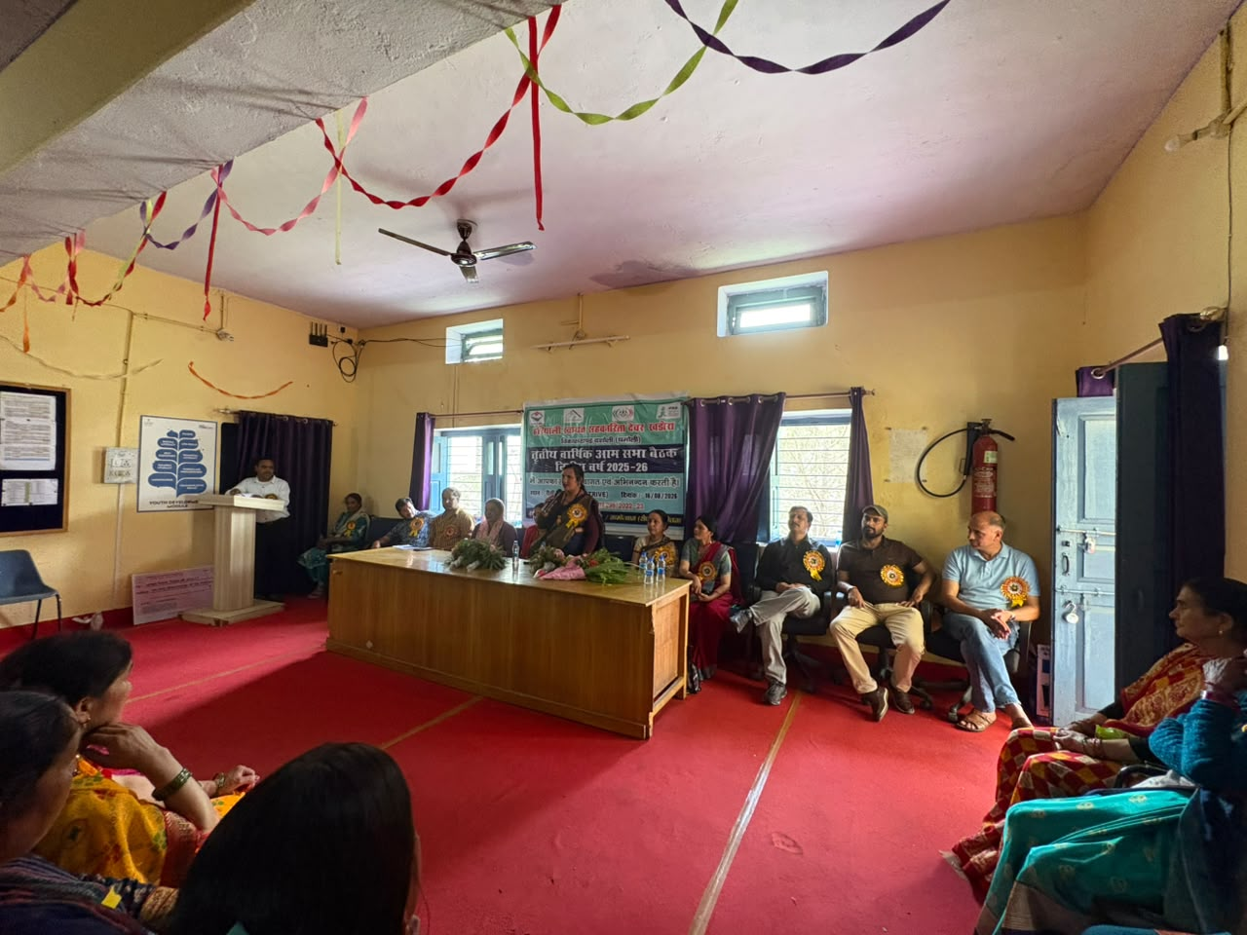  Block Workshops - Dasholi  Chamoli | 16 Aug 2026 | 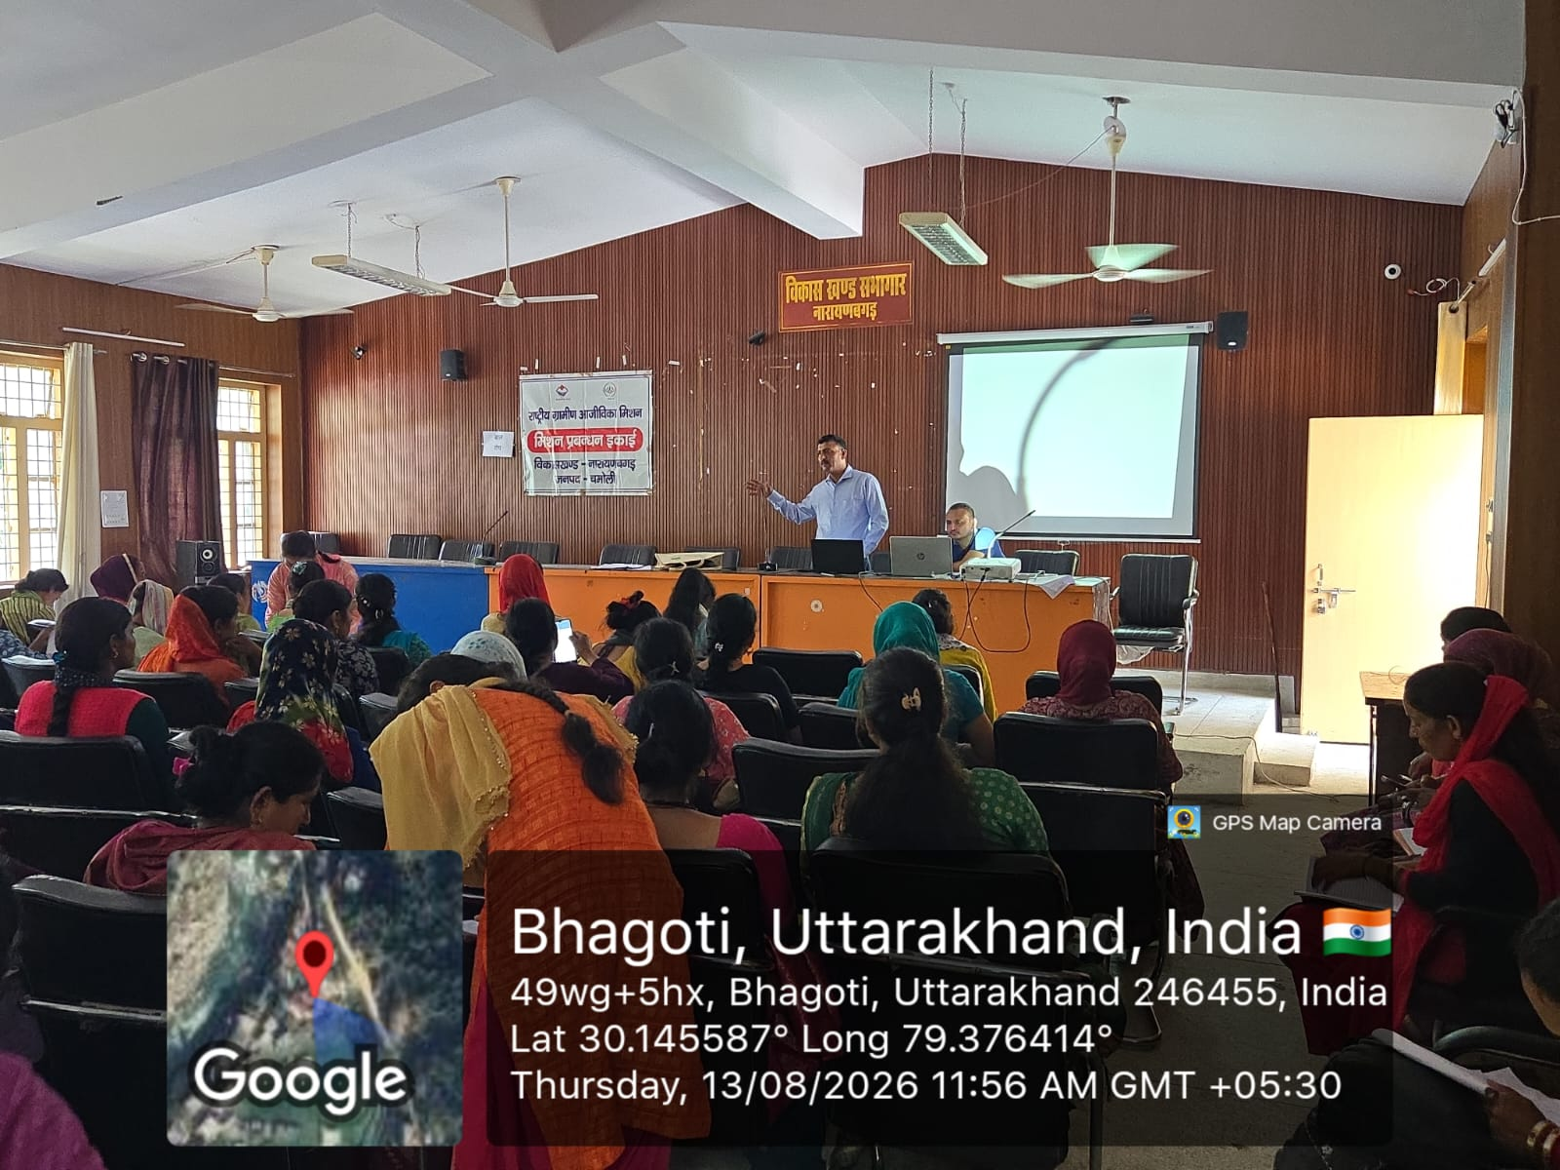  Block Workshops - Narayanbagar  Chamoli | 13 Aug 2026
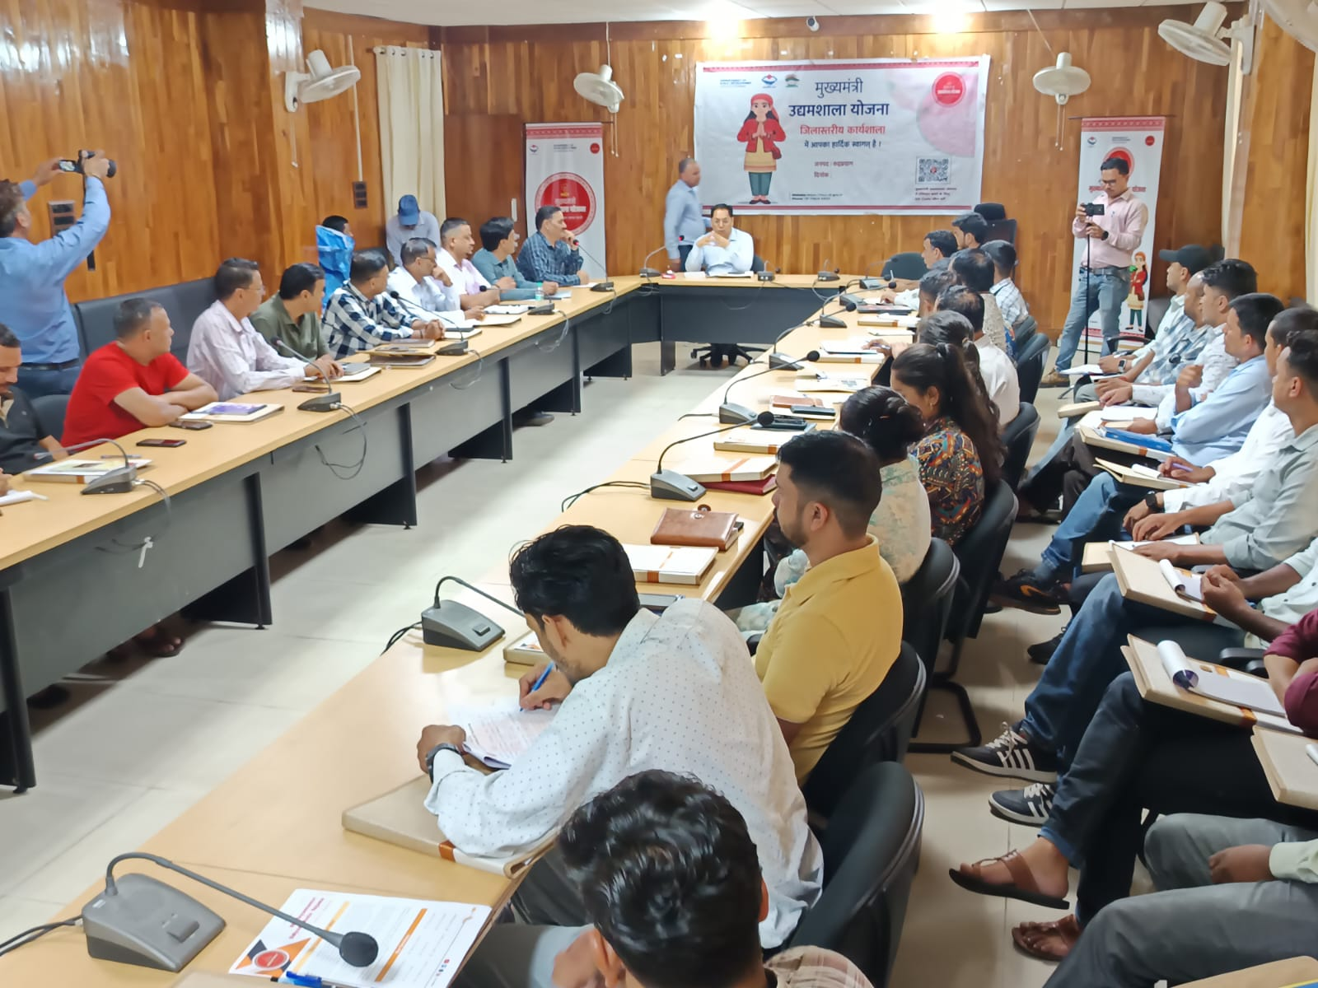  District Workshops - District workshop  Rudraprayag | 05 Aug 2026 | 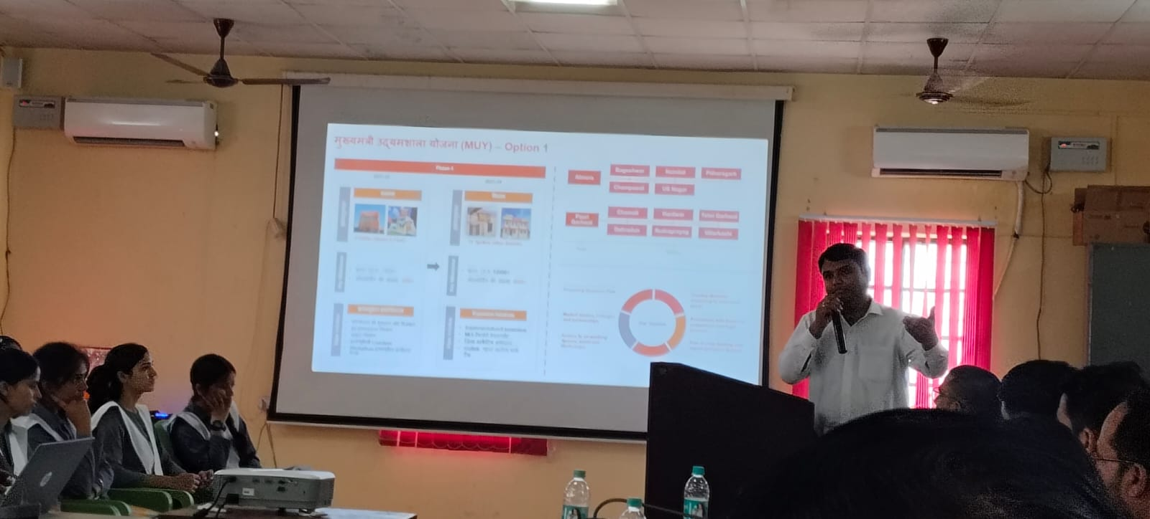  District Workshops - District workshop  Pauri Garhwal | 05 Aug 2026

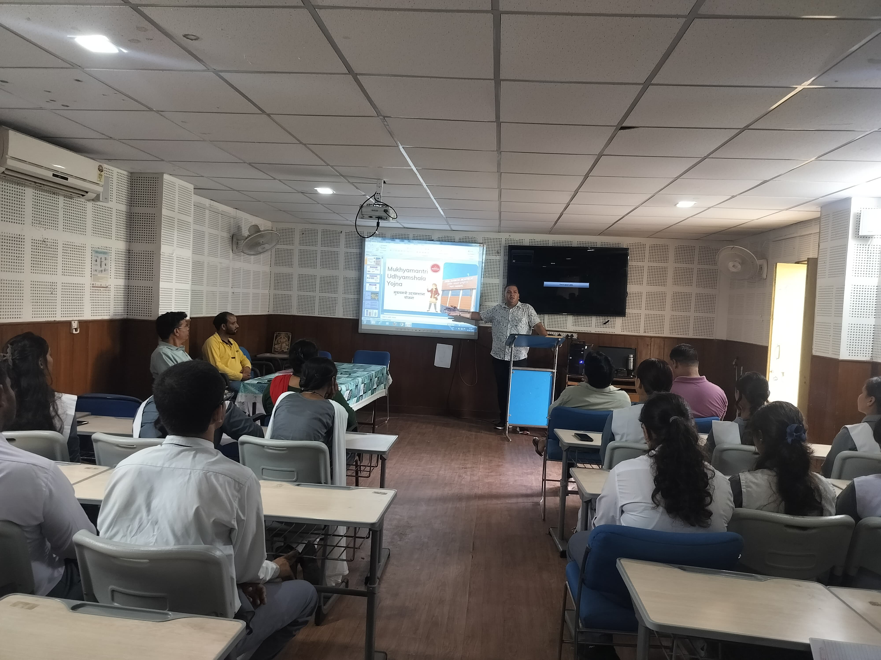  EAP / EDP Sessions - EAP/EDP session  Pauri Garhwal | 17 Aug 2026 | 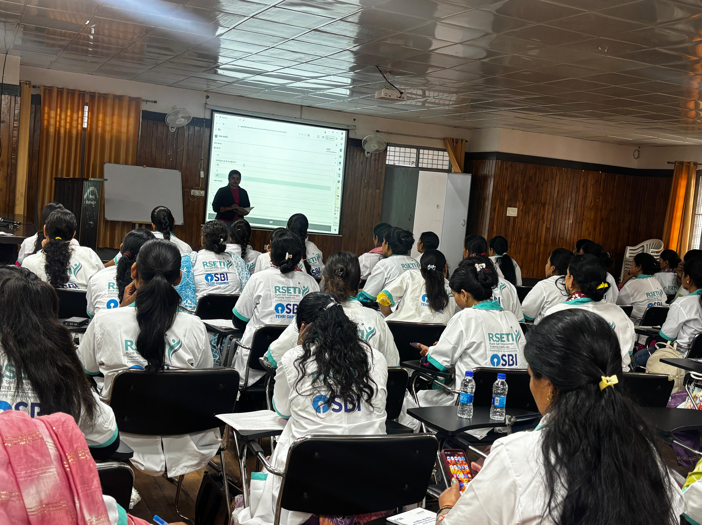  EAP / EDP Sessions - EAP/EDP session  Tehri Garhwal | 14 Aug 2026
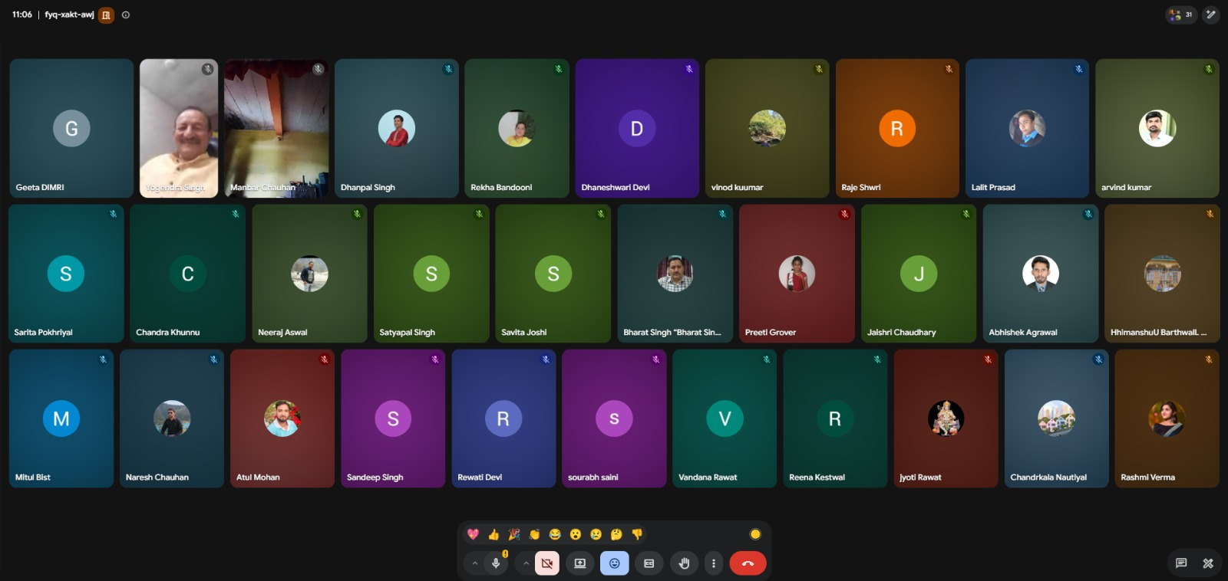  Lakhpati Technical Trainings - Importance of Social Media Management in collaboration with Upliftlive Foundation  Pauri Garhwal | 07 Aug 2026 | 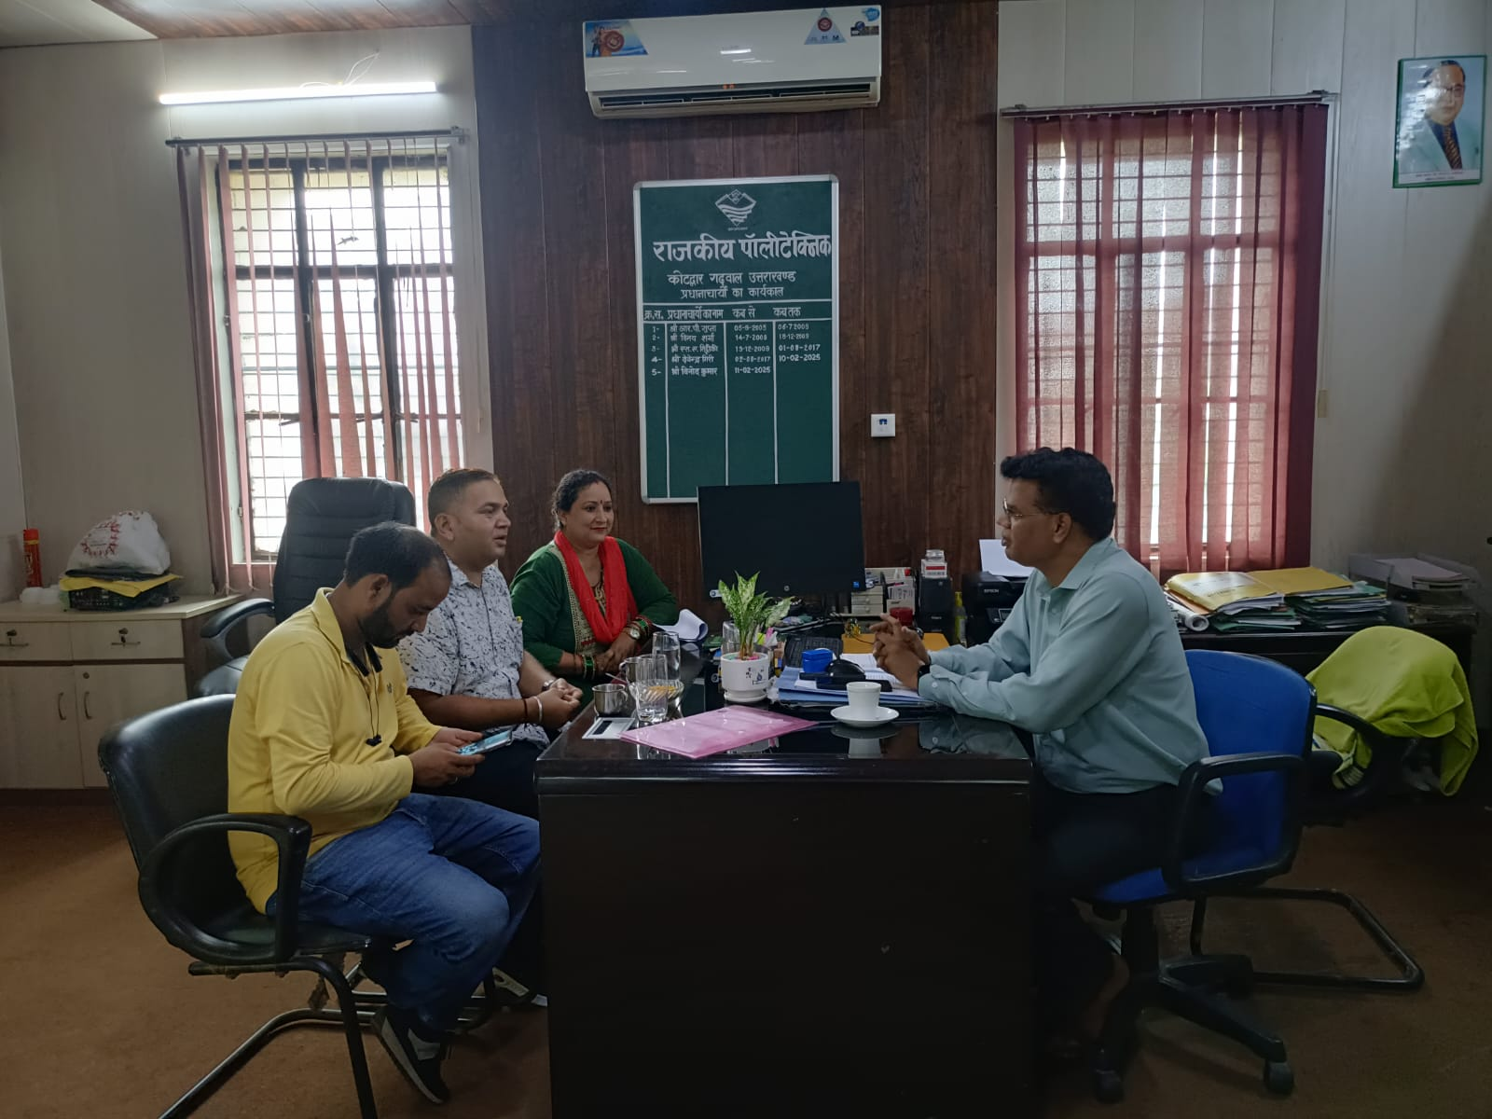  Line Department Meetings - Education  — | 17 Aug 2026

6. Report Basis and Data Notes
- Reporting period: 01 Aug 2026 to 31 Aug 2026.
- Fiscal year: FY 2026-27.
- Achievements are generated from approved MIS records and the existing MUY deliverables reporting logic.
- Cumulative values cover the start of the fiscal year through the end of the selected month.
- Field photographs are selected from Media Gallery records that satisfy the module visibility and approval rules.
- A zero indicates that no qualifying approved record was found under the applicable MIS logic; it does not replace independent program validation.
Report generated on 18 Aug 2026, 12:23 PM.

Thank You
- This report is generated from the MUY MIS for the selected reporting month and is intended for programme review.
- The document should be reviewed by the State Project Management Unit before external circulation.
- The report may contain forward-looking actions and operational observations that remain subject to validation.

