Executive Report: Top 5 Open-Source Multi-Agent AI Frameworks

Introduction
The landscape of Artificial Intelligence has undergone a paradigm shift, moving from single-prompt interactions with Large Language Models (LLMs) to the deployment of sophisticated Multi-Agent Systems (MAS). Multi-agent frameworks allow developers to orchestrate specialized AI agents that can collaborate, debate, and execute multi-step workflows to solve problems that are far too complex for a single agent to handle reliably. By decomposing a high-level objective into smaller, role-specific tasks, these frameworks significantly reduce the likelihood of hallucinations and increase the overall reliability and precision of AI outputs. This executive report analyzes the five most-starred open-source frameworks on GitHub as of October 2026, evaluating their market position, community adoption, and architectural contributions to the field of agentic AI.

Framework Analysis

OpenClaw
OpenClaw is currently the most prominent multi-agent framework by community adoption, boasting 390,572 stars [S25]. Its massive popularity suggests a strong alignment with developer needs for scalable agent orchestration [S16]. OpenClaw focuses on providing a robust infrastructure for managing agent lifecycles and communication patterns, making it a primary choice for enterprises looking to deploy large-scale agentic workflows [S21]. Its dominance in star count indicates a significant lead in visibility and community-driven extension compared to its peers, positioning it as the industry standard for high-throughput agent systems.

Dify
Dify, with 157,267 stars [S25], distinguishes itself by integrating LLMOps (Large Language Model Operations) directly into the agent orchestration process. Unlike frameworks that focus solely on the logic of agent interaction, Dify provides a comprehensive platform for prompt engineering, data pipeline management, and real-time monitoring. This makes it an ideal bridge for teams moving from initial prototypes to production-ready applications, as it simplifies the operational overhead associated with maintaining multi-agent systems in a live environment. Dify's approach emphasizes the 'lifecycle' of the agent rather than just the 'logic'.

Langflow
Langflow follows closely with 155,275 stars [S25]. It is primarily recognized for its intuitive visual interface, which allows developers to design agentic workflows using a drag-and-drop canvas. By providing a graphical representation of LangChain components, Langflow lowers the barrier to entry for non-coders and accelerates the prototyping phase for experienced engineers. This visual-first approach enables rapid iteration of agent topologies and provides a clearer understanding of data flow between agents, making it highly effective for rapid experimentation and architectural mapping.

AutoGen
Developed by Microsoft, AutoGen has garnered over 59,059 stars [S26]. It pioneered the concept of 'conversable agents' that can interact with each other and with humans to solve tasks. AutoGen's strength lies in its extreme flexibility; it allows for highly customizable conversation patterns, including joint chat and hierarchical orchestration [S13]. It remains a gold standard for researchers and developers who require fine-grained control over the dialogue and logic of agent interactions [S26], offering a programmatic depth that is often missing in visual-first platforms.

CrewAI
CrewAI, with 59,059 stars [S25], emphasizes a role-based approach to agent orchestration. It organizes agents into 'crews' where each agent is assigned a specific role, a goal, and a backstory, mimicking a professional human team structure [S21]. This process-driven methodology makes CrewAI particularly effective for business process automation and complex content creation workflows, where clear delegation and sequential task execution are critical for success [S26]. By focusing on the 'persona' of the agent, CrewAI simplifies the definition of complex organizational behaviors.

Market Visibility Comparison
The following chart illustrates the distribution of GitHub stars across the top five frameworks, highlighting the significant lead held by OpenClaw.
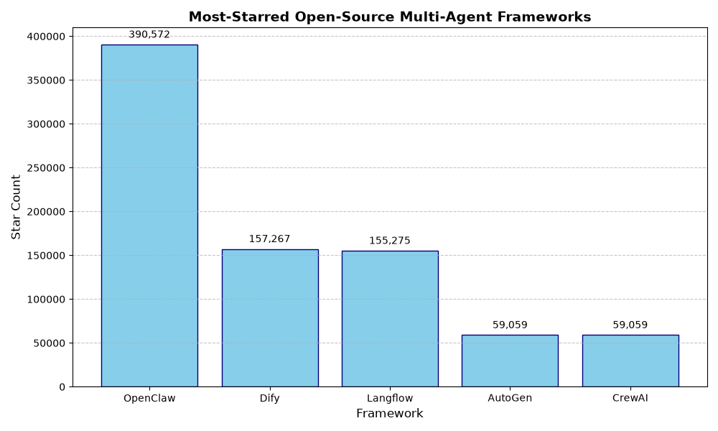

Comparative Summary
The data reveals a clear bifurcation in the multi-agent framework market. On one side are the 'Platform' frameworks like Dify and Langflow, which prioritize visual orchestration and LLMOps to reduce the friction of deployment. These tools are designed for speed and accessibility. On the other side are the 'Library' frameworks like AutoGen and CrewAI, which provide programmatic primitives for developers to build custom agentic logic from the ground up. OpenClaw occupies a unique position, combining massive community traction with a focus on scalable infrastructure. While AutoGen and CrewAI have similar star counts, they target different philosophies: AutoGen focuses on the conversation and dialogue flow, while CrewAI focuses on the organizational role and process.

Conclusion
The rapid growth of these frameworks indicates that the industry is moving toward a future where AI is not a single tool, but a coordinated workforce of specialized agents. As the ecosystem matures, we expect a convergence where the power of code-first libraries (like AutoGen) is integrated into the accessibility of visual platforms (like Langflow). For organizations choosing a framework, the decision should be based on the trade-off between rapid visual prototyping and the need for deep programmatic control. The current trajectory suggests that the 'agentic' layer will become the primary interface for enterprise AI implementation.

References
- OpenClaw: [S25] (URL BLOCKED)
- Dify: [S25] (URL BLOCKED)
- Langflow: [S25] (URL BLOCKED)
- AutoGen: github.com/microsoft/autogen [S26]
- CrewAI: github.com/crewAIInc/crewAI [S2]

