**There are five workouts**

**To be completed before Sunday 30-Jan-2021**

**Workout-5 (Postgresql DVDRENTAL Database)**

**Problem Statement**: Write a function which will accept two inputs and return a grade depending on the inputs provided with the below criteria.

**Function Name**: calculate_grade

**Inputs:**

1. rate numeric
2. cost numeric

**Logic:**

|  |  |  |
| --- | --- | --- |
| value of "rate" | value of "cost" | grade * |
| less than 1.00 | less than 10 | A |
| less than 1.00 | 10 or more but less than 20 | B |
| less than 1.00 | 20 or more | C |
| 1 or more but less than 4 | less than 12 | D |
| 1 or more but less than 4 | 12 or more but less than 24 | E |
| 1 or more but less than 4 | 24 or more | F |
| 4 or more | less than 13.5 | G |
| 4 or more | 13.5 or more but less than 19.2 | H |
| 4 or more | 19.2 or more | K |

* A is minimum and K is maximum grade

CREATE FUNCTION public.calculate_grade(IN rate numeric, IN cost numeric)

RETURNS "char"

LANGUAGE 'plpgsql'

AS $BODY$declare

grade char;

begin

if rate<1 then

if cost<10 then

grade='A';

elsif cost>=10 and cost<20 then

grade='B';

else

grade='C';

end if;

elsif rate>=1 and rate<4 then

if cost<12 then

grade='D';

elsif cost>=12 and cost<24 then

grade='E';

else

grade='F';

end if;

else

if cost<13.5 then

grade='G';

elsif cost>=13.5 and cost<19.2 then

grade='H';

else

grade='K';

end if;

end if;

return grade;

end;

$BODY$;

ALTER FUNCTION public.calculate_grade(numeric, numeric)

OWNER TO postgres;

**Workout-6 (Postgresql DVDRENTAL Database)**

**Problem Statement**: Write a procedure which will populate a target table for all actor information stated below.

**Target table name:** actor_performance

**Target table columns:**

|  |  |  |
| --- | --- | --- |
| column name | column type | description |
| actor_id | integer | actor_id from actor table |
| actor_name | character varying | concatenation of first_name and last_name from actor |
| max_grade | character(1) | any value from A to K |
| min_grade | character(1) | any value from A to K |
| ratings | character varying | comma separated ratings from film table |

**Hint**: Use tables – actor, film_actor, film

For each actor, find all the films done by that actor and then find all the grades from the above function, *calculate_grade*, using rental_rate and replacement_cost. Between the grades, A is the min grade and K is the maximum grade. Use these values to store min_grade and max_grade columns of *actor_performance* table. Also find the comma separated values of rating from *film* table per actor.

CREATE OR REPLACE PROCEDURE public.actor_data()

LANGUAGE 'plpgsql'

AS $BODY$declare

begin

delete from actor_performance;

commit;

insert into actor_performance(actor_id,actor_name,min_grade,max_grade,ratings)

select actorid,actor_name,min_grade,max_grade

,( select string_agg(cast(r.rating as varchar),',' order by r.rating)

from (select distinct actor.actor_id,film.rating

from actor,film_actor,film

where actor.actor_id=film_actor.actor_id

and film_actor.film_id=film.film_id

and actor.actor_id=actorid

) r

) ratings

from (

select actor.actor_id actorid

,actor.first_name||' '||actor.last_name actor_name

,min(calculate_grade(film.rental_rate,film.replacement_cost)) min_grade

,max(calculate_grade(film.rental_rate,film.replacement_cost)) max_grade

from actor,film_actor,film

where

actor.actor_id=film_actor.actor_id

and film_actor.film_id=film.film_id

group by

actorid

,actor_name

) v

order by actorid;

commit;

end;$BODY$;

**Use the below schema diagram for better understanding of oracle table associations.**

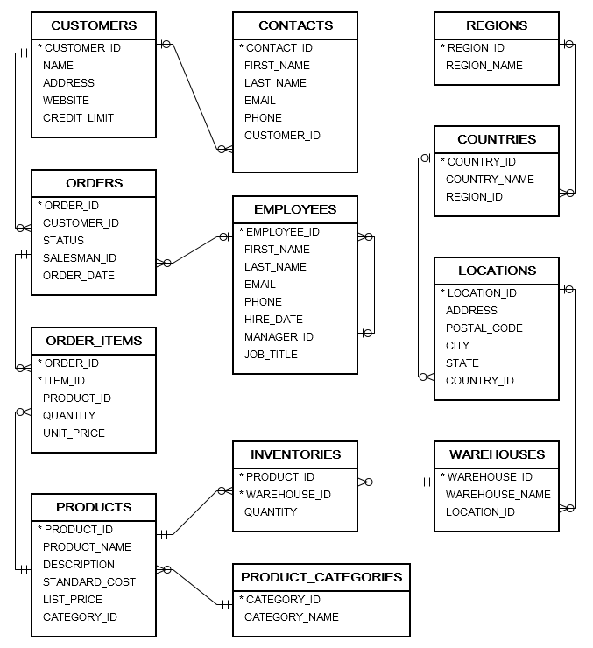

**Workout-7 (Oracle Sample Data, Oracle database)**

**Problem Statement**: Write a function which take input two values and return a string.

**Function name:** get_assesment

**Input:** amount numeric, ranges numeric

**Output:** Function will take the amount and ranges as inputs and find those amounts in list_price of products table such that list_price lies between amount+ranges and amount-ranges. After finding the rows from products table, it will find the category_names using category_id along with company names from product_name (use 1st word). Concatenate the category_name and company name using "@" sign [category_name@ company name]. All these strings will be concatenated using "OR" and return the value.

**Hint**: Use tables – products, product_categories,

create or replace FUNCTION get_assesment (amount NUMERIC, ranges NUMERIC)

RETURN clob

AS

result clob;

BEGIN

begin

select listagg(company_name||'@'||category_name,' OR ')

within group (order by company_name) into result

from

(select distinct trim(substr(p.product_name,1,decode(instr(p.product_name,' '),0,length(p.product_name),instr(p.product_name,' ')))) company_name, c.category_name

from products p, product_categories c

where p.category_id=c.category_id

and p.list_price between amount-ranges and amount+ranges);

exception

when others then

return null;

end;

return result;

END;

**Workout-8 (Oracle Sample Data, Oracle database)**

**Problem Statement**: Write a procedure to populate a table having columns customer_id, customer_name and purchase_posibilities varchar2(4000).

**Hint**: Use tables – customers,orders, order_items,products

**Rule to fillup purchase_posibilities:** find all the purchases per customer. Find average of standard_cost and average of list_price. Send average of standard_cost as amount and difference of averages between standard_cost and list_price as ranges in the above function. The output of the function will be the purchase_posibilities.

CREATE OR REPLACE PROCEDURE CUSTOMER_POSSIBILITIES AS

cursor c1 is

select customer_id,name

,get_assesment(standard_cost,abs(standard_cost-list_price)) possibility

from (

select customers.customer_id,customers.name

,avg(products.standard_cost) standard_cost

,avg(products.list_price) list_price

from

customers,orders, order_items,products

where

customers.customer_id=orders.customer_id

and orders.order_id=order_items.order_id

and order_items.product_id=products.product_id

group by customers.customer_id,customers.name

);

BEGIN

begin

delete from customer_purchase_possibility;

for r1 in c1 loop

insert into customer_purchase_possibility(customer_id, customer_name , purchase_posibilities)

values (r1.customer_id,r1.name,r1.possibility);

end loop;

exception

when others then

rollback;

return;

end;

commit;

END CUSTOMER_POSSIBILITIES;

**Workout-9 Design Database**

Consider a Medicine shop management system. System must have the below capabilities:

1. Keep medicine information.
2. Keep seller information.
3. Keep purchase information by which it can increase stock.
4. Sell medicine and keep information for sell along with seller and purchaser.
5. Able to provide current stock of all medicines.
6. Can produce purchase report for a specified period time.
7. Able to find Moving Averages.

Try to design the required tables along with columns which you may find best suitable from your practical experience.

Try to define table constraints (PK, FK, UNIQUE, CHECK) which may be imposed to check bad data.

Try to guess what indexes are required to build for faster queries.

Try to define some function for getting current stock.

Try to define procedure for outputs (output tables may also be defined).

**SELLER_MASTER**

SELLER_ID NUMBER PRIMARY KEY

SELLER_NAME VARCJAR2(30)

SELLER_ADDRESS VARCHAR2(1000)

SELLER_PHONE NUMBER

**MEDICINE_MASTER**

MED_ID NUMBER PRIMARY KEY

MED_NAME VARCHAR2(500)

CURRENT_STOCK NUMBER CHECK (CURRENT_STOCK>=0)

MED_POWER VARCHAR2(20)

SELLER_ID NUMBER REFERENCES SELLER_MASTER(SELLER_ID)

CREATE INDEX MEDICINE_MASTER_IDX1 ON MEDICINE_MASTER (MED_NAME);

CREATE INDEX MEDICINE_MASTER_IDX2 ON MEDICINE_MASTER (SELLER_ID);

**MED_PURCHASE**

PURCHASE_ID NUMBER PRIMARY_KEY

MED_ID NUMBER REFERENCES MEDICINE_MASTER

SELLER_ID NUMBER REFERENCES SELLER_MASTER

PURCHASE_AMOUNT NUMBER CHECK PURCHASE_AMOUNT>0

PURCHASE_QTY NUMBER CHECK PURCHASE_QTY>0

PURCHASE_DATE DATE

BATCH_NUMBER VARCHAR2(100)

EXPIRY_DATE DATE

MANUFACTURER_NAME VARCHAR2(200)

CREATE INDEX MED_PURCHASE_IDX1 ON MED_PURCHASE(MED_ID);

CREATE INDEX MED_PURCHASE_IDX2 ON MED_PURCHASE(PURCHASE_DATE);

CREATE INDEX MED_PURCHASE_IDX3 ON MED_PURCHASE(BATCH_NUMBER);

CREATE INDEX MED_PURCHASE_IDX4 ON MED_PURCHASE(EXPIRY_DATE);

CREATE INDEX MED_PURCHASE_IDX5 ON MED_PURCHASE(COMPANY_NAME);

**MED_SELL**

SELL_ID NUMBER PRIMARY_KEY

VOUCHER_NUMBER VARCHAR2(200) UNIQUE

MED_ID NUMBER REFERENCES MEDICINE_MASTER

SELLER_ID NUMBER REFERENCES SELLER_MASTER

SELL_AMOUNT NUMBER CHECK PURCHASE_AMOUNT>0

SELL_QTY NUMBER CHECK PURCHASE_QTY>0

SELL_DATE DATE

BUYER_NAME VARCHAR2(30)

BUYER_DOCTOR_NAME VARCHAR2(30)

BUYER_MOBILE_NO NUMBER

BUYER_ADDRESS VARCHAR2(2000)

CREATE INDEX MED_SELL_IDX1 ON MED_SELL(BUYER_NAME, BUYER_MOBILE_NO);

CREATE INDEX MED_SELL_IDX2 ON MED_SELL(MED_ID);

CREATE INDEX MED_SELL_IDX3 ON MED_SELL(SELLER_ID);

CREATE INDEX MED_SELL_IDX4 ON MED_SELL(SELL_DATE);

CREATE OR REPLACE PROCEDURE UPDATE_STOCK(SELLID IN NUMBER) AS

BEGIN

UPDATE MEDICINE_MASTER

SET CURRENT_STOCK:=CURRENT_STOCK-(SELECT SELL_QTY FROM MED_SELL WHERE SELL_ID=SELLID)

WHERE MED_ID=(SELECT MED_ID FROM MED_SELL WHERE SELL_ID=SELLID);

COMMIT;

END;

Some queries:

* select all medicine sold by any seller for a period of time.
* select all medicine sold in a period of time.
* select whine is sold very frequently and sold maximum in a period of time.
* find voucher by buyer mobile number or name.
* find which medicines are expired and about to expire in some days.
* find which seller sold maximum medicines in a period of time.
* find profit in a period of time.