ASSIGNMENT BY ARJUN and GROUP

Q) Write a program that appends a log to a *.log file whenever your computer connects to the internet.

FLOWCHART:-
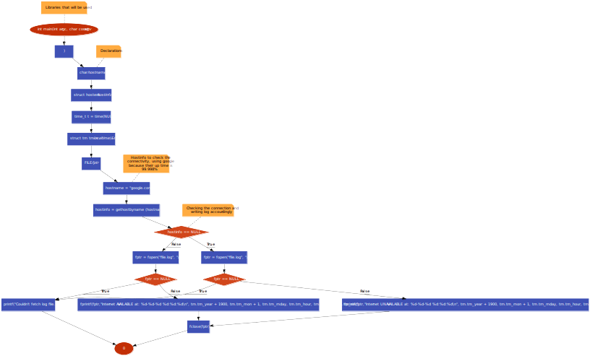
ALGORITHM:-

1. START
2. Use libraries argc, const
3. Declare variables *hostname, hostent *hostinfo, time t_t = time(null), tm_tm = *localtime(&t), FILE *fptr

4. Hostinfo to check the connectivity(Using google because its up time is 99.998%)
hostname=google.com
hostinfo=gethostbyname(hostname)

5. if (hostinfo == NULL) fptr = fopen("file.log", "a")

if(fptr == NULL)
DISPLAY Couldn't fetch log file.
else
DISPLAY Internet unavailable at that date and time.

6. else

fptr=fopen(“file.log”, “a”)
if(fptr==NULL)
DISPLAY Couldn't fetch log file.
else
DISPLAY Internet available at that date and time.

7. STOP

Some Screenshots of Running the program and its output:-
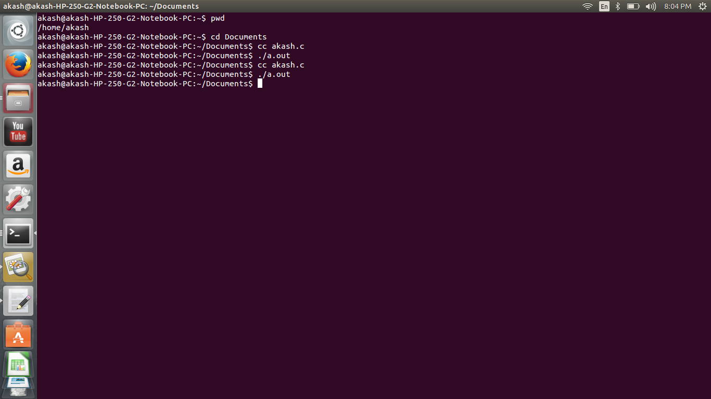
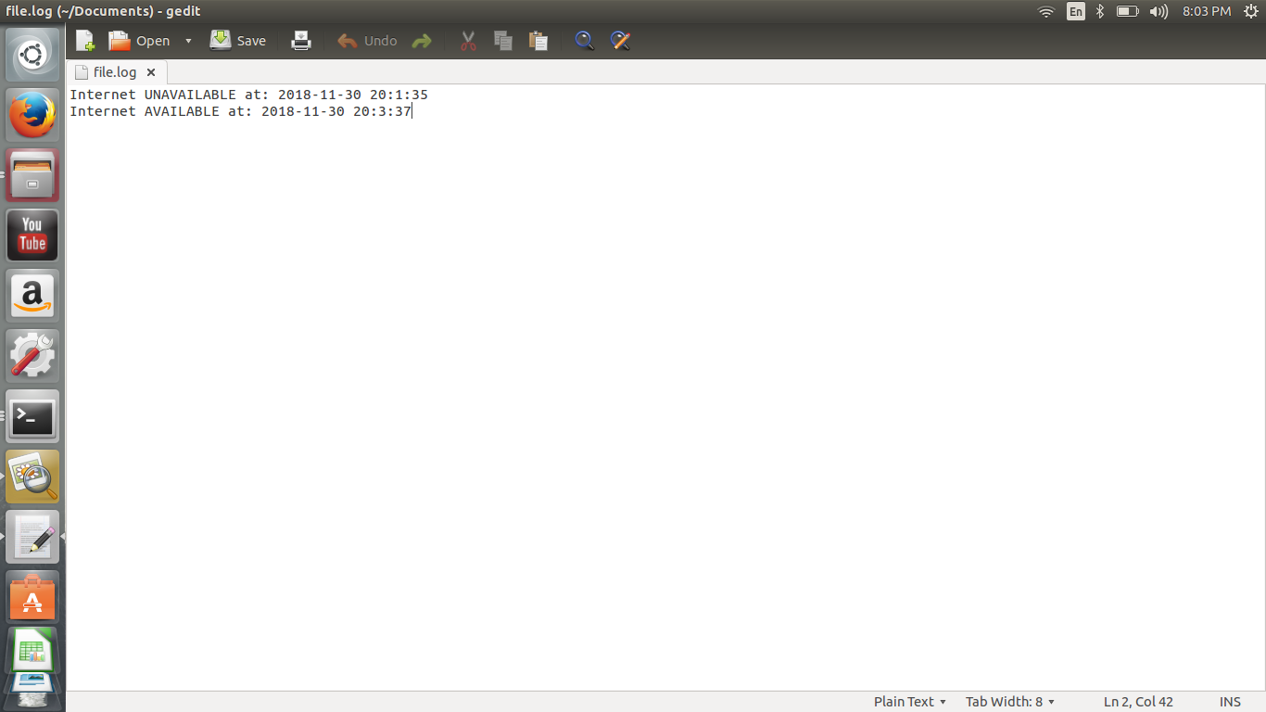

OBJECTIVE OF PROGRAM:- In this program we have to check whether the device is connected to the internet or not.

Made by:-
1).Akash Deep Choudhary (70-CSE-18)
2).Arjun Singh (65-CSE-18)
3).Sourav Kumar Sharma (75-CSE-18)
4).Abhishek Raina(83-CSE-18)
5).Rishab Verma(87-CSE-18)

____________________***********************************************______________________

