A Project Report

On

Online Voting System

Submitted in partial fulfilment of the requirements

For the Award of the degree of

Masters of Computer Application

in

Session: 2021-2022

By

(Akashdeep Chand – 20MCA1411,
Abhishek Gupta – 20MCA1319,
Pooja Sharma – 20MCA1377)

Supervised By

Ms. Amandeep Kaur

Assistant Professor/Project Coordinator,

Chandigarh University


University Institute of Computing

CHANDIGARH UNIVERSITY, GHARUAN, MOHALI, PUNJAB, 140413

Project Coordinator Head-UIC

2021-2022
TABLE OF INDEX

- Introduction
- Gaps of existing system
- Features of the project
- Objective of the project
- Scope of the project
- Proposed Methodology
- Tools, Hardware and Software Specification
- Planning and Requirement Gathering
- Software Requirement Specification
- Feasibility Study
- Data Flow Diagram
- Work Progress as per timeline
- Expected Outcome
- Reference

INTRODUCTION

The word ‘vote’ means a formal choice in an election or at a meeting, which you show by holding up your hand or writing on a piece of paper and election is a formal group decision making processes by which a population chooses an individual or multiple individuals to hold public offices and party. Elections have been the usual mechanism by which modern representative democracy has operated since the 17th century. Elections may fill offices in the legislature, sometimes in the executive and judiciary, and for regional and local government. This process is also used in many other private and business organisations, from clubs to voluntary associations and corporations. Every citizen's vote is, important, counted during the polling procedure. One single vote can be a game-changer and decisive element if the people are evenly divided between two contenders. We've seen how one MP's vote may determine the government's demise in the past. In the same way, a single person's vote can determine whether an aspiring MP or MLA wins or loses.
Online Voting System is an online voting technique which is highly usable nowadays and demanding too. In this system people can simply register the portal and then vote the party they want and the user interface is very simple, so that anyone can easily vote without going to any public place. Nowadays, the COVID-19 pandemic has led to dramatic loss of human life worldwide and presents an unprecedented challenge to public health. So, people have to maintain social distancing and take care of their health and we are keeping this situation in mind. Our system is very helpful in this situation, there is no need to go out of home.

GAPS OF EXISTING SYSTEM

- Expensive and Time Consuming
- Too much paper work
- Errors during data entry
- Loss of registration forms
- Short time provided to view the voter register
- There are no real-time results
- Number of voters end up being locked out from voting

FEATURES OF THE PROJECT

Existing.
- You can easily vote using your phone and System.
- Easy registration and login.
- Change your password anytime.
- Simple interface.

Unique
- Responsive user-friendly interface
- Can see Real-Time result.
- Can create new poll by users.

OBJECTIVES OF THE PROJECT

The specific objectives of the project include:

- Reviewing the existing/current voting process or approach in Chandigarh.
- Coming up with an automated voting system in Chandigarh.
- Implementing an automated/online voting system.
- Validating the system to ensure that only eligible voters are allowed to vote.

SCOPE OF THE PROJECT

As this website provides better way of election between voter and political parties. We provide a better interface experience. Hence, we suppose that this project has a greater scope and its important requirement is to provide a compact and stable system of voting with a facility through online.

PROPOSED METHODOLOGY

Brief overview of the technology:

- Front-end: HTML, CSS, Bootstrap 5 and JavaScript
  - HTML: It is used to create and save web document.
  - CSS: For creating attractive Layout of the webpage.
  - Bootstrap 5: Used for user friendly, responsive design and mobile friendly site
  - JavaScript: it is a programming language, commonly use with web browsers.

- Back-end: PHP, MySQL
  - PHP: Hypertext Pre-processor (PHP) is a technology that allows software developers to create dynamically generated web pages, in HTML, XML, or other document types, as per client request. PHP is open-source software.
  - MySQL: MySQL is a database, widely used for accessing querying, updating, and managing data in databases.

TOOLS, HARDWARE AND SOFTWARE SPECIFICATION

Hardware Requirements:
- Minimum:
  - Processor: Intel dual-core
  - Processor Speed: 2.0 GHz
  - Ram: 2 GB
  - Hard Disk: 128GB HDD
- Recommended:
  - Processor: Intel i3 or above
  - Processor Speed: 2.2 GHz or above
  - Ram: 4 GB or above
  - Hard Disk: 256GB HDD/128 SSD

Software Requirements:
- Front-end:
  - Visual Studio Code v1.59
  - Notepad/Notepad++
- Back-end:
  - Database- MySQL 8.0.26
  - Testing by- XAMPP Server
- Browser:
  - Google Chrome/Firefox Mozilla/Microsoft Edge/Any browser with newer version

PLANNING AND REQUIREMENT GATHERING

Online Voting Machine is very demanding project as government needs this project.
But the problems that come along with it are not a strange fiction, problems like encryption, security, low bandwidth, pixelated videos, video lagging, audio disruption and unexpected freezing are very real. These problems need to be addressed.

SOFTWARE REQUIREMENT SPECIFICATION

- Minimum:
  - Processor: Intel dual-core
  - Processor Speed: 2.0 GHz
  - Ram: 2 GB
  - Hard Disk: 128GB HDD
- Browser:
  - Google Chrome/Firefox Mozilla/Microsoft Edge/Any browser with newer version

SYSTEM ANALYSIS AND FEASIBILITY STUDY

. A web development project requires a comprehensive evaluation of its technical requirements, the implementations plans & roadmaps, company & customers readiness, legal & cultural issues & timescale.
The feasibility analysis asks that why should your web app project be given the green signal?

What is a possible analysis of web application?
Feasible analysis of a web application includes a clear understanding of the application. This research is related to the design and development of a web application to enable prospective web developers to efficiently assess the feasibility of a proposed project and enhance their learning of feasibility analysis.

What are the primary objectives of the feasibility analysis?
The primary objective of this is to present a feasibility study scheme that enables system analysts to verify the preliminary essentials established by the idea innovator and to generate other genuine user’s requirements.
Major well – being of the feasibility study is it helps in the guesswork (to a certain degree) out of the website launch. Hence avoiding any surprises during Web app development/launch.
A complete study of the project concerning input, processes, output, fields, programs, and procedures.
Feasibility analysis evaluates the web development project’s potential for success; therefore, perceived objectivity is an essential factor in the credibility of the study for potential investors and lending institutions.
There we have mentioned the five area of feasibility analysis examines…
Technical feasibility: Analysis of technical resources available in the organizations concerning the project requirement comes under technical feasibility. Technical feasibility analysis helps web development companies to find out the technical resources meet the capacity and evaluates the hardware, software and other technical requirements.
Legal Feasibility: Analysis of the laws and actions related to the project comes under Legal, feasible analysis. This analysis investigates whether any aspect of the proposed project conflicts with legal requirements like data protection acts, social media laws, etc.
Economic Feasibility: Analysis of costs, benefits of the project fall under Economic feasibility. Economic feasibility helps web development companies to find out the viability, cost, and benefits related to a project before financial resources are allocated.
Operational Feasibility: Analysis of the operations that the Web App Development Company adopts to perform the completion of the project falls under operational feasibility. This assessment involves the study to analyse and determine whether and how the Web App development company needs can be met by completing the project.
Scheduling Feasibility: This is the important one for the project success because a project will fail if not completed on time. Under scheduling feasibility, the company decides the time duration that how much time the project will take to complete

DATAFLOW DIAGRAM

The data flow diagram(DFD) is a graphical tool used for expressing system requirements in a graphical form. The DFD also known as the “bubble chart” as the purpose of clarification system requirements and identification major transformation that will become program in system design. Thus DFD can be stated as the starting point of the design phase that functionality decomposes the requirements specification down to the lowest level of details. The DFD consists of series of bubble joined by lines. The bubble represents data transformation and the lines represents the data flows in the system. A DFD describes what data flow is does not to construct a Data Flow Diagram, we use

• Arrow: An arrow identifies the data flow in motion. It is a pipeline through which information is flow like the rectangle in the flowchart.
• Circle: A circle stands for process that converts data into information
• Open End Box: An open ended box represents a data store, data at rest or a temporary repository of data.
• Squares: A square defines a source or destination of system.

Level 0
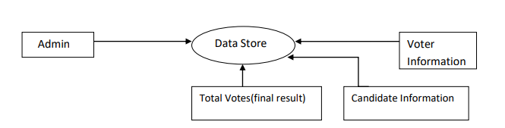

Level 1
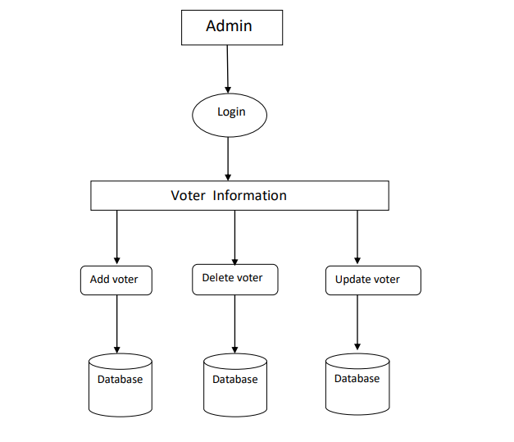

E-R Diagram

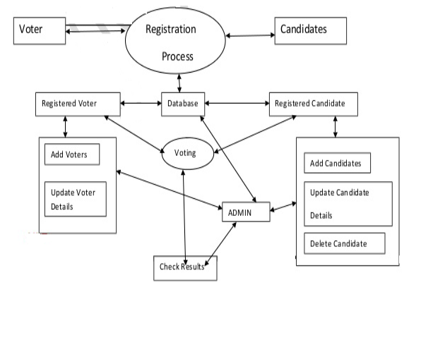

WORK PROGRESS AS PER TIMELINE

Task | 15Aug -25Aug | 27Aug -10Sept | 11sept-10oct | 11oct- 12oct | 13oct-15oct
Proposal Designing | 5 days
Analysis &  Front end Designing |  | 14 days
Backend coding |  |  | 30 days
Testing |  |  |  | 2 days
Implementation |  |  |  |  | 3 days

EXPECTED OUTCOME

Result is considered as the E-Voting system which will work in online mode. Anyone can easily vote here and they can easily create their parties and check the real-time votes. By online voting system percentage of voting is increases. It decreases the cost and time of voting process.

REFERENCES

[1] YouTube: https://www.youtube.com/watch?v=3x697N7sHl8

