SecureIt : Complete Web Sceurity chrome extension

Abstract
CSRF is an attack that forces an end user to execute unwanted actions on a web application in which he/she is currently authenticated. With a little help of social engineering (like sending a link via email or chat), an attacker may force the users of a web application to execute actions of the attacker's choosing. A successful CSRF exploit can compromise end user data and operation, when it targets a normal user. If the targeted end user is the administrator account, a CSRF attack can compromise the entire web application.

CSRF relies on the following:
- Web browser behavior regarding the handling of session-related information such as cookies and http authentication information
- Knowledge by the attacker of valid web application URLs
- Application session management relying only on information which is known by the browser
- Existence of HTML tags whose presence cause immediate access to an http[s] resource; for example the image tag

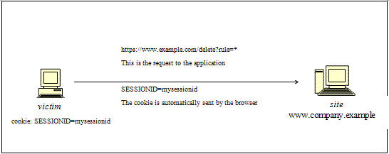
Figure 1 : How a Cross Site Request Forgery (CSRF) works

Security Threats : Current scenario

37% | Cross-site scripting
16% | SQL injection
5% | Path disclosure
5% | Denial-of-service attack
4% | Arbitrary code execution
4% | Memory corruption
4% | Cross-site request forgery
3% | Data breach (information disclosure)
3% | Arbitrary file inclusion
2% | Local file inclusion
1% | Remote file inclusion
1% | Buffer overflow
15% | Other, including code injection (PHP/JavaScript), etc.

About SecureIt
It is extension to the hacktab security tests chrome extension for CSRF; deploying CSRF testing methods for checking whether a site is CSRF vulnerable or not. It will be helpful for developers, QA and Pen testers.
Further work
There is a scope for AI algorithms in generalising and making web 2.0 (and ahead) secure.

References :
[1]Testing for CSRF (OTG-SESS-005) https://www.owasp.org/index.php/Testing_for_CSRF_(OTG-SESS-005)

[2]Web Security
http://en.wikipedia.org/wiki/Web_application_security

