|  |
| --- |
| Indian institute of technology, bombay |
| CL 716 - Modelling Chemical and Biological Patterns |
| Bifurcation analysis of nonlinear reaction-diffusion equations |
|  |
|  |
| **30-Mar-15** |

|  |  |
| --- | --- |
|  |  |
|  |  |
| Akash Deep Singhal | 11D020024 |
| Amit Kumar Agarwal | 11D020014 |
|  |  |
|  |  |

|  |
| --- |
| **Abstract** The theoretical expressions are limited to the neighborhood of the marginal stability point. Computer simulations allow not only the verification of their predictions but also the investigation of the behavior of the system for larger deviations from the instability point. |

**Introduction**

The general ideas underlying the theory of dissipative structures have been illustrated on a simple model system involving the following set of coupled chemical reactions:

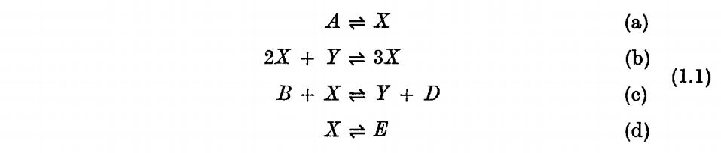

the system is open to the initial and final chemicals A, B, D and E, whose concentrations are imposed throughout the system; nonlinearity is introduced by the auto- and cross-catalytic steps (b) and (c);

We analyze some properties of the dissipative structures arising in nonlinear reaction-diffusion systems, within the framework of this model. Assuming a bounded, one-dimensional medium, the rate equations describing (1.1) are:

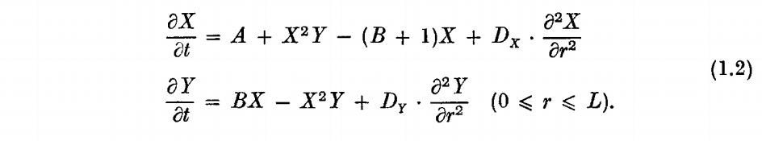

where D x and D r are the diffusion coefficients of X and Y assuming that Fick's law is valid. Two types of boundary conditions will be considered:

1. Zero flux boundary conditions (Neumann conditions):



2. Fixed boundary conditions (Dirichlet conditions):



**MATLAB Code**

The Matlab code consists of four files:-

**The main script file**

function pdex4

m=0; %slab

r=linspace(0,pi,100);

t=linspace(0,200,100);

sol=pdepe(m,@pdex4pde,@pdex4ic,@bc2fn,r,t);

disp(sol);

u1 = sol(:,:,1);

u2 = sol(:,:,2);

figure

surf(r,t,u1)

title('X(r,t)')

xlabel('Distance r')

ylabel('Time t')

figure

surf(r,t,u2)

title('Y(r,t)')

xlabel('Distance r')

ylabel('Time t')

**Boundary condition definition file**

Note: Two types of boundary conditions will be considered:-

1. Zero Flux Boundary Conditions (Neumann conditions)
2. Fixed Boundary Conditions (Dirichlet conditions)

function [pl,ql,pr,qr]=bc2fn(xl,ul,xr,ur,t)

% Constants

A = 2;

B = 0.4; %NOT GIVEN | TO BE CHANGED

% Case 1:- Zero Flux Boundary Conditions (Neumann conditions)

pl= [0;0];

ql=[1;1];

pr =[0;0];

qr =[1;1];

% Case 2:- Fixed Boundary Conditions (Dirichlet conditions)

% pl = [A; B/A];

% ql = [0; 0];

% pr = [A; B/A];

% qr = [0; 0];

**Initial condition definition file**

function u0 = pdex4ic(r);

c1 = 10;

c2 = 10;

L = 1;

u0 = [c1*cos(pi*r/L); c2*cos(pi*r/L)];

**The PDE solver file**

function [c,f,s] = pdex4pde(r,t,u,DuDr)

% Diffusion Coefficients

Dy = 1.6*10^(-3);

Dx = 8.0*10^(-3);

% Constants

A = 2;

L = 1;

u1 = u(1);

u2 = u(2);

B = 3.7; %NOT GIVEN | TO BE CHANGED

c = [1; 1];

f = [Dx; Dy] .* DuDr;

% Rate equations describing the phenomenon

s1 = A + u1^2*u2 - (B+1)*u1;

s2 = B*u1 - u1^2*u2;

% Linearized equations for the perturbation x and y

% s1 = (B-1)*u1 + A^2*u2;

% s2 = -B*u1 - A^2*u2;

s = [s1; s2];

**Numerical Analysis**

We use the simulation using MATLAB to verify the numerical results with the analytical ones. Following are the major numerical simulations:-

**Case 1**

All the equations are restricted to the constraint 0 ≤ r ≤ L and L is taken to be 1.

Also diffusion coefficients are taken to be:-

1. Dx = 1.6 x 10-3
2. Dy = 8.0 x 10-3

A = 2 and B = 3.7 for zero flux boundary condition

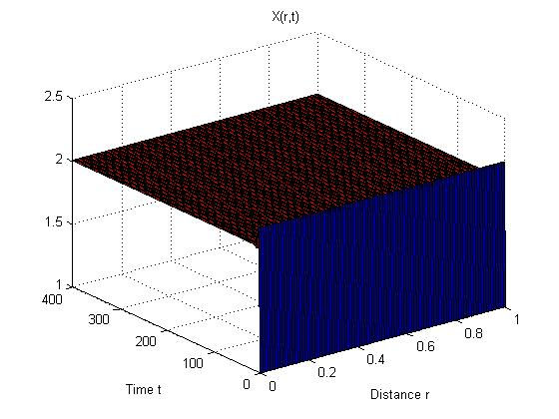

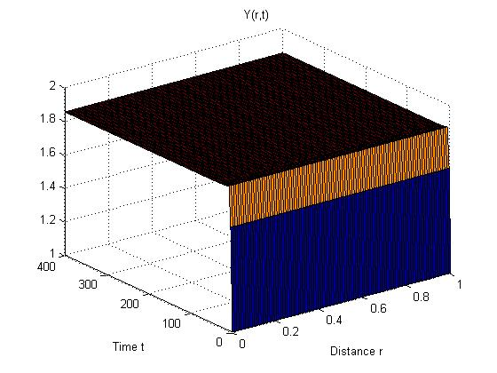

A spatio-temporal curve is plotted between X and Y vs distance ‘r’ and time ‘t’ resulting from solving the system numerically by simulating on MATLAB. Figure 1A: X vs distance ‘r’ and time ‘t’ for A=2, B=3.7, L=1, Dx = 1.6 x 10-3, Dy = 8.0 X 10-3. Figure 1B: Y vs distance ‘r’ and time ‘t’ for A=2, B=3.7, L=1, Dx = 1.6 X 10-3, Dy = 8.0 X 10-3.

**Case 2**

All the equations are restricted to the constraint 0 ≤ r ≤ L and L is taken to be 1.

Also diffusion coefficients are taken to be:-

1. Dx = 8.0 x 10-3
2. Dy = 1.6 x 10-3

A = 2 and B = 3.7 for zero flux boundary condition

­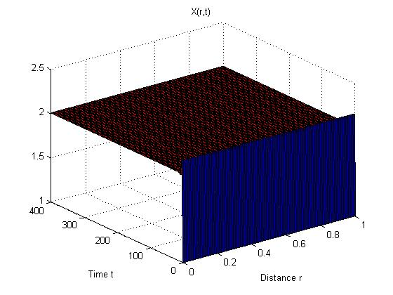

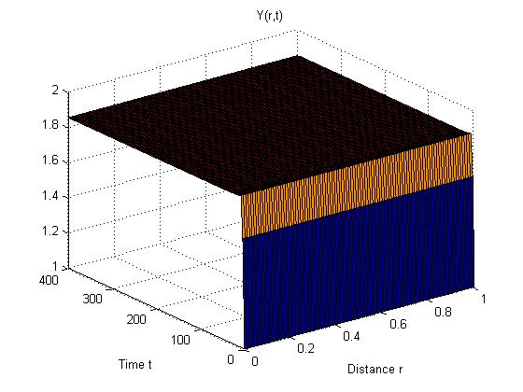

A spatio-temporal curve is plotted between X and Y vs distance ‘r’ and time ‘t’ resulting from solving the system numerically by simulating on MATLAB. Figure 2A: X vs distance ‘r’ and time ‘t’ for A=2, B=3.7, L=1, Dx = 8.0 x 10-3, Dy = 1.6 x 10-3. Figure 2B: Y vs distance ‘r’ and time ‘t’ for A=2, B=3.7, L=1, Dx = 8.0 x 10-3, Dy = 1.6 x 10-3.

**References**

**J. F. G. Auchmuty and Nicholis G.** Bifurcation analysis of Nonlinear Reaction-Diffusion Equations - I [Journal]. - [s.l.] : Bull. Math. Biology, 1974. - Vol. 37.

**Kaufman M. Herschkowitz** Bifurcation analysis of non-linear reaction-diffusion equations - II [Journal]. - Belgium : [s.n.], 1975. - Vol. 37.

**Murray J. D.** Mathematical Biology [Book]. - Vol. II.

Solving Initial-Boundary value problems for parabolic-elliptic PDEs in 1-D [Online] // Mathworks India. - http://in.mathworks.com/help/matlab/ref/pdepe.html.