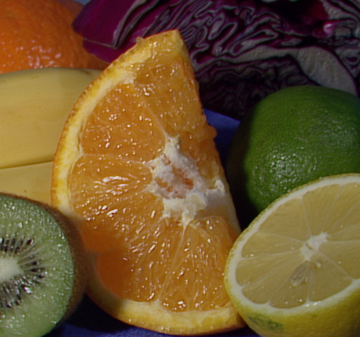Program 1: I found my min and max L in window, then the L values were stretched between 0 and 100 in the whole image based off min and max of window. My window is 0.3 0.3 0.7 0.7. You can see that the Luv image looks brighter around the orange. The window is centered in the image.

Original Image

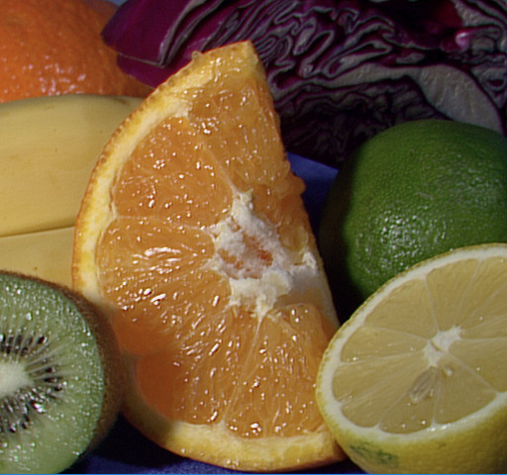

Luv Image with specified window

Program 2: Histogram Equalization. I have a window of 0.3 0.3 0.7 0.7. I found my min and max L, then stretched my L values between 0 and 100 in the window. Then I made my look up table. I used the total number of pixels in the window in my calculation. Then I converted the entire image to Luv and stretched the values between 0 and 100 using the min and max from my window. Then used the look up table made from the window to preform equalization. (I rounded L to nearest integer in discretization.)



Original Image

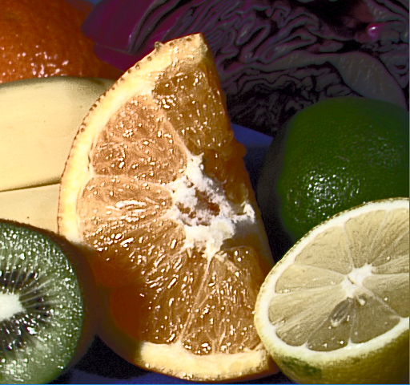

Histogram Equalization using Window