

Module: CET 313 ARTIFICIAL INTELLIGENCE

Name: Akash Dhital

Student ID: **219305860**

Centre: University of Sunderland

Local Centre: ISMT COLLEGE(Nepal,Kathmandu)

# E-Portfolio Documentation

**Below is a link to my e-portfolio.**

<https://canvas.sunderland.ac.uk/eportfolios/7761?verifier=8FXGyL91lwqh2C1xvimV11RbJ2Ygj6Zh4uzvTpHw>

# WEEK 1:

On the first week of Machine Learning I was introduced to python programming. In this tutorial I was taught where python programming language can be applied in real life applications such as stock market prediction, weather forecast prediction etc.

I was introduced to programming using google colab which acts an online IDE for python. In this first tutorial I was taught how to make comments in python as they provide useful reminders of what you are doing with the line or chunk of code you are developing.

I was also taught how to use variables in python as they are used to store information to be referenced and manipulated in a computer program**.** the screen shot below shows how variables are used in python.

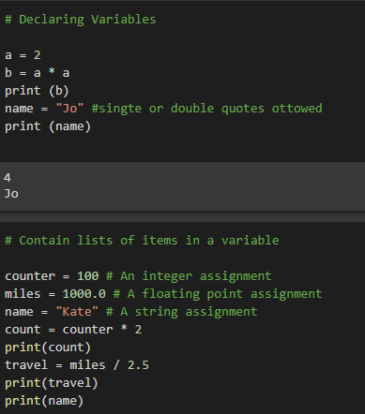

I learned how to use the following using python.

1. Arrays

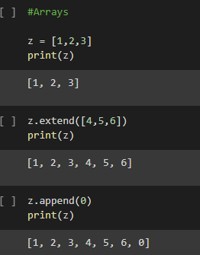

1. 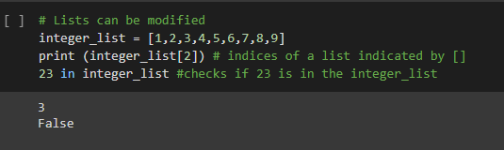Lists
2. 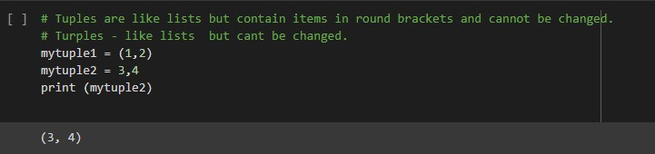Turples
3. 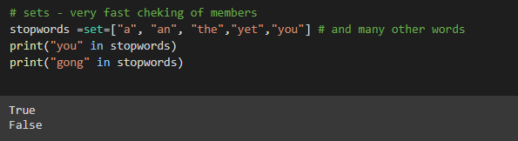Dictionaries
4. Functions

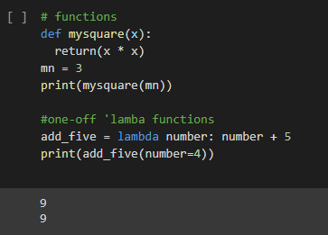

1. 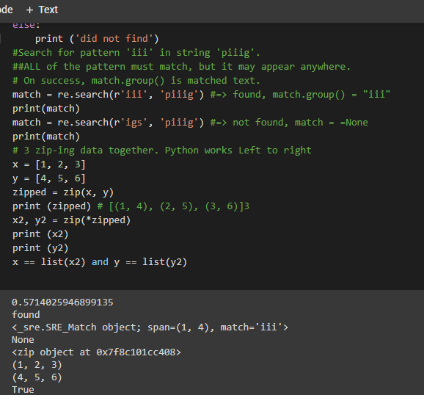Random
2. Classes

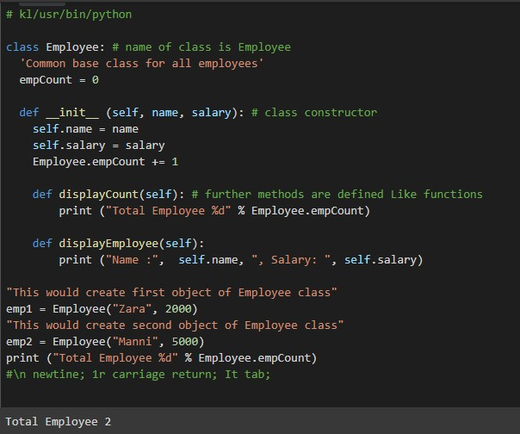

I managed to create a simple conversion between Fahrenheit and centigrade.

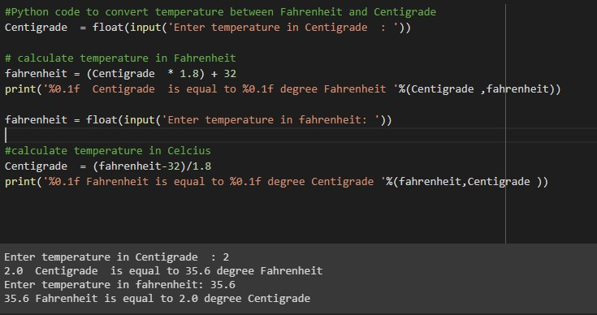

I managed to create a simple program to average any number of numbers.

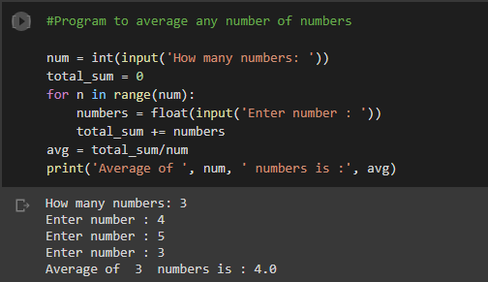

I was given a research to discuss the possible techniques being used to deliver solutions in my chosen application area, its impact on society and any associated ethical implications.

# WEEK 2:

In week 2 I was introduced to artificial intelligence logic. I was able to install logpy and sympy using the pip install command. The next thing was to import the relationship.json to work with relationships.

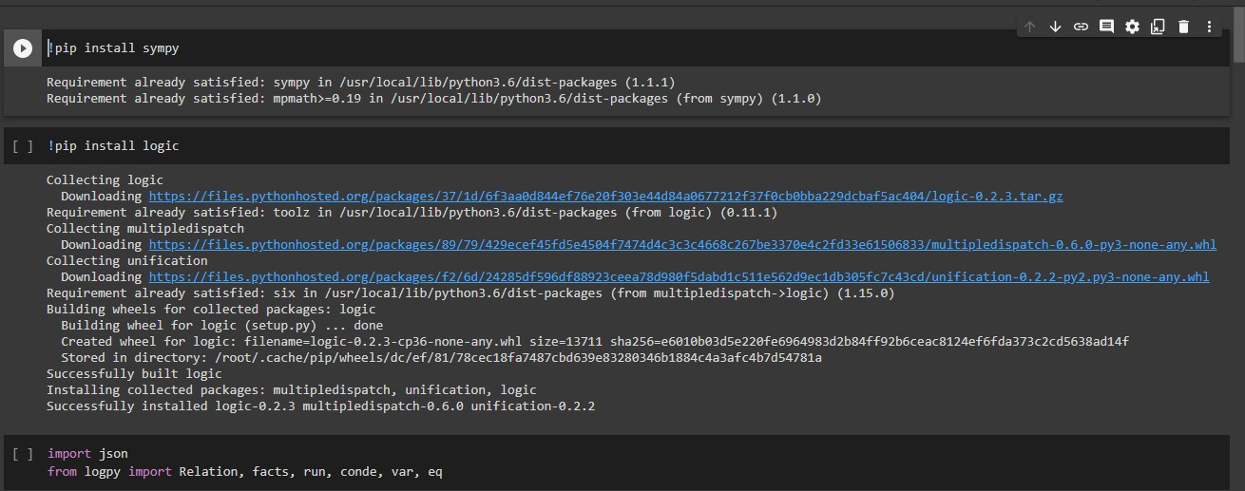

I was able to:

* 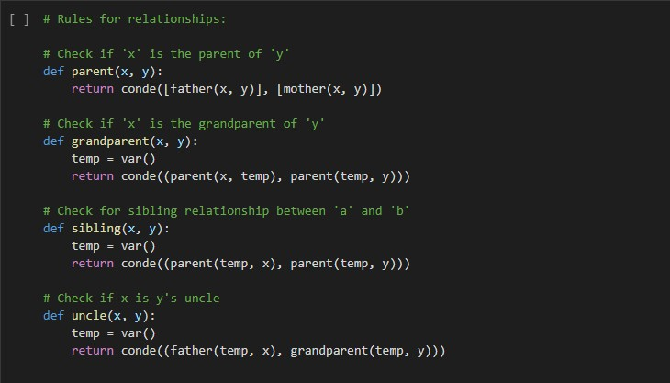Define some rules for relationships.
* access the file and set parental relationships.

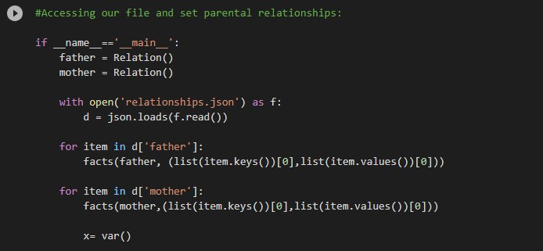

* Run a set of further queries on the information using the relationships i defined earlier in the code.

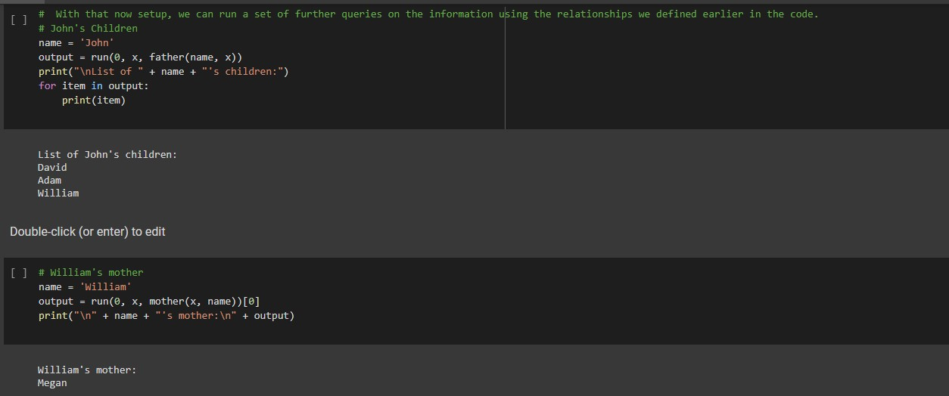

# Week 3:

Using the A* algorithm to solve a maze.

I first had to import the necessary packages shown below:



I then had to create a class that contains the method needed to solve the problem.

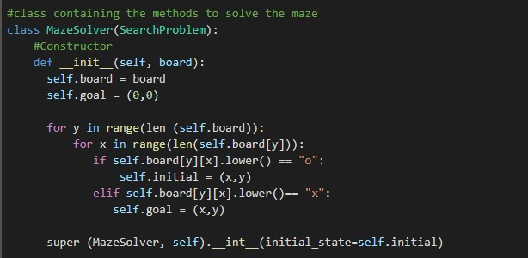

I then defined the method that takes action to arrive at the solution using the code below.

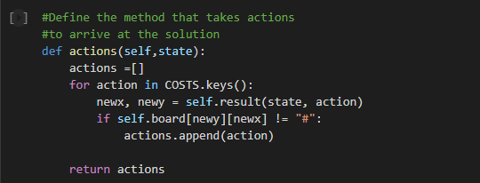

I then updated the state basing on the action.

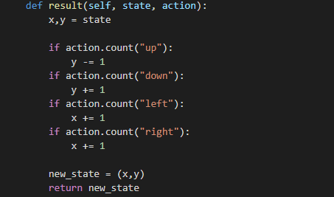

To check if I have reached the goal, I used the code below.



To compute the cost of taking the action, I used the code below.



Below is the heuristic used to arrive at the final solution.

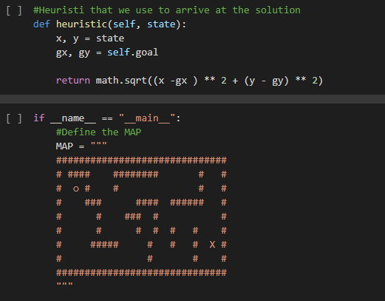

I did some background research on the search algorithms and methods proposed and produced a scenario where each one might be used and a set of pros and cons for each of them.

# Week 4

Natural language in python processing

Firstly I imported all packages from nltk.book using the following command.

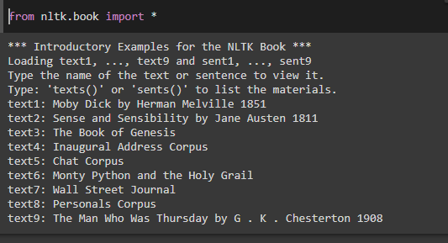

I used the codes below to look at other words used in the same or similar context by using similar**.**

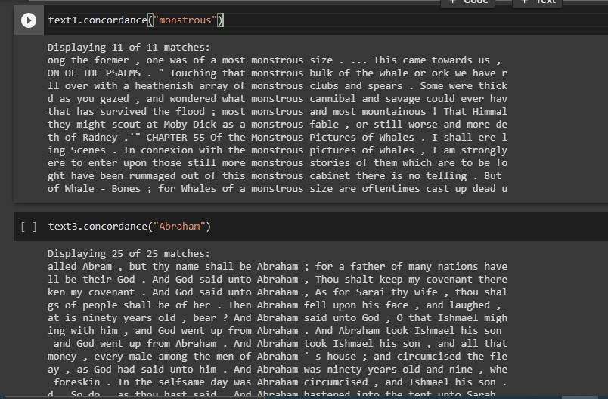

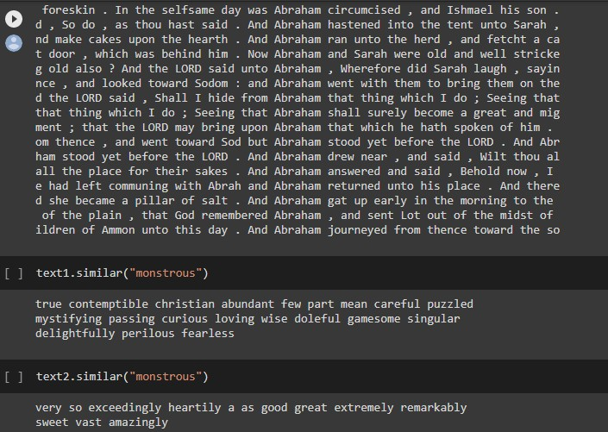

The following codes were used to determine the length of the texts.

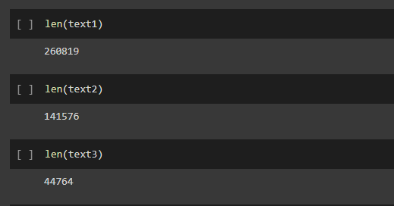

I was able to Create a function using **def** and use it on one or more of the texts.

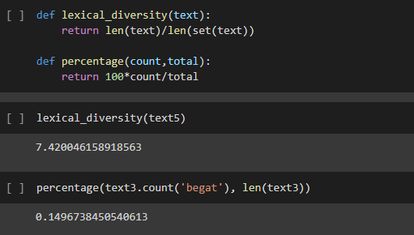

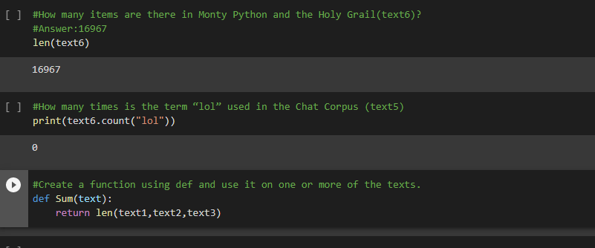

# Week 5

On the fifth week I was given a task to create a **chatbot** from scratch using the python programming language.

Firstly, I had to import the following packages to create a chatbot.

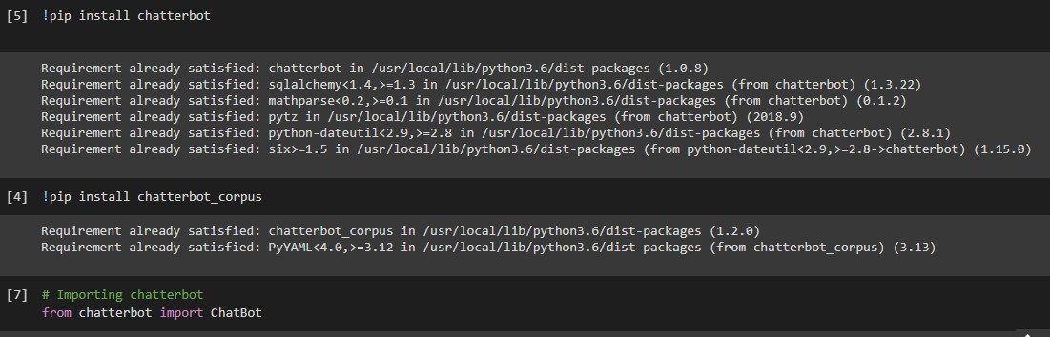

Creating an object of chat bot class.



Create object of chatbot class with storage adapter.

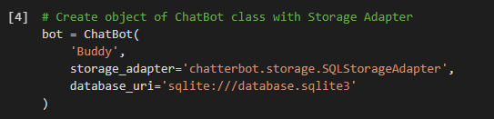

Create object of chatbot class with logic adapter.

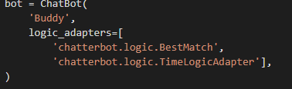

Importing list trainer

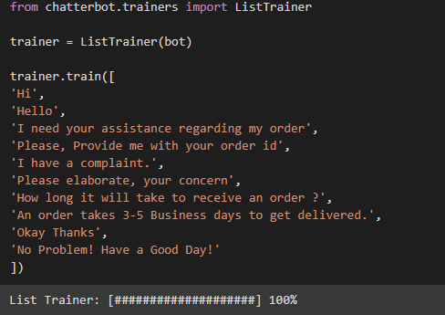

Get a response to the input text.

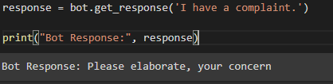

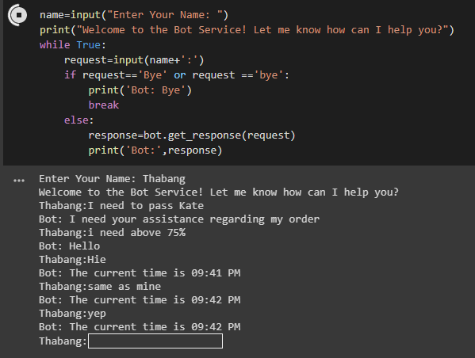

# Week 6

in week six I learned how to work with WEKA, the aim was to predict whether tomorrow’s weather will be good to play football using a sample of 14 weather samples based on outlook,

temperature, humidity, wind and when the game did play. I used the naive-bayes algorithm to calculate probabilities.

# Week 7

I developed a simple regarding Artificial Neural Network as shown by the screen shot below.

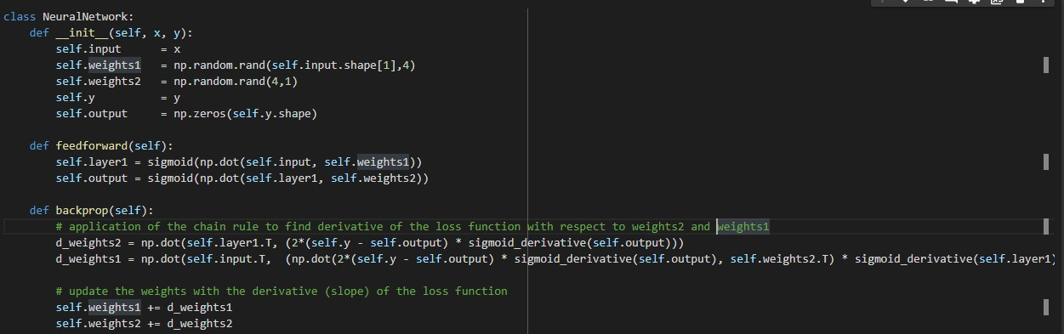

I was given a task to research about the speech recognition and uploaded the research on e-portfolio.

# Week 8

I was given a task to download the dataset from Kaggle.com and display the:

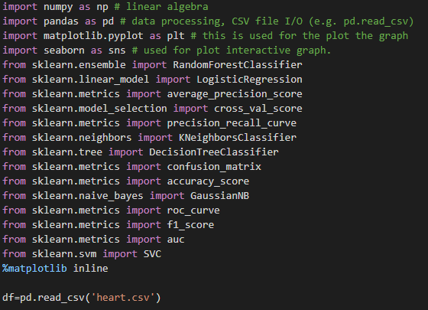

**Shape** of the data set

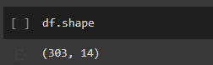

The first **30 rows** of the dataset

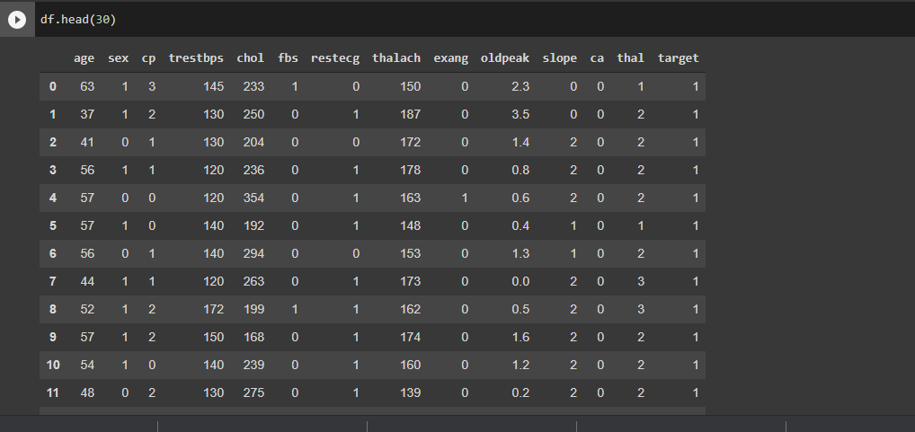

A **description** of the dataset.

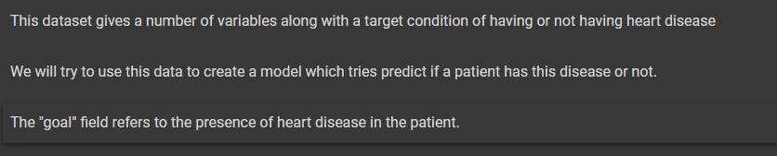

I was also requested to Create a **histogram** for elements of the dataset.

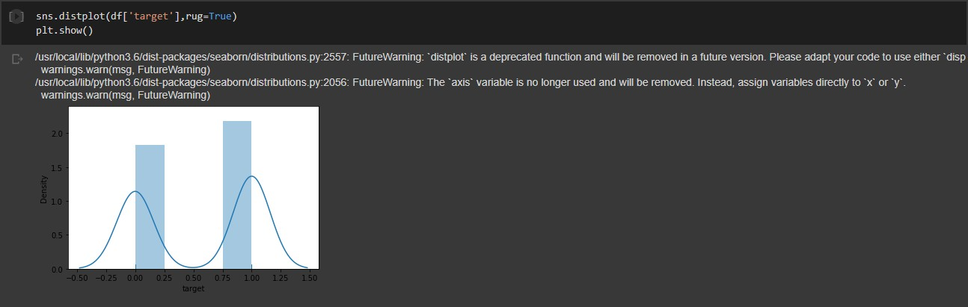

I was requested to conduct a research regarding machine learning clustering algorithms and list the best use for each of the algorithms found, which was then uploaded on e-portfolio.

# Week 9

I was requested to build my own neural network by which the code was uploaded to e-portfolio. Below is the screen shots of the code.

Importing necessary packages and loading the dataset

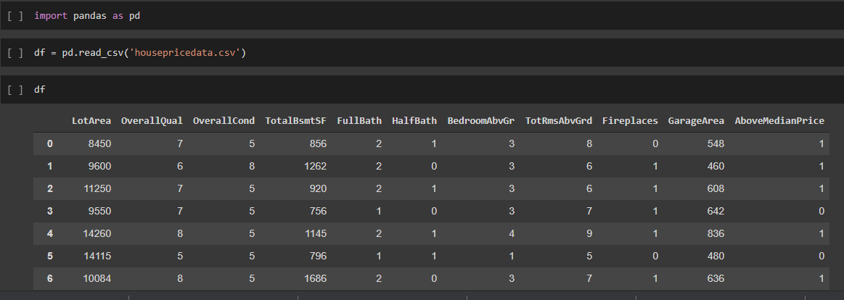

Converting the dataset to array from pandas dataframe.

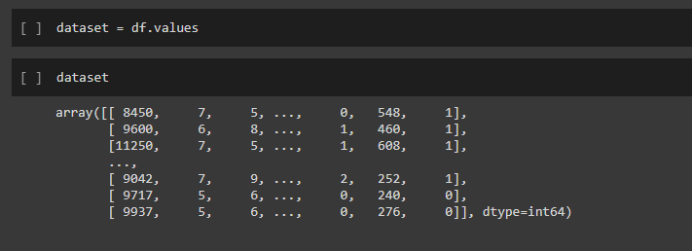

Splitting the dataset into input features and labels I wish to predict.



Normalizing data to arrange input features on the same order of magnitude and make training easier.

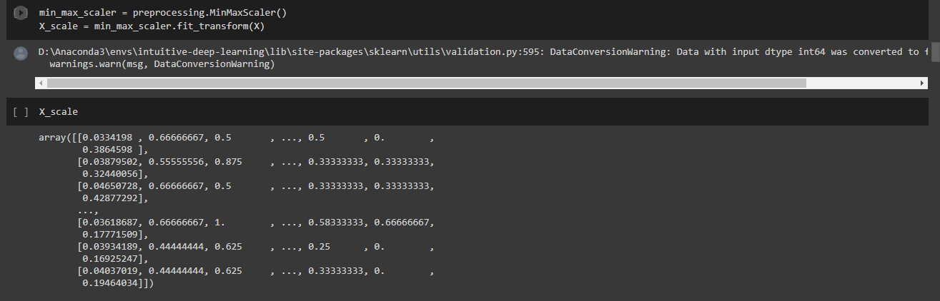

Setting aside some parts of the dataset for a validation set and a test set.

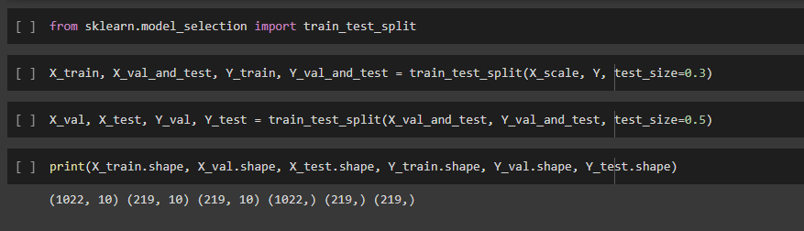

Building and training the first neural network

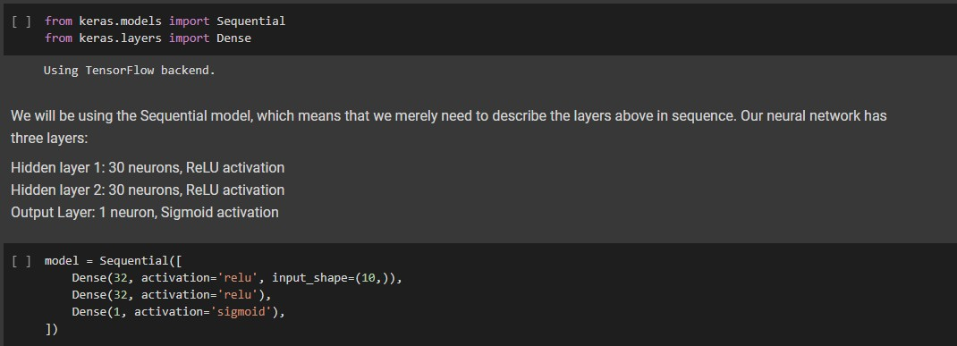

Configuring the model

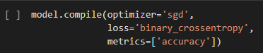

The following function will output a history, which is saved under the variable list.

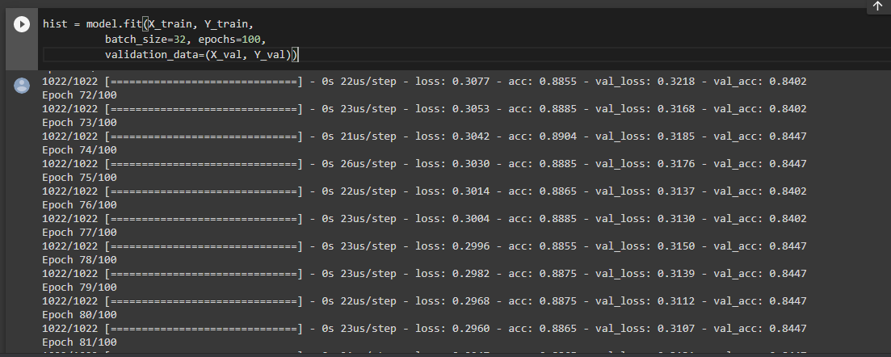

Evaluating data on the test set.

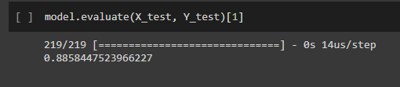

Visualizing loss and Accuracy

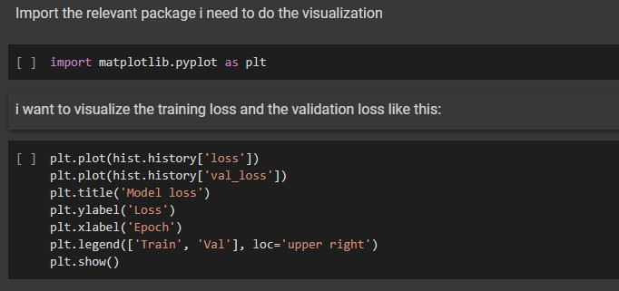

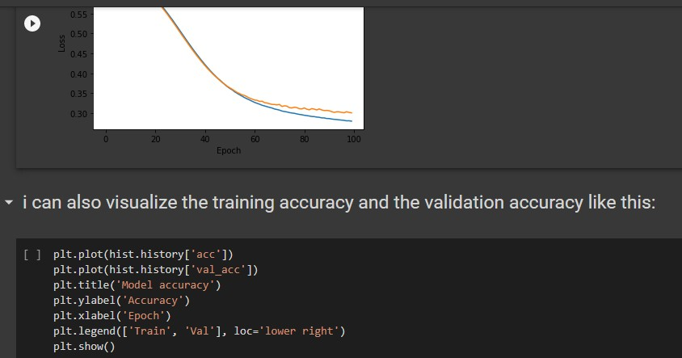

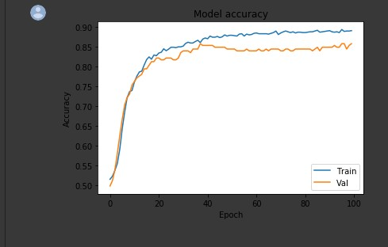

I was also given a task to find an interesting application of an Artificial Neural Network, then compile a short info regarding its use, success/ failure, type of ANN it Is and its interest. The document was the uploaded to e-portfolio.

# Week 10

The following are screenshots of activities done in week 10.

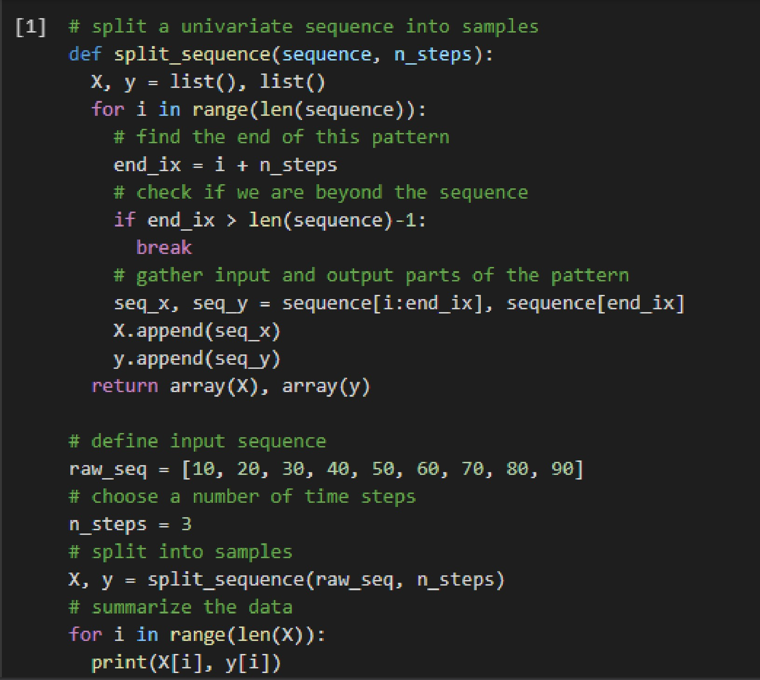

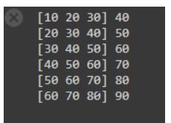

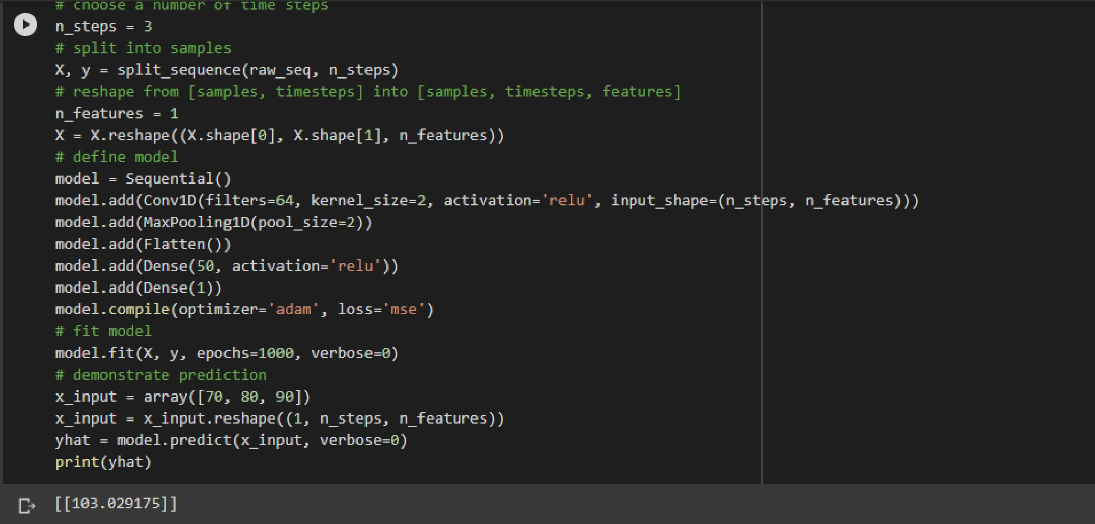

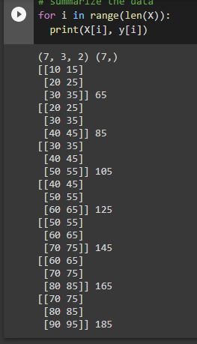

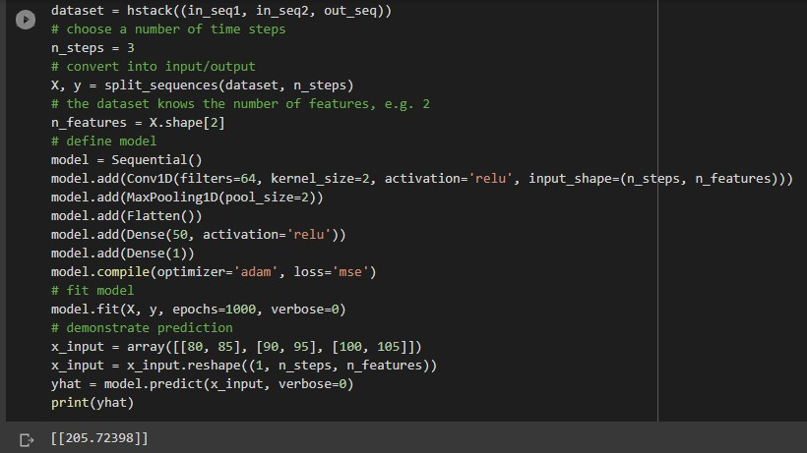

# Week 11

In week 11 I watched a video of a Turing test where two chatbots were chatting and arguing like humans. I was able to learn that machines can also imitate human behavior.

