Uber Driver Dashboard
Supporting Document
Product: Uber · User Persona: The Driver
Prototype
Click here to access the interactive prototype
The driver-facing app is designed for glanceable, at-a-red-light decisions and is presented in the driver’s language (Hindi). The screens below are captured from the working prototype.
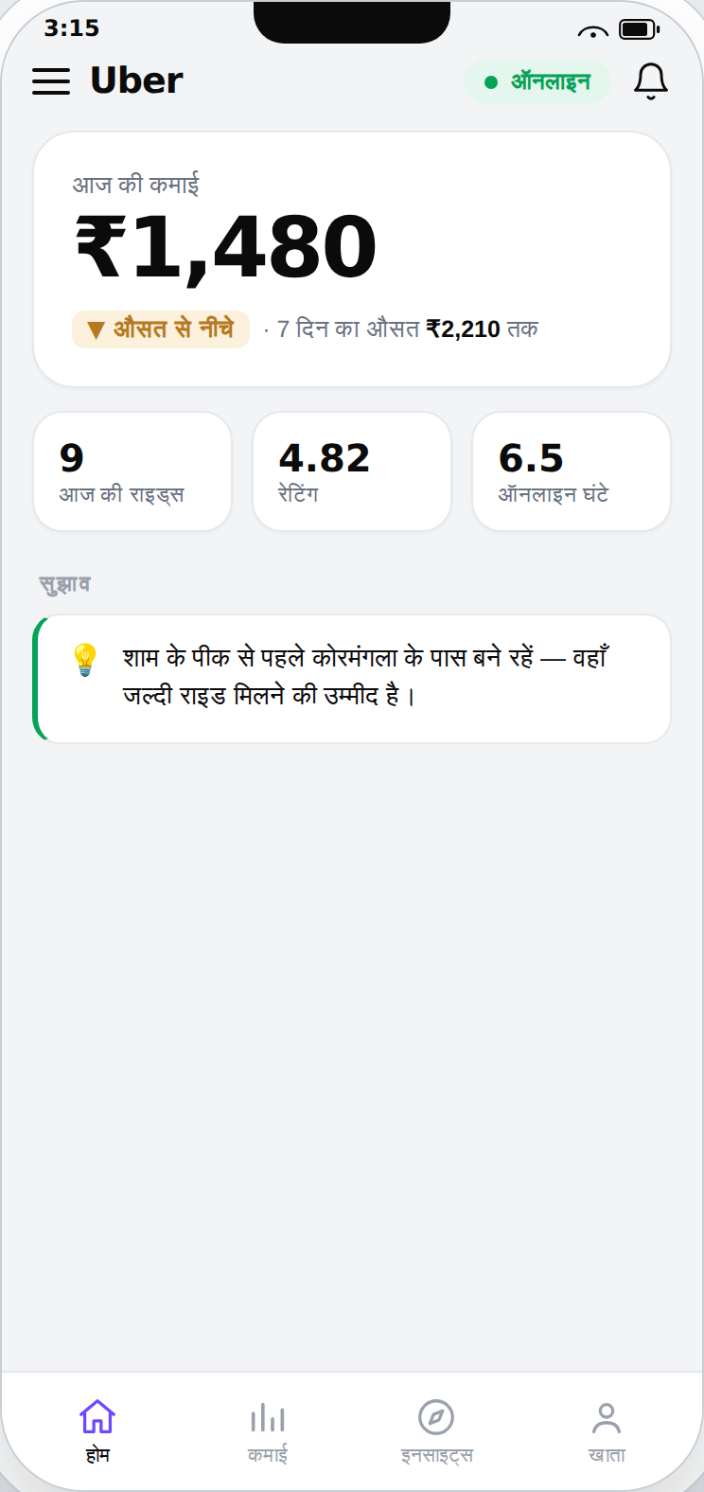  Home — today’s earnings & pace | 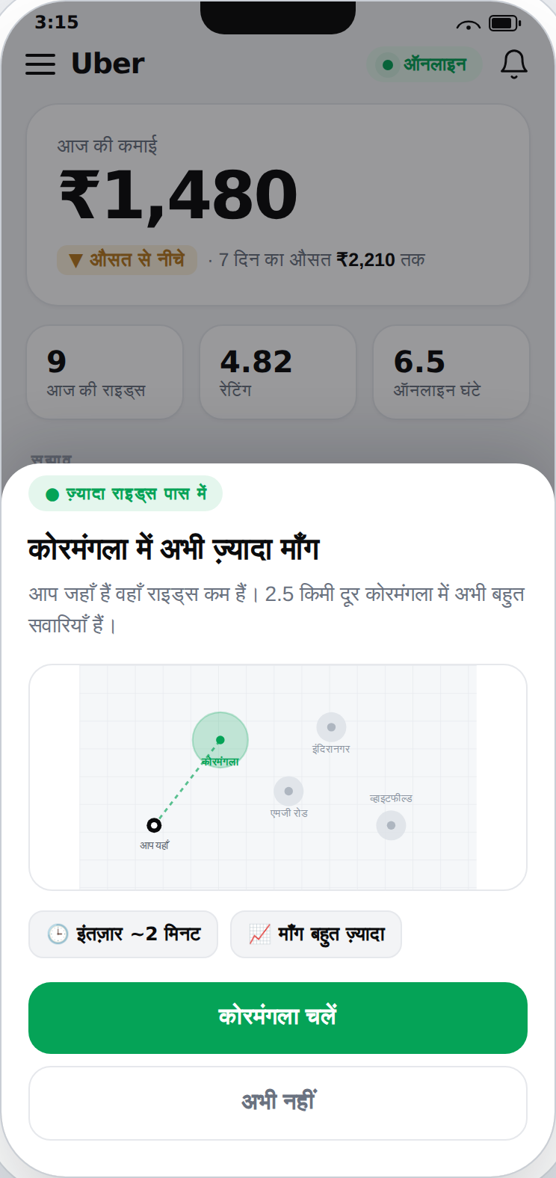  Hotspot tip (map) | 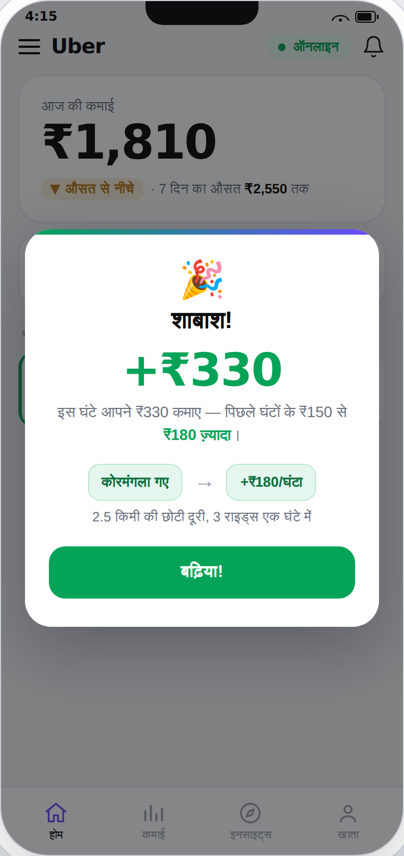  Earning tied to the action

Objective
Help drivers earn more for the time they are online.
Personas
- New driver
- Part-time driver
- Full-time driver
For this case study I’ll choose the full-time driver, since they spend the most hours on the platform and impact the business the most.
Jobs to be Done
Earn more money by providing more rides to customers.
North Star Metric
Earnings can be defined as:
- Earnings per ride
- Earnings per day
- Earnings per hour
We’ll proceed with earnings-per-hour as our North Star Metric (NSM).
Why not earnings per ride
From a driver’s perspective, if earnings-per-ride were the NSM, the driver would only wait for big-ticket rides; cancelling or not accepting small-distance rides would affect their reputation on the platform and hamper their earnings. Hence this is ruled out as the NSM.
The business perspective
Uber, on the other hand, would want to optimize for more rides taken through the platform. It can’t control the demand, but controlling the supply would help bring the demand to the platform. To maintain predictability of the supply, it’s important to keep the drivers engaged on the platform by providing them rides consistently throughout their working shift. Providing them rides in bursts risks them losing to the competition during the slack hours. Hence, optimizing to provide more rides per hour would mean more earnings for the driver and Uber.
Why per hour, not per day
Earnings is a lagging metric, so for a driver, attributing a decision to a resulting earning is more accurate on a per-hour basis than on a per-day basis, where value realization would only happen at the end of the day, without the ability to pinpoint which specific decisions led to higher earnings. Since earnings-per-hour brings value realisation closer to the calls a driver makes during the day, it fits better as the NSM. Moreover, the definition of a full-day shift may vary across drivers and could be anywhere between 9–14 hours. Hence, optimizing for earnings per hour makes more sense than per day, as some days might experience slack demand.
Benchmarking against the driver’s own history
Earnings per hour can be benchmarked for the driver against their own past ride data, to help them see how they are faring against how they did before using the insights and tips provided by the Uber dashboard.
Showing a driver’s earnings leaderboard based on benchmarks would lead to unhealthy competition amongst drivers and harm the platform in the long run. Hence, we will avoid such benchmarking.
How the NSM is used
One note on the NSM: we don’t want it to be a target that drivers aspire to during the day. It would be used internally to help drivers earn more, through insights, tips and nudges (the secondary metrics). The NSM would act as a suggestive direction (not a specific figure), based on demand conditions and on drivers with similar demographics (cab type, zones worked, shift timings, ratings, duration on the platform, etc.), and would augment the secondary metrics. This number might vary from week to week, or even day to day, impacted by factors beyond the driver’s control.
Secondary Metrics
To provide more rides, Uber has to consistently place drivers in hotspots (to get rides faster and reduce their idle time) or move them to high-surge areas (to make extra money). Demand varies through the day, so when a driver goes online also affects their earnings. Hotspots, Surge alerts and Shift timings can be tracked as the secondary metrics for the driver. It’s also important for Uber to manage the supply by showing these tips to fewer drivers; otherwise hotspots may turn into coldspots, the surge may die, or no drivers remain available during low-demand shifts.
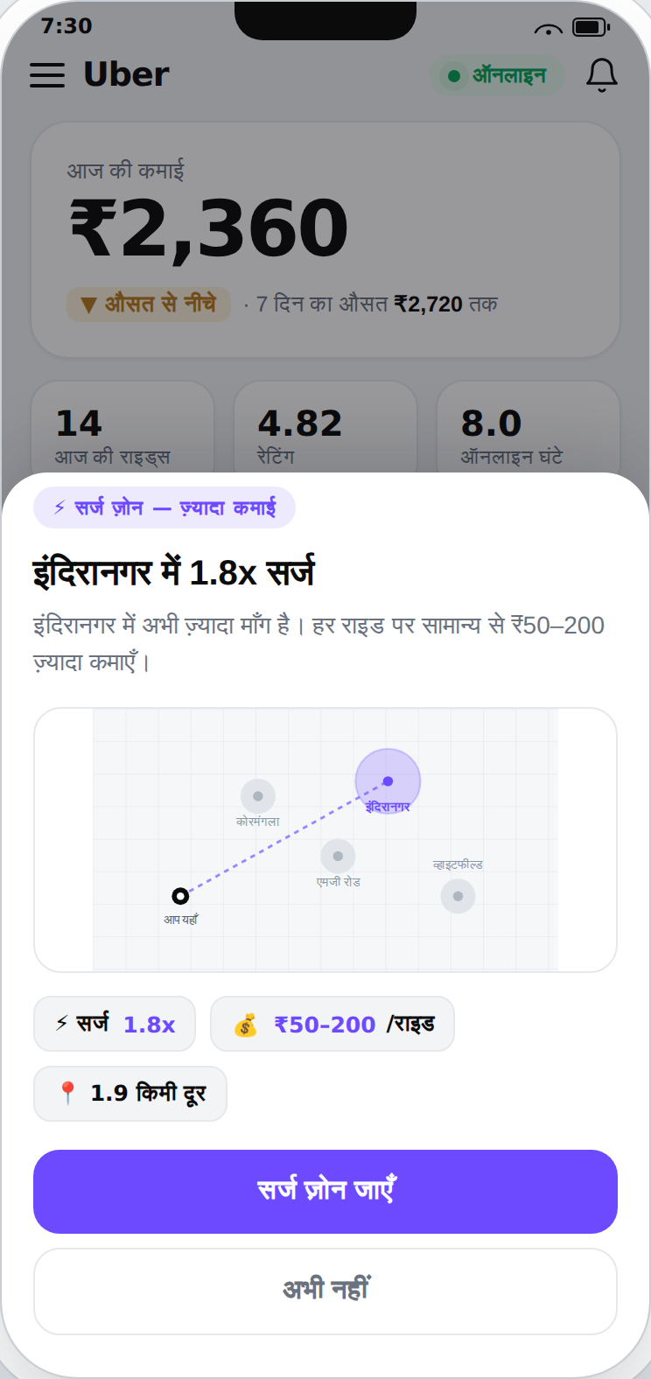
Surge alert — the extra earning shown in rupees, on a map
Guardrail Metric
In the pursuit of earning more, a driver may work longer shifts. This is not sustainable for Uber in the long run, as this unhealthy behaviour risks the lives of the rider and the driver alike. To discourage it, the driver can be shown their number-of-hours-online. When a driver crosses a 10-hour shift (a ceiling that would differ for each driver, based on their past data), they’ll see the number in red, with a note to sign off and rest, explaining how not doing so would affect both the rider’s experience and the driver’s own wellbeing. Here, the number of hours online works as the guardrail metric.
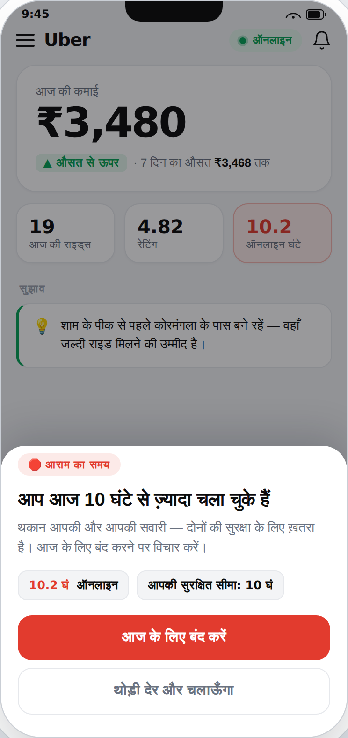
Guardrail — hours turn red past the driver’s personal ceiling, with a rest nudge
User Experience Degradation
A lower ride acceptance rate, more cancellations (by the driver or for the driver), or a sliding rating all degrade the user experience and may push demand to the competition.
Penalizing the driver by simply offering fewer rides only lowers driver supply, again pushing demand to the competition. The fix is a behaviour change by the driver, towards both the platform and the rider.
Behaviour change
Insight: “Did you know a low acceptance rate, more cancellations, or a sliding rating can leave fewer rides available for you?”
Prototype: Show the message above, followed by the ride acceptance / cancellation rate and the 7-day rolling user rating.
This improves the ride experience for the rider and keeps demand on the platform.
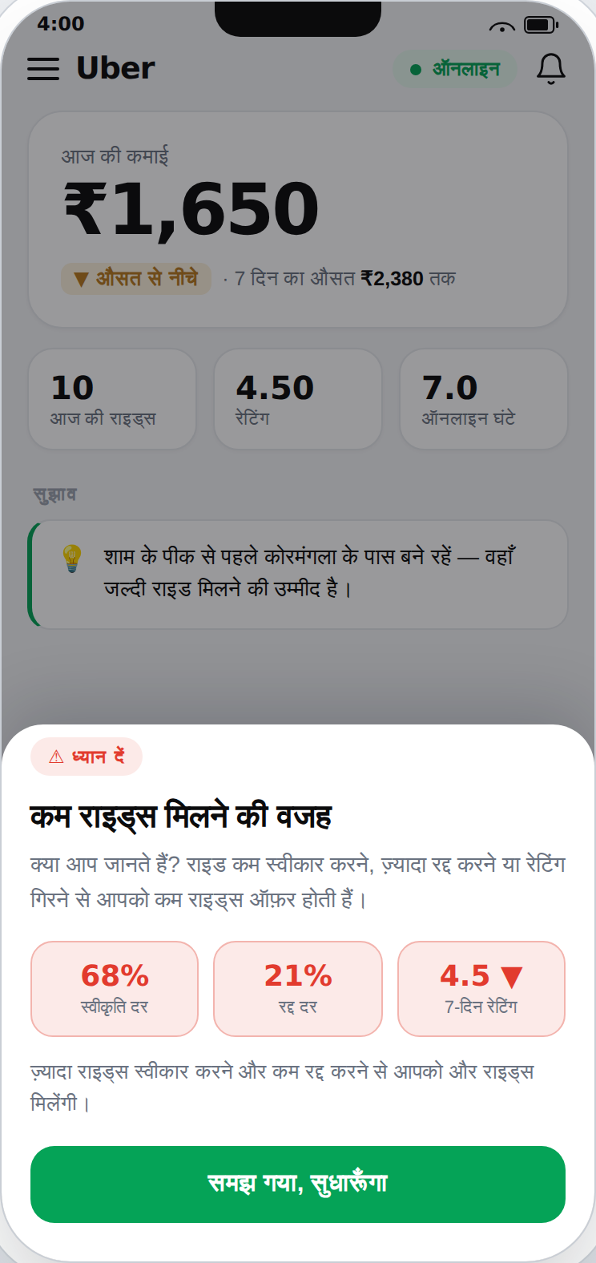
Behaviour-change insight — the hidden link between behaviour and ride offers
Driver Activation (Slow Shift → Use Driver Dashboard)
If a driver experiences a slow shift, that’s when they can be activated, using the right triggers.
If a driver is having a slow shift due to low earnings (benchmarked against the driver’s own 7-day rolling average, or other drivers’ cumulative 7-day rolling average), three factors can be analysed to help activate them:
- Parking in cold zones → not getting rides quickly, resulting in longer idle times
- Missing the surge → a missed opportunity to make extra money
- Low demand → the driver may be online during a low-demand shift
Instead of showing fixed stats, the driver can be shown messages like these:
- “It seems you’ve received fewer rides this afternoon. The partner dashboard can help you find hotspots to get rides quickly.”
- “Serving in surge zones can help you earn an extra ₹50–200 per ride. Check our surge alerts on the partner dashboard.”
- “You might want to adjust your shift timings. Due to sporting events in the city, there’s high demand after 10:00 pm. Check our partner dashboard for high-demand shifts.”
A slow shift can also stem from factors beyond the driver’s position or shift timing. For instance, demand could genuinely be low across the city on a particular day, or at a particular time of day. We have to account for these false-positive slow shifts before triggering the activation flow for a driver.
Activation Flow
Slow shift (below the 7-day rolling average) → Reason (cold zone, missed surge, or online during low demand) → Use these tips → More earnings (day’s earning above the 7-day rolling average) → Activation
Dashboard Experience
Drivers are not data analysts, and they often make quick decisions (where to park, whether to head to a surge zone) on the move, sometimes at a red light. Tracking these five metrics — one NSM, three secondary, and one guardrail — should be enough to help them earn more on the platform. And they should be presented as insights or tips, in the driver’s language, rather than a dashboard of graphs and figures.

