CAN-Based Intelligent Bus Accident Prevention and Automatic Braking System using LPC2129

E.AKASH B.E-EEE

TABLE OF CONTENTS
- Abstract
- Introduction
- Literature Survey
- System Architecture
- Hardware Components and Explanation
- Block Diagram
- Working Methodology
- Software Implementation
- Results and Discussion
- Conclusion and Future Scope
- References

ABSTRACT
Road accidents in public transport systems are primarily caused by delayed human reaction, inadequate obstacle detection, and lack of coordinated electronic control. This project proposes a Controller Area Network (CAN) based intelligent accident prevention and automatic braking system using the LPC2129 ARM7 microcontroller.
The system consists of multiple Electronic Control Units (ECUs) connected via CAN bus. An obstacle detection ECU measures distance using an ultrasonic sensor. A speed monitoring ECU calculates vehicle speed. A central decision ECU computes collision risk and automatically applies braking using a DC motor control mechanism when unsafe conditions are detected.
The distributed CAN architecture ensures reliable real-time communication, reduced wiring complexity, and improved system scalability. The system demonstrates enhanced safety performance and faster reaction time compared to conventional driver-dependent braking systems.

COMPONENTS
- Microcontroller (LPC2129)
- CAN Controller
- CAN Transceiver (MCP2551)
- Ultrasonic sensor (HC-SR04)
- Pulse Width Modulation (controlling speed)
- DC motor
- LCD Display(16x2)

Microcontroller – LPC2129
Specification:
- 32-bit ARM7TDMI-S core
- Up to 60 MHz clock frequency
- Dual CAN 2.0B controllers (on-chip)
- PWM module for motor control
- Multiple GPIO, UART, SPI, I2C interfaces
Role in Project:
- Acts as the main ECU
- Measures ultrasonic echo timing
- Processes speed and distance data
- Calculates collision risk
- Generates PWM signal for braking control
- Handles CAN communication

CAN Controller (Internal to LPC2129)
Specification:
- Fully compliant with CAN 2.0B
- Supports standard (11-bit) and extended (29-bit) identifiers
- Hardware message filtering
- Automatic error detection & retransmission
Role in Project:
- Frames and transmits distance/speed data
- Receives messages from other ECUs
- Performs arbitration and ensures real-time communication
Note: External CAN controller is not required since LPC2129 includes built-in CAN modules.

CAN Transceiver – MCP2551
Specification:
- High-speed CAN transceiver (up to 1 Mbps)
- Converts TTL logic to differential CAN signals (CANH & CANL)
- Short-circuit and thermal protection
Role in Project:
- Interfaces LPC2129 CAN controller to physical CAN bus
- Provides noise immunity
- Enables reliable communication between ECUs

4 Ultrasonic Sensor – HC-SR04
Specification:
- Operating Voltage: 5V
- Measuring Range: 2 cm – 400 cm
- Frequency: 40 kHz
Working Principle:
Distance=(Time × Speed of Sound) / 2
Role in Project:
- Detects obstacle distance in front of vehicle
- Sends echo pulse width to LPC2129
- Used for collision risk calculation

Pulse Width Modulation (PWM)
Generated by: LPC2129 PWM module
Purpose:
- Controls DC motor speed
- Reduces duty cycle when obstacle distance decreases
- Stops motor completely during brake condition
Function in Project:
- Simulates automatic braking mechanism

DC Motor
Specification:
- 6V–12V DC motor (for prototype)
- Controlled using motor driver (e.g., L293D)
Role in Project:
- Represents vehicle movement
- Speed reduced or stopped based on PWM control
- Demonstrates automatic braking functionality

LCD Display – 16×2 Alphanumeric Display
Specification:
- Display Type: 16 characters × 2 lines
- Controller: HD44780 compatible
- Operating Voltage: 5V
- Interface Mode: 4-bit / 8-bit
- Backlight: LED

📌 Role in Project
The 16×2 LCD is used to display real-time system parameters such as:
- Measured Distance (cm)
- Vehicle Speed
- Brake Status (“BRAKE APPLIED”)
- System Messages (CAN OK / WARNING)
It provides visual feedback to the driver or system operator.

DISPLAY

SPEED
ULTRA
SONIC SENSOR

ECU-1

ECU-2

ECU-3

CAN_H CAN_L

CAN_H

RT CAN_L

BLOCK DIAGRAM OF CAN

ECU 1 – Obstacle Detection ECU
- Ultrasonic Sensor
- Sends Distance via CAN

ECU 2 – Speed Monitoring ECU
- Speed Sensor
- Sends Speed via CAN

ECU 3 – Decision & Control ECU (Main ECU)
- Receives data
- Calculates collision risk
- Applies braking
PROJECT EXPLANATION (WORKING PRINCIPLE)

Step 1: Distance Measurement
The HC-SR04 ultrasonic sensor continuously measures the distance between the vehicle and any obstacle in front.
It sends an ultrasonic pulse and calculates the echo return time. The LPC2129 computes the distance using:
Distance=Time × Speed of Sound) / 2
This value is sent to the decision ECU via CAN.

Step 2: Speed Measurement
Vehicle speed is measured using:
- Timer-based pulse counting (from a wheel sensor), or
- Potentiometer simulation (for prototype testing)
The measured speed is processed by the microcontroller and transmitted through the CAN bus.

Step 3: CAN Communication
Each ECU transmits its data over the CAN network using unique identifiers:
Parameter | CAN ID | Data Size
Distance | 0x100 | 2 bytes
Speed | 0x200 | 1 byte
The CAN protocol ensures reliable, real-time communication between ECUs.

Step 4: Collision Risk Calculation
The main ECU compares the received distance and speed values.
Collision condition:
If Distance < (Speed × Reaction Time)
If the measured distance is less than the calculated safe stopping distance, the system identifies a collision risk.
Example:
- Speed = 40 km/h
- Safe distance threshold = 20 cm
- If measured distance < 20 cm → Collision risk detected

Step 5: Automatic Braking
When collision risk is detected:
- PWM duty cycle is reduced gradually
- DC motor speed decreases
- If required, motor stops completely
- LCD displays: “BRAKE APPLIED”
This demonstrates automatic braking without driver intervention.

HARDWARE SETUP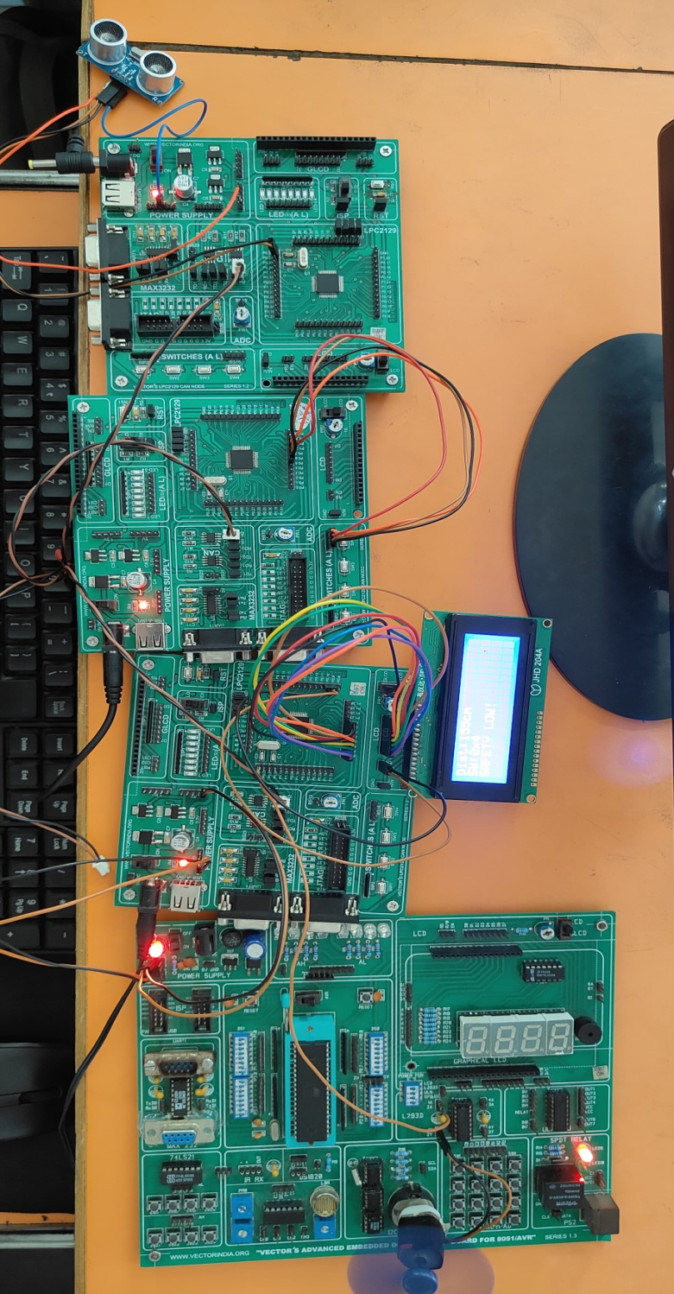

Observed System Behavior
- When obstacle is far → Motor runs normally.
- When obstacle distance reduces → Speed decreases.
- When distance < threshold → Motor stops.
- LCD shows “BRAKE APPLIED”.

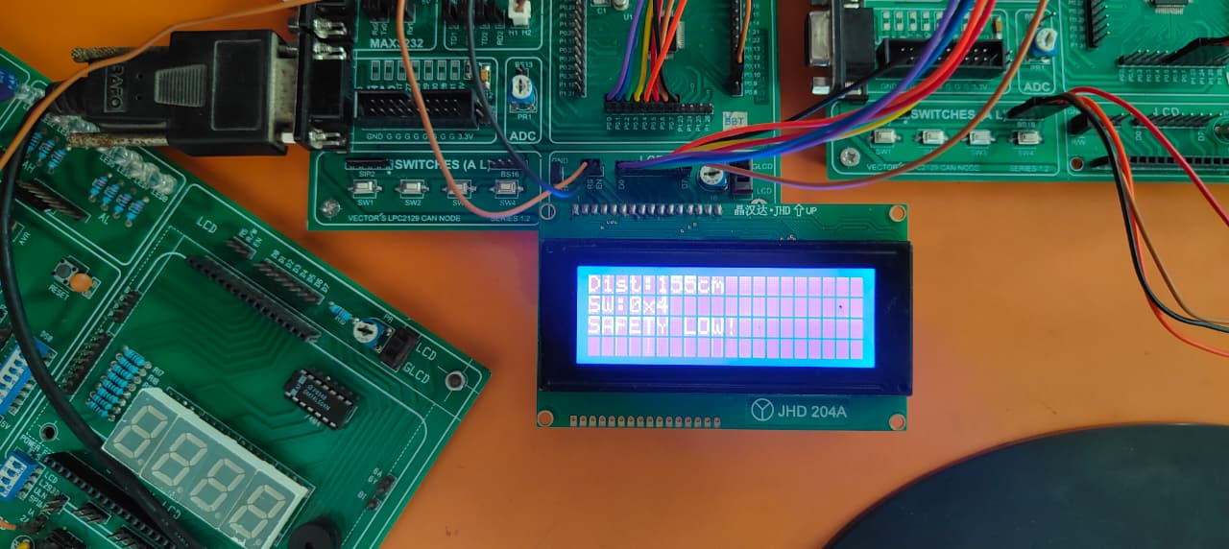

Advantages

Improved Road Safety
- Automatically detects obstacles and applies braking.
- Reduces dependency on driver reaction time.

Real-Time Communication
- CAN protocol provides fast and reliable data transfer between ECUs.
- Supports priority-based message arbitration.

High Noise Immunity
- Differential CAN signaling (CANH & CANL) reduces electromagnetic interference.
- Suitable for automotive environments.

Distributed Architecture
- Multiple ECUs reduce processing load on a single controller.
- System becomes scalable and modular.

Reduced Wiring Complexity
- CAN bus uses only two communication lines.
- Minimizes wiring compared to point-to-point communication.

Automatic Braking Mechanism
- PWM-based motor control enables smooth speed reduction.
- Prevents sudden jerks.

Cost-Effective Prototype
- Uses low-cost sensors and microcontroller.
- Suitable for academic and research purposes.

Disadvantages

Limited Sensor Accuracy
- Ultrasonic sensor may give errors in rain, dust, or uneven surfaces.
- Limited range compared to radar or LiDAR systems.

Reaction Time Approximation
- Collision calculation depends on predefined reaction time.
- Not dynamically adaptive to real driving conditions.

No ABS Integration
- System stops motor directly without anti-lock braking logic.
- Not suitable for high-speed real vehicles without further development.

Single Sensor Dependency
- Only front obstacle detection implemented.
- No side or rear detection.

Prototype-Level Implementation
- DC motor simulation does not fully represent actual vehicle dynamics.
- Real vehicle braking requires hydraulic integration.

Power Dependency
- System failure may occur if power supply becomes unstable.

CONCLUSION
- The proposed CAN-based intelligent braking system successfully demonstrates:
- Real-time obstacle detection
- Reliable multi-ECU communication
- Automatic braking without driver input
- Improved passenger safety
- The system can be extended for:
- ABS integration
- GPS-based speed control
- V2V communication
- AI-based collision prediction

REFERENCES
- Bosch, “CAN Specification Version 2.0,” 1991.
- W. Wolf, Computers as Components, Morgan Kaufmann, 2012.
- LPC2129 User Manual, NXP Semiconductors.
- K. Etschberger, Controller Area Network, IXXAT Press.
- IEEE Paper: “Design of CAN-Based Distributed Embedded Control Systems,” IEEE Transactions on Industrial Electronics.

THANK YOU

