BookNest – Digital Library

INTRODUCTION:
BookNest – Digital Library is a modern web-based library management platform developed to digitize and simplify the complete process of managing books, users, borrowing activities, reservations, returns, and library records. Traditional libraries often depend on manual registers, spreadsheets, or disconnected software applications to maintain information about books and borrowing transactions. These approaches can make it difficult for students and library staff to quickly identify available books, track borrowed books, monitor due dates, manage reservations, and generate meaningful reports.
BookNest addresses these challenges by providing a centralized digital platform where all major library operations can be managed through a single application. Library members can register and securely log in to the platform, browse the available book catalog, search for books using different criteria, view detailed information, check availability, borrow books, return books, reserve unavailable books, and monitor their borrowing history.
SCENARIO Based Case Study:
Scenario: Student Using BookNest
Consider a college student named Arun who wants to borrow a programming book from his college library.
Step 1 – Registration and Login
Arun creates an account in BookNest using his name, email, and password. After successful registration, he logs into the system.
Step 2 – Discovering a Book
Arun searches for a book using the search bar.
BookNest displays matching books along with:
- Book title
- Author
- Category
- ISBN
- Description
- Availability status
Step 3 – Checking Availability
Arun opens the book details page and sees:
Step 4 – Borrowing
Arun clicks the Borrow Book button.
BookNest creates a borrowing transaction containing:
- User
- Book
- Issue date
- Due date
- Transaction status
The book availability is automatically updated.
Step 5 – Returning the Book
After reading the book, Arun opens his borrowing history and selects Return Book.
The system records the return date and changes the transaction status to Returned.
The available copy count is updated.
Step 6 – Reserving an Unavailable Book
Suppose another student has already borrowed the book.
BookNest displays:
Currently Unavailable
Arun can click Reserve Book.
When the book becomes available, the reservation can be processed and the user can be notified.
Administrator Scenario
The librarian logs into the administrator dashboard and can:
- Add books
- Edit book information
- Delete books
- Manage authors
- Manage categories
- View users
- Manage reservations
- Monitor overdue books
- View library statistics
Therefore, BookNest provides a complete digital workflow from book discovery → borrowing → returning → reservation → history → administration.
SYSTEM REQUIREMENTS
Software Requirements
The following software tools are required for developing and running BookNest:
Operating System
- Windows 10/11
Development Environment
- Visual Studio Code
- Node.js
- npm
- Git
- GitHub
Frontend Technologies
- React.js
- React Router
- Redux Toolkit
- Axios
- Tailwind CSS
- HTML
- CSS
- JavaScript
Backend Technologies
- Node.js
- Express.js
- REST API
- JWT Authentication
- Mongoose
Database
- MongoDB
- MongoDB Compass
Optional Services
- Cloudinary for book-cover image storage
Hardware Requirements
Minimum Requirements
- Processor: Intel Core i5 / AMD Ryzen 5
- RAM: 8 GB
- Storage: Minimum 5 GB free space
- Internet connection for package installation and cloud services
Recommended
- Processor: Intel Core i5/i7 or AMD Ryzen 5/7
- RAM: 16 GB
- SSD Storage
The uploaded reference document similarly separates software and hardware requirements and recommends Node.js, React, Express, MongoDB, Postman, and Visual Studio Code.
PROJECT ARCHITECTURE:
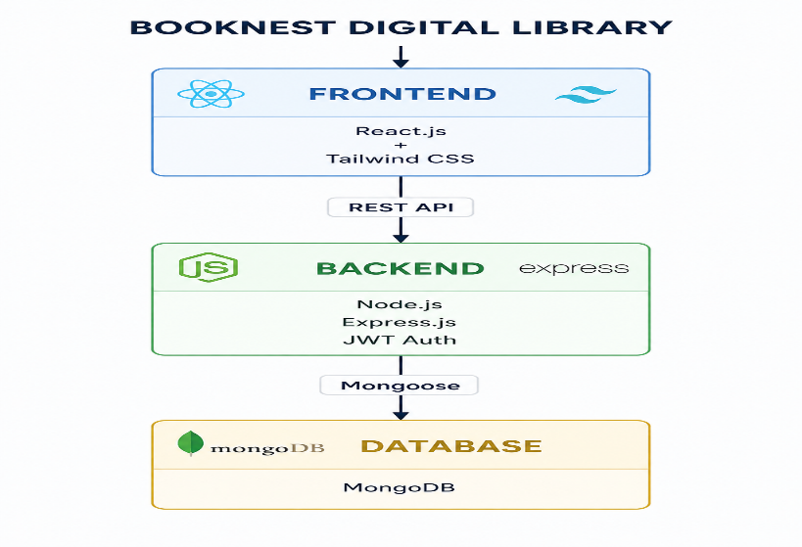
TECHNICAL ARCHITECTURE:
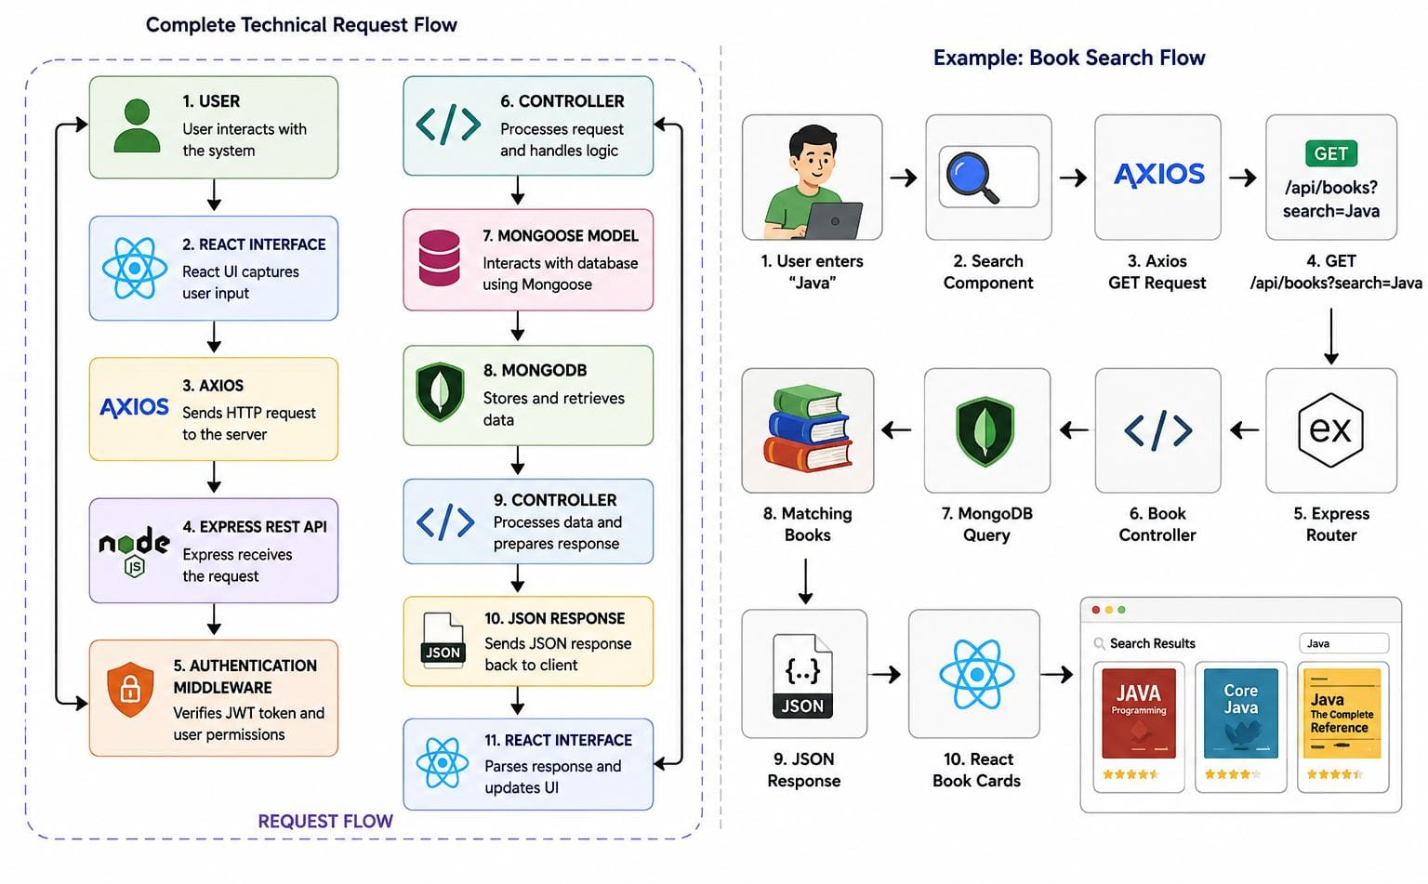

ER DIAGRAM:
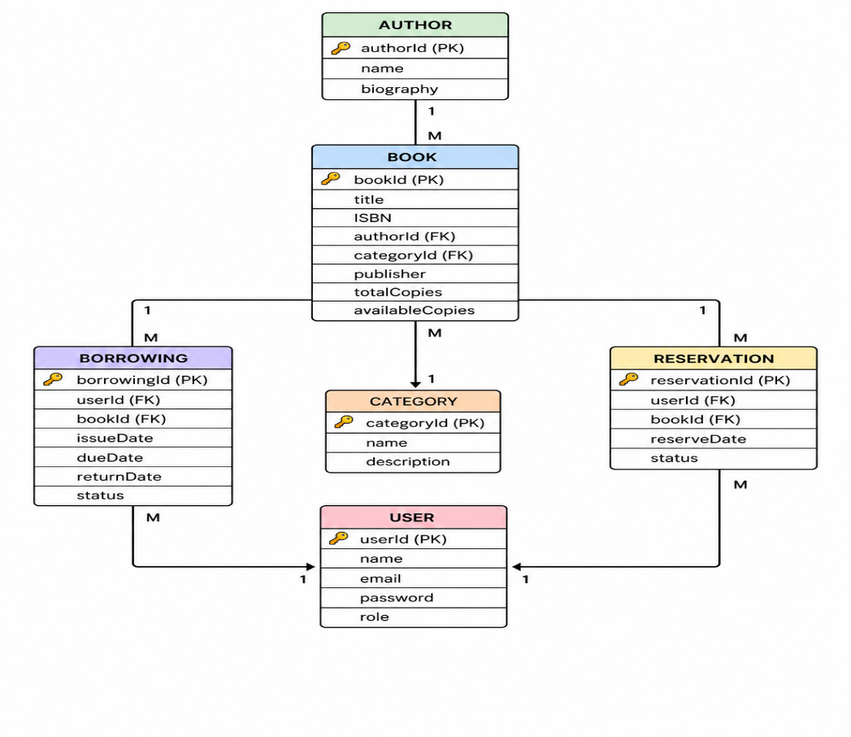

The Entity-Relationship (ER) diagram for BookNest – Digital Library represents the various entities and their relationships within the digital library management system. It describes how books, users, authors, categories, borrowing records, and reservations are connected within the system.

Relationships

Book – Author
Represents the relationship between books and authors, indicating which author has written each book.
Relationship: One Author → Many Books
Book – Category
Represents the relationship between books and categories, indicating the category to which each book belongs.
Relationship: One Category → Many Books
User – Borrowing
Represents the relationship between users and borrowing records, indicating which user has borrowed which books.
Relationship: One User → Many Borrowing Records
Book – Borrowing
Represents the relationship between books and borrowing records, indicating which books are involved in borrowing transactions.
Relationship: One Book → Many Borrowing Records
User – Reservation
Represents the relationship between users and reservations, indicating which user has reserved a book.
Relationship: One User → Many Reservations
Book – Reservation
Represents the relationship between books and reservations, indicating which books have been reserved by users.
Relationship: One Book → Many Reservations

Key Features:
User Registration and Profiles: Allow library members to create accounts, manage their profiles, and securely access their library activities.
Book Discovery and Search: Enable users to browse and search books by title, author, category, ISBN, publisher, and keywords.
Real-Time Book Availability: Display the current status of books, such as available, issued, reserved, or unavailable.
Borrowing and Return Management: Allow users to issue available books, track due dates, and complete the return process.
Book Reservation: Enable users to reserve books that are currently unavailable and receive notifications when they become available.
Borrowing History: Maintain records of previously borrowed and returned books, allowing users to track their reading history.
Overdue Management: Automatically track due dates and identify overdue books to help users and librarians manage timely returns.
Library Administration: Provide dedicated dashboards for librarians and administrators to manage books, users, authors, categories, borrowing records, and reservations.
Notifications and Alerts: Notify users about upcoming due dates, overdue books, reservation availability, and important library updates.
Project Setup And Configuration.

- Creating project folder
  - Create a new folder with <BOOKNEST-SHARE>.
  - Inside that folder create two new folders.
  - Name one as **Frontend**.
  - Name another one as **Backend**.
  - Now open that folder in VS Code.
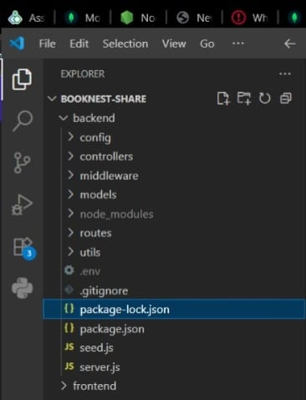

- Client setup (installing react app)
○ Open the Client folder in the terminal of VScode.
■ npm create vite@latest . -- --template react ○ Select React framework from the given options.
■ Select a framework:
■ │ React
○ Select JavaScript variant from the given options.
■ Select a variant:
■ │ JavaScript
○ Now lets navigate to the client folder by giving the following command. ■cd client
○ To install all the packages run the following command. ■npm install
○ To start the React server type the following command.
■ npm run dev

- Server setup (npm init)
○ Open Server folder in terminal of VScode.
■ npm init -y ○ Create files:
■ server.js
○ Create folders: ■ models
■ controllers
■ Routes

BACKEND DEVELOPMENT:

Backend Reference Video:
https://drive.google.com/drive/folders/18j9u34Dla0Ej3VWcUnTUrzw055j9Cp6s

Backend Structure:
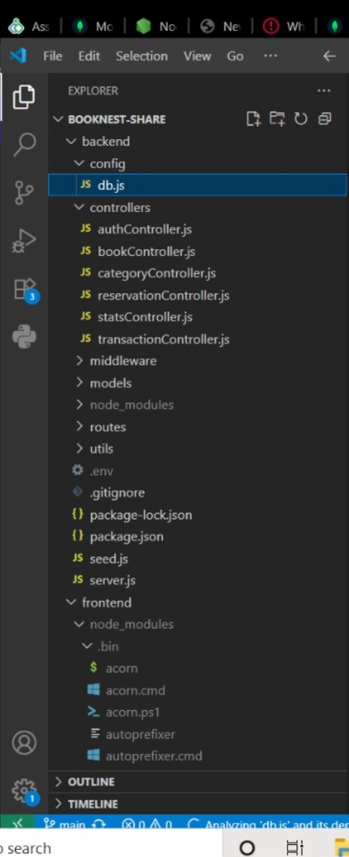

DATABASE DEVELOPMENT:
1. Configure MongoDB:

- Install Mongoose.
In your Node.js project directory, run:
npm install mongoose

- Create database connection.
- Create Schemas & Models.

Create Database connection:
Now, make sure the database is connected before performing any of the actions through the backend. The connection code looks similar to the one provided below

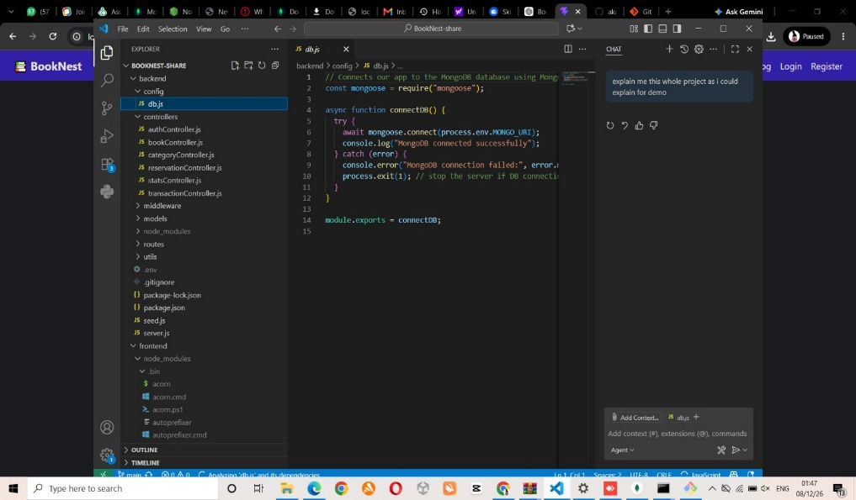

FRONT-END DEVELOPMENT:
Frontend Reference Video:
https://drive.google.com/drive/folders/18j9u34Dla0Ej3VWcUnTUrzw055j9Cp6s

Frontend Structure:
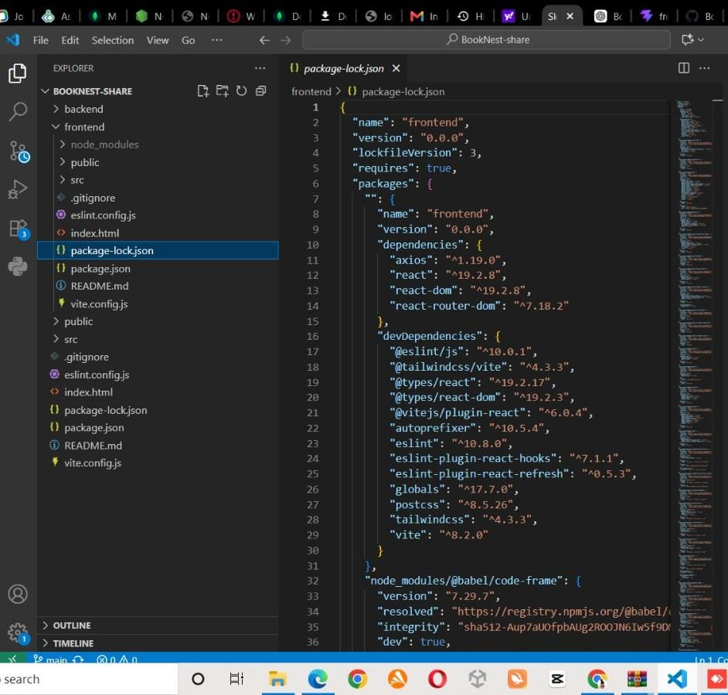

Output ScreenShots:

Landing Page:
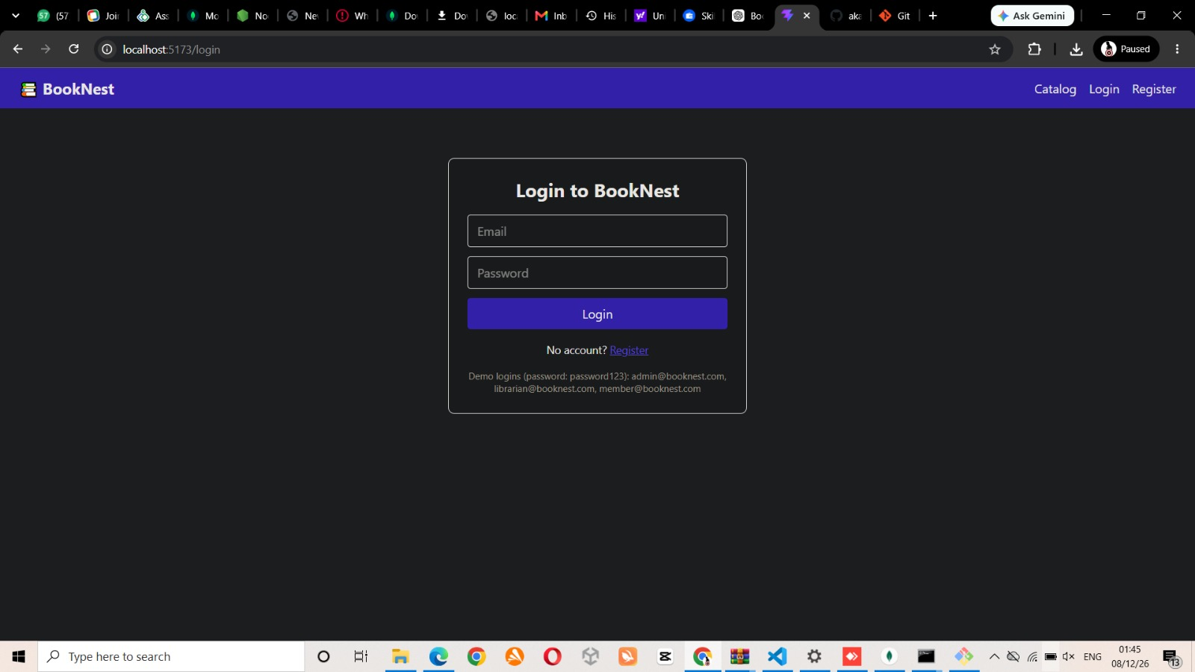

Register :
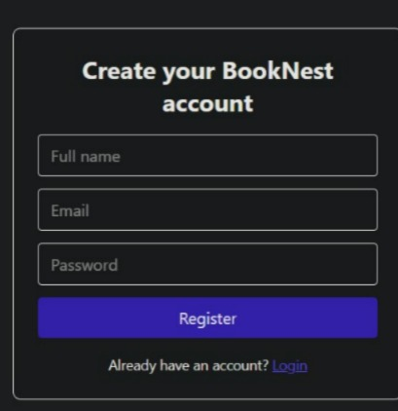

Login :
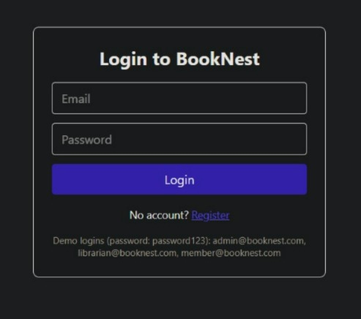

Admin Home Page :
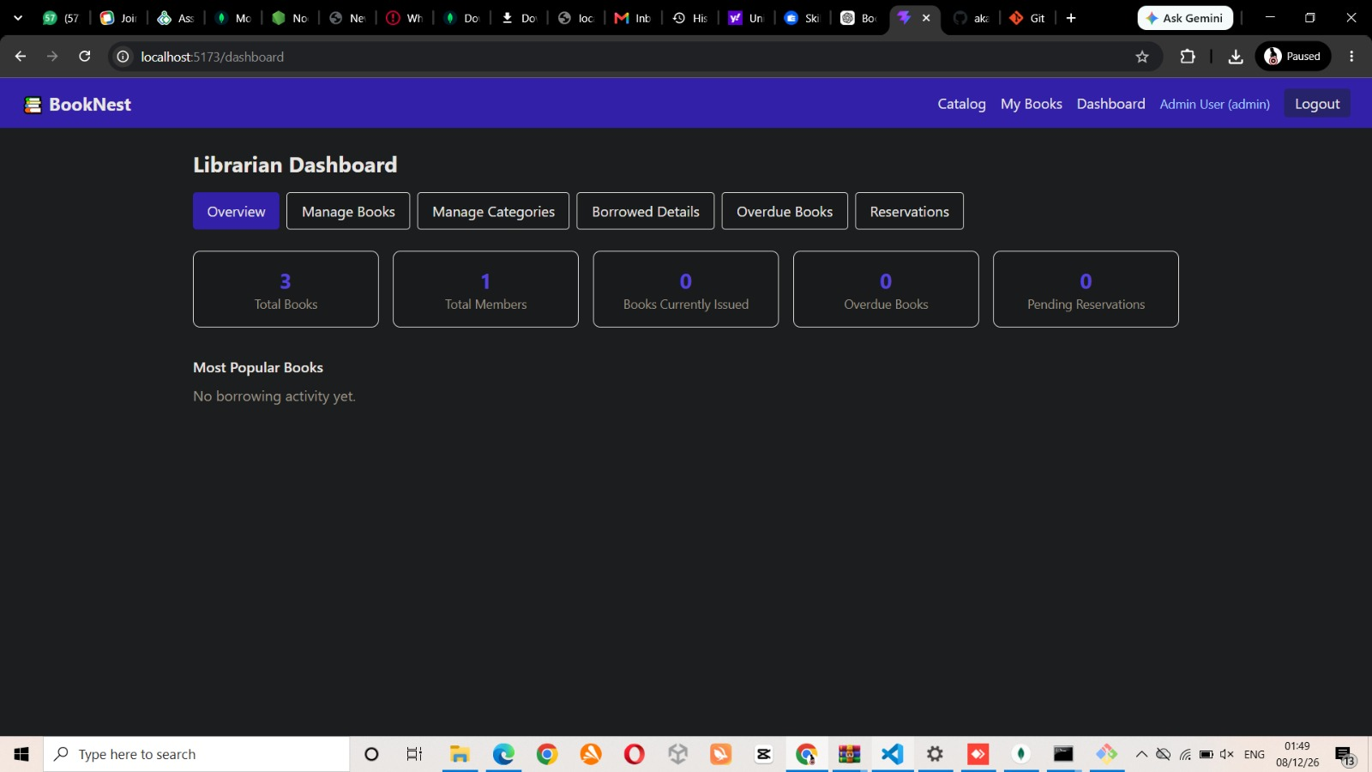

User’s Page:

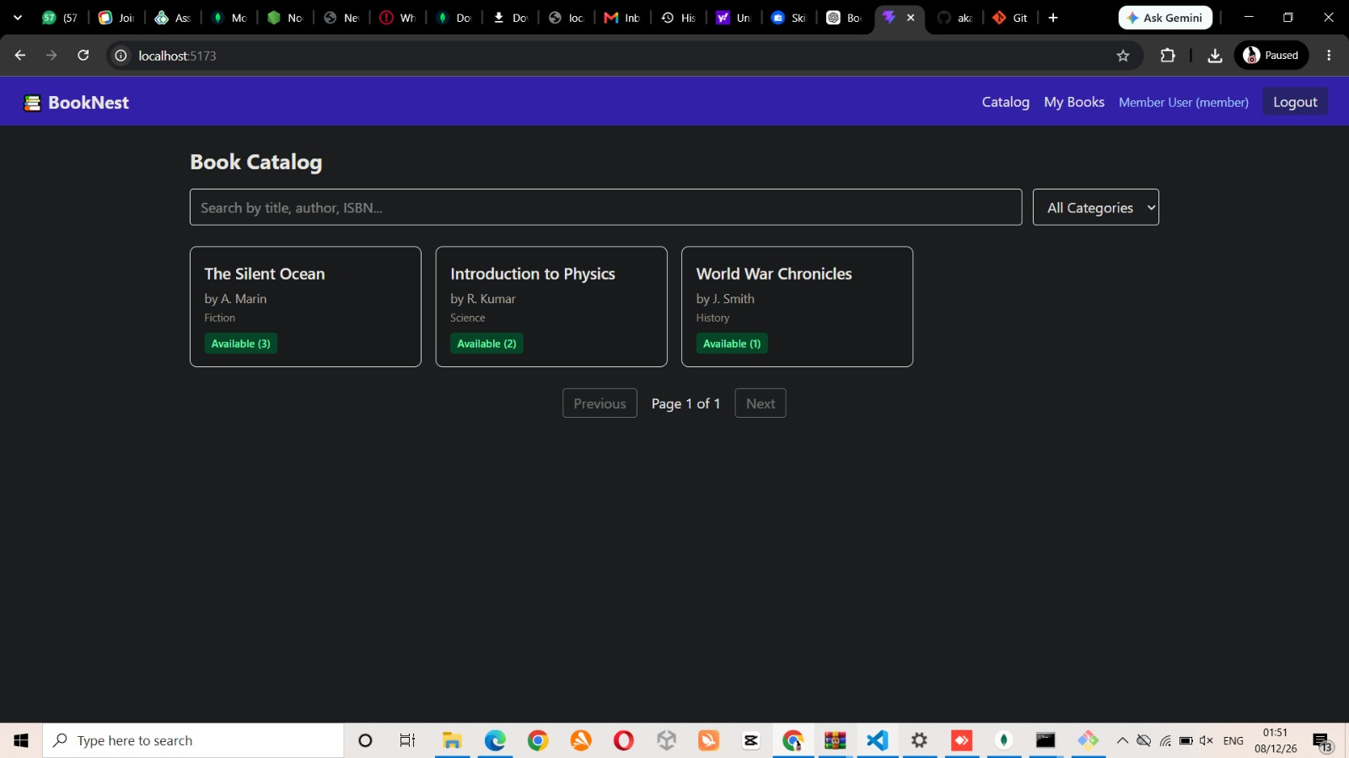

Add Page:

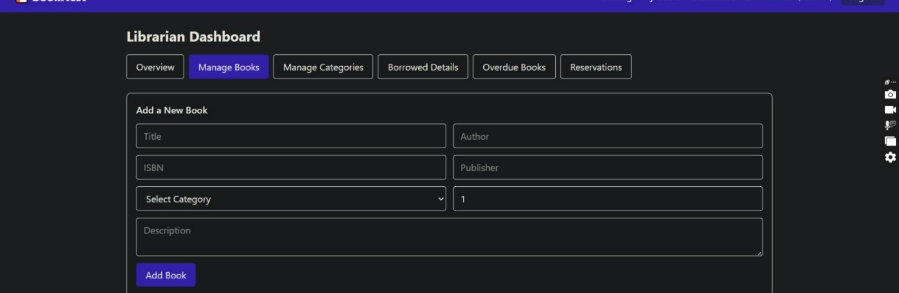

Product Detail Page:

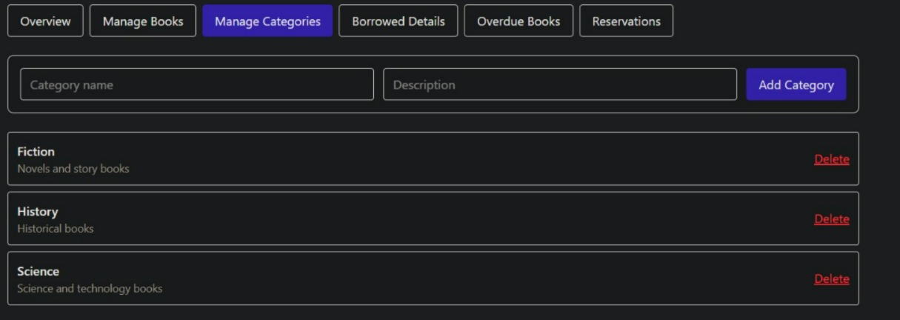

Demo Video Link:

https://drive.google.com/drive/folders/18j9u34Dla0Ej3VWcUnTUrzw055j9Cp6s

Code Drive Link:
https://github.com/akashduraic2006-cyber/BookNest

