ECEN 214-302 – Electric Circuit Theory

Summer 2020

Lab 2: Non-Ideal Sources

**Submitted by:**

|  |  |  |  |
| --- | --- | --- | --- |
| **Table 1.** UIN, names, and section numbers. | | | |
| **Student Name** | **UIN** | **Section #** | **Group #** |
| Akash  Gajendra | 927009622 | 302 |  |
| Elijah Montgomery | 427006372 | 301 |  |

**Date Performed: June 9th, 2020**

**Due Date: June 15th, 2020**

**TA : Chen Gong**

I. Objective

The lab serves as an introduction to the concept of practical voltage and Thevenin Equivalent for individuals. It reinforces the fundamentals of circuit building while proving emphasis on the observable internal resistance associated with voltage sources and their modelling using resistors.

II. Procedure

Materials Required

* Analog Discovery
* Two 1.5 V battery holder
* Two 1.5 V batteries
* Variety of resistors
* Breadboard
* Wires

(a) Measuring the voltage and internal resistance of a battery

1. Collect materials given above
2. Open the Voltmeter on the Waveforms program
3. Place a 1.5 V battery into the battery holder
4. Place the leads of the battery holder into the positive and negative strips of the breadboards
5. Assemble a circuit using the given resistors in a connections with the battery
6. Note down the effective resistance and record voltmeter readings
7. Alter resistance and record new readings accordingly
8. Then repeat the process for the other battery

The lab mentions the restriction of the resistors to be 10 ohms because it has a power limit which if exceeded will cause the resistors to burn out, using the formula P = V^2/R, we see that as the resistance goes lower, the power dissipated across the resistor rises so we had to use 10 ohms to avoid upper power limits. We also took note of the nominal resistance on the resistors to compare these values with those that we measured in our lab experiment.

(b) Measuring voltage and internal resistance of a series combination of batteries

1. Collect the PMD and the bread board.
2. Open the Voltmeter on the Waveforms program.
3. Place both batteries in their respective holders
4. Connect the batteries in series with each other
5. Place the leads of the battery holder onto the power lines of the breadboard
6. Assemble a circuit similar to the previous part
7. Take note of the required readings

(c) Once all the data has been recorded, we then proceed to make the required plots which can be found in the results section.

III. Difficulties

One of the issues that was experienced dealt with the fluctuating voltmeter readings and loose connections.

IV. Results

This section has the data recorded along with the required plots and sample calculation to be found.

(A) Battery 1 (V_S=1.51 V)

**Data Table**

**Table 1.1**

|  |  |  |
| --- | --- | --- |
| Combination of Resistors | Nominal R_L (Ω) | Measured V_L (V) |
| 4 x 100 Ω | 25 | 1.083 |
| 3 x 100 Ω | 33.3 | 1.219 |
| 2 x 100 Ω | 50 | 1.323 |
| 1 x 100 Ω | 100 | 1.407 |

**Plot 1.1**

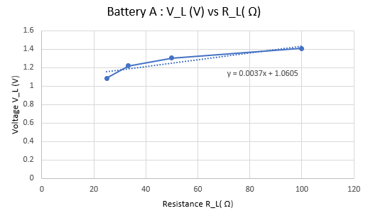

**Plot 1.2**

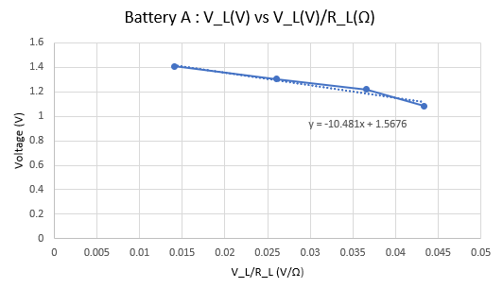

(B) Battery 2 (V_S=1.39 V)

**Table 2.1**

|  |  |  |
| --- | --- | --- |
| Combination of Resistors | Nominal R_L (Ω) | Measured V_L (V) |
| 4 x 100 Ω | 25 | 0.964 |
| 3 x 100 Ω | 33.3 | 1.113 |
| 2 x 100 Ω | 50 | 1.234 |
| 1 x 100 Ω | 100 | 1.301 |

**Plot 2.1**

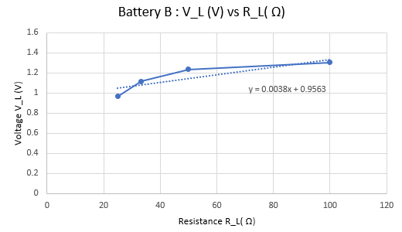

**Plot 2.2**

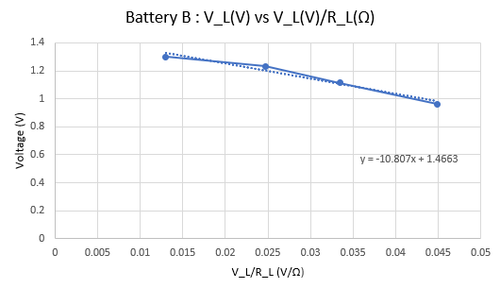

(C) Series combination of the batteries (V_S=2.75 V)

**Table 3.1**

|  |  |  |
| --- | --- | --- |
| Combination of Resistors | Nominal R_L (Ω) | Measured V_L |
| 4 x 100 Ω | 25 | 2.371 |
| 3 x 100 Ω | 33.3 | 2.456 |
| 2 x 100 Ω | 50 | 2.542 |
| 1 x 100 Ω | 100 | 2.672 |

**Plot 3.1**

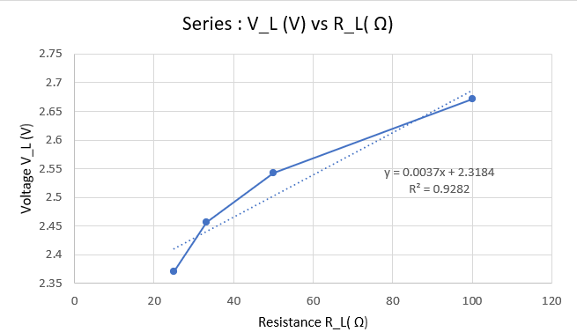

**Plot 3.2**

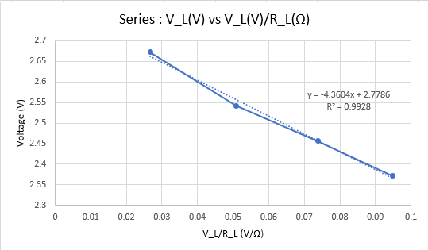

**Sample Calculation**

To determine the source voltage and internal resistance associated with the battery, there was a need to plot the V_L vs (V_L/R_L) graph

The following equation:

**V_L=V_S - (V_L/R_L) * R_S** represents the graph

The method below suggests a way to retrieve the required quantities

V_S=Y-intercept = 2.78 V

R_S=Slope=4.36 Ω

**Note:** The error associated with the readings was mitigated by using multiple measurements to get around the oscillation of the voltage. Moreover, the discrepancy between the calculated measured resistance also adds to the process being erroneous. Equipment errors also contribute to this.

V. Conclusion

The goal of the experiment was to learn to use the PMD functions like the voltmeter to measure practical voltage. The source voltage and internal resistance of the batteries were found. Possible areas of inaccuracies were also discussed.