ECEN 214-302 – Electric Circuit Theory

Summer 2020

Lab 6: Transient Response of a 1st Order RC Circuit

**Submitted by:**

|  |  |  |  |
| --- | --- | --- | --- |
| **Table 1.** UIN, names, and section numbers. | | | |
| **Student Name** | **UIN** | **Section #** | **Group #** |
| Akash  Gajendra | 927009622 | 302 |  |
| Elijah Montgomery | 427006372 | 301 |  |

**Date Performed: July 10th, 2020**

**Due Date: July 13th, 2020**

**TA : Chen Gong**

I. Objective

The lab serves as an introduction to the concept of first order circuits and the transient behavior of this class of circuits. It also reinforces the fundamentals of circuit building while creating a custom LED circuit flashing at a pre-defined frequency.

II. Procedure

Materials Required

* Analog Discovery
* One 741 Op-Amp
* Breadboard
* Wires
* 5.1kΩ Resistor
* 5.81kΩ Resistor (Combination)
* 50kΩ Resistor (Combination)
* 25kΩ (Combination)
* 1kΩ Resistor
* 10 µF Capacitor
* Two LEDs
* 10kΩ Potentiometer
* Potentiometer Turner

(a) Flashing LED Circuit

1. Collect materials given above
2. Connect the AD2 to the computer
3. Open the Waveforms program
4. Place the leads of the battery holder into the positive and negative strips of the breadboards
5. Insert the 741 op-amp in center of the breadboard and connect the power supply to its respective Vcc ports
6. Assemble the circuit using the given resistors and the power supplies in accordance with the provided schematic
7. Connect the oscilloscope across the input voltages of the oscillating circuit
8. Before connecting a load in the form of LEDs across the output voltage of the op-amp, ensure an appropriate waves are observed using the “Scope” option of the AD2
9. Connect the LEDs to the op-amp output through a 1kΩ resistor to prevent burnout
10. Take screenshots of the desired waveforms
11. Measure the required quantities using the “Scope” function
12. Compare the measured values with their theoretical counterparts

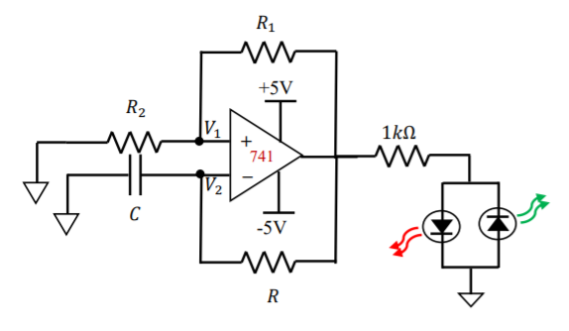

Figure 1: LED circuit schematic

(b) Potentiometers

1. Remove the resistors R1 and R2 from the circuit
2. Connect the potentiometer to the circuit following the provided schematic
3. Set the terminal voltages of the op-amp to +15V and -15V respectively
4. Use the scope option and adjust to make the circuit oscillate at 2Hz
5. After achieving the 2Hz condition, record the waveforms
6. Then replace the R value resistor with a resistor of R/2 ohms
7. Measure the new frequency of oscillation and the waveforms
8. Adjust the circuit until it oscillates at 2Hz and record the waveforms
9. Collect the PMD and the bread board.
10. Open the Voltmeter on the Waveforms program.
11. Take note of the required readings

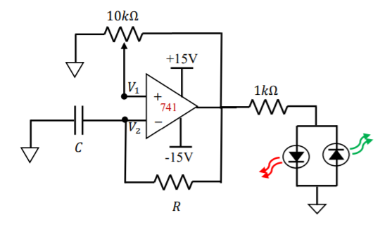



Figure 2: Modified Flashing LED Circuit

III. Difficulties

One of the issues that was experienced dealt with the fluctuating power supply for the op-amp. I also found it difficult to debug i.e. isolate loose connections and faulty equipment due to the sheer complexity of the circuit.

IV. Results

**Task 1:** LED Circuit

Here lies the required sample calculation

Equation to be used:

f=1/T

Frequency, f=1/0.9901=1.001 Hz

**Where** f - Frequency (Hz)

T - Time Period (s)

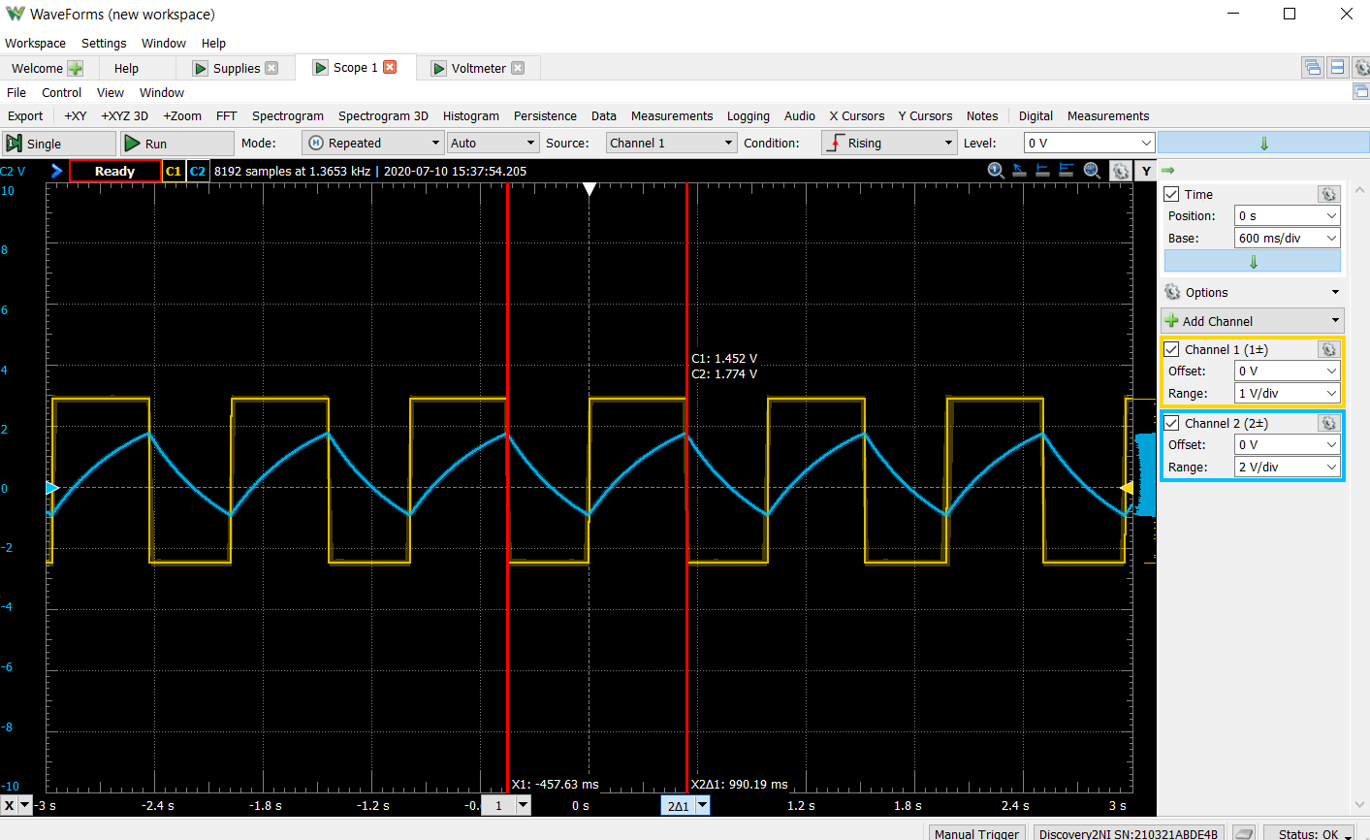

Figure 3: Task 1 - LED Circuit Waveform

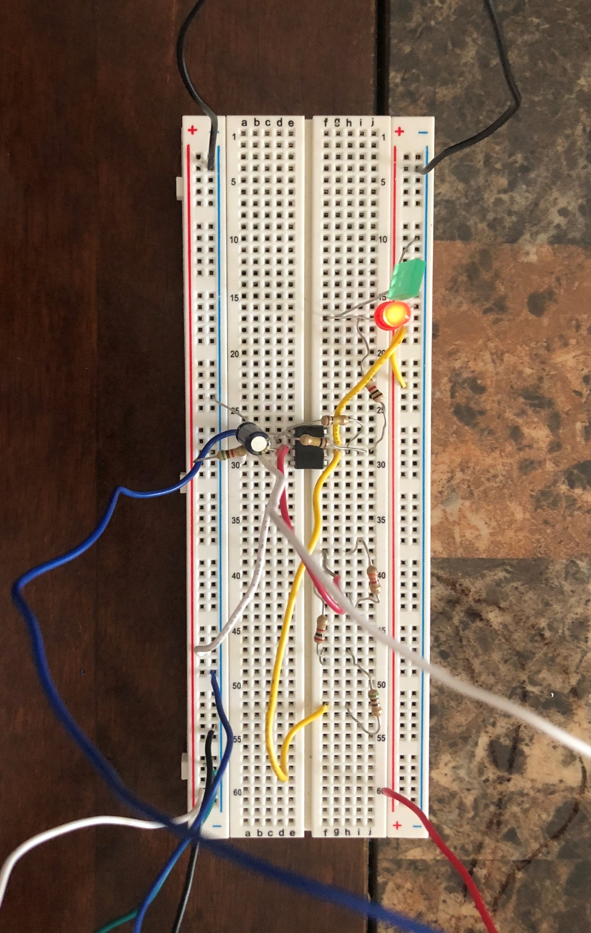

Figure 4: Task 1 - LED Circuit

(a) f=1.001Hz

(b)

Measured Vpp of V_1=3 V

Measured Vpp of V_2= 2.31 V

(c)

V1_rms= 2.1 V

V2_rms= 1.3 V

**Data Tables:-**

|  |  |
| --- | --- |
| **Circuit Component** | **Theoretical Value** |
| R1 | 5.1 kΩ |
| R2 | 5.81 kΩ |
| C | 10 μF |
| R | 50 kΩ |

Table 1: Component Data

|  |  |  |
| --- | --- | --- |
| **Quantity** | **Measured Value** | **Theoretical Value** |
| Frequency(Hz) | 1.001 | 0.988 |
| Vpp (V2) | 2.31 | 3.58 |
| V_rms (V2) | 1.3 | 2.06 |

Table 2: Data comparison

**Compare:-**

The theoretical and measured frequency were almost identical which does add to the accuracy of the experiment. Whereas the Vpp and Vrms showcases inconsistency which can be accounted to errors that creept in due to fault prone equipment. A more detailed explanation can be found in the discussion section.

**Task 2 :** Modified LED Circuit

**Part A**

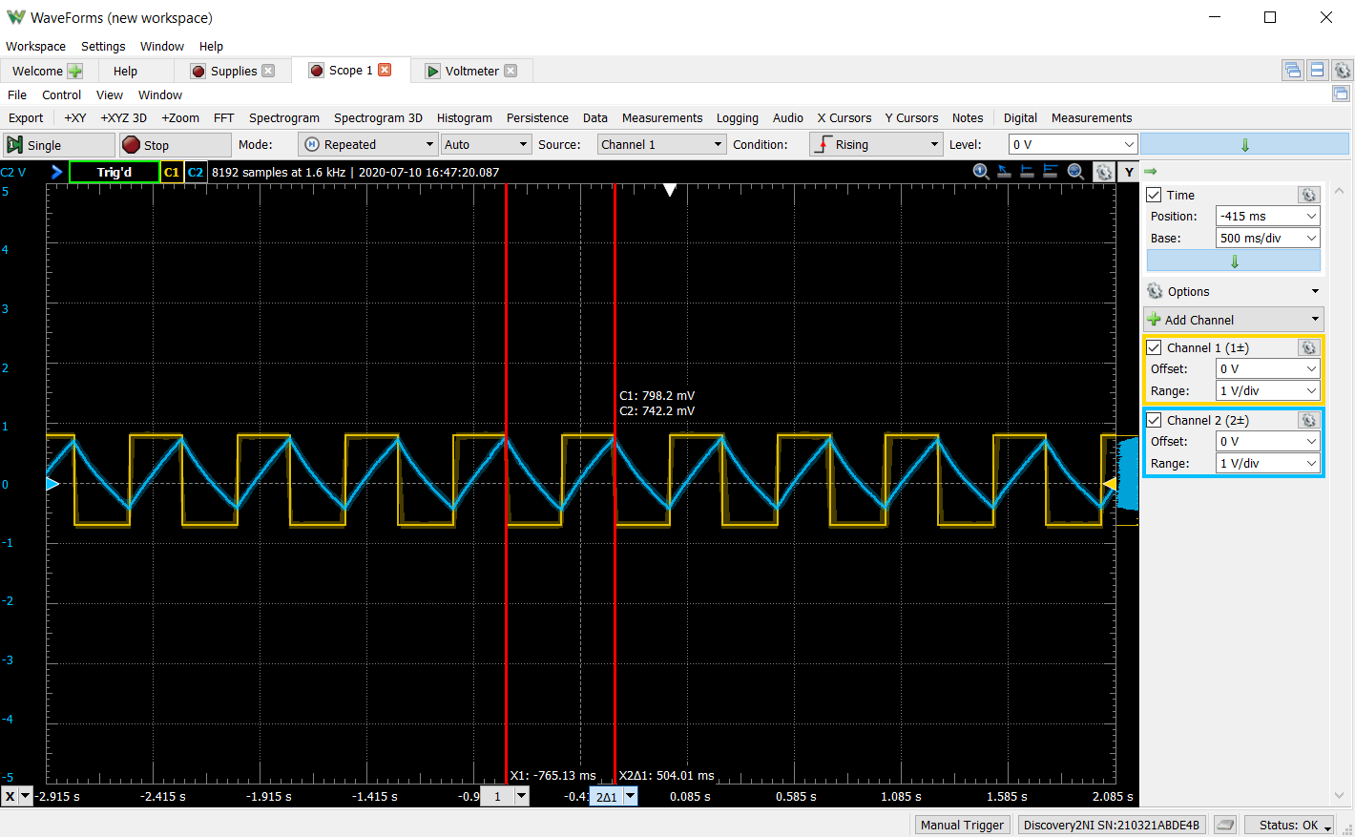

Figure 5: Modified Flashing LED Circuit Waveforms

Period, T= 0.504s

Frequency, f=1/0.504=1.984 Hz

Hence the LEDs are flashing at the required 2 Hz.

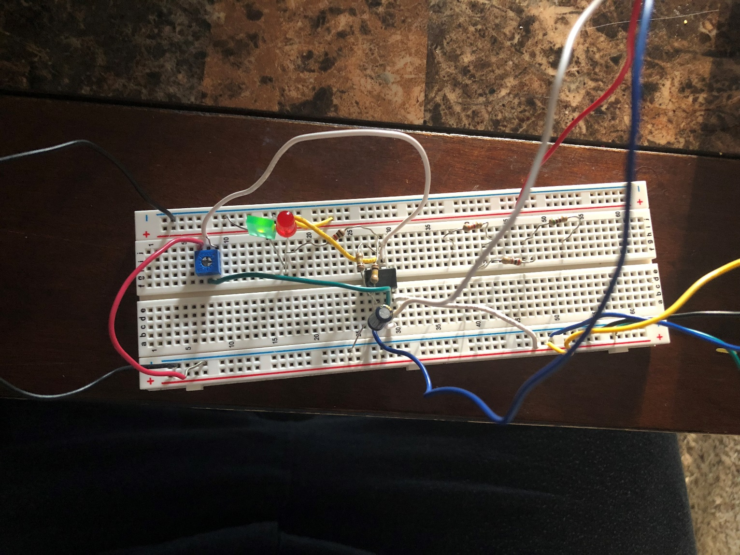

Figure 6: Modified Flashing LED Circuit

**Part B**

R is halved as required by the lab report guidelines

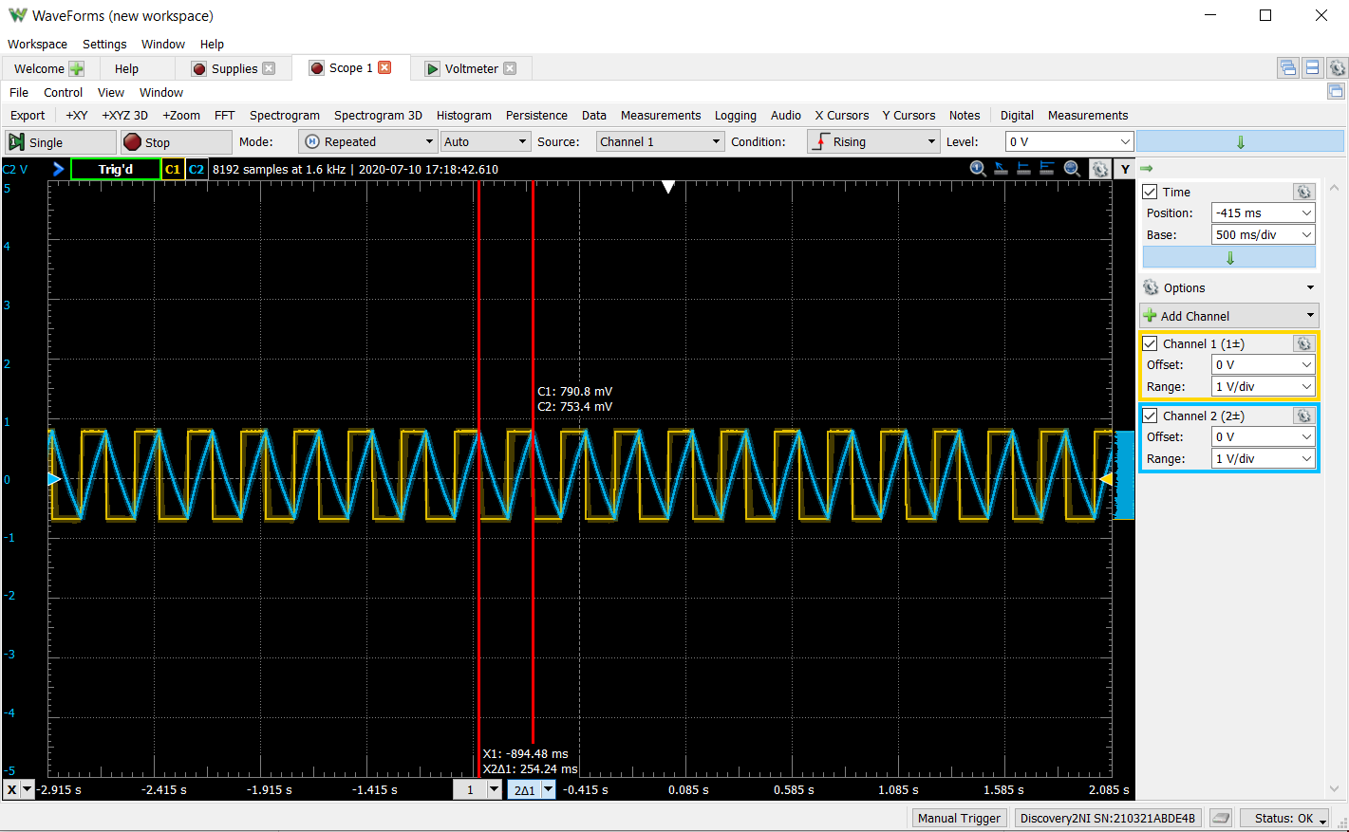

Figure 7: Task 2B – With R/2 in the LED circuit waveform

Period, T= 0.254s

Frequency, f=1/0.254=3.937 Hz

Hence the LEDs are flashing at 3.937 Hz.

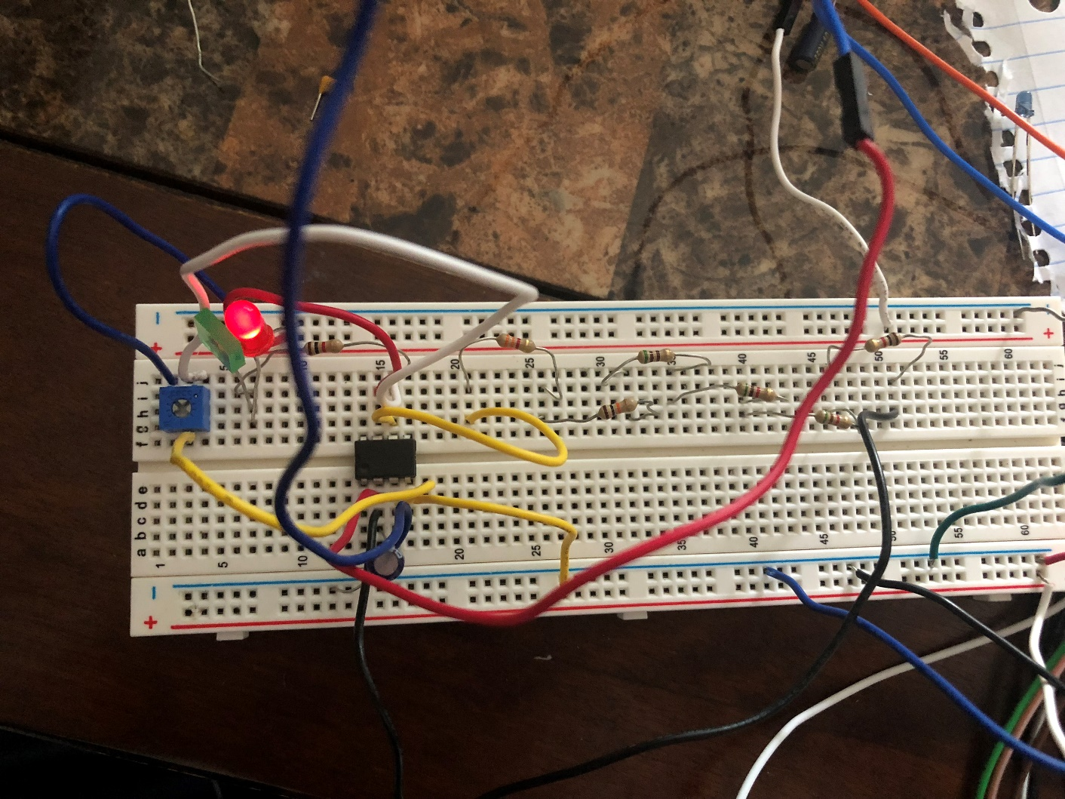/

Figure 8: Task 2B – With R/2 in the LED circuit

**Part C**

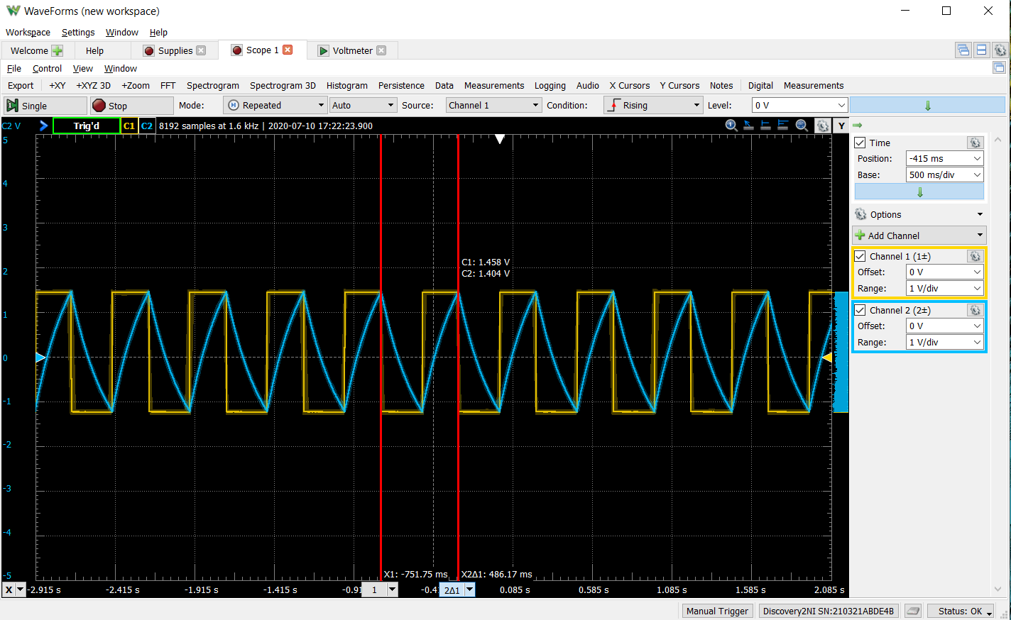

Figure 9: Task 2C – With R/2 in the LED circuit

Period, T= 0.486s

Frequency, f=1/0.486= 2.057 Hz

Hence the LEDs are flashing at 2 Hz.

**Note:** The resistor division cannot be found as the DMM equipment is not available.

V. Discussion

Building on the observations made earlier, a possible reason for the discrepency between the recorded values is the required resistors were made from a combination of individual resistors in different configurations which contributed to the errenous nature of the readings.

Moreover, prolonged current flow through the circuits also increased the uncertainty revolving the resistances. Additionally, there is the unknown resistance of the wires, board, and capacitor that may cause uncertainty to the measured voltage values.

**Note:** The saturation value measured will be lower than the theoretical value because how the OP-Amp gives an effective lower saturation value than calculated.

VI. Conclusion

The goal of the experiment was to learn more about the transient behavior of a 1st order circuit. A flashing LED circuit was built and made to oscillate at a frequency of our choosing. Overall, gained a better understanding of working with the AD2 and debugging breadboard circuits.