ECEN 214-302 – Electric Circuit Theory

Summer 2020

Lab 7: Transient Response of a 2nd Order RC Circuit

**Submitted by:**

|  |  |  |  |
| --- | --- | --- | --- |
| **Table 1.** UIN, names, and section numbers. | | | |
| **Student Name** | **UIN** | **Section #** | **Group #** |
| Akash  Gajendra | 927009622 | 302 |  |
| Elijah Montgomery | 427006372 | 301 |  |

**Date Performed: July 17th, 2020**

**Due Date: July 20th, 2020**

**TA : Chen Gong**

I. Objective

The lab serves as an introduction to the concept of second order circuits and the transient behavior of this class of circuits. The core objective of the lab is to build a 2nd order circuit and analyze the experimental transient response obtained in both the theoretical and simulated manners.

II. Procedure

Materials Required

* Analog Discovery
* One 741 Op-Amp
* Breadboard
* Wires
* Variety of Capacitors
  + 39 nF Capacitor
  + 10 nF Capacitor
  + 5 nF Capacitor
  + 1 nF Capacitor
  + 0.1 µF Capacitor
* Variety of Resistors
  + 10kΩ Resistor
  + 5.1kΩ Resistor
  + 3.3kΩ Resistor
  + 2kΩ (Combination)
  + 1kΩ Resistor

(a) Task 1: Transient Response of 2nd Order Circuit

1. Collect materials given above
2. Connect the AD2 to the computer
3. Open the Waveforms program
4. Insert the 741 op-amp in center of the breadboard and connect the power supply to its respective Vcc ports
5. Assemble the Sallen Key circuit using the given resistors and capacitors in accordance with the provided schematic
6. Use the “Wavegen” option of the AD2 to produce a input square wave of 100Hz, 2V configuration
7. Connect the oscilloscope across the input voltage and output voltage of the op-amp circuit
8. Take screenshots of the desired waveforms from the “Scope” option
9. Repeat the steps for the other Q values – 0.25, 0.1, 1, 2.5
10. Compare the measured values with their theoretical counterparts

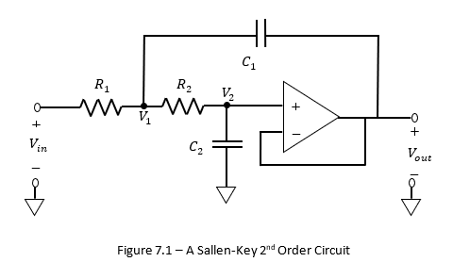

**Figure 1: Salley Key Circuit**

III. Difficulties

It was hard to figure out to figure which combination of the capacitors and resistors made the circuit function in the desired way. Prior mistakes forced reconsideration of the component values and a combination of loose connections and faulty equipment also proved to be obstacles. The fluctuating power supply for the op-amp also contributed to the delay in completion of the experiment.

IV. Results

**Task 1:** Transient Response of 2nd Circuit

Knowledge to be used:

If Q = ½ then the circuit is critically damped.

If Q > ½ then the circuit is underdamped

If Q < ½ then the circuit is overdamped

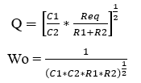

**Table 1: Revised Component Values**

|  |  |  |  |  |  |
| --- | --- | --- | --- | --- | --- |
| **R1 (**kΩ) | **R2 (**kΩ) | **C1** (nF) | **C2** (nF) | **Q** | **Wo** |
| 16.1 | 16.1 | 10 | 10 | 0.5 | 1990π |
| 8 | 8.3 | 10 | 39 | 0.25 | 1979π |
| 8.1 | 8.4 | 4 | 100 | 0.1 | 1930π |
| 8 | 8.3 | 39 | 10 | 1 | 1979π |
| 8.1 | 8.4 | 100 | 4 | 2.5 | 1930π |

**Waveforms**

**(A)** Q=0.5

The circuit is critically damped because the Q is equal to ½ causing the wave to oscillate as desired. Both the simulation and observed waveforms are almost identical.

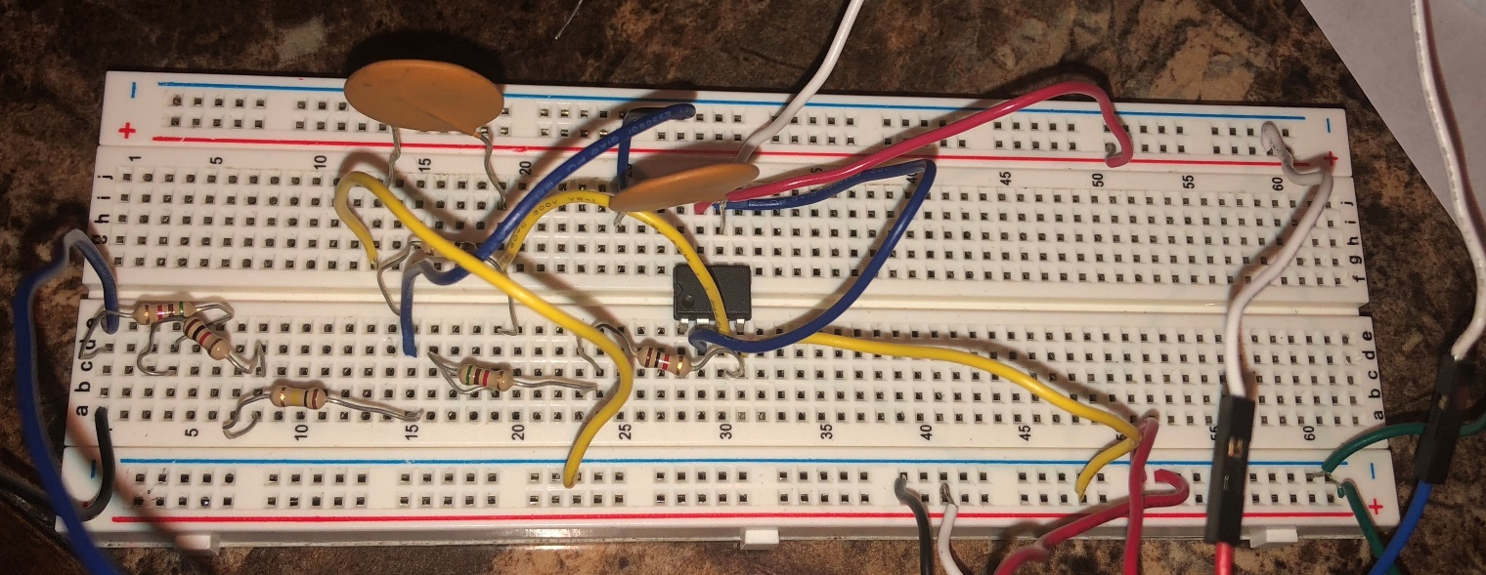

**Figure 2: RC Circuit for Q=0.5**

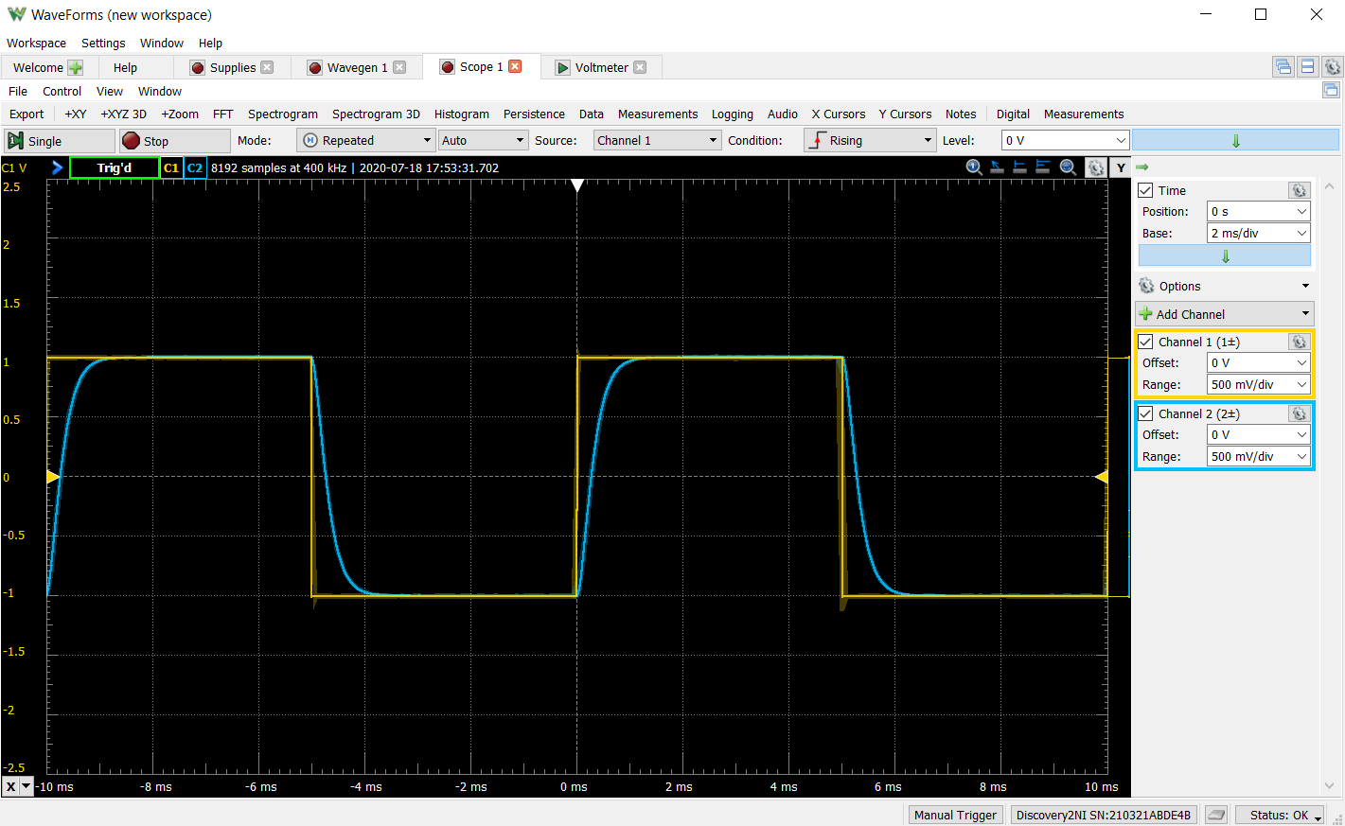

**Figure 3: Waveform for Q=0.5**

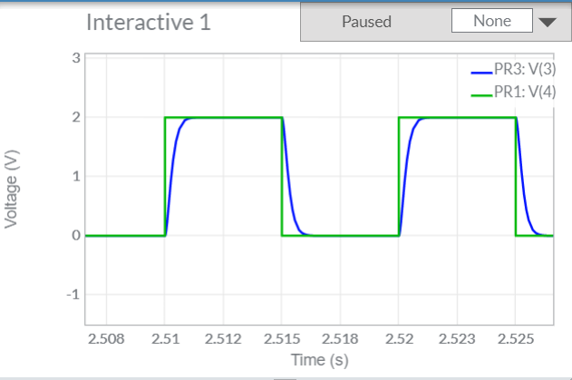

**Figure 4: Multisim simulation for Q=0.5**

**(B)** Q=0.25

The circuit is slightly over damped because Q is slightly less than ½. The wave will have the same characteristics as the over damped wave but to a lesser degree.

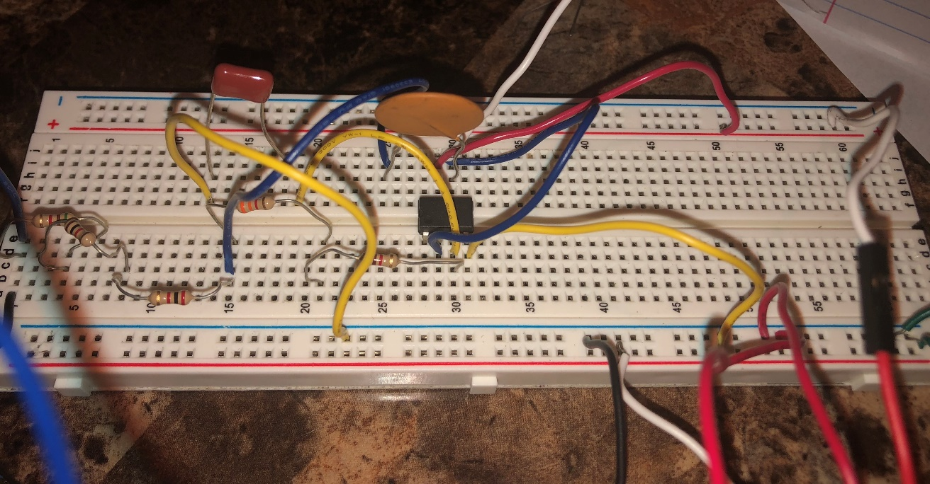

**Figure 5: RC Circuit for Q=0.25**

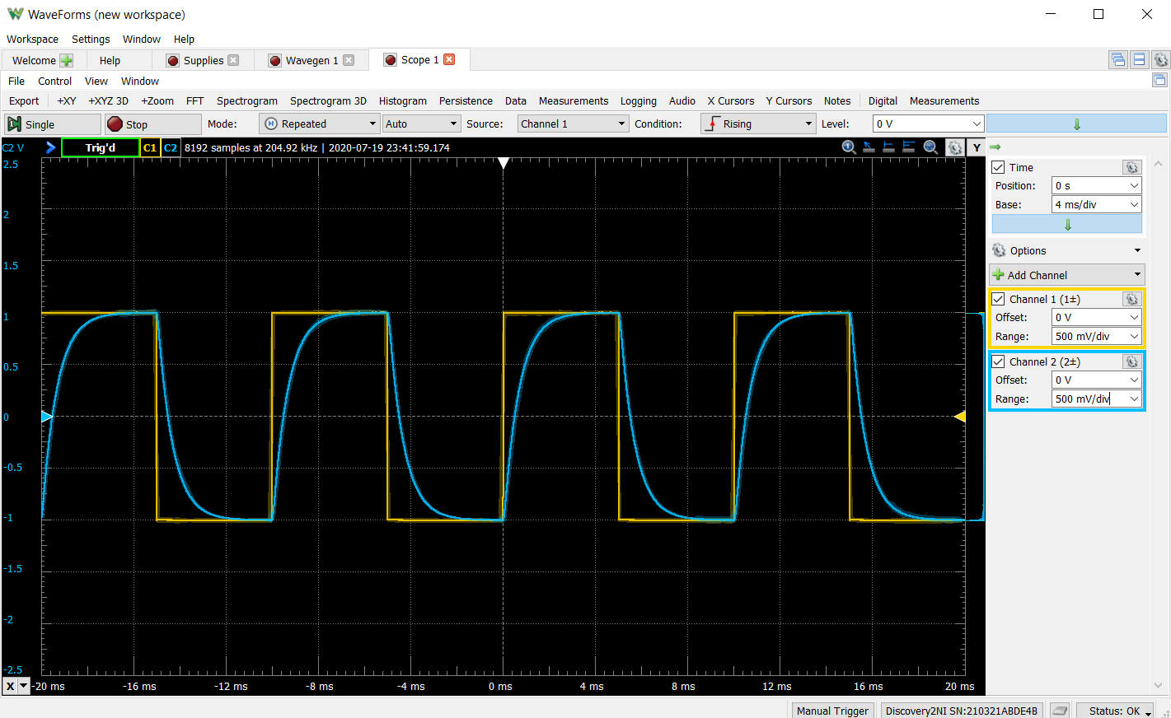

**Figure 6: Waveform for Q=0.25**

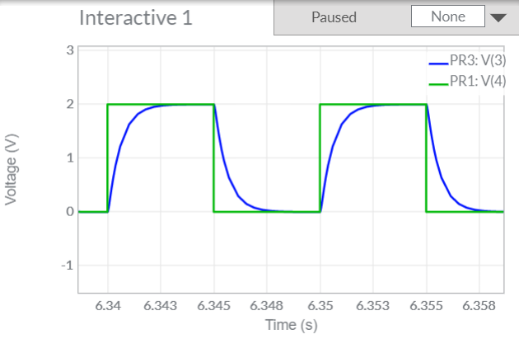

**Figure 7: Multisim simulation for Q=0.5**

**(C)** Q=0.1

Since Q is less than ½ the circuit waveform is overdamped. When the circuit is overdamped, the wave approaches the lower peak faster than the critically damped wave.

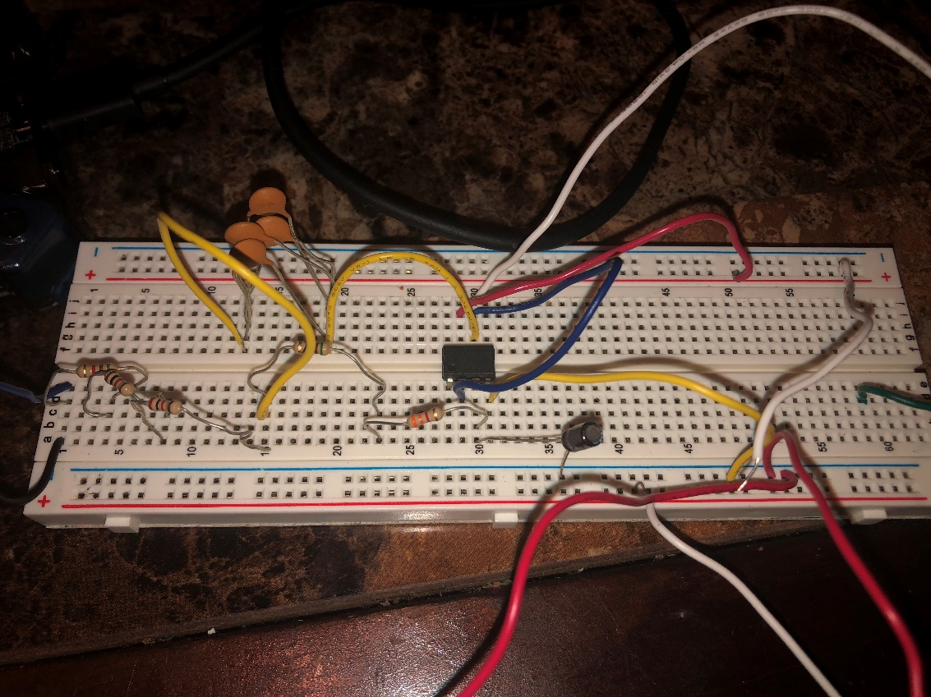

**Figure 8: RC Circuit for Q=0.1**

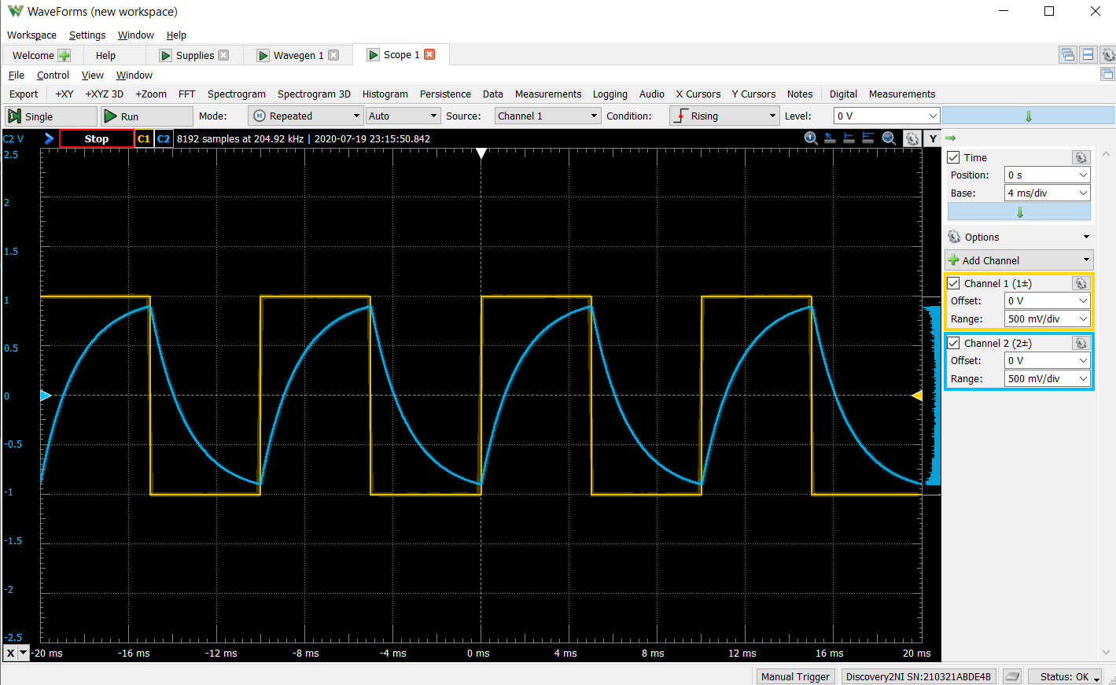

**Figure 9: Waveform for Q=0.1**

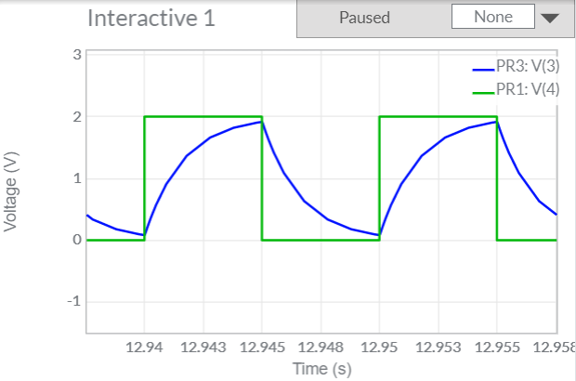

**Figure 10: Multisim simulation for Q=0.1**

**(D)** Q=1

The circuit when Q = 1 is slightly underdamped almost causing it to oscillate loosley like in the waveform below.

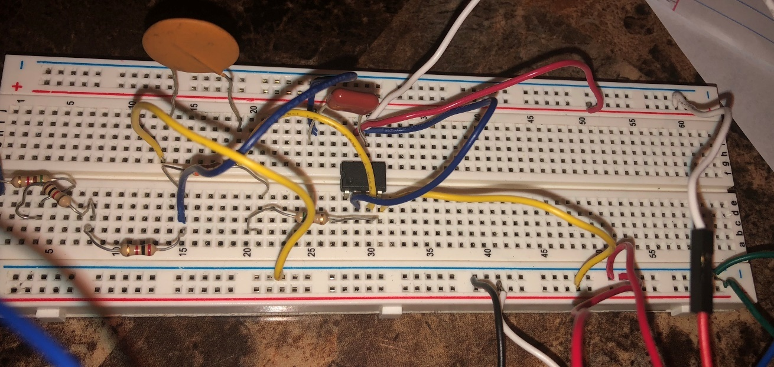

**Figure 11: Waveform for Q=0.1**

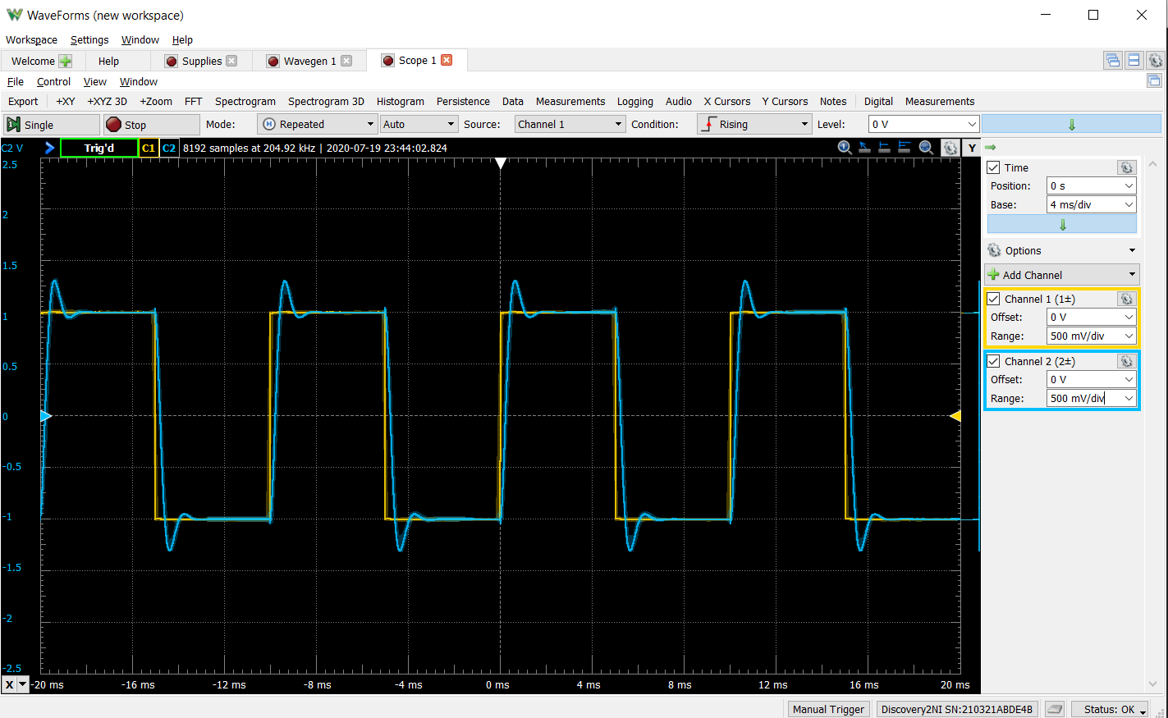

**Figure 12: Waveform for Q=1**

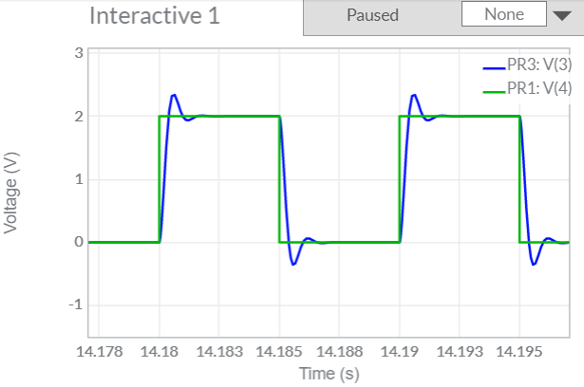

**Figure 13: Multisim simulation for Q=1**

**(E)** Q=2.5

Since the Q is much larger than ½ the wave is underdamped causing the wave to oscillate ‘loosely’ which looks like the wave above.

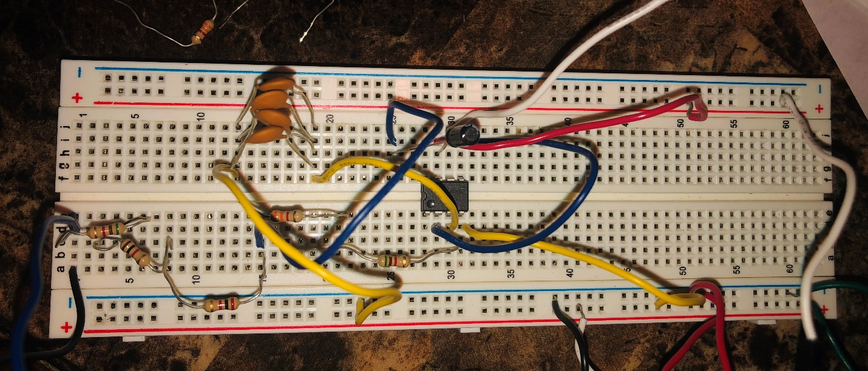

**Figure 14: RC Circuit for Q=2.5**

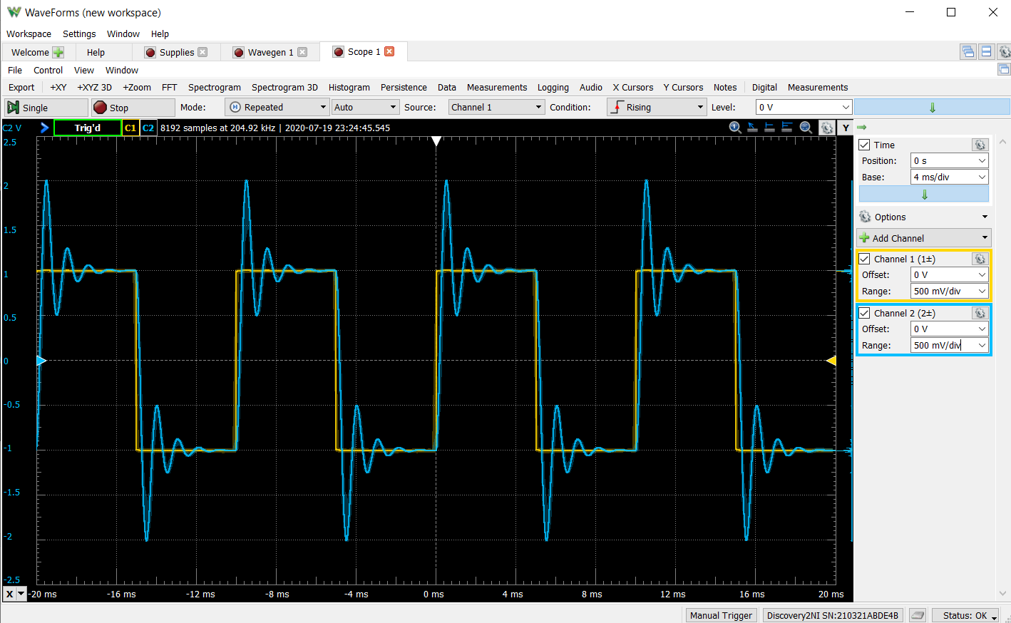

**Figure 15: Waveform for Q=2.5**

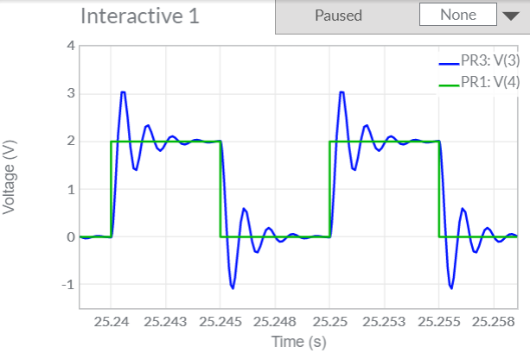

**Figure 16: Multisim simulation for Q=2.5**

**Note:** From the provided waveforms obtained via theoretical and observed means, one can comment favorably on the accuracy of the experiment as observation of the plots showcases almost identical plots.

**Calculations**

(a) Q=0.5

**R1**=16kΩ **R2**=16kΩ **C1**=10nF **C2**=10nF

Q===0.5

Wo==6250=1990π

(b) Q=0.25

**R1**=8kΩ **R2**=8.3kΩ **C1**=10nF **C2**=39nF

Q===0.25

Wo==6214.1=1979π

(c) Q=0.1

**R1**=8.1kΩ **R2**=8.4kΩ **C1**=4nF **C2**=100nF

Q===0.099=0.1

Wo==6061.46=1930.4π

(d) Q=1

**R1**=8kΩ **R2**=8.3kΩ **C1**=39nF **C2**=10nF

Q===0.98=1

Wo==6250=1990π

(e) Q=2.5

**R1**=8.1kΩ **R2**=8.4kΩ **C1**=100nF **C2**=4nF

Q===2.499=2.5

Wo==6061.46=1930.4π

V. Discussion

I wouldn’t make any procedural changes to the lab as I believe that it was apt for inculcating the required lessons. However, I would like to make a couple of changes in the way that I performed the experiment. There lie discrepancies between the prelab values and the component values used in the lab as the previously considered values were changed due to either lack of the specific value or its failure to satisfy the provided conditions.

Hence, I would go back and rectify my mistakes in the pre-lab as it cost a lot of time trying to obtain the correct component values required to achieve the desired quality factor and frequency. Moreover choosing capcitor and resistor values which were easily accesible through my current inventory would have been a wiser call.

Building on the reforms made earlier, a possible source of errors is the fact that the required resistors and capacitors were mostly made from a combination of individual components in different configurations. Prolonged current flow through the circuits also increased the uncertainty of the resistances. Additionally, there is the unknown resistance of the wires, board, and capacitor that may cause uncertainty to the measured values.

VI. Conclusion

The goal of the experiment i.e to learn more about the transient behavior of a 2nd order circuits was achieved. A detailed comparison was also made between the simulated and theoretical damping conditions obtained. Also, further practice debugging breadboard circuits and a better understanding of working with the RC circuits was obtained.