ECEN 214-302 – Electric Circuit Theory

Summer 2020

Lab 8: Sinusoidal Steady State Response of a 2nd Order Circuit

**Submitted by:**

|  |  |  |  |
| --- | --- | --- | --- |
| **Table 1.** UIN, names, and section numbers. | | | |
| **Student Name** | **UIN** | **Section #** | **Group #** |
| Akash  Gajendra | 927009622 | 302 |  |
| Elijah Montgomery | 427006372 | 301 |  |

**Date Performed: July 24th, 2020**

**Due Date: July 27th, 2020**

**TA: Chen Gong**

I. Objective

The core objective of the lab is to build a 2nd order circuit and analyze the response of these circuits to sinusoidal (AC) inputs. It reinforces the fundamentals of circuit building while emphasizing the use of analysis techniques using complex phasors.

II. Procedure

Materials Required

* Analog Discovery
* One 741 Op-Amp
* Breadboard
* Wires
* Variety of Capacitors (Non-polarized)
  + 39 nF Capacitor
  + 10 nF Capacitor
  + 1 nF Capacitor
  + 10 µF Capacitor
* Variety of Resistors
  + 5.1kΩ Resistor
  + 3.3kΩ Resistor
  + 1kΩ Resistor
  + 510Ω Resistor

(a) Task 1: Sinusoidal Steady-State Response of a 2nd Order Low-Pass Circuit

1. Collect materials given above
2. Connect the AD2 to the computer
3. Open the Waveforms program
4. Insert the 741 op-amp in center of the breadboard and connect the power supply to its respective Vcc ports
5. Assemble the Sallen Key circuit using the given resistors and capacitors in accordance with the provided schematic
6. Use the “Wavegen” option of the AD2 to produce a input sine wave of 10Hz, 2V configuration
7. Connect the oscilloscope across the input voltage and output voltage of the op-amp circuit
8. Calculate the phase of the circuit if observed
9. Take screenshots of the desired waveforms from the “Scope” option
10. Repeat the above-mentioned steps for the following input wave frequencies – 18Hz, 32Hz, 56Hz, 100Hz, 178Hz, 316Hz, 562Hz, 1000Hz, 1778Hz, 3162Hz, 5623Hz, 10kHz
11. Once the data has been recorded for all the frequencies, then we adjust the input wave until the ratio of Vo and Vi is 0.707

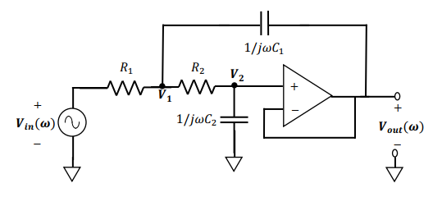

**Figure 1: Sallen-Key Schematic**

(b) Task 2: Sinusoidal Steady-State Response of a 2nd Order High-Pass Circuit

1. Assemble the modified Sallen Key circuit using the given resistors and capacitors in accordance with the provided schematic
2. Then repeat the procedure of task 1 and record the data
3. Use the obtained data and create the required plots

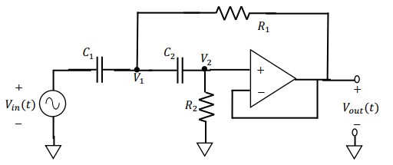

**Figure 2: Modified Sallen Key Schematic**

III. Difficulties

There seemed to an overlap in the issues experienced in this lab and the previous one. Even though I was able to get the required combination of component values to satisfy the pre-defined criteria, careless mistakes concerning net resistances, capacitances and blatant misreading of values forced multiple attempts at completing this lab. A combination of fluctuating power supply for the op-amp, loose connections and faulty equipment also contributed to the delay in completion of the experiment.

IV. Results

Knowledge to be used:

If Q = ½ then the circuit is critically damped.

If Q > ½ then the circuit is underdamped

If Q < ½ then the circuit is overdamped

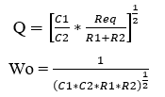

**Table 1: Revised Component Values**

|  |  |  |  |
| --- | --- | --- | --- |
| **R1(kΩ)** | **R2 (kΩ)** | **C1 (nF)** | **C2 (nF)** |
| 7.2 | 7.2 | 250 | 25 |

**Task 1:** Sinusoidal Steady-State Response of a 2nd Order Low-Pass Circuit

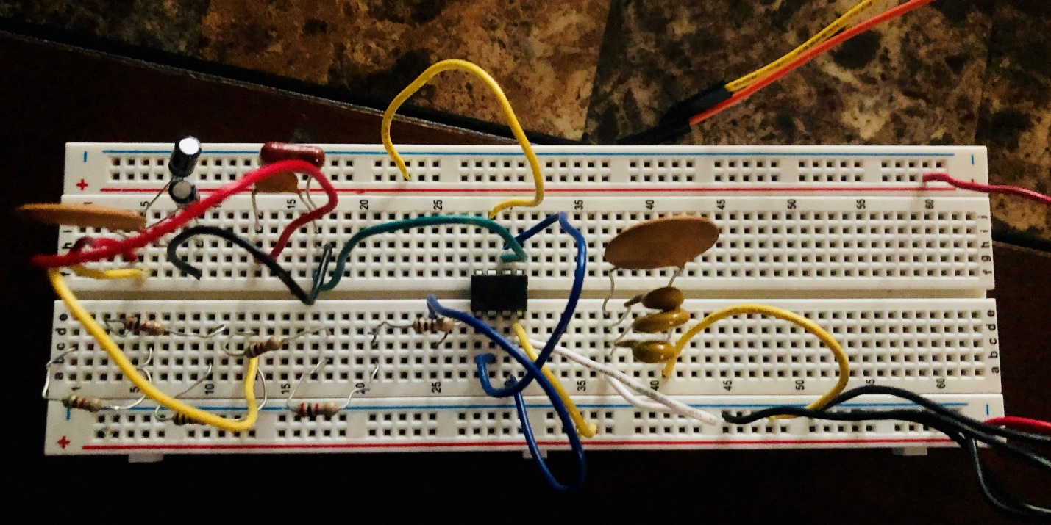

**Figure 3: Sallen Key Circuit for Q=1.5**

**Table 2: Task 1**

|  |  |  |  |
| --- | --- | --- | --- |
| **Frequency** | **Input Voltage Amplitude (Vi)** | **Output Voltage Amplitude (Vo)** | **Phase Difference (°)** |
| 10 Hz | 1 V | 1.02 V | Negligible |
| 18 Hz | 1 V | 1.04 V | Negligible |
| 32 Hz | 1 V | 1 V | Negligible |
| 56 Hz | 1 V | 1.066 V | -7.67 |
| 100 Hz | 999.7 mV | 1.2 V | -15.43 |
| 178 Hz | 999.3 mV | 1.461 V | -34.31 |
| 316 Hz | 999.8 mV | 1.253 V | -117.14 |
| 562 Hz | 998.9 mV | 453.4 mV | -146.77 |
| 1000 Hz | 999.2 mV | 98.237 mV | -166.89 |
| 1778 Hz | 1 V | 24.635 mV | -173.18 |
| 3162 Hz | 999.5 mV | 9.79 mV | -177.94 |
| 5623 Hz | 998.7 mV | 4.75 mV | -178.07 |
| 10000 Hz | 1 V | 1.06 mV | -179.56 |

**Cutoff : 425 Hz, -141.32°**

**Task 2:** Sinusoidal Steady-State Response of a 2nd Order High-Pass Circuit

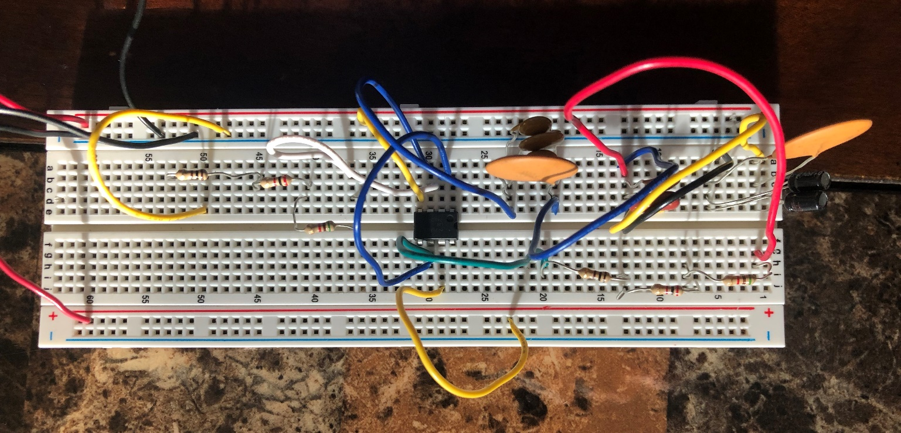

**Figure 4: Modified Sallen Key Circuit**

**Table 3: Task 2**

|  |  |  |  |
| --- | --- | --- | --- |
| **Frequency** | **Input Voltage Amplitude (Vi)** | **Output Voltage Amplitude (Vo)** | **Phase Difference (°)** |
| 10 Hz | 1 V | 0.350 mV | 173.62 |
| 18 Hz | 1 V | 2.05 mV | 163.12 |
| 32 Hz | 999.4 V | 7.43 mV | 153.56 |
| 56 Hz | 999.8 V | 19.13 mV | 137.49 |
| 100 Hz | 999.3 mV | 48.19 mV | 121.28 |
| 178 Hz | 999.5 mV | 102.2 mV | 108.29 |
| 316 Hz | 999.2 mV | 191.4 mV | 90.58 |
| 562 Hz | 1 V | 335.5 mV | 77.95 |
| 1000 Hz | 999.3 mV | 534.4 mV | 62.21 |
| 1778 Hz | 999.8 V | 743.1 mV | 43.06 |
| 3162 Hz | 999.6 mV | 889.7 mV | 27.06 |
| 5623 Hz | 1 V | 954 mV | 14.37 |
| 10000 Hz | 1 V | 1 V | 1 |

**Cutoff : 1778 Hz, 43.06°**

**Plots**

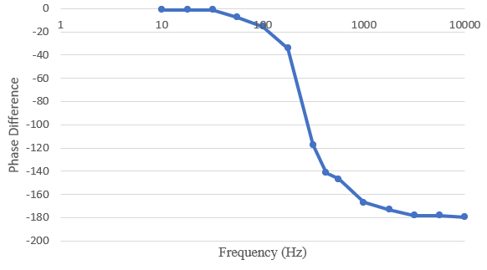

**Figure 5: Modified Phase vs Frequency Plot for Task 1**

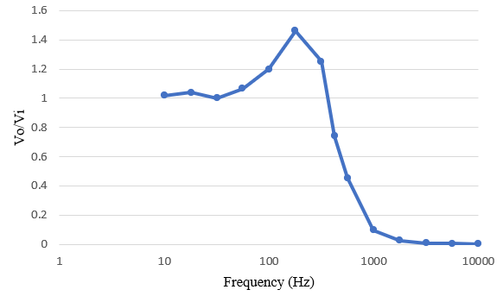

**Figure 6: Magnitude vs Frequency Plot for Task 1**

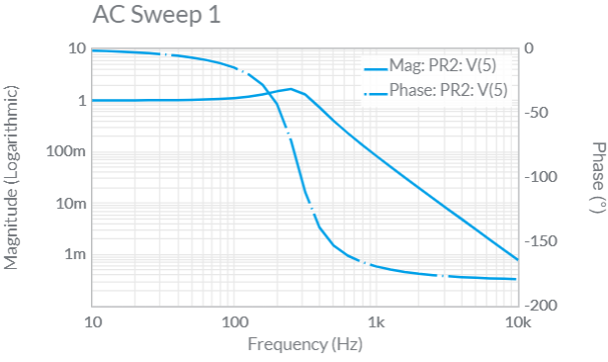

**Figure 7: Theoretical plot obtained for Task 1**

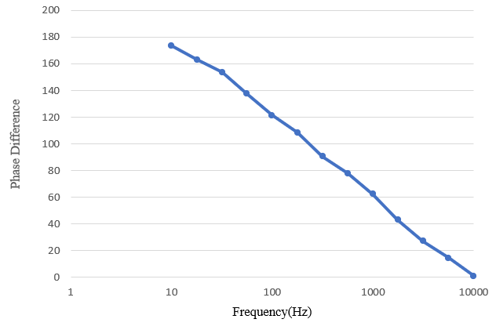

**Figure 8: Phase vs Frequency Plot for Task 2**

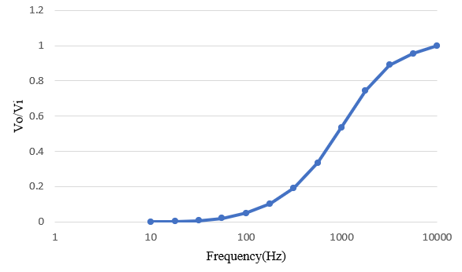

**Figure 9: Magnitude vs Frequency Plot for Task 2**

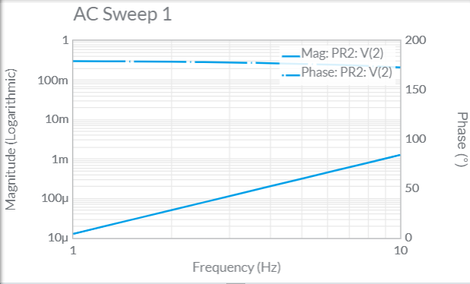

**Figure 10: Theoretical plot obtained for Task 2**

**Note:** The above provided graphs are scaled and have the frequency axis presented on a logarithmic scale. The reason behind this arrangement is that it showcases the general trends and datapoint changes more accurately compared to other configurations.

Graphs consisting of the vertical scale as the logarithmic scale were also made but not displayed in the report as they seemed repetitive and were not mentioned in the lab guidelines.

From the provided plots obtained via theoretical and observed means, one can comment favorably on the accuracy of the experiment as observation of the plots showcases similar graphs and overlapping trends. Upon comparison, the plots obtained in the low pass circuit do match up except for small bumps along the curve which did not affect the overall shape of the curve. Whereas the high pass circuit, the curve trend is similar but there tends to discrepancies.

There were hardly any differences found in the low pass one, while the high pass one showed more variation. This can be attributed a whole bunch of factors ranging from components chosen, human error etc. Overall, the experiment was done with a priority for accuracy and I shall continue to minimize errors as we continue with the other labs.

**Sample Calculations**

(A) Obtaining the Q and Wo value for the configuration

**R1**=7.2kΩ **R2**=7.2kΩ **C1**=250nF **C2**=25nF

Q===1.5

Wo==1756.82=560π

(B) Obtaining the phase from the waveform

Time obtained from the waveform, T= 795.1 µs

Phase = =90.58°

V. Discussion

Questions:

1. In the low-pass filter, the graphs suggest that the pass band would be around 150Hz or less and the stop band would be somewhere near 370Hz and greater. In the high pass filter, the data suggests that the pass band would lie around 3162 Hz and greater and the stop band would span 1000 Hz and less.
2. To adjust the range of the stop and pass bands, you must be able to adjust the input voltage which relies on R1, R2, C1, and C2. As those components increase, the Transfer Function will decrease, calling for greater range for the bands.
3. This may occur when the frequency is extremely low in a low-pass circuit or very high in a high-pass circuit. In this case the op-amp may produce a small spike in voltage that makes the output greater than the input due to the small capacitance that the transistors have within the component. Once the output voltage is greater than the input voltage, the wave will act like an underdamped response and oscillate with a decaying envelope.
4. I wouldn’t make any procedural changes to the lab as I believe that it was apt for inculcating the required lessons. However, I would like to make a couple of changes in the way that I performed the experiment. There lie discrepancies between the prelab values and the component values used in the lab as the previously considered values were changed due to lack of the specific component value.

Building on the reforms made earlier, a possible source of errors is the fact that the required resistors and capacitors were mostly made from a combination of individual components in different configurations. I would love to use a DMM next time and measure the exact resistance to avoid such errors from creeping into the lab. Additionally, there is the unknown resistance of the wires, board, and capacitor that may cause uncertainty to the measured values.

VI. Conclusion

The goal of the experiment i.e to learn more about the response of 2nd order circuits to sinusoidal inputs was achieved. A detailed comparison was also made between the simulated and theoretical data was obtained. Also, further practice debugging breadboard circuits and a better understanding of working with the RC circuits was obtained.