**Anagram Calculator**

The code is a Maven project created in Spring Tool Suite.

It uses the Spring MVC framework, with dependencies: spring-webmvc, javax.servlet-api

Servlet used is of a DispatcherServlet class and is mapped to a http request

Once the http request is sent with the *word* as the parameter, the controller extracts the *word* from the request, determines the valid anagrams and passes the information to the view for display.

Determination of the valid anagrams happen in 2 steps:

* Call a recursive method to fetch all possible combination of words with the *word* by rearranging its characters
* Looking up in the Dictionary of any of those words exists.

**Unit Test**

* Generates a GET request and returns 200 on successful match
* Result set does not have the word itself
* Anagrams are ordered alphabetically
* Anagrams are in the original case as in the Dictionary
* 404 error if the given string does not have an anagram or if the word is not provided

<http://localhost:8080/AnagramCalculator/getWord?word=glare>

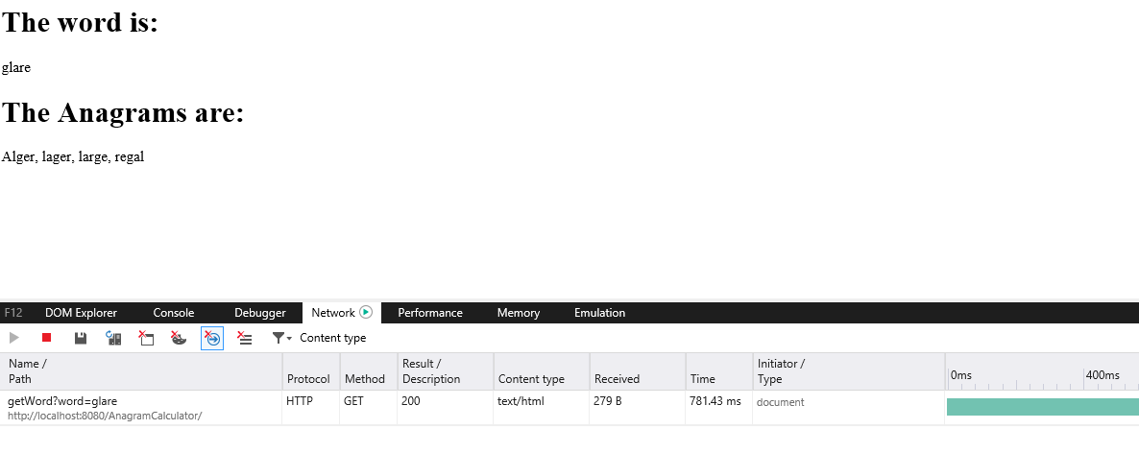

<http://localhost:8080/AnagramCalculator/getWord?word=team>

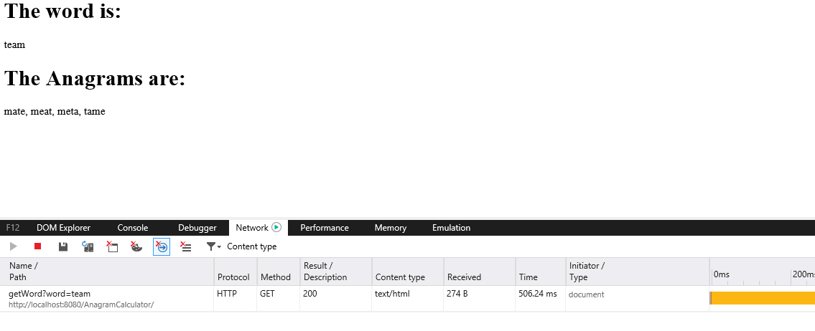

<http://localhost:8080/AnagramCalculator/getWord?word=sdf>

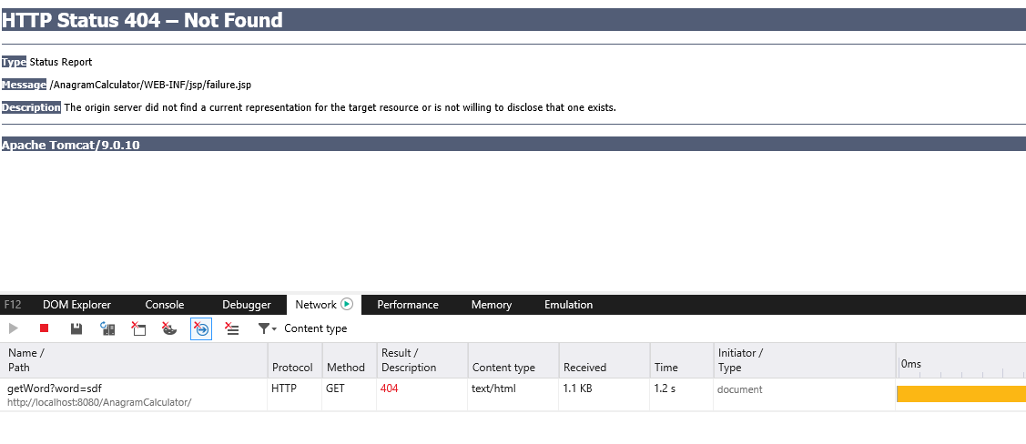

<http://localhost:8080/AnagramCalculator/getWord?word>=

