**PROJECT REPORT ON**

**QUIZZER- A QUIZ MANAGEMENT SYSTEM**

**ACADEMIC YEAR : 2020-21**



**NAME : Sajal Kumar**

**Shivam Sonkar**

**ROLL NO. : 13681781, 13681784**

**CLASS : XII-A**

**SUBJECT : COMPUTER SCIENCE**

**SUB CODE : 083**

**PROJECT GUIDE: Mr. Devinder Kumar [PGT (CS)]**

## KENDRIYA VIDYALAYA 3BRD CHANDIGARH



# **CERTIFICATE**

This is to certify that Mr. Sajal Kumar (33) & Mr. Shivam Sonkar (36) has successfully completed the project Work entitled **QUIZZER- A QUIZ MANAGEMENT SYSTEM** in the subject Computer Science (083) laid down in the regulations of CBSE for the purpose of Practical Examination in Class XII to be held in Kendriya Vidyalaya 3BRD Chandigarh.

Mr. Devinder Kumar

PGT Comp Science

**Examiner:**

Name: _______________

Signature:

|  |  |  |
| --- | --- | --- |
| **TABLE OF CONTENTS** | | |
| **SER** | **DESCRIPTION** | **PAGE NO** |
| 01 | ACKNOWLEDGEMENT |  |
| 02 | INTRODUCTION |  |
| 03 | OBJECTIVES OF THE PROJECT |  |
| 04 | PROPOSED SYSTEM |  |
| 05 | MOTIVATION |  |
| 06 | SYSTEM DEVELOPMENT LIFE CYCLE (SDLC) |  |
| 07 | ADVANTAGES |  |
| 08 | SOURCE CODE |  |
| 09 | OUTPUT |  |
| 10 | HARDWARE AND SOFTWARE REQUIREMENTS |  |
| 11 | BIBLIOGRAPHY |  |
| 12 | THE END |  |

**ACKNOWLEDGEMENT**

Apart from the efforts of me, the success of any project depends largely on the encouragement and guidelines of many others. I take this opportunity to express my gratitude to the people who have been instrumental in the successful completion of this project.

I gratefully acknowledge the contribution of the individuals who contributed in bringing this project up to this level, who continues to look after me despite my flaws,

My sincere thanks to Mr Devinder  A guide, Mentor all the above a friend, who critically reviewed my project and helped in solving each and every problem, occurred during implementation of the project

The guidance and support received from all the members who contributed and who are contributing to this project, was vital for the success of the project. I am grateful for their constant support and help.

**INTRODUCTION**

Quiz is a wonderful way to test one’s knowledge . But when it comes to storing the data is a structured and schematic way it is a hectic task so in order to tackle this problem we must have a data management system for this ,so this work of software management will not only help you to store the data but will also help you to maintain a detailed record of your quiz programme. **ENJOY!!!!!!**

­­­

**OBJECTIVES OF THE PROJECT**

The objective of this project is to allow the management to maintain a clean and structured detail of their quiz programme.

The main objective of “Quizzer” is to facilitate a user friendly environment for all users and reduces the manual effort. In past days quiz is conducted manually but in further resolution of the technology we are able to generate the score and pose the queries automatically.

The functional requirements include to create users that are going to participate in the quiz, automatic score and report generation and administrative tasks like add, delete, update for admin privilege users. In this application, all the permissions lies with the administrator.

Write programs utilizing modern software tools.

1. Apply simple principles effectively when developing small to medium sized projects.
2. Write effective procedural code to store small to medium sized information.

**PROPOSED SYSTEM**

Today one cannot afford to rely on the fallible human beings of be really wants to stand against today’s merciless competition where not to

One has to use the data management software. Software has been an ascent in atomization various organisations. Many software products working are now in markets, which have helped in making the organizations work easier and efficiently. Data management initially had to maintain a lot of ledgers and a lot of paper work has to be done but now software product on this organization has made their work faster and easier. Now only this software has to be loaded on the computer and work can be done.

This prevents a lot of time and money. The work becomes fully automated and any information regarding the organization can be obtained by clicking the button. Moreover, now it’s an age of computers of and automating such an organization gives the better look

**Motivation**

Currently most of the Examination like organizational recruitment, University class test are paper based, which costs time and resources. Questionnaire is developed, printed, and then collect data, entry, editing, cleaning, which time consuming and costly. Proposed application is the starting for avoid those circumstances which are been currently faced by any organization

**Problem Statement**

In the early days it was the most popular methods of assessing student. Still now the system is quite popular to the students as well as to the teacher. In this system there are several problems that we faces in a common way. Some of those problems are: Manual system requires pen/ pencils and paper. Teacher needs to spend time to script checking. Student needs to wait to get their result up to the teacher finishes the script checking. These are the most common problems of manual quiz system that rotated each and every time of quiz held. For these causes the popularity of manual system decreases day by day and online intelligent quiz system is taking the place of the manual system.

**SYSTEM DEVELOPMENT LIFE CYCLE (SDLC)**

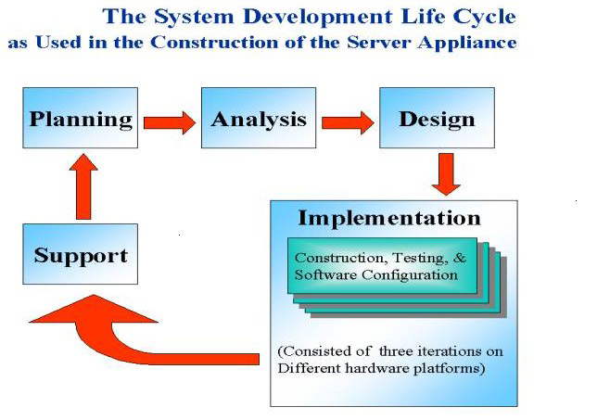

The systems development life cycle is a project management technique that divides complex projects into smaller, more easily managed segments or phases. Segmenting projects allows managers to verify the successful completion of project phases before allocating resources to subsequent phases.

**PICTORIAL REPRESENTATION OF SDLC:**

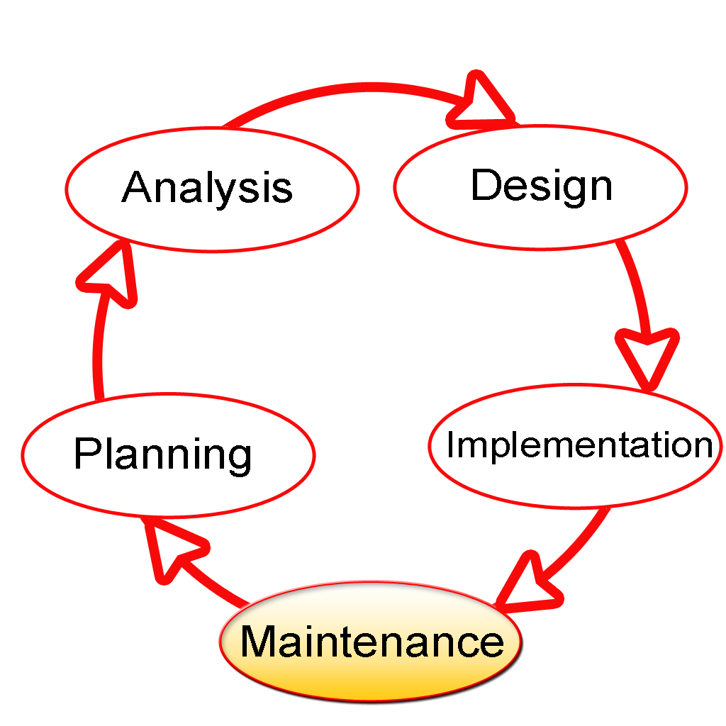

Software development projects typically include initiation, planning, design, development, testing, implementation, and maintenance phases. However, the phases may be divided differently depending on the organization involved.

For example, initial project activities might be designated as request, requirements-definition, and planning phases, or initiation, concept-development, and planning phases. End users of the system under development should be involved in reviewing the output of each phase to ensure the system is being built to deliver the needed functionality.

**ADVANTAGE**

* There is no interaction with pencil and paper.
* Teachers can use the system for evaluating students effectively, efficiently and perfectly. It is the more efficient and effective methods of assessing distant students
* There is provision of automated marking, that is, teachers do not need to check the answer script as they do in manual quiz.
* Valuable time of a teacher is saved.
* The system will give feedback about a student in which side he/she is weak.
* The system implements distant education

**SOURCE CODE**

* **import mysql.connector**
* **mydb=mysql.connector.connect(host="localhost",user="root",passwd="manager",database="quiz_comp")**
* **mycursor=mydb.cursor()**
* **#mycursor.execute("create table questions1(qno_no int(3) primary key , qno_desc varchar(10000),opt_a varchar(500), opt_b varchar(500), opt_c varchar(500) ,opt_d varchar(500) , ans varchar(5000))")**
* **print("QUIZ SOFTWARE")**
* **print("1.questions")**
* **print("2.participants")**
* **print("3.scores update")**
* **print("4.display")**
* **choice=int(input("enter your wish:"))**
* **if choice==1:**
* **sql=int(input("enter the index_no:"))**
* **sql1=input("enter the ques_desc:")**
* **sql2=input("enter the option a:")**
* **sql3=input("enter the option b:")**
* **sql4=input("enter the option c:")**
* **sql5=input("enter the option d:")**
* **sql6=input("the answer is:")**
* **sql_in= "insert into questions1 values(" + str( sql) + ",'" + (sql1)+ "'"+",'" + (sql2) + "'"+",'" + (sql3) +"'" +",'"+ (sql4) +"'"+",'" + (sql5) +"'"+ ",'"+(sql6) +"'"")"**
* **mycursor.execute(sql_in)**
* **mydb.commit()**
* **print("your request has been processed.Thank you for making us as a part of your project")**
* **#mycursor.execute("create table participants(reg_no int(5) primary key, pname varchar(50) ,age_group int(10),city varchar(50),no_of_appearances_made int(10))")**
* **if choice==2:**
* **sql6=int(input("enter the participant reg_no:"))**
* **sql7=input("enter the participant name:")**
* **sql8=int(input("enter the age group:"))**
* **sql9=input("enter the city:")**
* **sql10=int(input("enter the no of appearances made:"))**
* **sql_int="insert into participants values("+ str(sql6)+ ",'" + (sql7) + "'" + ",'"+str(sql8) + "'" + ",'"+(sql9) +"'"+ ",'"+str(sql10)+"'"")"**
* **print(sql_int)**
* **mycursor.execute(sql_int)**
* **print("participants are all updated")**
* **mydb.commit()**
* **#mycursor.execute("create table scores(reg_no int(5) primary key , participant_name varchar(50),scores int(50),total_correct int(50),total_wrong int(50),total_attempted int(50))")**
* **if choice==3:**
* **a=int(input("enter the reg_no"))**
* **b=input("enter the participants name")**
* **c=int(input("enter the scores"))**
* **d=int(input("enter the total correct answer"))**
* **e=int(input("enter the incorrect answer"))**
* **f=int(input("enter the no_of_attempted_questions"))**
* **sql_insert="insert into scores values("+ str(a) +",'"+ (b) +"'"+",'"+ str(c)+"'"+",'"+ str(d) +"'"+ ",'"+str(e) +"'"+",'"+ str(f)+ "'"")"**
* **print(sql_insert)**
* **mycursor.execute(sql_insert)**
* **mydb.commit()**
* **if choice==4:**
* **mycursor.execute("select * from questions1")**
* **data=mycursor.fetchall()**
* **print(data)**

**OUTPUT**

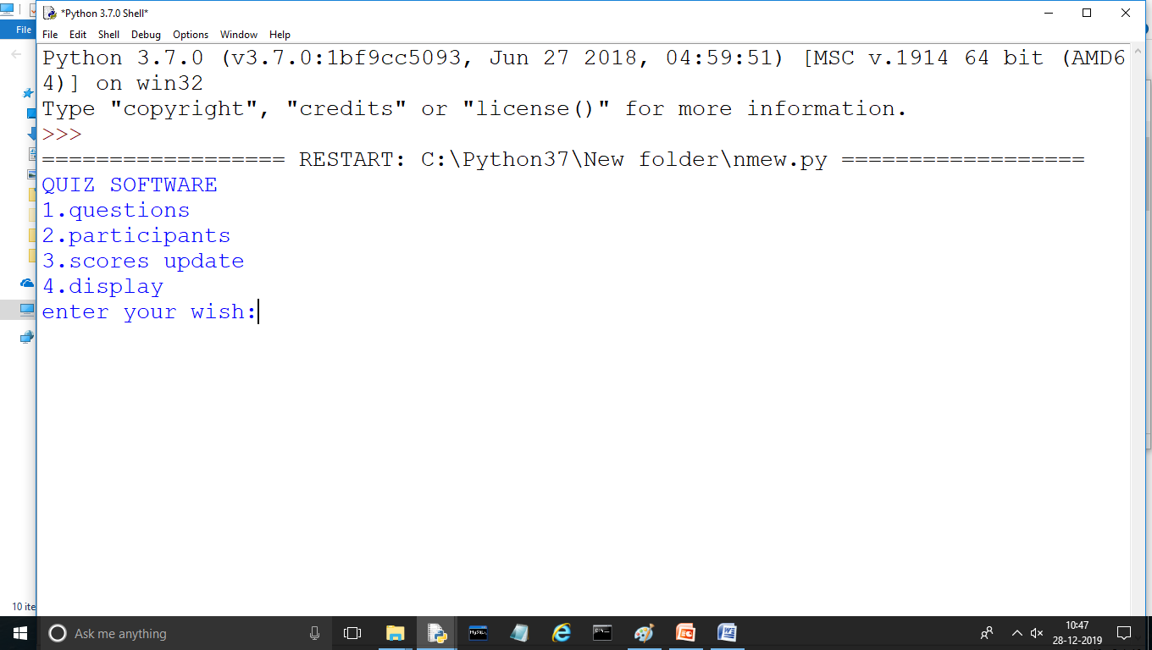



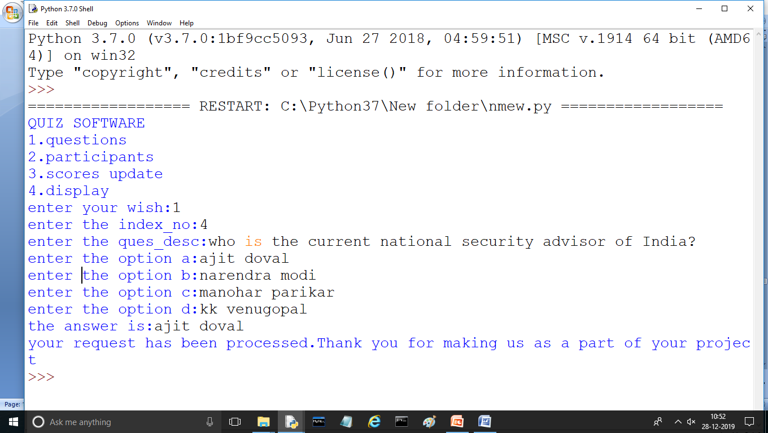

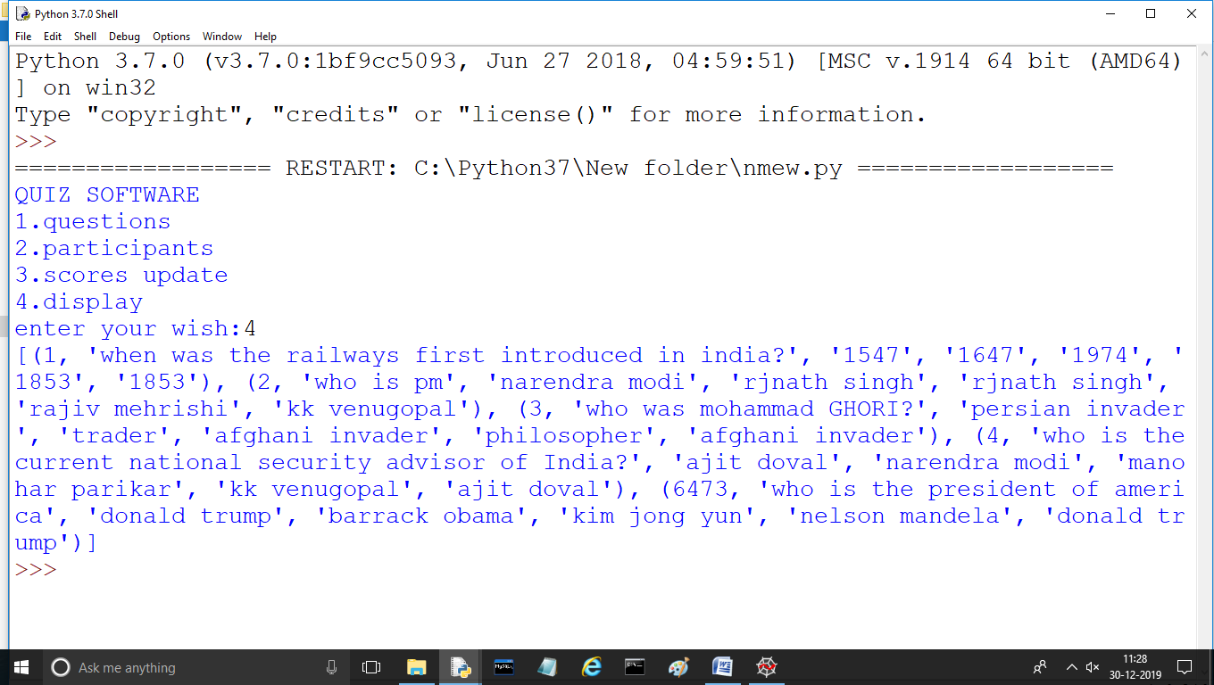

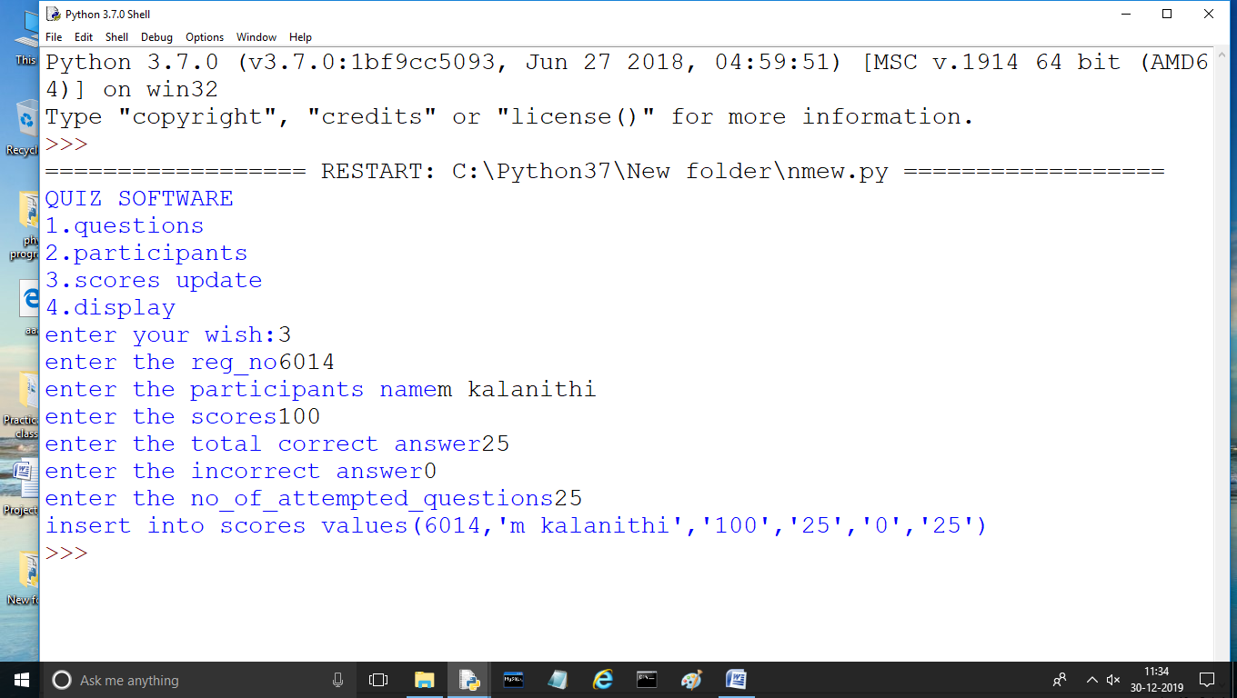

## System Configuration:

#### ****H/W System Configuration:-****

I.OPERATING SYSTEM : WINDOWS 7 AND ABOVE

II. PROCESSOR : PENTIUM(ANY) OR AMD

ATHALON(3800+- 4200+ DUAL CORE)

III. MOTHERBOARD : 1.845 OR 915,995 FOR PENTIUM 0R MSI

K9MM-V VIA K8M800+8237R PLUS CHIPSET FOR AMD ATHALON

IV. RAM : 512MB+

V. Hard disk : SATA 40 GB OR ABOVE

VI. MONITOR

VII. Key board and mouse

VIII. Printer : (if print is required – [Hard copy])

#### ****S/W System Configuration:-****

Operating system              : Windows 7/8/10.  
Available Coding Language : Python  
Database                          : MYSQL

.**BIBLIOGRAPHY**

1. ***Computer science With Python - Class XII By : Sumita Arora***
2. ***Website:*** [**https://www.w3resource.com**](https://www.w3resource.com)
3. ***Website- https://github.com***
4. ***Website- https://itsourcecode.com***

# ***The End***

## Thank You

***\*\*\****