Project Charter — Sales & Revenue Analytics

1. Business Context
The company operates an online retail business selling products to customers across multiple countries. Each transaction is recorded at the invoice level with item details, quantity, price, customer identity, and timestamp. Leadership wants to improve visibility into sales performance, customer value, and product profitability trends to support data-driven decision-making.

2. Business Objectives
This project aims to:
- Analyze total revenue and sales trends over time
- Identify top-performing products and underperformers
- Understand customer purchasing behavior and repeat purchase trends
- Analyze regional and country-wise sales distribution
- Detect returns and cancellations impact on revenue
- Build an interactive Power BI dashboard for ongoing business monitoring

3. Dataset Description (Mapped to Provided Columns)
Column | Meaning | Usage
InvoiceNo | Unique transaction ID (C* = cancelled) | Identify orders & returns
StockCode | Product code | Product-level metrics
Description | Product name | Reporting & grouping
Quantity | Units sold (negative = return) | Sales volume & revenue
InvoiceDate | Date & time of order | Trend & seasonality
UnitPrice | Price per unit (£) | Revenue calculation
CustomerID | Unique customer identifier | Customer analytics
Country | Customer country | Regional performance
A derived Revenue column will be created as:
Revenue = Quantity × UnitPrice

4. Key Business Questions
- Revenue Performance
  - What is the total revenue trend by day, month, and year?
  - Are there seasonal/peak sales periods?
- Product Performance
  - Which products generate the highest revenue?
  - Which products have the highest return volume?
- Customer Insights
  - What percentage of revenue comes from repeat customers?
  - Who are the highest-value customers?
- Geographic Performance
  - Which countries contribute the most revenue?
- Operational Risk
  - How much revenue is lost due to cancellations/returns?

5. Key Performance Indicators (KPIs)

Revenue & Sales
- Total Revenue
- Revenue Growth % (MoM / QoQ)
- Average Order Value (AOV)
- Revenue by Country
- Revenue by Product

Customer Analytics
- Total Customers
- Repeat Customer Rate
- Revenue per Customer

Returns / Risk
- Total Returned Quantity
- % of Orders Returned
- Revenue Impact from Returns

Operational
- Number of Orders
- Items per Order

6. Stakeholders
- CEO / Business Head – Strategic overview
- Sales & Marketing Teams – Customer & product insights
- Finance Team – Revenue & returns impact
- Operations Team – Return behavior monitoring

7. Project Scope

In Scope
✔ Data cleaning, preprocessing, and validation
✔ KPI design using SQL & Python
✔ Exploratory Data Analysis
✔ Customer segmentation & repeat analysis
✔ Interactive dashboards in Power BI
✔ Business insights & recommendations report

Out of Scope
✖ Real-time data ingestion
✖ Deployment to production systems
✖ Advanced machine learning (optional stretch goal later)

8. Tools & Technologies
- SQL – Data extraction, joins, KPI aggregation
- Python (Pandas, NumPy, Matplotlib/Seaborn) – Cleaning, EDA, RFM segmentation
- Power BI – Dashboard visualization & storytelling
- Excel / CSV – Initial exploration

9. Data Quality Considerations
We will handle:
- Missing CustomerID values
- Negative quantities (returns)
- Cancellations (InvoiceNo starting with “C”)
- Zero/negative prices
- Duplicate records
Returns will be flagged and treated separately during revenue calculation.

10. Success Criteria
This project will be considered successful when:
- KPIs are validated and accurate
- Dashboard clearly answers business questions
- Users (stakeholders) can drill down into:
  - Revenue by time, product, and geography
  - Customer behavior & repeat purchases
  - Returns and cancellation impact
- Insights are actionable and clearly documented

Readme File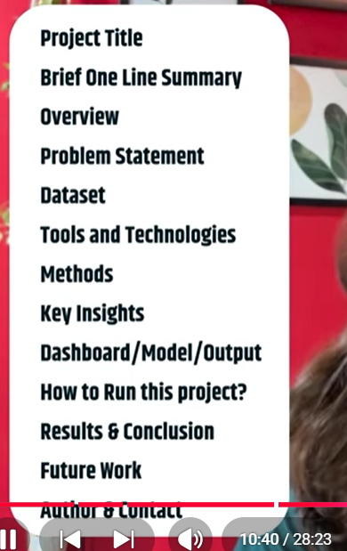

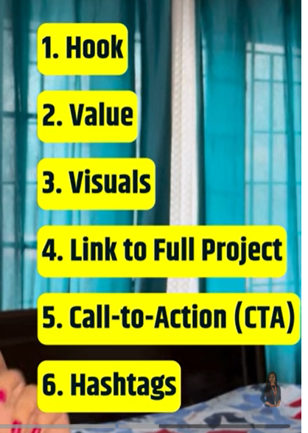

Healthcare analytics (patient wait times)

