Sales & Revenue Analytics
- See all the data imported
select * from retail_sales;
- Basic Data Validation

SELECT COUNT(*) FROM retail_sales;
SELECT MIN(InvoiceDate), MAX(InvoiceDate)
FROM retail_sales;
SELECT * FROM retail_sales LIMIT 10;

- Create retail_sales_clean with col : OrderDate, OrderMonth, Revenue, IsCancelled
CREATE TABLE retail_sales_clean AS
SELECT
InvoiceNo,
StockCode,
Description,
Quantity,
InvoiceDate,
DATE(InvoiceDate) AS OrderDate,
DATE_FORMAT(InvoiceDate, '%Y-%m') AS OrderMonth,
UnitPrice,
CustomerID,
Country,

(Quantity * UnitPrice) AS Revenue,

CASE
WHEN InvoiceNo LIKE 'C%' OR Quantity < 0 THEN 1
ELSE 0
END AS IsCancelled

FROM retail_sales;

- Remove zero/negative price rows

DELETE FROM retail_sales_clean
WHERE UnitPrice <= 0;

- Remove rows with zero quantity

DELETE FROM retail_sales_clean
WHERE Quantity = 0;

Business KPIs

1. Total Revenue (Excluding Returns)

SELECT
SUM(Revenue) AS Total_Revenue
FROM retail_sales_clean
WHERE IsCancelled = 0;

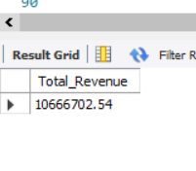

2. Total Revenue Lost Due to Returns

SELECT
SUM(Revenue) AS Return_Revenue_Impact
FROM retail_sales_clean
WHERE IsCancelled = 1;

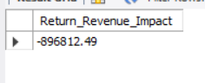

3. Net Revenue (Revenue − Returns)

SELECT
SUM(CASE WHEN IsCancelled=0 THEN Revenue ELSE 0 END) -
ABS(SUM(CASE WHEN IsCancelled=1 THEN Revenue ELSE 0 END))
AS Net_Revenue
FROM retail_sales_clean;

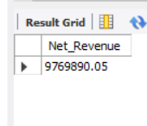

4. Monthly Revenue Trend

SELECT
OrderMonth,
SUM(CASE WHEN IsCancelled=0 THEN Revenue ELSE 0 END) AS Monthly_Revenue,
SUM(CASE WHEN IsCancelled=1 THEN Revenue ELSE 0 END) AS Return_Impact
FROM retail_sales_clean
GROUP BY OrderMonth
ORDER BY OrderMonth;

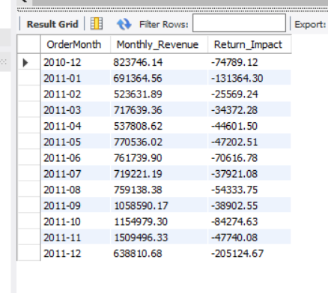

5. Top 10 Countries by Revenue

SELECT
Country,
SUM(Revenue) AS Revenue
FROM retail_sales_clean
WHERE IsCancelled = 0
GROUP BY Country
ORDER BY Revenue DESC
LIMIT 10;
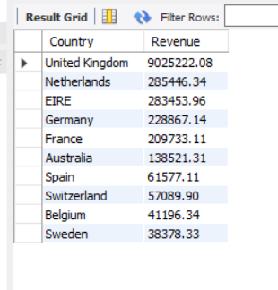

6. Top 10 Products by Revenue

SELECT
Description,
SUM(Revenue) AS Revenue
FROM retail_sales_clean
WHERE IsCancelled = 0
GROUP BY Description
ORDER BY Revenue DESC
LIMIT 10;

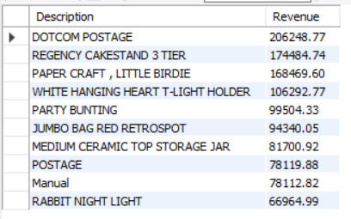

7. Repeat Customer Rate

SELECT COUNT(DISTINCT CustomerID)
FROM retail_sales_clean
WHERE CustomerID IS NOT NULL;

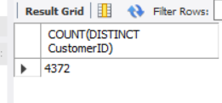

8. Customers with more than 1 order

SELECT COUNT(*)
FROM (
SELECT CustomerID
FROM retail_sales_clean
WHERE CustomerID IS NOT NULL
GROUP BY CustomerID
HAVING COUNT(DISTINCT InvoiceNo) > 1
) t;
