﻿NAME: Akash Gupta

ASSIGNMENT1

ID NO: 1001122031

a)READ ME and Explanation of code:

-Execute the Programming assignment 2 by going to

'http://cloudcomp2-979.appspot.com/uploadfile' into browser window.

(screenshot1)

-uploadform function of main.py will be executed.

-After uploading csv file page will be redirected to

'http://cloudcomp2-979.appspot.com/uploadfile' (screenshot2)

-Time taken to upload the file into google bucket will be displayed.

-By clicking 'Go to MySQL', main function of main.py will be executed.

-Database and Table is created

-Different functions of main.py is called internally.

-Final result gives time to insert data in MySQL database and query result

as values for each week and each magnitude (screenshot3,4,5)

-views folder contain

upload_form.tpl

upload_file.tpl

b)Timinings

2 Example Result of Timings:

Resul1:

i) Time taken to upload file into bucket is: 0.731189966202 sec

ii)Time taken to Insert data into MySQL database is: 22.65294981

Result2:

i) Time taken to upload file into bucket is: 0.451280117035 sec

ii)Time taken to Insert data into MySQL database is: 23.9177899361

c)References:

-https://www.google.com/search?client=ubuntu&channel=fs&q=slicing+in+python&ie=utf-8&oe=uf-8#channel=fs&q=sub+string+in+python+stackoverflow

-http://www.tutorialspoint.com/python/string_replace.htm

-https://console.developers.google.com/freetrial?hl=en&_ga=1.170330921.840266212.1433886398

-http://stackoverflow.com/questions/15064376/python-read-a-csv-and-place-values-in-mysql-database

-https://cloud.google.com/appengine/docs/python/requests

-http://stackoverflow.com/questions/17841468/how-to-open-and-process-csv-file-stored-in-googlecloud-storage-using-python

d)Screenshots

Screenshot1:

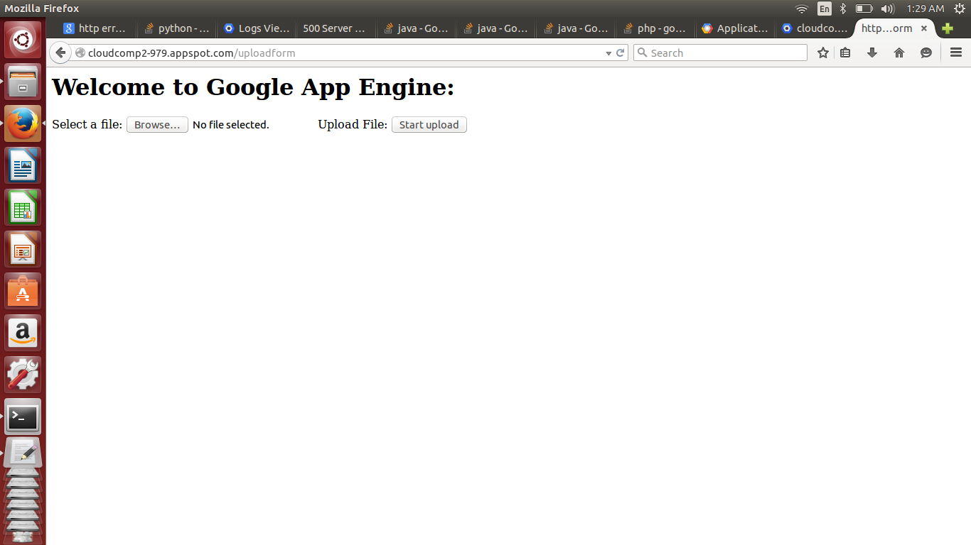

Screenshot2:

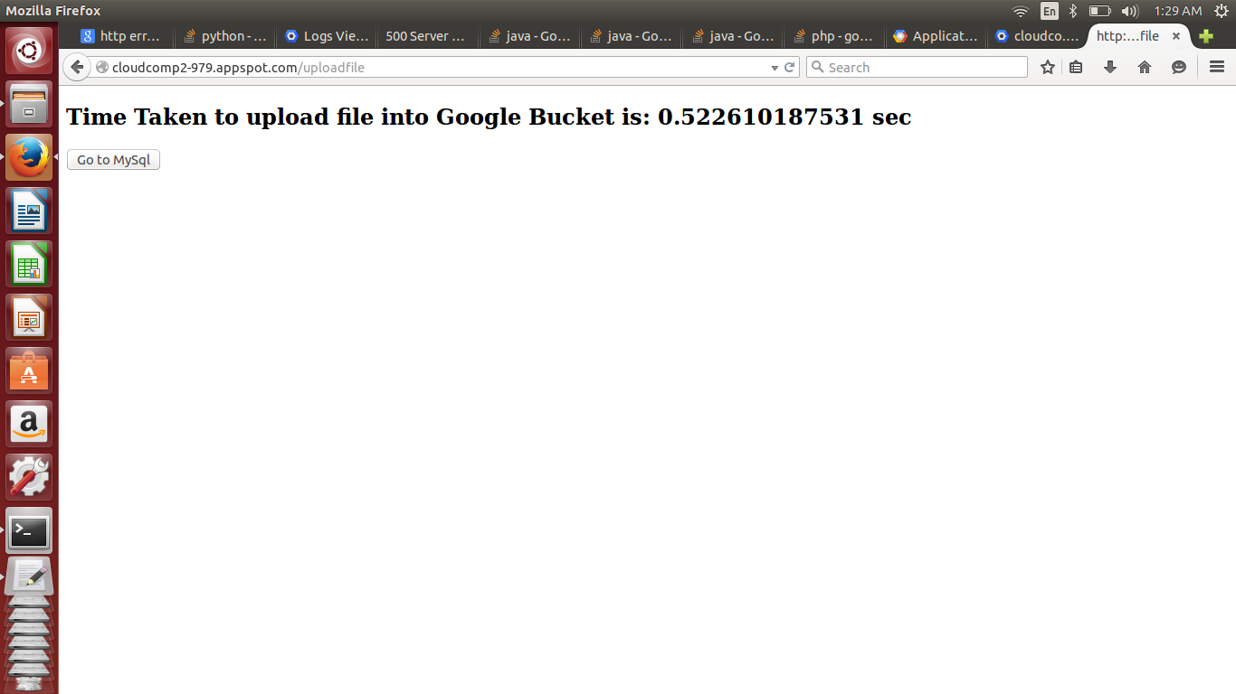

Screenshot3: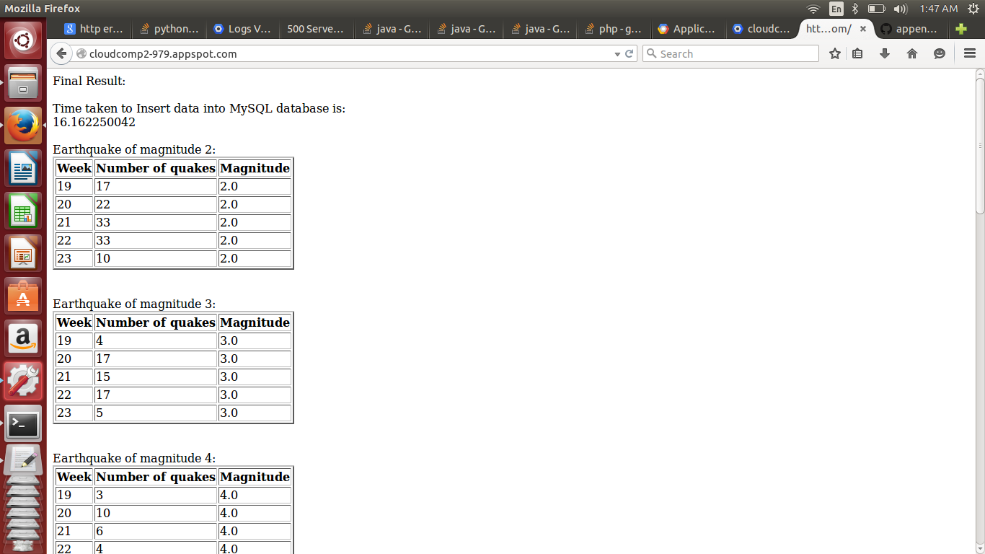

Screenshot4:

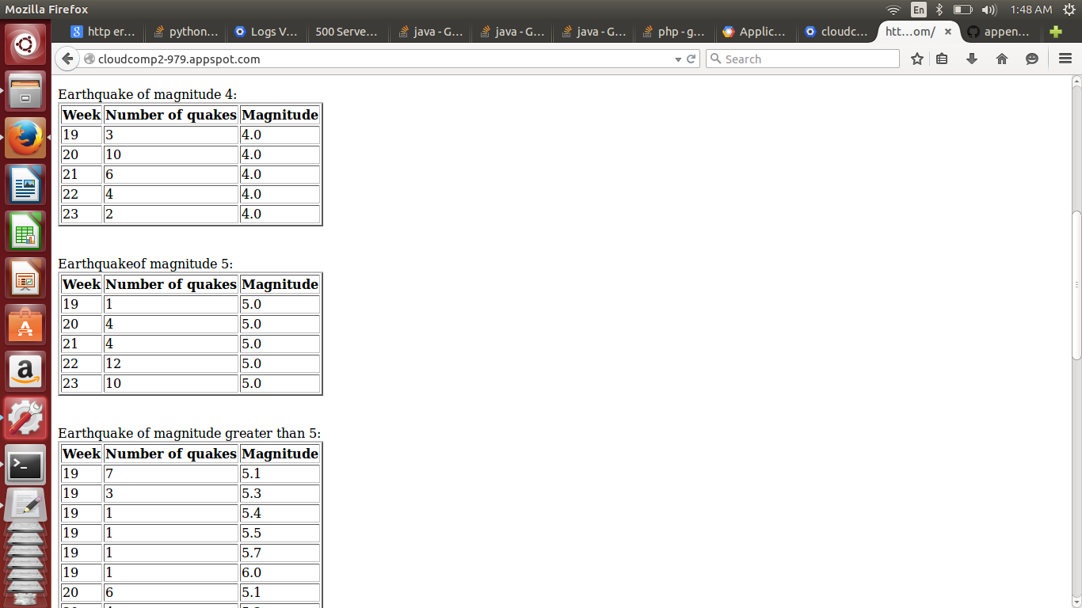

Screenshot 5:

