AIM :-

- To generate Pulse Amplitude Modulated(PAM) wave & observe its characteristics on a CRO.

APPARATUS REQUIRED :-

- PAM Modulator
- Function Generator
- CRO setup

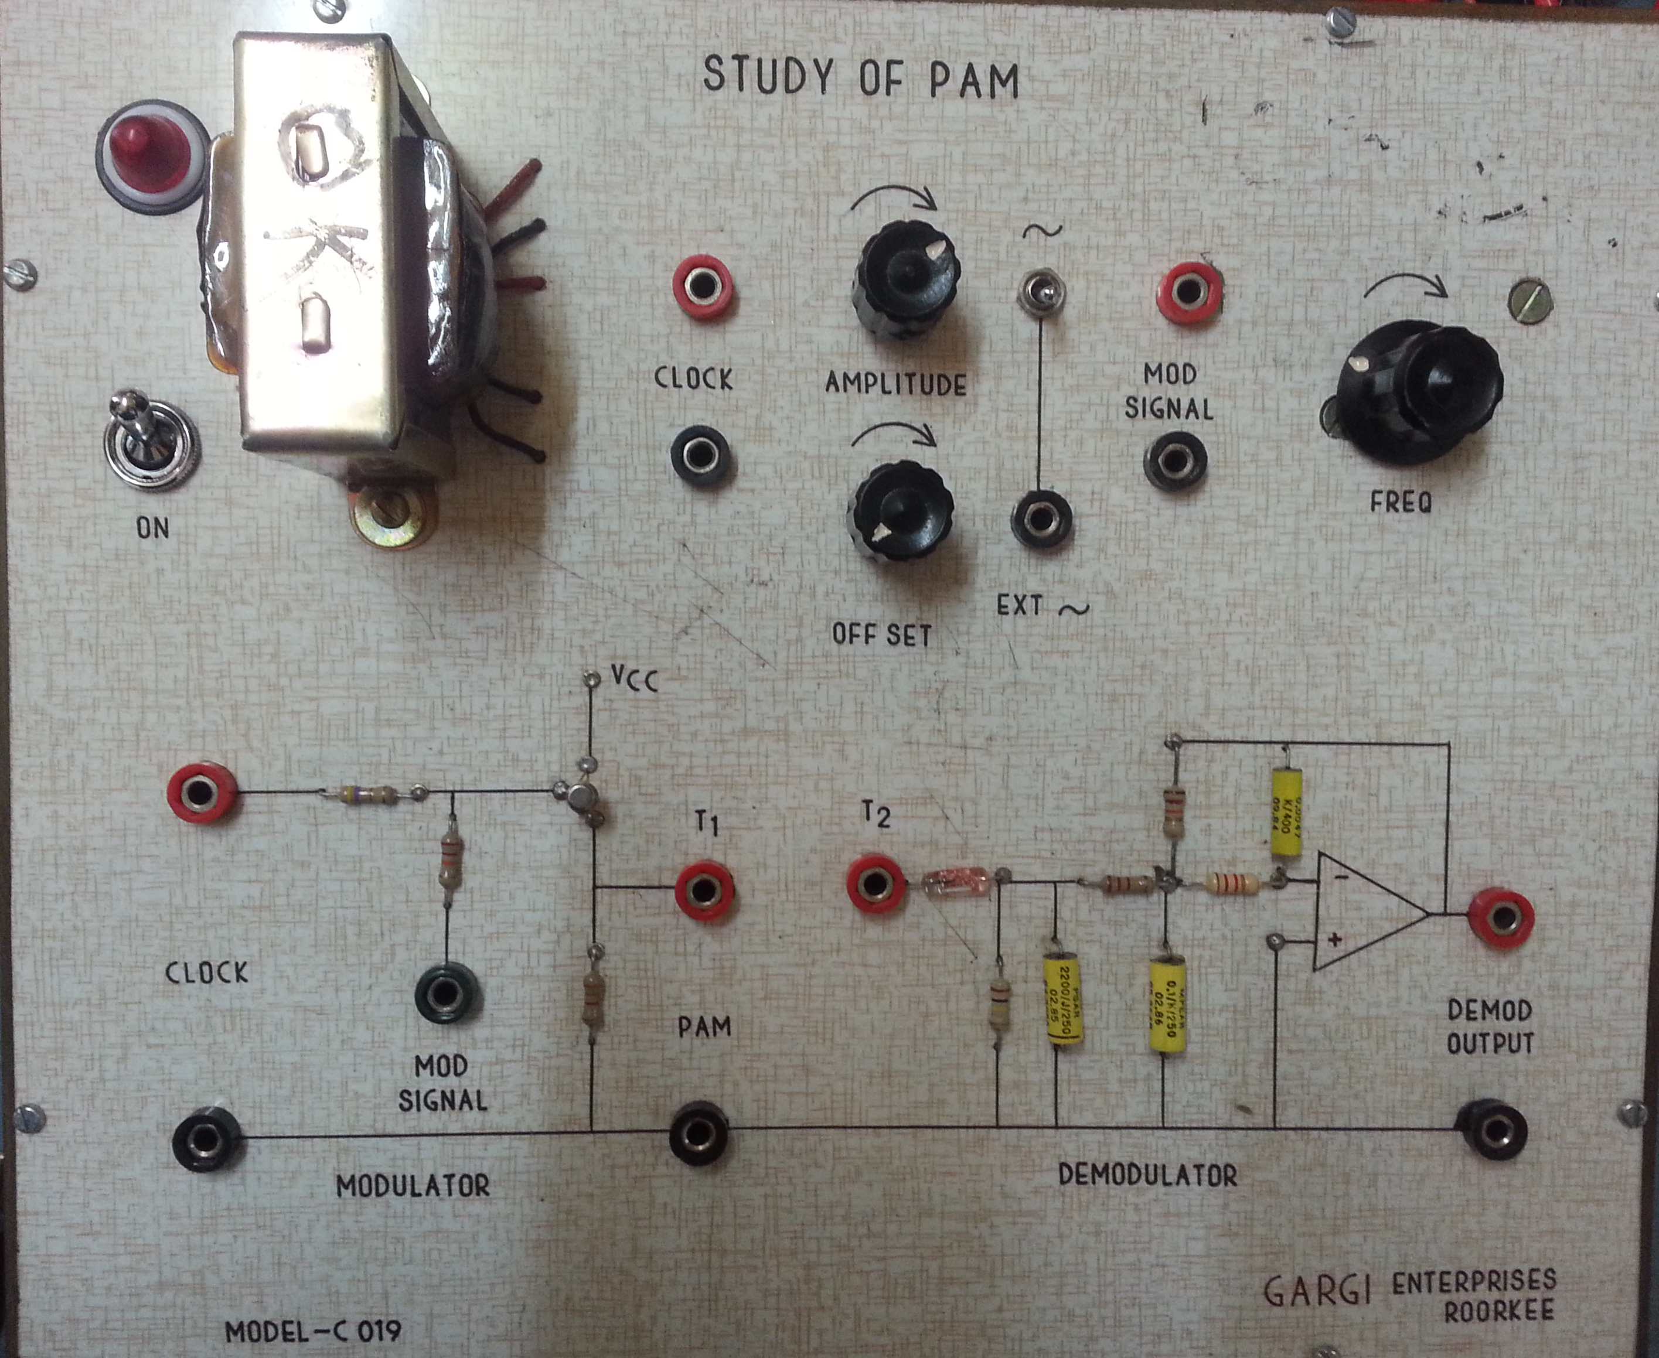

THEORY :-

Pulse Amplitude Modulation (PAM) : It is a form of signal modulation where the message information is encoded in the amplitude of a series of signal pulses. It is an analog pulse modulation scheme in which the amplitudes of a train of carrier pulses are varied according to the sample value of the message signal. Demodulation is performed by detecting the amplitude level of the carrier at every symbol period.

In PAM, the amplitude of a train of constant-width pulses is varied in proportional to the sample values of the modulating signal.
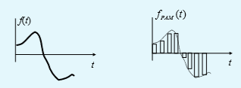

Generating a PAM signal could be divided into two processes: Sampling and Holding.

SAMPLING : Consider a low pass signal that is band- limited to and multiplied by a periodic train of very narrow rectangular pulses. The sampling interval T is taken as the Nyquist interval seconds.

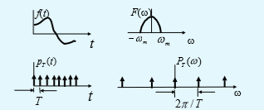
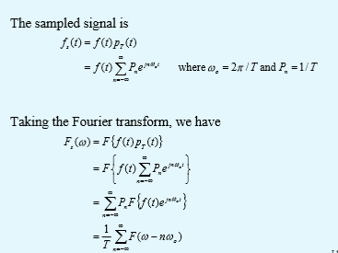
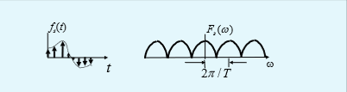

HOLDING (Lengthening): It can be achieved by applying the sampled signal to a time-invariant filter with unit impulse response.

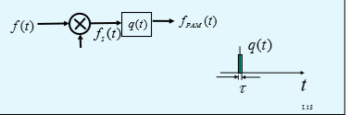

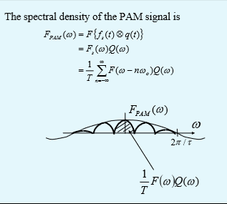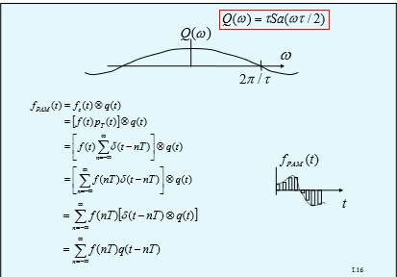

TYPES OF PAM:

There are two types of Pulse Amplitude Modulation:

- SINGLE POLARITY PAM: In this a suitable fixed DC bias is added to the signal to ensure that all the pulses are positive.

- DOUBLE POLARITY PAM: In this the pulses are both positive and negative.

- In case of wireless transmission of PAM signal, we always use PAM either with Amplitude Modulation or Frequency Modulation.
- The number of possible pulse amplitudes in analog PAM is said to be infinite. Digital PAM reduces the number of pulse amplitudes to some power of two.
For ex- in 4-level PAM there are 2*2 possible discrete pulse amplitudes.

OBSERVATIONS:

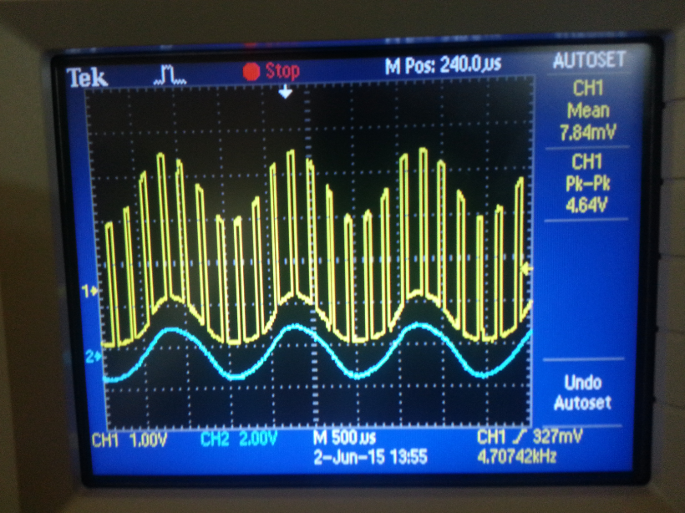
- CH1 – Yellow wave- Pulse Amplitude Modulated(PAM) signal
- CH2 – Blue wave- Modulating signal

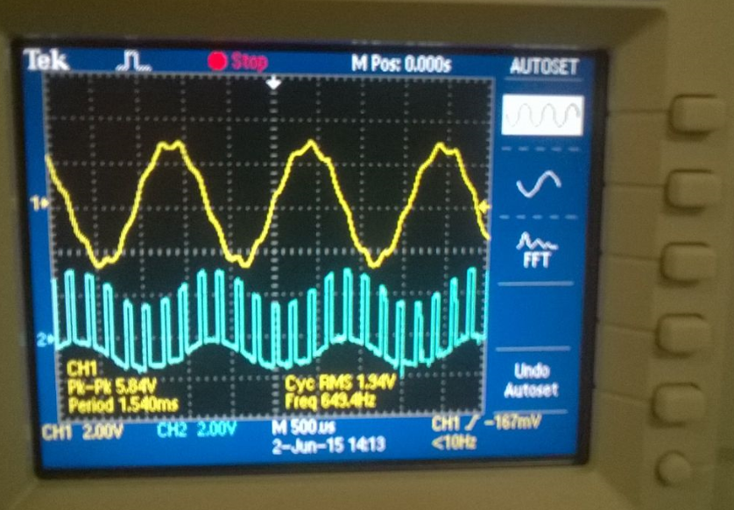

- CH1 – Yellow wave- Demodulated output
- CH2 - Blue wave- Pulse- Amplitude Modulated(PAM) signal

PRECAUTIONS:

- All connections should be tight while observing the experiment.
- PAM trainer kit should be handled with care.
- Set an appropriate scale of Voltage & Time axis in CRO while observing the output.

USES:

- Pulse-Amplitude Modulation is widely used in modulating signal transmission of digital data, with non-baseband applications having been largely replaced by Pulse-Code Modulation and more recently by Pulse-Position Modulation.

- All telephone Modems faster than 300 bit/s use Quadrature Amplitude Modulation(QAM).

- Some versions of the Ethernet communication are an example of PAM usage.

- Pulse-amplitude modulation has also been developed for the control of LEDs especially for lighting applications.

Drawbacks of Pulse-Amplitude Modulated Signal:

- The bandwidth required for the transmission of a PAM signal is very large in comparison to the maximum frequency present in the modulating signal.

- Since the amplitude of the PAM pulses varies in accordance with the modulating signal therefore the interference of noise is maximum in a PAM signal, this noise cannot be removed easily.

- Since the amplitude of the PAM signal varies therefore, this also varies the peak power required by the transmitter with modulating signal.

IC-741 Operational Amplifier:

( Here it is used as a component in PAM Demodulator circuit.)

FEATURES:

- Overload Protection on the Input and Output.
- No Latch-Up When the Common Mode Range is Exceeded.

DESCRIPTION :

- The IC741 series are general purpose operational amplifiers which feature improved performance over industry standards like the IC709. They are direct plug-in replacements for the 709C, IC201, IC1439 and 748 in most applications.

- The amplifiers offer many features which make their application nearly foolproof: overload protection on the input and output, no latch-up when the common mode range is exceeded, as well as freedom from oscillations.

- The IC741C is identical to the IC741/IC741A except that the IC741C has their performance ensured over a 0°C to +70°C temperature range, instead of −55°C to +125°C.

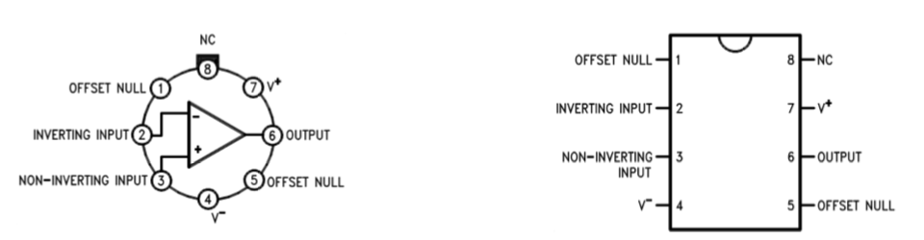

PROCEDURE:

- Switch on pulse Amplitude modulation and demodulation trainer.

- Check the clock generator (RF)output signal.

- Connect RF output of clock generator to the RF input of modulator section.

- Connect a 1KHz; 2vp-p of sine wave from function generator to the AF input of modulator section.

- Short the terminal1 and terminal2 of modulator.

- Connect the CRO to modulated output of modulator section.

- Adjust the 1k potentiometer to vary the amplitude of the modulated signal.

- Adjust the AF signal frequency from 1KHZ-10KHZ to get stable output waveform. While increases the AF signal frequency decreases the output signal pulses.

- During demodulation, connect the modulated output to the PAM input of Demodulator section.

- Connect channel 1 of CRO to modulating signal and channel-2 to demodulated output. Observe the two waveforms that they are 180degree out of phase, since the transistor detector operates in CE configuration.

