R2 Library Trusted Authentication Configuration

Document Purpose:
This document defines the basic configuration and client coding for creating an access link from a secure internal intranet page to R2libary.com

Intended Audience:
This document is intended for developers and technical support staff. Technical questions should be referred to customerservice@r2library.com

Trusted Authentication Configuration:
This feature allows an institution to create an access link from a secure internal intranet page to R2library.com. It requires coding on the institution’s web site to implement properly. There are two methods to setup the trusted authentication. The first way is to implement the logic used to create the hash values appended to query string parameters on the URL for R2library.com. This is the most secure way. The second way utilizes the same authentication logic as the first method, but r2library.com will create the query string parameters for the URLs via a secure web service.
Before implementing either method, trusted authentication must be enabled for your institution. This configuration can be performed on the Profile page in the Institutional Management section under the Admin tab. To enable trusted authentication, edit your institution and enter a 16 alphanumeric string in the Trusted Authentication Key text field. (See the blue arrow in the screenshot below.) This key can be any random sequence of letters or numbers but must be exactly 16 characters in length. This key value along with other parameters is used to calculate a SHA1 hash passed along in the URL to authenticate the identity of your institution.
Note: Trusted authentication links will not allow access to the admin area of R2library.com, but will allow access to all your institution’s titles. Trusted authentication links are only valid for 30 minute. Your intranet web site should generate new trusted authentication links for each page request where the links appear. Caching these links is NOT recommended.

R2Library.com Links:
Note that the link into R2library.com cannot be placed on a public page or you will give access to
R2library.com to the general public which is a violation of your license agreement. Providing public access could greatly impact your institution’s reporting statistics.
The trusted authentication links require three query string parameters.
- acctno – Rittenhouse/R2Library.com account number. This value can be found on the institution profile page under the R2Library.com Admin tab. (See the red arrow in the screenshot below.)
- timestamp – This is the UTC timestamp of when the link or hash was generated. The format of this field is “yyyyMMddHHmmss” where:
  - yyyy – 4 digit year
  - MM – 2 digit month
  - dd – 2 digit day
  - HH – 2 digit hour, 00 to 23
  - mm – 2 digit minute
  - ss – 2 digit second
- hash – This value is generated use one of the two method outline below.

R2Library.com Home Page Link
http://www.r2library.com/?acctno=005034&timestamp=20140422182130&hash=SUbIaxbkP0UIrsRe1pljYuXACZIxMjM0NTY3ODkxMDEyMTMx

R2Library.com Resource Title Page Link
http://www.r2library.com/Resource/Title/1284025373/?acctno=005034&timestamp=20140422182353&hash=sMgzvTSFn9YcUcmFGLEhbLdJNLExMjM0NTY3ODkxMDEyMTMx

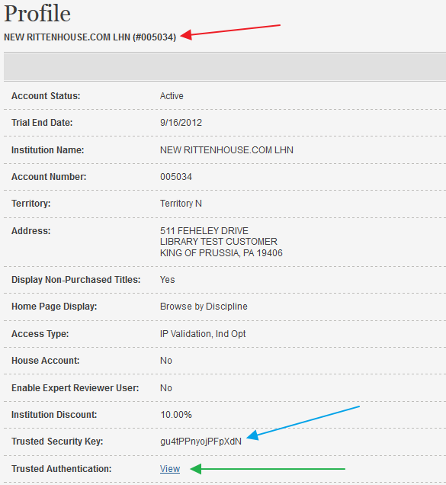

Method 1 – Hash created by code:
The recommended method for implementing R2Library.com trusted authentication is by implementing the hash generation code on your institutions web server. The code can be implemented in any server side language. Provided below is a C# implementation of the hash generation code.

C# Code Example:
The following code few lines of code generated the trusted authentication link into R2Library.com. This code utilizes the code contained in the R2LibraryTrustedAuth.cs, which is also provided below.
string accountNumber = "005034";
string r2TrustedSecurityKey = "gu4tPPnyojPFpXdN";
R2LibraryTrustedAuth trustedAuth = new R2LibraryTrustedAuth();
string r2Link =
string.Format("http://www.r2Library.com/?acctno={0}&timestamp={1}&hash={2}",
accountNumber, trustedAuth.GetTimeStamp(),
trustedAuth.GetHashKey(accountNumber, r2TrustedSecurityKey));

R2LibraryTrustedAuth.cs
Class to generate the hash value and the timestamp value needed for the query string parameters.
using System;
using System.Collections.Generic;
using System.Security.Cryptography;
using System.Text;

namespace TrustedAuthenicationExample
{
public class R2LibraryTrustedAuth
{
private DateTime _utcTimestamp = DateTime.UtcNow;

public DateTime UtcTimestamp
{
get { return _utcTimestamp; }
}

public string GetTimeStamp()
{
return string.Format("{0:yyyyMMddHHmmss}", _utcTimestamp);
}

public string GetHashKey(string accountNumber, string saltKey)
{
string builder = new StringBuilder()
.Append(accountNumber)
.Append("|")
.Append(_utcTimestamp)
.ToString();
byte[] bytes = new ASCIIEncoding().GetBytes(saltKey);
string str = ComputeSha1Hash(builder, bytes);
return Uri.EscapeUriString(str);
}

private static string ComputeSha1Hash(string plaintext,
IList<byte> saltBytes)
{
Byte[] plainTextBytes = Encoding.UTF8.GetBytes(plaintext);
Byte[] plainTextWithSaltBytes = new byte[plainTextBytes.Length +
saltBytes.Count];

for (int i = 0; i < plainTextBytes.Length; i++)
{
plainTextWithSaltBytes[i] = plainTextBytes[i];
}

for (int i = 0; i < saltBytes.Count; i++)
{
plainTextWithSaltBytes[plainTextBytes.Length + i] =
saltBytes[i];
}

HashAlgorithm hash = new SHA1Managed();
Byte[] hashBytes = hash.ComputeHash(plainTextWithSaltBytes);
Byte[] hashWithSaltBytes = new byte[hashBytes.Length +
saltBytes.Count];

for (int i = 0; i < hashBytes.Length; i++)
{
hashWithSaltBytes[i] = hashBytes[i];
}

for (int i = 0; i < saltBytes.Count; i++)
{
hashWithSaltBytes[hashBytes.Length + i] = saltBytes[i];
}
String hashValue = Convert.ToBase64String(hashWithSaltBytes);
return hashValue;
}
}
}

Method 2 – Hash created by R2Library.com web service:
To make trusted authentication easier to implement for our clients, an alternate method for generating the hash value was created. This method utilizes a secure web service on the R2Library.com server to generate the hash value. (The web service is recurred via IP authentication.)
In order to use the web service, R2Library.com must be configured to allow your institution access to the web service. Please contact customer support for access. When contact customer server, please provide the IP address of your institution’s intranet web service.
When your institution is configured, you will see your intranet web server’s IP address and authentication key displayed when you click the ‘view’ link next to Trusted Authentication on the institution profile page. (See the green arrow on the screenshot above.)

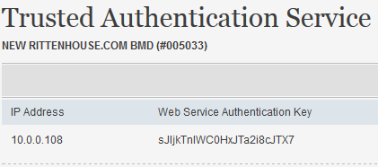
This authentication key is used to identify your institution. This key along with the servers IP address must be entered by a Rittenhouse Administrator and will be part of the initial implementation.
The URL for the web service is, www.r2library.com/TrustedAuthentication/. This service take only one query string parameter, ‘authenticationKey’. Example:
http://www.r2library.com/TrustedAuthentication/?authenticationKey=sJIjkTnlWC0HxJTa2i8cJTX7
The request will than pass back a query string parameters that will need to be appended to the URLs into R2library.com. This type of authentication will not allow you to access the admin area of R2library.com, but it will allow access to all your titles. The links on the institution’s web page will have a 30 minute time out. After the 30 minute time out new links will need to be generated. Examples of links into the website, the portions highlighted in yellow is what the web request will provide:
A .NET and a PHP example are provided below. However, the call to the R2Library.com web service can be implemented in other server-side web programming languages. This CANNOT be implemented utilizing client side scripting (ex. JavaScript) because R2library.com will use the server side IP address as part of the institutional authentication. You will need to contact the support above to do the initial implementation.

.NET Code Example:

WebTrustedAuthentication.cs – Helper Class
public class WebTrustedAuthentication
{
public string Timestamp { get; set; }
public string Hash { get; set; }
public string ErrorMessage { get; set; }

public string GetQueryStringParameters(string accountNumber)
{
return string.Format("acctno={0}&timestamp={1}&hash={2}",
accountNumber, Timestamp, Hash);
}
}

TrustedAuthentication.aspx – ASPX code
<%@ Page Language="C#" AutoEventWireup="true"
CodeBehind="TrustedAuthentication.aspx.cs" Inherits="TrustedAuthentication" %>
<!DOCTYPE html>

<html xmlns="http://www.w3.org/1999/xhtml">
<head runat="server">
<title>A Basic Implementation of Trusted Authentication Service</title>
</head>
<body>
<label>Links to R2library.com</label>
<br/>
<a id="HomePageLink" runat="server" target="_blank"></a>
<br/>
<a id="BookLink" runat="server" target="_blank"></a>
<br/>
<label id="ErrorMessage" runat="server"></label>
</body>
</html>

TrustedAuthentication.aspx.cs – ASPX Code Behind
//24 character Trusted Authenication Serivce Key.
private const string TrustedAuthenticationKey = "BChwmnK0WXYjq9sbvVdxCkGS";

//Institution account number
private const string AccountNumber = "005034";

protected void Page_Load(object sender, EventArgs e)
{
string r2Url = "http://www.r2library.com/TrustedAuthentication/";
string webRequestUrl = string.Format("{0}?authenticationKey={1}",
r2Url, TrustedAuthenticationKey);

WebRequest webRequest = WebRequest.Create(webRequestUrl);

HttpWebResponse response = (HttpWebResponse) webRequest.GetResponse();

Console.WriteLine(response.StatusDescription);
// Get the stream containing content returned by the server.
Stream dataStream = response.GetResponseStream();
// Open the stream using a StreamReader for easy access.
StreamReader reader = new StreamReader(dataStream);
// Read the content.
string responseFromServer = reader.ReadToEnd();
// Display the content.
Console.WriteLine(responseFromServer);
// Cleanup the streams and the response.
reader.Close();
dataStream.Close();
response.Close();

//Deserialize the response from the server
WebTrustedAuthentication webTrustedAuthentication =
new JavaScriptSerializer()
.Deserialize<WebTrustedAuthentication>(responseFromServer);

//If error message is not emtpy there is a problem with the implementation
if (!string.IsNullOrWhiteSpace(webTrustedAuthentication.ErrorMessage))
{
ErrorMessage.InnerText = string.Format("Error: {0}",
webTrustedAuthentication.ErrorMessage);
}
else
{
// Method to easily create all the query string parameters needed for
// authentication
string queryStringParameters =
webTrustedAuthentication.GetQueryStringParameters(AccountNumber);

HomePageLink.HRef = string.Format("http://www.r2library.com/?{0}",
queryStringParameters);
HomePageLink.InnerText = "Home page";

BookLink.HRef =
string.Format(
"http://www.r2library.com/resource/detail/1449640397/pr0003?{0}",
queryStringParameters);
BookLink.InnerHtml = "Into a Book";
}
}

PHP Code Example:
<html>
<head>
<title>A Basic Implementation of Trusted Authentication</title>
</head>
<body>

<?php
class WebTrustedAuthentication
{
public $Timestamp;
public $Hash;
public $ErrorMessage;

public function GetQueryStringParameters($accountNumber)
{
$format = 'timestamp=%s&acctno=%s&hash=%s';
return sprintf($format, $this->Timestamp, $accountNumber, $this->Hash);
}

public function __construct( $Timestamp, $Hash, $ErrorMessage )
{
$this->Timestamp = $Timestamp;
$this->Hash = $Hash;
$this->ErrorMessage = $ErrorMessage;
}

public static function createFromJson( $jsonString )
{
$object = json_decode( $jsonString );
return new self( $object->Timestamp, $object->Hash, $object->ErrorMessage);
}
}

$authenticationKey = 'j5cpL0zxkLU9Y3MdG6YdhTEu';
$accountNumber = "005033";

$r2RequestString = 'http://dev.r2library.com/TrustedAuthentication/?authenticationKey=%s';
$r2RequestLink = sprintf($r2RequestString, $authenticationKey);
$json = implode('', file($r2RequestLink));

$reconstructedWebTrustedAuthentication = WebTrustedAuthentication::createFromJson( $json );

if(isset($reconstructedWebTrustedAuthentication-> ErrorMessage))
{
echo $reconstructedWebTrustedAuthentication-> ErrorMessage;
return;
}

$queryStringParameters =
$reconstructedWebTrustedAuthentication->GetQueryStringParameters($accountNumber);

$HomePageLink = sprintf('http://dev.r2library.com/?%s', $queryStringParameters);

$BookLink =
sprintf('http://dev.r2library.com/resource/detail/1449640397/pr0003?%s',
$queryStringParameters);

$anchorTag = "<a target='_blank' href='%s'>%s</a><br />";

echo "Links to R2library.com";
echo "<br />";
echo sprintf($anchorTag, $HomePageLink, "Home page");
echo "<br />";
echo sprintf($anchorTag, $BookLink, "Into a Book");

?>
</body>
</html>

