v1 — single-video flag-and-notify pipeline
Requirement
Build a system which flags a responsible person when something in a video changes. To understand how the system works, the video will not be live — change in the video can be a person entering a restricted area. Finalize the scope of "change" based on what the system can actually deliver.
Functional scope
- Accept a natural-language query describing what to detect; parse intent via an agent
- Accept a video file as input and process it
- Run a local (cheap) model to scan the video; escalate to a stronger model if a frame matches the intent — escalation ships if a reasonably working system results, cost permitting
- On a confirmed event, send an email to the responsible person
- Log every LLM call (cost, latency, escalation) for retro analysis

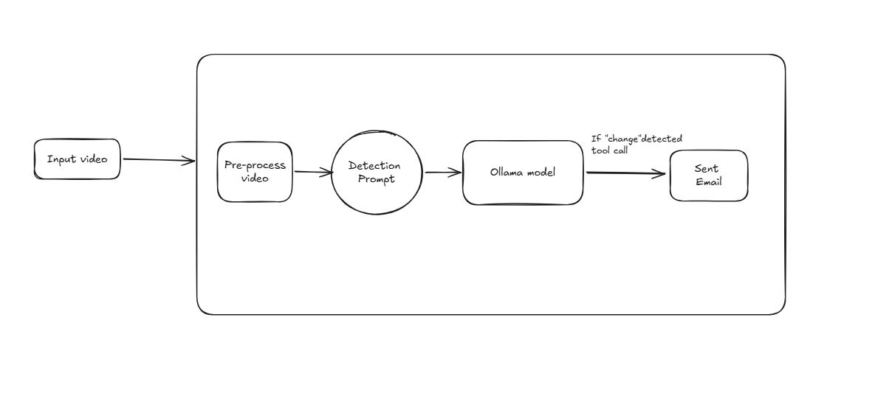
Constrained by
- No live/streaming input — batch processing of a pre-recorded file only
- Single detection type per run, not a multi-node graph — that's a later version
- No temporal/dwell tracking — a match on one frame is enough to trigger, no "present for N frames" logic yet
- Local models only for v1 (Ollama) — escalation tier is a stronger local model unless a cloud budget is confirmed
- Single recipient, single alert channel (email) — no routing rules
V2
Requirement add-on /changes
Ollama doesn’t contain any models which process video input , that said for lets split the video into frames of each 1 second or 2 second and process that using moondream model in ollama , the output may not be very accurate but the cost/infra constraints is real so lets go with this.
Also before the query reaches the moondream , it might be a good idea to have another agent refreame the user request to detect what in the video

