What are the top 5 products by revenue?

Select SP."Product_Code", SUM("Norm_Sales_Amount") AS NSA

From "sales_products" AS SP

LEFT Join Sales_transactions AS ST

ON SP."Product_Code" = ST."Product_Code"

Group By SP."Product_Code"

Order by NSA DESC

Limit 5

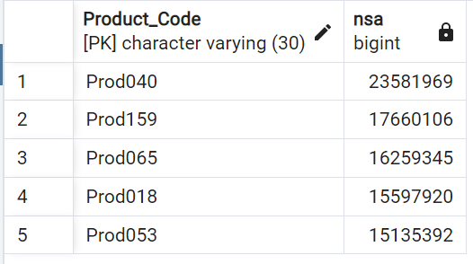

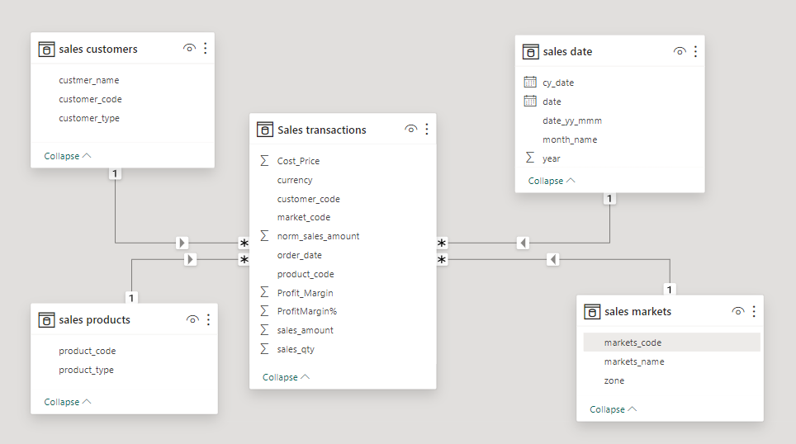

Using Windows Function:

With my_cte AS (

Select "Product_Code", "tsa", "rn" from

(Select ST.*,

SUM("Sales_Amount") OVER(Partition by "Product_Code") AS TSA,

Row_number() OVER(Partition by "Product_Code" Order by "Sales_Amount") AS RN

From "sales_transactions" AS ST) AS x

Where x.RN = 1

Order by "tsa" DESC

)

Select SP."Product_Code", "tsa", "Product_Type"

From my_cte

right join "sales_products" AS SP

ON my_cte."Product_Code" = SP."Product_Code"

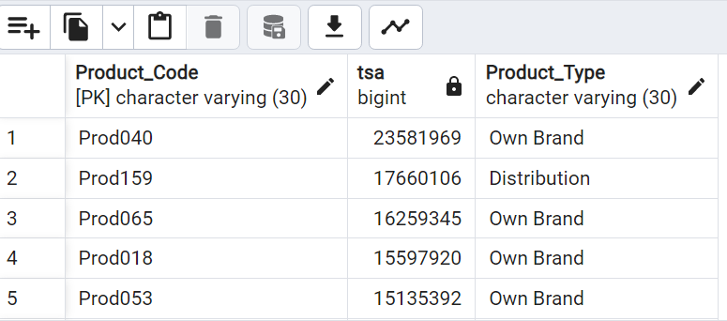

Revenue 2 = SUM('Sales transactions'[sales_amount])

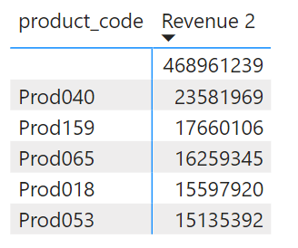

What are the top 5 Customers by revenue?

Select SC."Customer_Name", SUM("Norm_Sales_Amount") AS NSA

From "sales_customers" AS SC

LEFT Join Sales_transactions AS ST

ON SC."Customer_Code" = ST."Customer_Code"

Group By SC."Customer_Name"

Order by NSA DESC

Limit 5

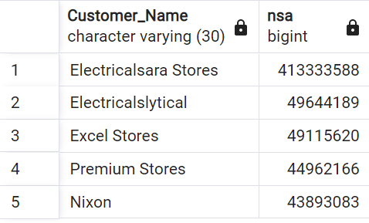

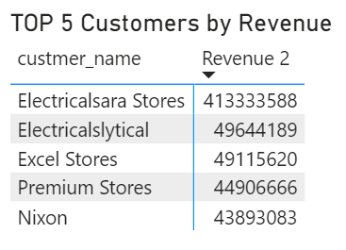

What is the total Revenue ?

Select SUM("Norm_Sales_Amount") from sales_transactions;

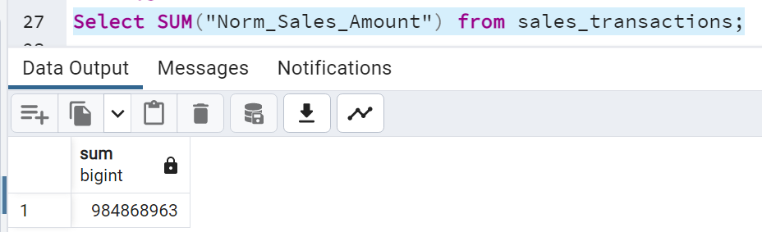

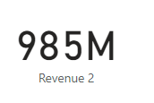

What is the total quantity of sales:

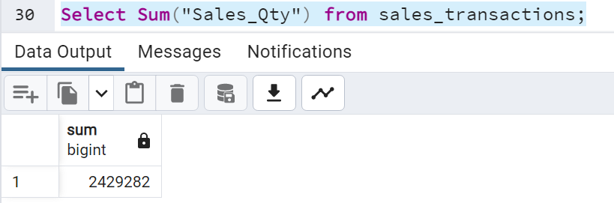

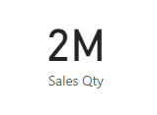

List the Markets with their Revenue

Select SM."Market_Code", SM."Markets_Name", SUM(ST."Norm_Sales_Amount") AS NSA

From "sales_markets" AS SM

Join "sales_transactions" AS ST

ON SM."Market_Code" = ST."Market_Code"

Group by SM."Market_Code"

Order by NSA DESC

