**Project I – Implementation of Hash Tables**

**CIS6930 Network Data Streaming**

**UFID- 6132-6882**

**Steps to execute-**

1. Extract Project1.zip to your local machine.

2. Open the project directory.

3. Compile the project using **javac HashTables.java**, one class file will be generated.

4. Execute the project using **java HashTables** and put the desired input.

5. Following is a sample input format-

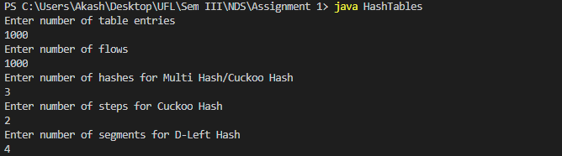

**Output format-**

Three output files will be generated, one for each Hash Table. First line of the output file shows the number of flow ids successfully inserted in the hash table and the following lines show the **flowID** stored at different index in the table (0 to n-1) entries where n is the number of table entries.