Analytical Study of Ankita Cashew Processing
Mid-term Report for the BDM Capstone Project
Submitted by
Name: Akash Jana
Roll Number: 23f2000990

IITM Online BS Degree Program,
Indian Institute of Technology Madras, Chennai
Tamil Nadu, India, 600036

Contents
Declaration Statement 3
1. Executive Summary and Title 4
2. Proof of Originality of the Data 5
3. Metadata and Data Collection 6
4. Descriptive Statistics 7
5. Methods (How the Analysis Was Done) 8
5.1 Data Cleaning and Preprocessing 8
5.2 Demand Forecasting 8
5.3 Inventory Yield Analysis 9
6. Results and Findings 10
6.1 Business Overview 10
6.2 Demand and Price Forecasting 11
6.3 Inventory and Yield 14
6.4 Revenue Mix and Buyers 16
6.5 Main Findings 17

Declaration Statement
I am working on a project titled "Analytical Study of Ankita Cashew Processing". I thank Ankita Cashew Processing and its sister unit Adrita Cashew Processing for giving me the data and help I needed for this project.
The data in this report is real and correct to the best of my knowledge. It was taken from the business itself (primary source) and checked with care.
I have explained how I collected and studied the data in this report. The results shown here are a true picture of what the data says.
I did this project on my own. I did not copy or work jointly with anyone else. If any copied work is found at any stage, I accept that the authority can take action against me.
The suggestions in this report are only for this business and this project. They cannot be used elsewhere with an IIT Madras tag. IIT Madras does not endorse this.
Signature of Candidate: (Digital Signature)
Name: Akash Jana
Date: 07 April 2026

1. Executive Summary and Title
Ankita Cashew Processing is a cashew business in West Bengal, India. It buys raw cashew nuts (RCN), processes them into kernels (the eatable cashew, called FCN here), and sells to other traders. Its sister unit, Adrita Cashew Processing, does the same work. This report studies both units together. The work is the mid-term stage of the project, covering data cleaning, demand forecasting, and inventory yield, as set out in the proposal.
The data is real and is backed by clear proof. The owner, Usha Jana, gave a signed No Objection Certificate (NOC) on the company letterhead, dated 08 June 2026. A short video talk with the owner and the signed letter are also kept in the project portal (links in Section 2). On top of this, the raw Tally accounting files for sales, purchase and stock were shared directly by the business. These items together show that the data comes from the business itself.
The cleaned data has 850 entries from April 2022 to February 2026. A single sale is about ₹5,14,839 on average, with a middle value (median) of ₹3,49,333 and a standard deviation (SD) of ₹5,11,815. The smallest sale is ₹10,476 and the largest is ₹40,00,000. Over four years the two units sold goods worth about ₹29.76 crore and bought goods worth about ₹27.07 crore. Kernels bring in most of the money, about 80.8 percent of sales.
The following methods are used in this report, grouped by problem:
- Data cleaning and preprocessing — reading the raw Tally sheets, dropping non-data rows, removing duplicates, and tagging each entry.
- Demand forecasting — splitting sales into trend and season (decomposition), a straight-line (linear) trend as a base model, and an ARIMA model for a short forecast. Accuracy is checked with RMSE and MAE on a 6-month test.
- Inventory yield analysis — yield per cycle (kernel out ÷ raw nut in), a variance check against a 22% target, Z-score to flag odd cycles, and ABC classification of stock by value.
Main results: sales follow a season (highest around January and in May–June); the raw nut price has risen from about ₹103.79 to ₹157.33 per kg; yield is about 19.92% for Adrita and 15.99% for Ankita; and a few buyers give most of the sales. Tools used: Microsoft Excel for tables and charts, and Python for cleaning, forecasting and yield work. All money is in ₹ and all weights in KG.

2. Proof of Originality of the Data
The data is real and was given by the business owners. The main proof items are listed below, and the signed papers are in the file "Proof Of Originality.pdf".
Table 1: Business identification and proof details
Item | Detail
Business (main) | Ankita Cashew Processing
Sister unit | Adrita Cashew Processing
Owner (Ankita) | Usha Jana
Owner (Adrita) | Mithu Jana
GST number | 19BAKPJ1580R1ZY
Address | Sitalpur, P.S. Contai, Purba Medinipur, West Bengal, India
Contact | +91 8597310103 | ankitacashew@gmail.com
NOC given on | 08 June 2026 (signed by Usha Jana, Owner)
2.1 Links (available in the portal section)
Video interview with the owner: [INSERT PORTAL VIDEO LINK BEFORE SUBMISSION]
Signed owner letter (NOC): [INSERT PORTAL LETTER LINK BEFORE SUBMISSION]
The proof has three parts: the signed NOC on the company letterhead, the video talk and letter kept in the portal, and the Tally files for sales, purchase and stock. These files were turned into the clean data used in this report.

3. Metadata and Data Collection
How the data was collected: the data was taken straight from the two units as Tally accounting exports. It came in five kinds — (1) raw nut sales, (2) kernel sales, (3) raw nut purchases, (4) kernel purchases, and (5) year-end stock records with weights for each grade. Ankita also had a small export-sales record. Two files were given: "Sales Purchase 22-26.xlsx" (nine ledger sheets) and "Stock Summary.xlsx" (eight yearly stock sheets). In the ledger sheets several years were stacked one below the other. The data runs from 07 April 2022 to 10 February 2026. Both files were used: the ledgers gave the sales, purchase and price work, and the stock file gave the yield, stock movement and ABC work.
The table below is the data dictionary. It lists each feature, what it means, its unit, its data type, and which business problem it helps with.
Table 2: Data dictionary — features, units, data types and relevance
Feature | Description | Unit | Data type | Helps with
Company | Ankita or Adrita | — | Text | All problems
Flow | Sale, Purchase or Export | — | Text | Sales, cost
Goods | RCN (raw nut) or FCN (kernel) | — | Text | Yield, mix
Date | Date of the entry | Date | Date | Demand, season
Counterparty | Buyer or supplier name | — | Text | Buyer risk
Amount | Value of the entry | ₹ | Number | Sales, P&L
Financial Year | FY2022-23 to FY2025-26 | Year | Text | Yearly trend
RCN bought | Raw nuts bought per month | KG | Number | Yield, price
RCN value | Value of raw nuts bought | ₹ | Number | Price/kg
Kernel sold | Whole + broken sold per month | KG | Number | Yield
Stock value | Closing value of each item | ₹ | Number | ABC
The number of entries by unit and action is shown next.
Table 3: Record counts by unit and action
Company | Flow | No. of entries | Total value (₹)
Adrita | Purchase | 131 | 11,22,12,725
Adrita | Sale | 282 | 11,81,22,325
Ankita | Export | 3 | 14,43,562
Ankita | Purchase | 141 | 15,84,85,099
Ankita | Sale | 293 | 17,80,10,785

4. Descriptive Statistics
This section shows the key numbers for every variable used in the analysis. Mean is the average. Median is the middle value. SD (standard deviation) shows how far the values spread from the average. Min and Max are the smallest and largest values.
Table 4: Descriptive statistics of all variables used in the analysis
Variable | Count | Mean | Median | SD | Min | Max
Sale amount (₹) | 578 | 5,14,839 | 3,49,333 | 5,11,815 | 10,476 | 40,00,000
Purchase amount (₹) | 272 | 9,95,213 | 5,65,386 | 10,82,649 | 1,907 | 50,41,701
Monthly sales (₹) | 47 | 63,31,419 | 56,38,115 | 32,01,183 | 7,70,857 | 1,39,37,626
RCN buying price (₹/KG) | 79 | 126.5 | 120.0 | 25.3 | 89.0 | 179.1
Monthly RCN bought (KG) | 48 | 40,223 | 32,914 | 30,764 | 0 | 1,26,602
Monthly kernel sold (KG) | 48 | 7,058 | 6,632 | 3,428 | 0 | 15,950
Yield per cycle (%) | 8 | 18.5 | 18.8 | 4.6 | 10.8 | 25.0
What these numbers mean for the business. A sale entry is about ₹5,14,839 on average, but the median is lower at ₹3,49,333. The average is higher than the median, and the SD (₹5,11,815) is large. This tells us a few very big orders pull the average up, while most orders are smaller. The biggest single sale was ₹40,00,000, about 8 times the average. So the business depends on a small number of large orders.
Purchases are bigger per entry than sales (average ₹9,95,213 against ₹5,14,839). This is because raw nuts are bought in large lots a few times a year, while kernels are sold in many smaller lots. Monthly sales average about ₹63.3 lakh and swing from ₹7.7 lakh to ₹139.4 lakh, which shows the strong season.
The raw nut price averages ₹126 per kg and ranges from ₹89 to ₹179 per kg — a wide range that shows price risk. Yield per cycle averages 18.5 percent (SD 4.6 points), lower than the 22 percent target, which is studied in detail in Section 6.

5. Methods (How the Analysis Was Done)
The methods are grouped by the problem they solve.

5.1 Data Cleaning and Preprocessing
The raw sheets were not ready to use. Each cleaning step is shown below with the actual count from this data set.
- Read all nine ledger sheets: 5,572 cells were scanned in total.
- Keep only real entries: a row was kept only if it started with a real date. This dropped 4,720 non-data rows such as titles, addresses, the "Date / Particulars" header lines, and sub-totals.
- Remove duplicates: 2 exact duplicate rows were found and removed. For example, the same ₹70,000 cash sale (Ankita, 31 Mar 2023) and the same ₹25,00,000 raw nut purchase (Ankita, 30 Jul 2024) each appeared twice. These are double-export entries, so one copy of each was dropped.
- Check missing values: after cleaning, 0 rows had a missing amount. The sale value was read from the credit column and the purchase value from the debit column, so no amount was left blank.
- Tag each entry: every row was marked with its unit, action (sale/purchase), goods (RCN/FCN) and financial year, giving one clean list of 850 entries.
The stock file was cleaned in the same way: weights written as text like "172620 KG" were turned into plain numbers, and the monthly inward and outward tables for each grade were pulled out.

5.2 Demand Forecasting
The clean sales were added up by month to make a time line. Three steps were used, as set out in the proposal.
Step 1 — Decomposition. The time line is split into its trend (the slow long-term move) and its season (the repeating monthly pattern). This shows the shape of demand.
Step 2 — Linear trend (base model). A straight line is fitted to the sales over time. Its form is:
Sales = a + b × t
Here t is the month number, a is the starting level, and b is the rise per month. It is a simple base model to compare against.
Step 3 — ARIMA model. ARIMA stands for AutoRegressive Integrated Moving Average. In plain words it has three parts. AR (auto-regressive) means it leans on recent past sales. I (integrated) means it works on the change from one month to the next, which removes the trend. MA (moving average) means it corrects itself using how wrong it was in the recent past. Its form on the differenced series is:
Ŷₜ = c + φ₁Y(t−1) + … + φₚY(t−p) + θ₁e(t−1) + … + θq e(t−q) + eₜ
Here Ŷₜ is the predicted value, the φ (phi) terms weight past sales, the θ (theta) terms weight past errors e, and c is a constant.
Checking accuracy. The last 6 months were kept aside as a test. Each model guessed those months, and the guesses were compared with what really happened, using two error scores (a smaller score is better):
RMSE = √[ (1/n) × Σ (Aᵢ − Fᵢ)² ]
MAE = (1/n) × Σ | Aᵢ − Fᵢ |
Here Aᵢ is the actual sales, Fᵢ is the forecast, and n is the number of test months. RMSE squares the errors, so it punishes big misses more. MAE is the plain average error.

5.3 Inventory Yield Analysis
Yield means how much kernel comes out of the raw nuts. Each unit-year is treated as one processing cycle, because the business does not yet keep records for smaller batches. The yield is worked out as:
Yield (%) = ( Kernel Output [KG] ÷ Raw Nut Input [KG] ) × 100
Variance check. Each cycle's yield is compared with a target of 22 percent (a normal figure for this trade). Variance = actual yield − target. A negative variance means the cycle is below target.
Z-score (to flag odd cycles). The Z-score tells how far a cycle's yield is from the average, in units of SD:
Z = ( x − μ ) ÷ σ
Here x is one cycle's yield, μ (mu) is the average yield of all cycles, and σ (sigma) is the standard deviation. A cycle is flagged if its Z-score is beyond plus or minus 1.5.
ABC classification. The stock items are sorted by value. The few items that hold most of the value are class A (watch closely), the next group is B, and the rest is C. This shows where the money sits.
One limit should be noted. The two units also buy and sell kernels as a trade, and they hold raw nuts in stock from one year to the next. So a single year's yield can look high or low just because of timing. For this reason the full-period figure is the more reliable one.

6. Results and Findings
The charts below are grouped by problem: business overview, demand and price forecasting, inventory and yield, and revenue and buyers.

6.1 Business Overview
Table 5: Annual sales and purchase (both units together)
Financial Year | Sales (₹) | Purchase (₹) | Net (₹)
FY22-23 | 7,25,24,077 | 7,37,80,058 | -12,55,981
FY23-24 | 7,62,27,072 | 6,81,41,555 | 80,85,517
FY24-25 | 8,10,86,538 | 7,06,36,908 | 1,04,49,630
FY25-26 | 6,77,38,985 | 5,81,39,303 | 95,99,682
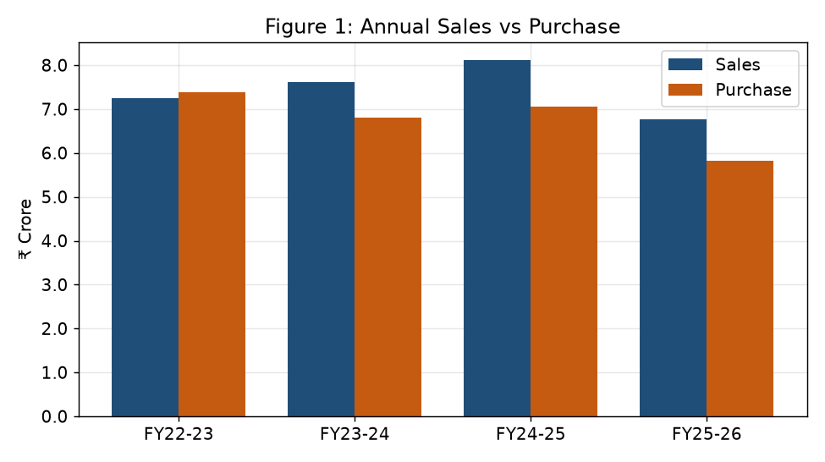
Figure 1: Annual sales versus purchase (₹ crore).
Sales grew each year up to about ₹8.11 crore in FY2024-25, then eased in the part-year FY2025-26 (data only to February 2026). In three of the four years sales were higher than purchases. Only in FY2022-23 were purchases a little higher than sales, as the units were building up raw nut stock that year.

6.2 Demand and Price Forecasting
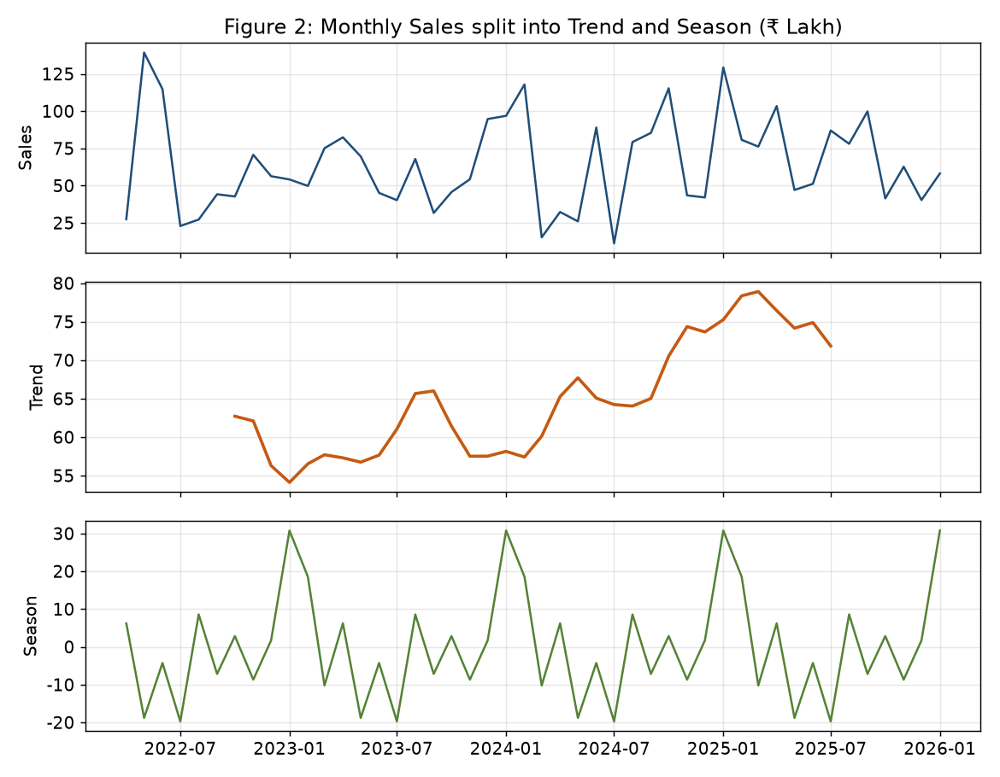
Figure 2: Monthly sales split into trend and season.
Comment on Figure 2. The top panel is the actual monthly sales. The middle panel is the trend — it drifts slowly upward, so demand is growing over the years. The bottom panel is the season — the same up-and-down shape repeats every 12 months, which proves the sales have a fixed seasonal pattern, not random noise. Together they show a rising business with a strong yearly cycle.
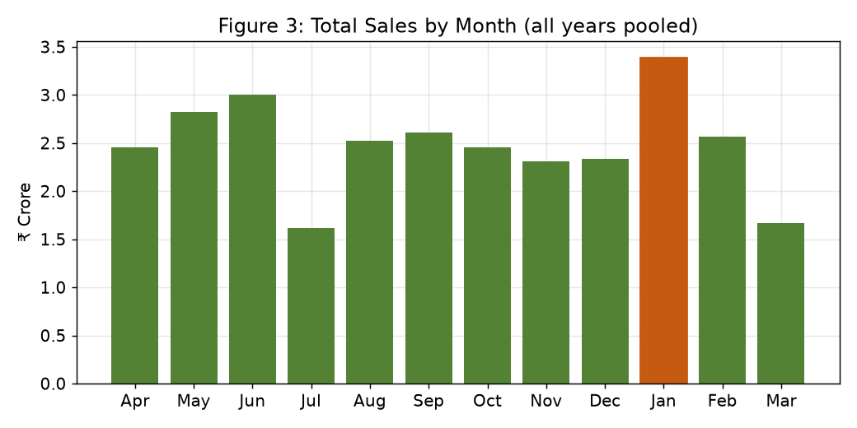
Figure 3: Total sales by month, all years pooled.
Sales are highest around January and again in May–June, and slowest in July and March. This fits wedding and festival demand for kernels and the buying of raw nuts before the monsoon. Knowing this helps plan how much to make and buy in each part of the year.
Validation before forecasting. Before trusting any forecast, the models were tested on the last 6 months (which were hidden from them). Figure 4 shows the test, and Table 6 gives the error scores.
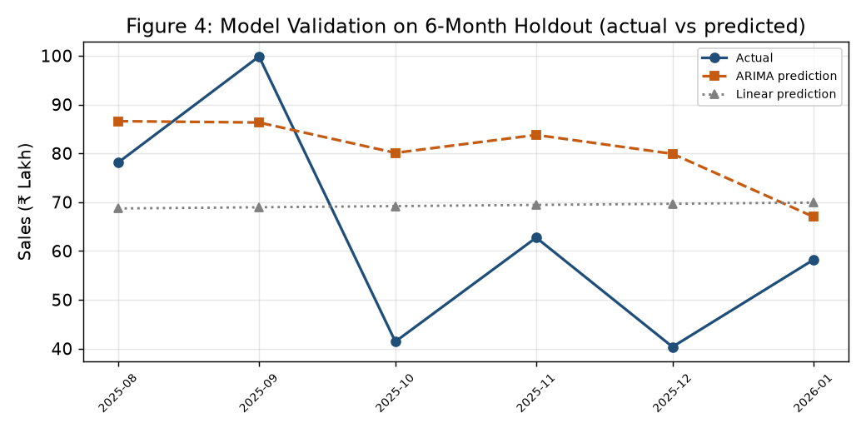
Figure 4: Model check on the 6-month holdout — actual versus predicted.
Table 6: Forecast accuracy on the 6-month test (lower is better)
Model | RMSE (₹) | MAE (₹)
ARIMA | 25,27,935 | 21,67,929
Linear trend (base) | 21,81,363 | 19,29,917
Naive (same month last year) | 43,04,027 | 30,28,328
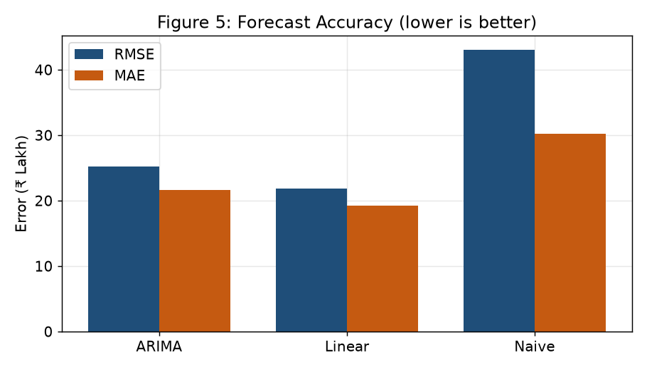
Figure 5: Forecast accuracy (RMSE and MAE).
On the test, the simple linear trend gave the smallest error (MAE about ₹19.3 lakh), a little better than ARIMA. Both were far better than the naive guess. The monthly sales jump around a lot, so no model is perfect, but the trend is clearly upward at about ₹24,026 more sales per month.
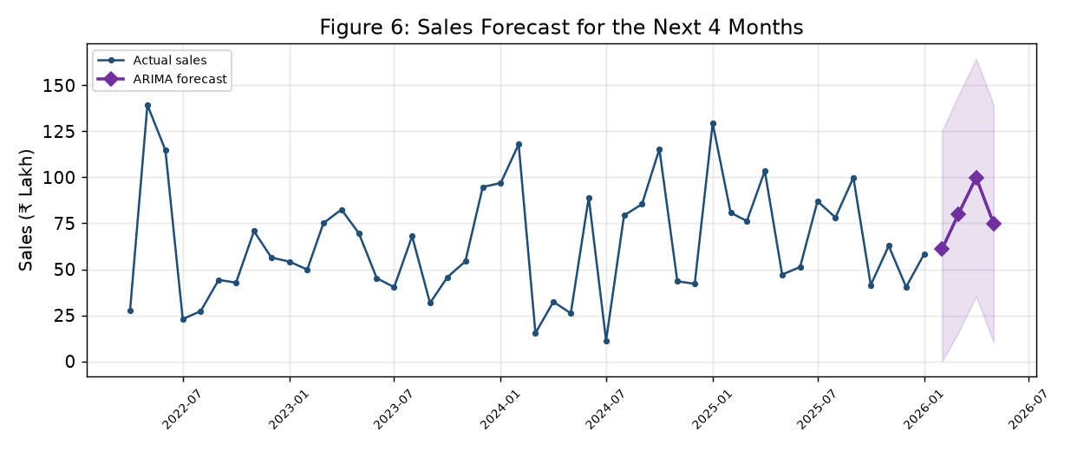
Figure 6: Sales forecast for the next 4 months (ARIMA).
The ARIMA forecast for the next four months is roughly ₹0.61 to ₹1.00 crore per month, in line with the usual season.
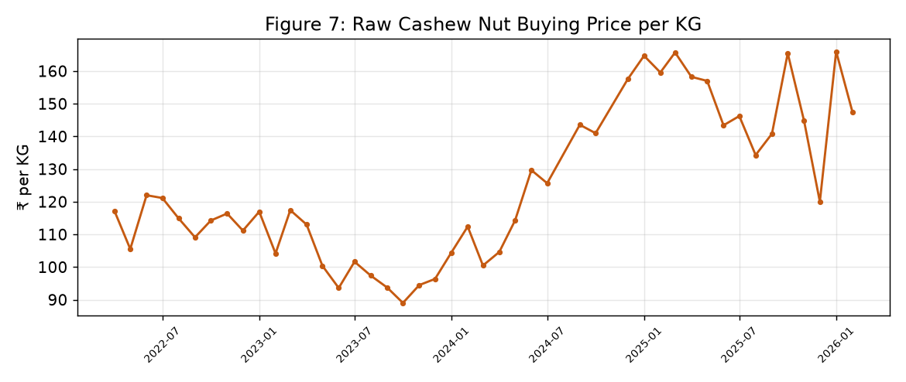
Figure 7: Raw cashew nut buying price per kg.
Table 7: Average raw nut price by year (₹/KG)
Year | Average RCN price (₹/KG)
2022 | 115.85
2023 | 103.79
2024 | 119.86
2025 | 152.72
2026 | 157.33
The raw nut price moves a lot within a year and has risen over time, from about ₹103.79 per kg in 2023 to about ₹157.33 per kg in 2026. A higher raw nut price raises costs, so the buying time and the selling price both need care. This is the price-change problem named in the proposal, now shown with real numbers.

6.3 Inventory and Yield
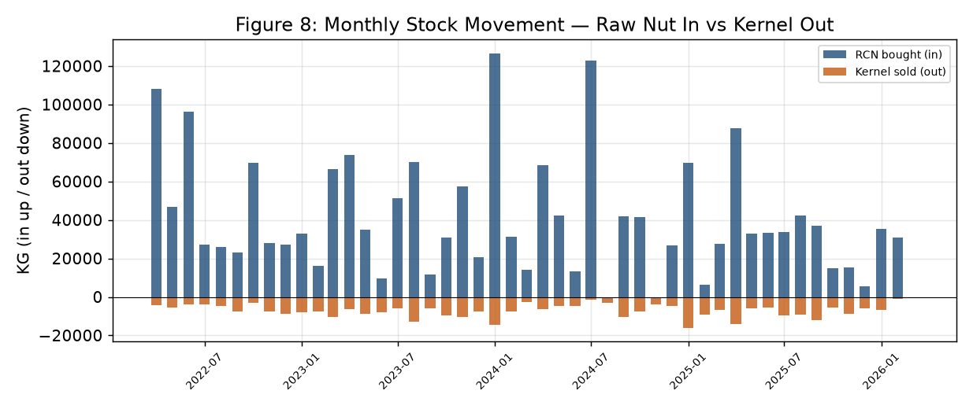
Figure 8: Monthly stock movement — raw nuts in versus kernels out.
Raw nuts are bought in large lots a few times a year, mostly before and during the season. Kernels are sold in smaller, steadier amounts through the year. So the business holds raw nut stock for some months before turning it into kernels and selling it.
Table 8: Yield per cycle with target, variance and Z-score
Cycle | Raw Nut In (KG) | Kernel Out (KG) | Yield % | Target % | Variance | Z-score | Outlier?
Adrita FY22-23 | 2,13,803 | 37,290 | 17.4 | 22.0 | -4.6 | -0.22 | No
Adrita FY23-24 | 2,32,306 | 47,030 | 20.2 | 22.0 | -1.8 | 0.39 | No
Adrita FY24-25 | 1,64,656 | 37,555 | 22.8 | 22.0 | 0.8 | 0.95 | No
Adrita FY25-26 | 1,55,513 | 30,772 | 19.8 | 22.0 | -2.2 | 0.29 | No
Ankita FY22-23 | 3,54,439 | 38,385 | 10.8 | 22.0 | -11.2 | -1.66 | Yes
Ankita FY23-24 | 2,99,996 | 53,264 | 17.8 | 22.0 | -4.3 | -0.16 | No
Ankita FY24-25 | 2,96,189 | 41,060 | 13.9 | 22.0 | -8.1 | -1.00 | No
Ankita FY25-26 | 2,13,785 | 53,427 | 25.0 | 22.0 | 3.0 | 1.42 | No
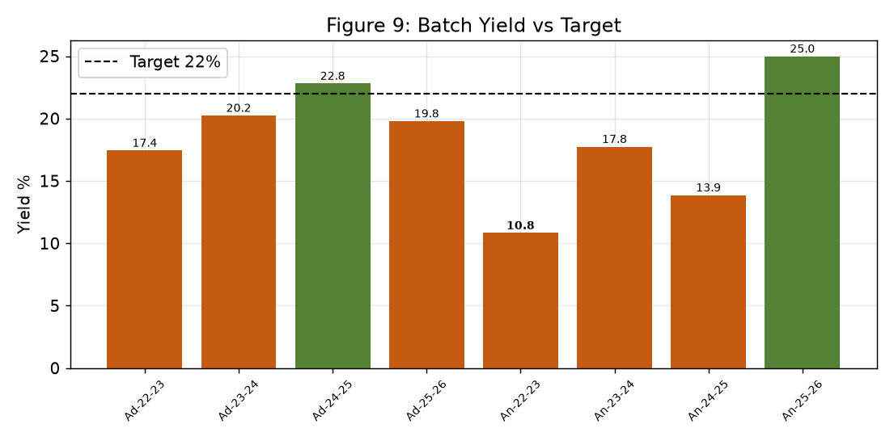
Figure 9: Yield of each cycle against the 22% target.
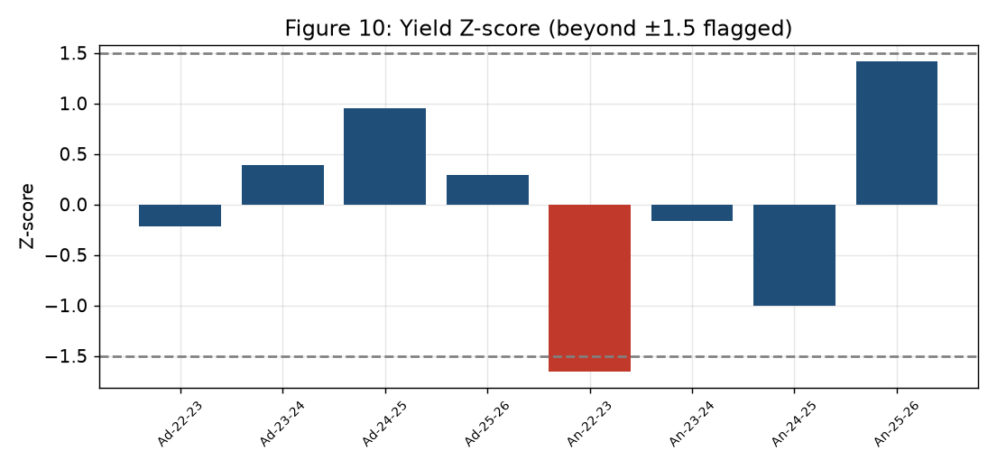
Figure 10: Yield Z-score. Bars past ±1.5 are flagged.
Table 9: Yield by unit over the full period
Unit | Raw Nut In (KG) | Kernel Out (KG) | Yield % | Whole share %
Adrita | 7,66,278 | 1,52,647 | 19.9 | 67.5
Ankita | 11,64,409 | 1,86,136 | 16.0 | 67.7
Over the full period the yield is about 19.92 percent for Adrita and 15.99 percent for Ankita. Adrita is close to the 22 percent target. Ankita is lower, mainly because it holds more raw nut stock across years, not because of poor work. Most cycles are below target. The Z-score test flags one cycle, Ankita FY2022-23, where the yield (10.8 percent) is well below the rest — a clear case to look into. Whole kernels make up about 67.7 percent of the graded output, which is a good quality mix.
Table 10: ABC classification of stock by value
Stock group | Value (₹) | % of total | Cumulative % | Class
Raw Cashew Nut (RCN) | 16,32,21,226 | 46.5 | 46.5 | A
Whole Kernel | 12,49,94,770 | 35.6 | 82.2 | B
Broken Kernel | 5,73,55,270 | 16.4 | 98.5 | C
Packing Material | 25,26,558 | 0.7 | 99.3 | C
Plant & Equipment | 15,25,581 | 0.4 | 99.7 | C
Other | 5,70,897 | 0.2 | 99.9 | C
Building Material | 4,09,203 | 0.1 | 100.0 | C
Rejection / Mix | 58,450 | 0.0 | 100.0 | C
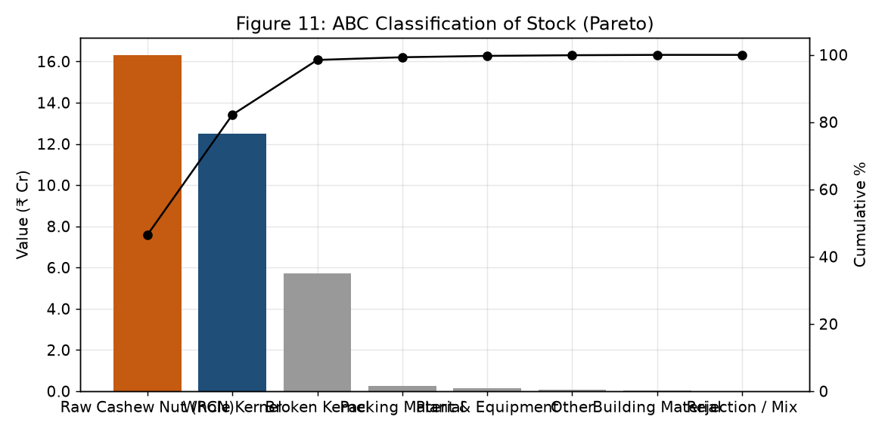
Figure 11: ABC chart of stock by value (Pareto).
Just three items — raw nuts, whole kernels and broken kernels — hold about 98 percent of the stock value. Raw nuts alone are the "A" group at 46.5 percent. So the owners should watch raw nut and kernel stock most closely, since that is where the money is.

6.4 Revenue Mix and Buyers
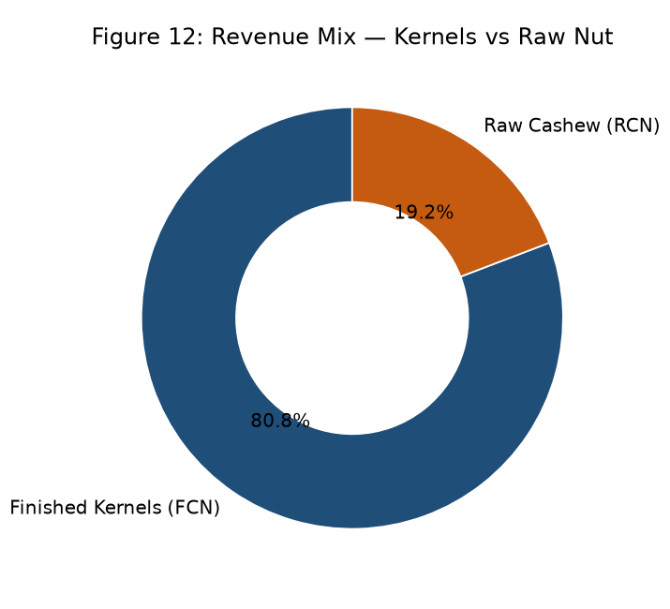
Figure 12: Revenue mix — kernels versus raw nut.
Kernels bring in about 80.8 percent of the money. Processing, not raw nut trading, is the heart of the business.
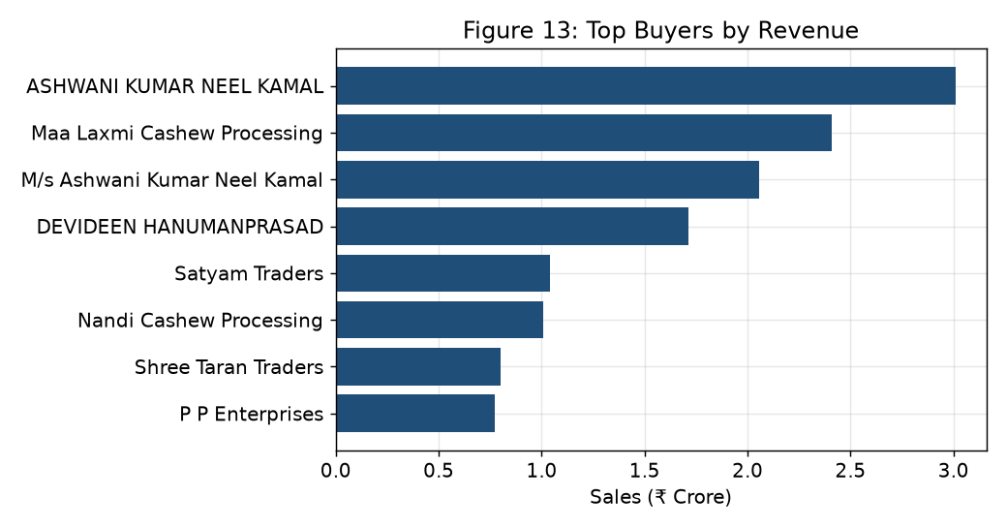
Figure 13: Top buyers by sales value.
The top five buyers bring in about 34 percent of all sales. So the business leans on a few big buyers. This is why the next stage of the project will score buyers for payment risk, as planned in the proposal.

6.5 Main Findings
- Over four years, sales were about ₹29.76 crore and purchases about ₹27.07 crore. Sales were higher than purchases in three of the four years; in FY2022-23 purchases were slightly higher.
- Kernels bring in about 81 percent of the money; processing is the heart of the business.
- Sales follow a season, highest in January and in May–June, with a slowly rising trend.
- The linear trend forecast was a little better than ARIMA on the test; both beat the naive guess.
- The raw nut price has risen over the years and moves a lot, so buying time and selling price need care.
- Yield is about 19.92% (Adrita) and 15.99% (Ankita); most cycles are below 22%, and Ankita FY2022-23 is a low outlier.
- Raw nuts and kernels hold about 98% of stock value (ABC A and B), so they need the closest watch.
- The top five buyers give about 34% of sales, so the business depends on a few buyers.

