**GO PROGRAMMING LANGAUGE**

* **GoLang** Launched in Nov 2009 by Google (Robert Griesemer, Rob Pike, and Ken Thompson).
* Open Source Programming Language That Makes It Easy to Build Simple, Reliable and Efficient Software.
* It is a statically-typed compiled language having syntax similar to that of C.
* It provides garbage collection, type safety, dynamic-typing capability.
* Go supports concurrent programming, i.e. it allows running multiple processes simultaneously.
* It provides many advanced built-in types such as variable length arrays and key-value maps.

**Go Program File Extension (. go)**

Open Command Line / Terminal to Build the **Go** program

>>> go build filename.go

Open Command Line / Terminal to Run the **Go** program

>>> go runfilename.go

**Go Tokens:** keyword, an identifier, a constant, string literal or a symbol.

**Line Separator:** the semicolon **;** is **optional** in GoLang. **\n** can also be separating the statements.

**Keywords:**

|  |  |  |  |  |
| --- | --- | --- | --- | --- |
| break | default | Func | interface | select |
| case | defer | Go | map | Struct |
| chan | else | Goto | package | Switch |
| const | fallthrough | If | range | Type |
| continue | for | Import | return | Var |

**Data Types:**

1. **Numerical Types** = byte, int, int8, int16, int32, int64, uint8, uint16, uint32, uint64, float32,

float64, Complex64, complex128. | Type Format of int is %d, float and complex is %g.

1. **String Types** = string. | Type Format: %s
   * Strings are immutable types that is once created, it is not possible to change the contents of a string.
2. **Boolean Types** = true, false | Type Format: %t. | Type Format for Chan and Pointers is %p

**Variables:**

**Syntax**:

* <variable_name> := <value>
* var <variable_name> <type>
* var <variable_name> <type> = <value>
* var <variable_name> = <value>
* var <variable_name1>, <variable_name2> <type>
* var <variable_name1>, <variable_name2> = <value1>, <value2>

**Go Online Playground** - <https://play.golang.org/>

**Code Snippets**

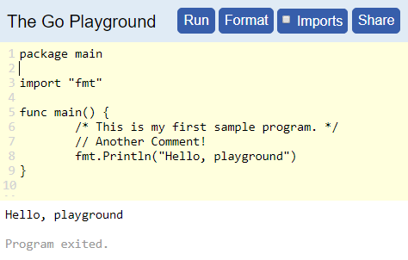 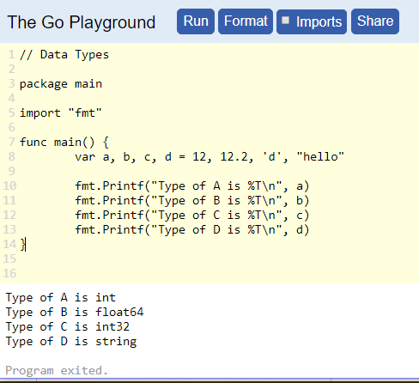

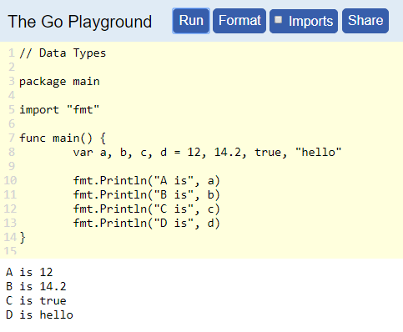 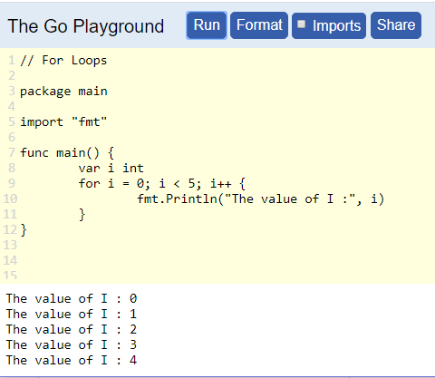

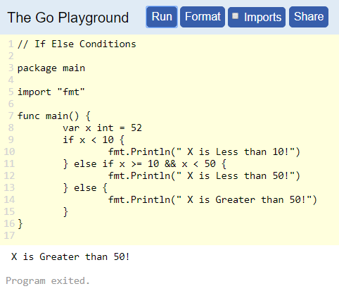 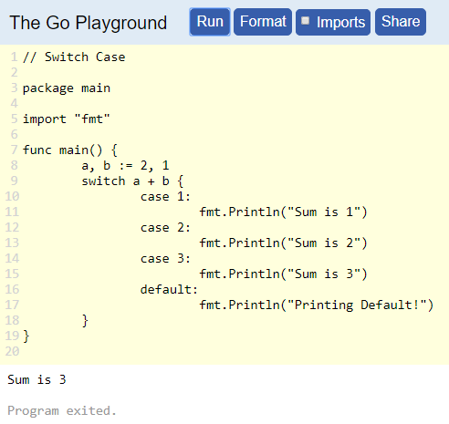

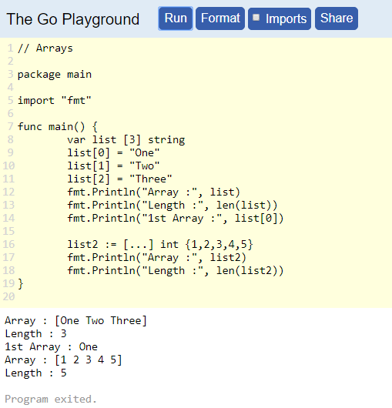 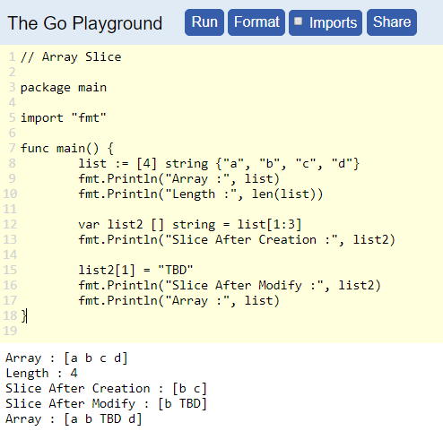

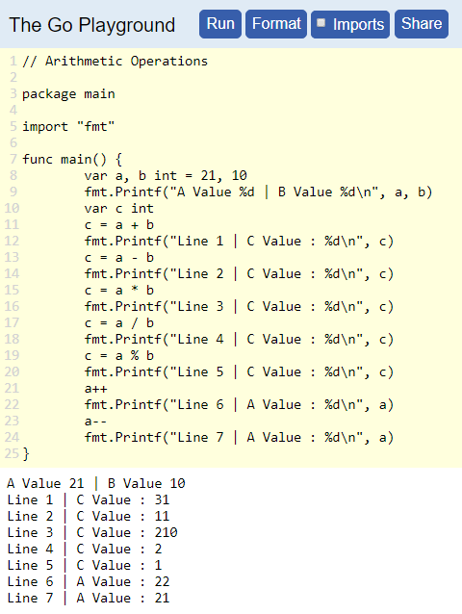 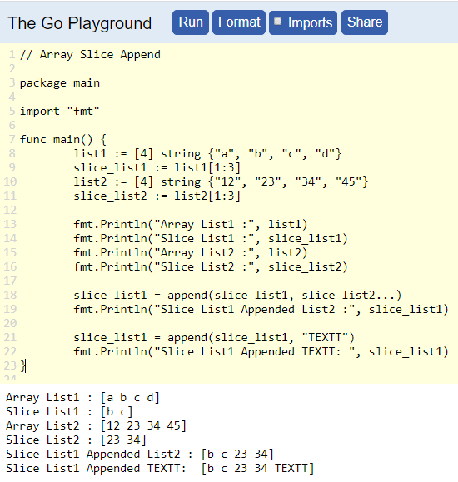

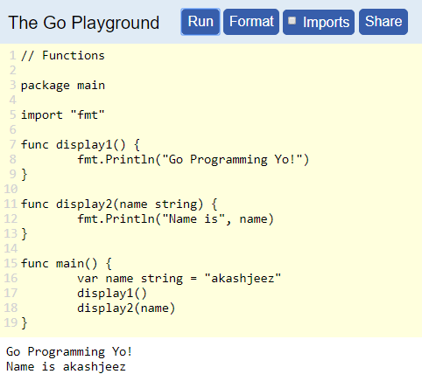 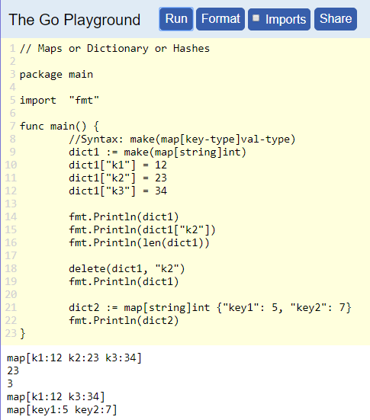

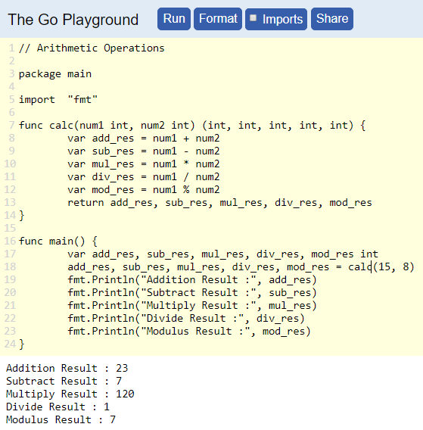 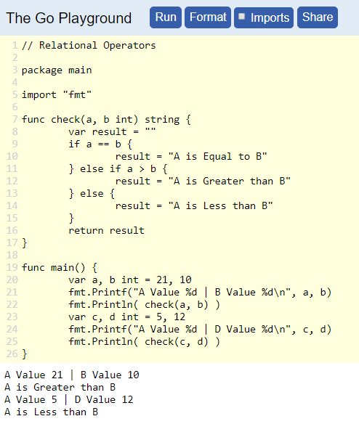

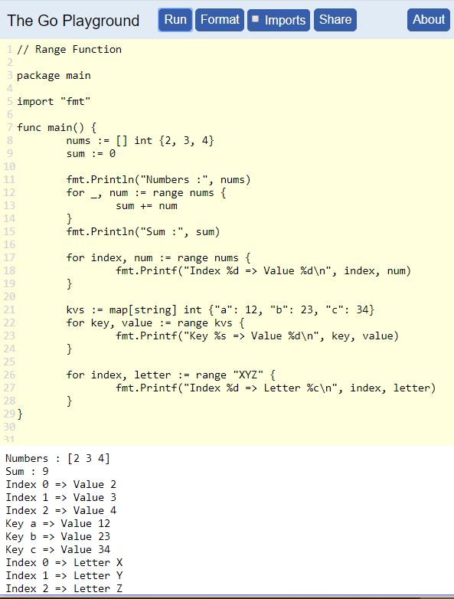 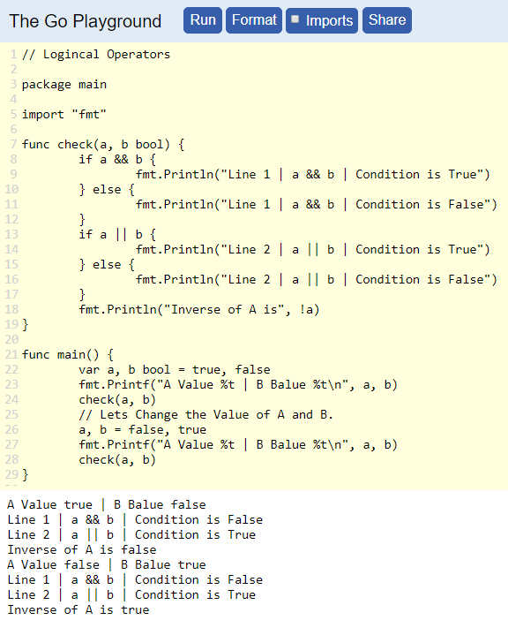

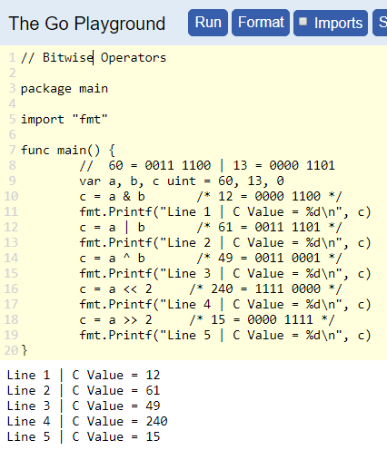 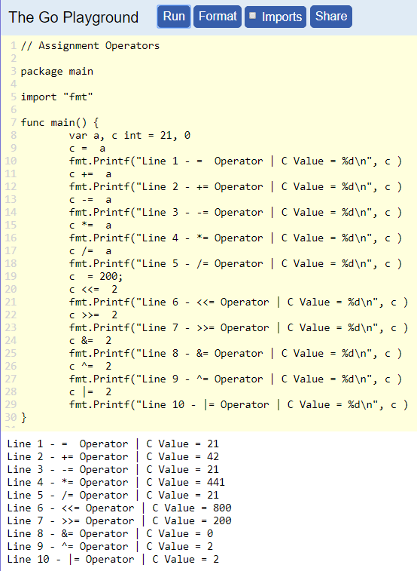

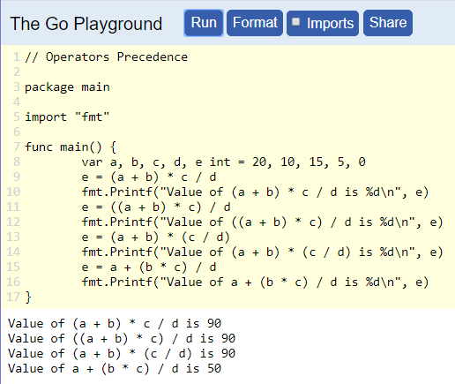 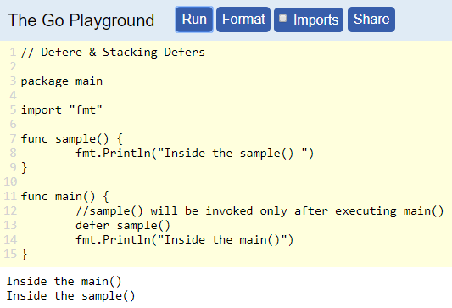

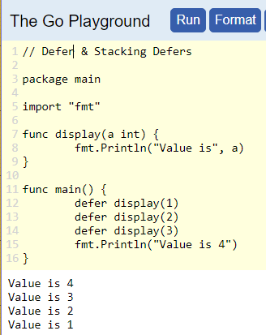 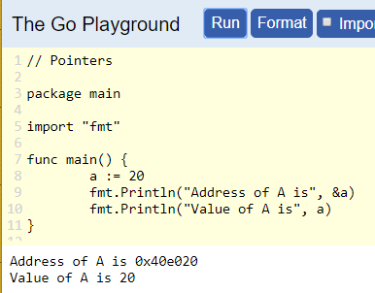

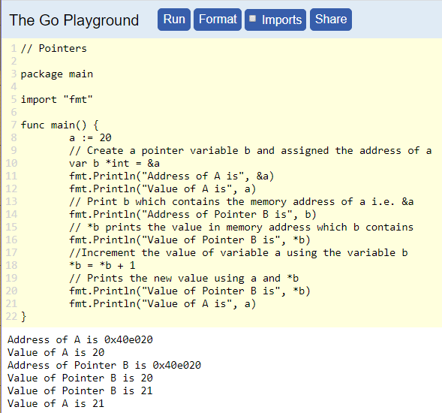 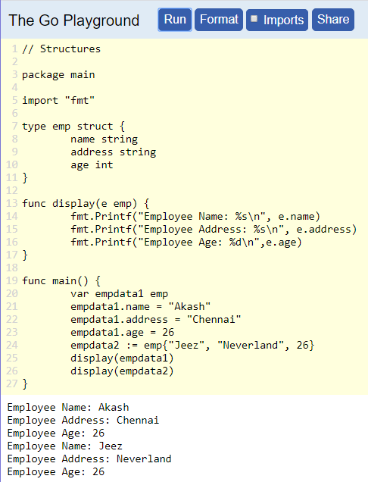

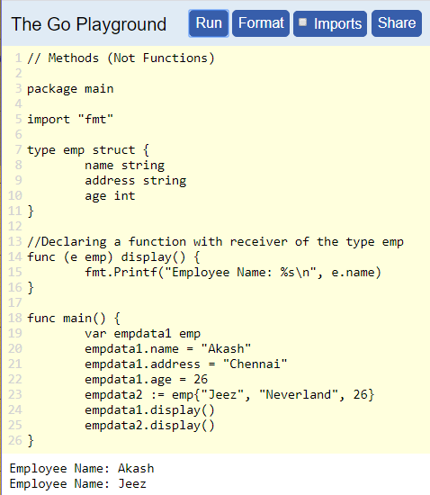 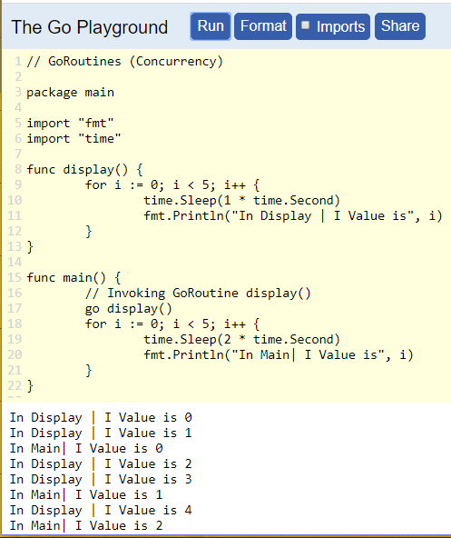

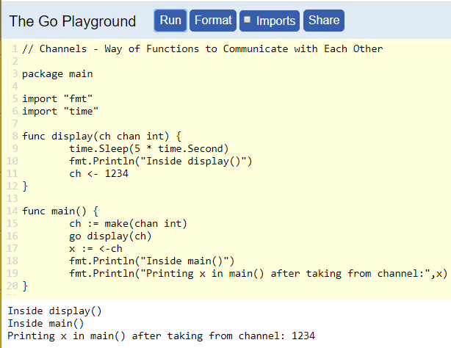 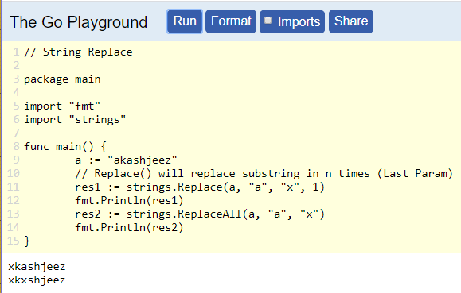

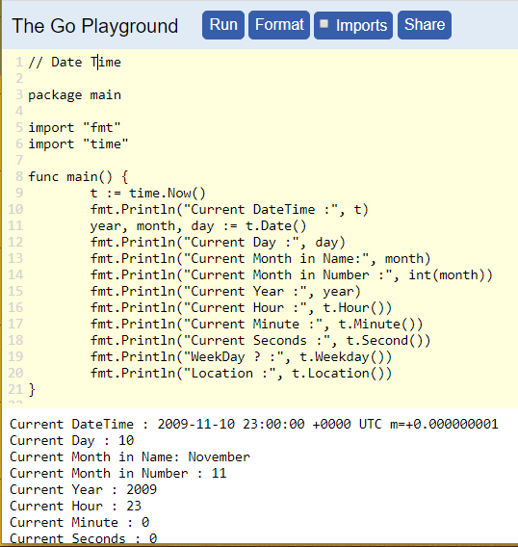 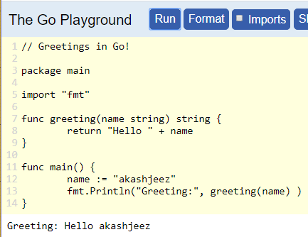

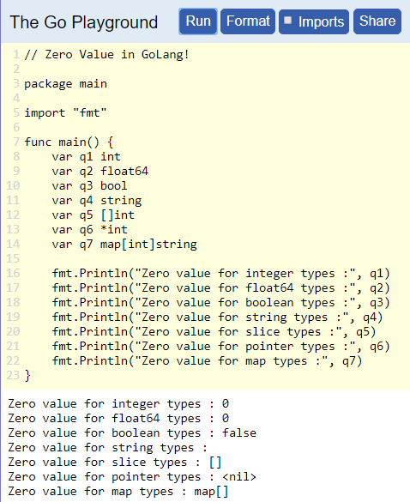 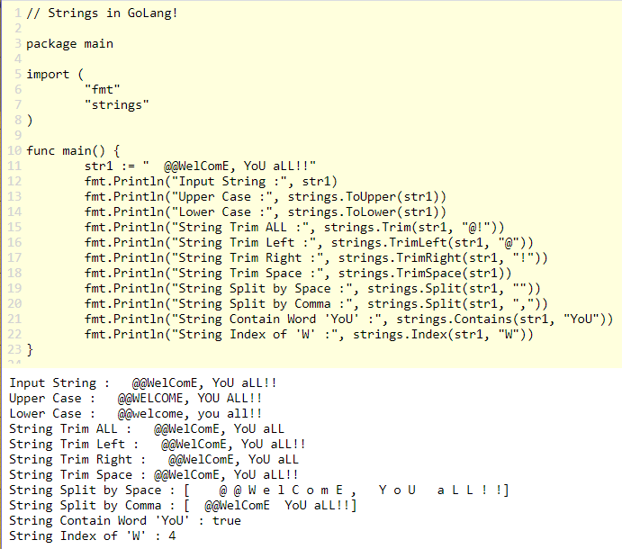

**GO Language – List Web Frameworks**

|  |  |
| --- | --- |
| Gin Gonic (Developed Year - 2014) | Buffalo (Developed Year - 2014) |
| Beego (Developed Year - 2012) | Net/HTTP |
| Iris (Developed Year - 2016) | Mango |
| Echo (Developed Year - 2015) | Gorilla |
| Revel (Developed Year - 2011) | Go Craft |
| Martini (Developed Year - 2013) | Goji |

**Net/HTTP:** Simple Web App | Running in Local Machine

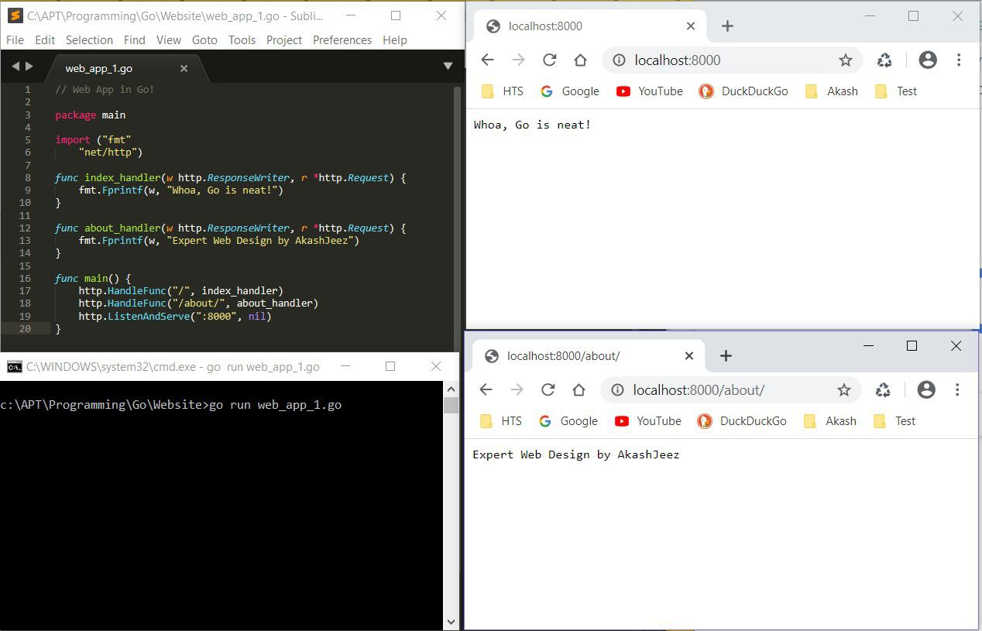

**Net/HTTP:** Simple Web App | Hosted on Heroku (PaaS) Cloud.

