**DJANGO – PYTHON WEB FRAMEWORK**

* **Django is a Web Development Framework Used for Building and Maintaining Quality Web Applications.**
* **Django** is a **Registered Trademark** of the **Django Software Foundation**, and is Licensed Under BSD License.
* **Django** Eliminates Repetitive Tasks Making the Development Process as Easy and Time Saving Experience.
* **Django (MVT Pattern – Model View Template)** Take Care of Controller Part (Software Code That Controls the Interactions Between the Model and View), leaving us the Template. The Template is a HTML File Mixed with Django Template Language (DTL).
* Install **Django** Library in **Python 3.7.X +** on Command Line / Terminal.

***>> pip install --upgrade django***

* **Web Servers**
  + **NGINX** – Web Server Used as Reverse Proxy, Load Balancer, Mail Proxy and HTTP Cache.
  + **IIS** – (Internet Information Services) Web Server for ASP.NET and Other .NET Web Application.
  + **Apache Tomcat** – Web Server for PHP and Java based Web Applications.
  + **Lighttpd** – Open Source Web Server Optimized for Speed Critical Environments While Remaining Standards Compliant, Secure and Flexible.
  + **Python Web Frameworks** has its **Own Web Server** Such as **Django**, **Tornado**, **Web2Py**, Gunicorn for **Flask**.
* **Django – Design Philosophies**: Loosely Coupled, Less Coding, Don’t Repeat Yourself, Fast Development, Clean Design.
* **Advantages**: Object Relational Mapping (ORM) Support, Multilingual Support, Framework Support, Administration GUI and Development Environment.

**Steps to Create Django Web Application**

1. **Create Project**: A Project is a Sum of Applications and Each Application is a Set of Code Files Relying on MVT Pattern. Open Command Line or Terminal and Type Below Line. **myproject** is a Custom Project

***C:\django> django-admin startproject myproject***

Just got to **C:\django** Directory and Check the Folder Structure. Yo

* **Manage.py** = Local Django Admin for Interacting with Your Project via Command Line such as Sync DB, Start the Development Server etc.
* **Myproject/ =** This Folder is the Actual Python Package of Your Project, It Contain Below 4 Files.
* **Myproject/__init__.py =** Just for Python, Treat This Folder as Package.
* **Myproject/settings.py** = Django Project Settings.
* **Myproject/urls.py** = All Links of Your Project and the Function to Call. A kind of ToC of Your Project.
* **Myproject/wsgi.py** = If you Need to Deploy Your Project Over WSGI.

1. Test The App Working? Just Execute Below Command in Command Prompt / Terminal.

***C:\django> python manage.py runserver***

1. You will Get Something Like the Following on Running the Above Code,

**Staring Development Server at** [**http://127.0.0.1:8000/**](http://127.0.0.1:8000/)

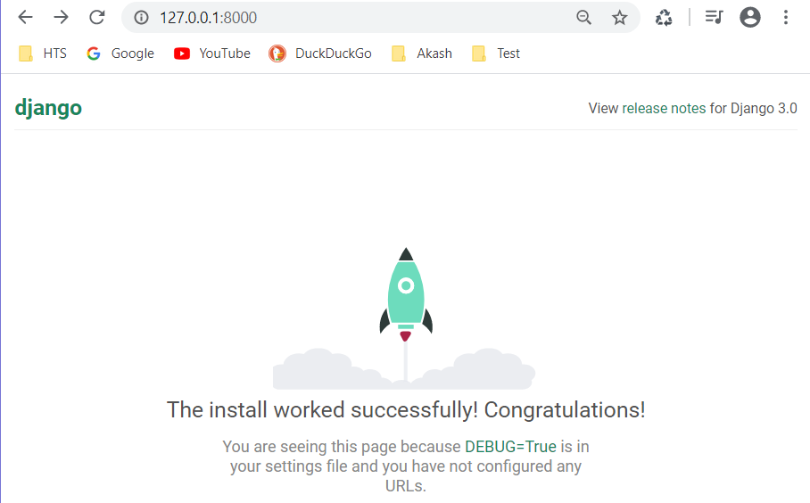

1. To **Create New Application** inside your Project **myproject**, Execute Below Command

***C:\django\myproject> python manage.py startapp myapp***

Just got to **C:\django\myproject\myapp** Directory and Check the Folder Structure. Yo

* **__init__.py** = Just to Make Sure Python handles this Folder as a Package.
* **Admin.py =** This File Helps You Make the App Modifiable in the Admin Interface.
* **Models.py =** All the Application Models Are Stored.
* **Test.py =** All the Application Units Test Are Stored.
* **Views.py =** All the Application Views Are Stored.

1. Get the Project to Know About Your Application, just go to **C:\django\myproject\myproject** Directory and Open **Settings.py** and add your Application Name.

INSTALLED_APPS = (

'django.contrib.admin',

'django.contrib.auth',

'django.contrib.contenttypes',

'django.contrib.sessions',

'django.contrib.messages',

'django.contrib.staticfiles',

'myapp',

)

1. **Every Django Project has Default Admin Interface Page**. Before Launching Your Server, To Access Your Admin Interface, You Need to Initiate the Database.

***C:\django\myproject> python manage.py migrate***

* Create Super User for Admin, Just Execute Below Command in Command Prompt or Terminal.

***C:\django\ myproject> python manage.py createsuperuser***

Give Custom Username, Email Address, Password and Confirm Password.

// Username is **akashjeez**, Email Address is [**akashit63@gmail.com**](mailto:akashit63@gmail.com) and Password is **Akash@123**

* Then Run the Django Project in Command Line / Terminal.

***C:\django\myproject> python manage.py runserver***

Just hit <http://127.0.0.1:8000/admin> in Browser and Give Above Credentials and Get into Admin Portal.

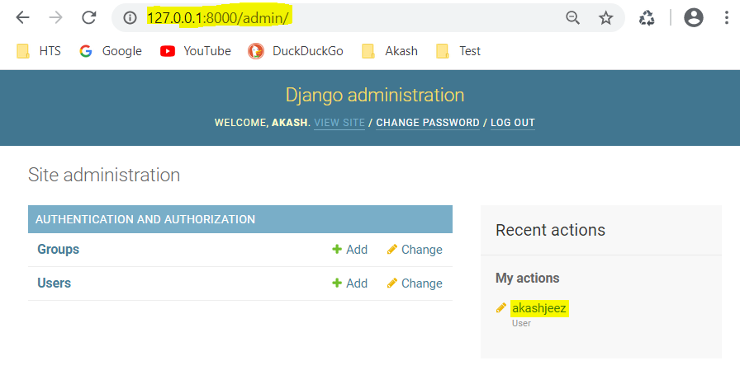

1. **Create Views** in My Application **myapp** under Django Project **myproject**.

A View is Simply a Python Function That takes a Web Request and Returns a Web Response (HTML Contents of Web Page, or Redirects, or 404 Error, or XML Document or an Image).

|  |  |
| --- | --- |
| **C:\django\myproject\myproject\urls.py** | **C:\django\myproject\myapp\views.py** |
|  |  |

Then Run the Django Project in Command Line / Terminal. Then Just hit <http://127.0.0.1:8000/> in Browser

***C:\django\myproject> python manage.py runserver***

|  |  |
| --- | --- |
| <http://127.0.0.1:8000/> | <http://127.0.0.1:8000/article/21> |
|  |  |

1. **Create Templates** under Django Project **myproject.**

**Jinja2** is **a Template Engine** for Python by Default. Its Dynamic Rendering Data from Python Views to HTML Content.

Create Folder **templates** under **C:\django\myproject** Directory and Place all Apps related HTML Files.

Create Folder **myapp** under **C:\django\myproject\templates** Directory and Place Specific App Related HTML Files,

Create **layout.html** file under **C:\django\myproject\templates** Directory.

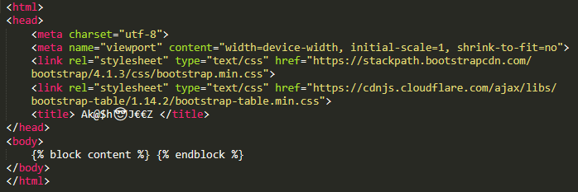

Add line 59 in **setting.py** Under **C:\django\myproject\myproject** Directory.

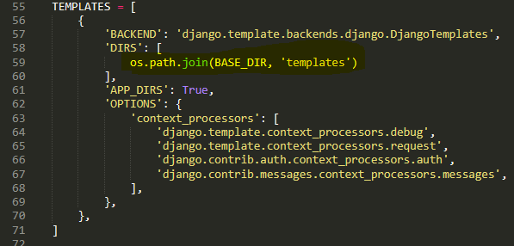

|  |  |
| --- | --- |
| **C:\django\myproject\myapp\views.py** | **C:\django\myproject\templates\myapp\index.py** |
|  |  |

Then Run the Django Project in Command Line / Terminal. Then Just hit <http://127.0.0.1:8000/> in Browser

***C:\django\myproject> python manage.py runserver***

|  |  |
| --- | --- |
| <http://127.0.0.1:8000/> | <http://127.0.0.1:8000/article/21> |
|  |  |

Now, the **urls.py** Getting Separated from Main Django Project to Sub Applications.

|  |  |
| --- | --- |
| **C:\django\myproject\myproject\urls.py** | **C:\django\myproject\myapp\urls.py** |
|  |  |

1. **Creating Models**

|  |  |
| --- | --- |
| **C:\django\myproject\myapp\model.py** | **C:\django\myproject\myapp\views.py** |
| **C:\django\myproject\templates\myapp\list_view.html** |  |

|  |  |
| --- | --- |
| Then Run the Django Project in Command Line / Terminal.  Then Just hit <http://127.0.0.1:8000/> in Browser  ***C:\django\myproject> python manage.py runserver*** |  |