Keras==2.3.1

Tensorflow==1.14.0

Title 1: output screens

Classification of Lung Cancer Nodules to Monitor Patients Health using Neural Network topology with SVM algorithm & Compare with K-Means Accuracy

In this project we are using CT Scan Lung Cancer Nodules dataset to predict patient health using SVM and KMeans algorithm and then comparing prediction accuracy between them. To implement this project we are using lung cancer images dataset and below screen showing dataset details and this dataset saved inside ‘Dataset’ folder.

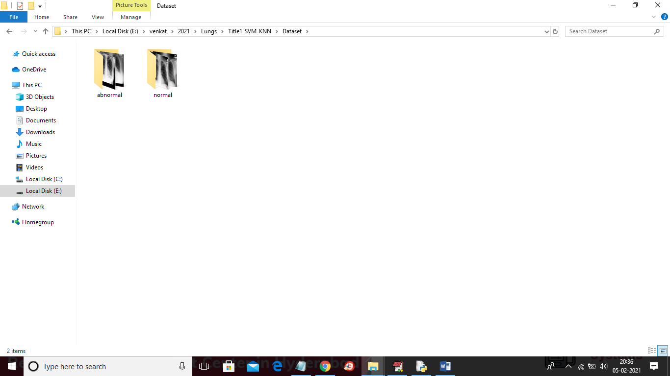

In above screen in dataset we have two types of images such as normal and abnormal and then SVM and KMEANS will get train on above dataset and when we upload new image then SVM will predict whether new image is normal or abnormal. To implement 4 titles we created 4 folders to separate algorithms for each title and you can run one by one

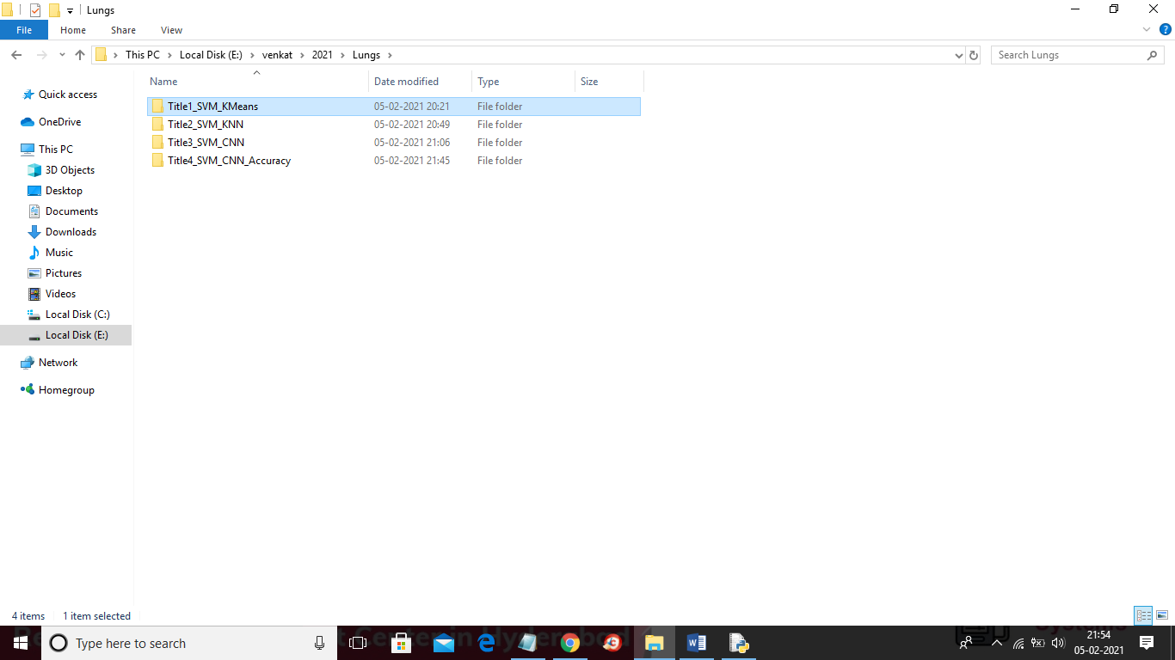

SCREENS SHOT

To run project double click on run.bat file from ‘Title1_SVM_KMeans’ folder to get below screen

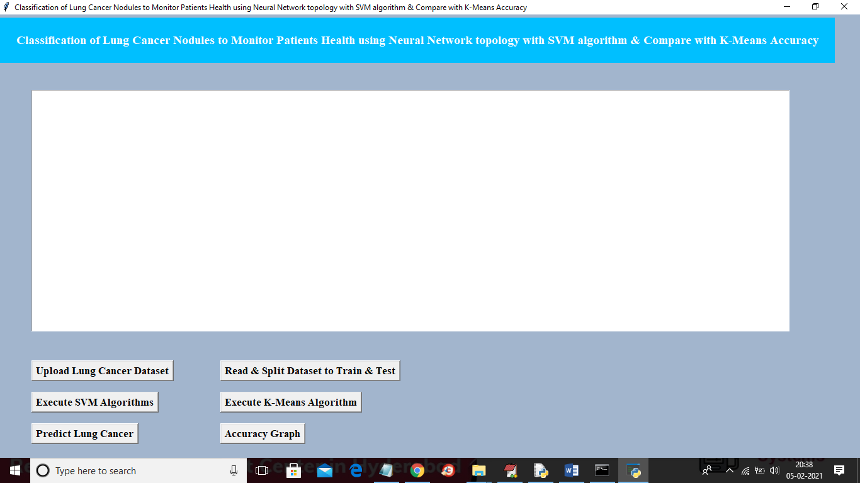

In above screen click on ‘Upload Lung Cancer Dataset’ button and then upload dataset folder

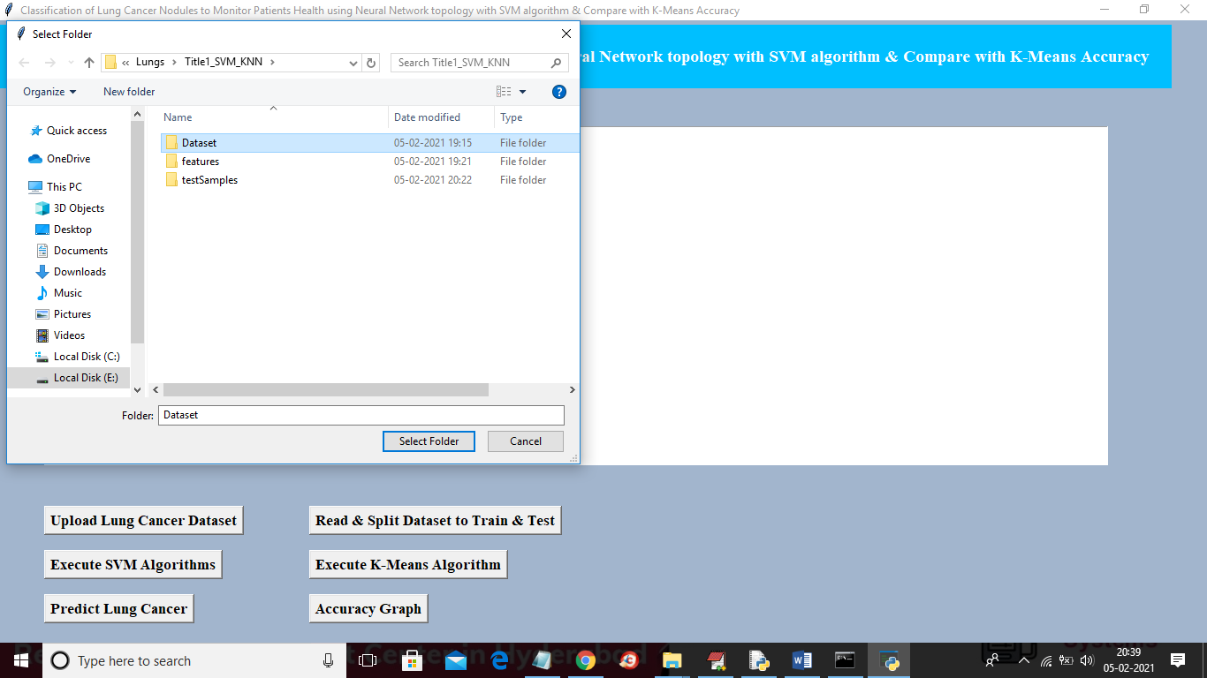

In above screen selecting and uploading ‘Dataset’ folder and then click on ‘Select Folder’ button to load dataset and to get below screen

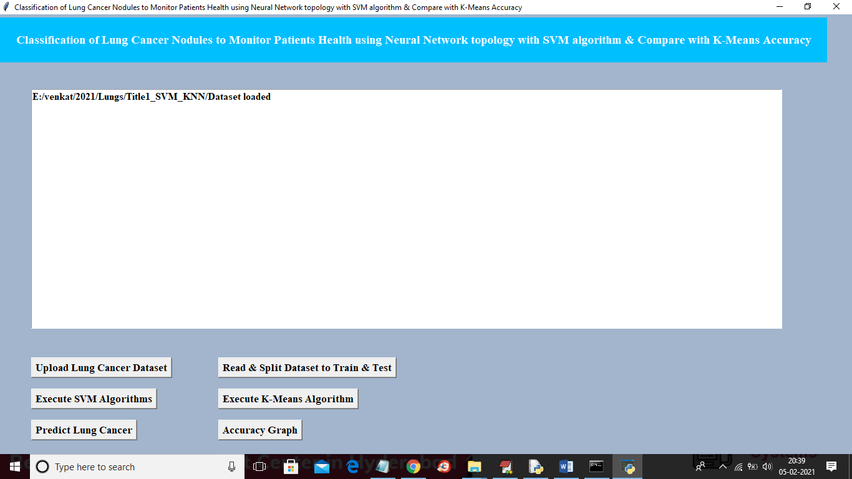

In above screen dataset loaded and now click on ‘Read & Split Dataset to Train & Test’ button to split dataset into train and test parts and application split 80% dataset for training and 20% dataset to test trained model

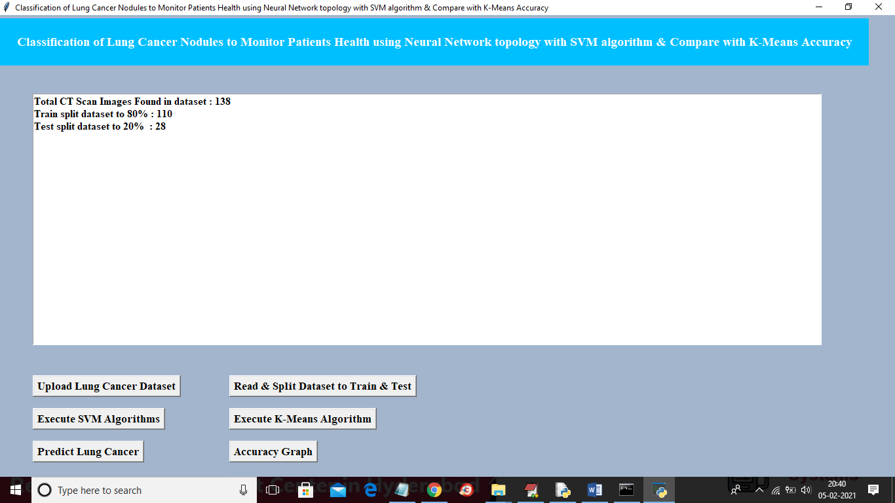

In above screen we can see dataset contains total 138 images and then application using 110 images for training and 28 images for testing and now data is ready and now click on ‘Execute SVM Algorithm’ button to run SVM on loaded dataset and to get below accuracy

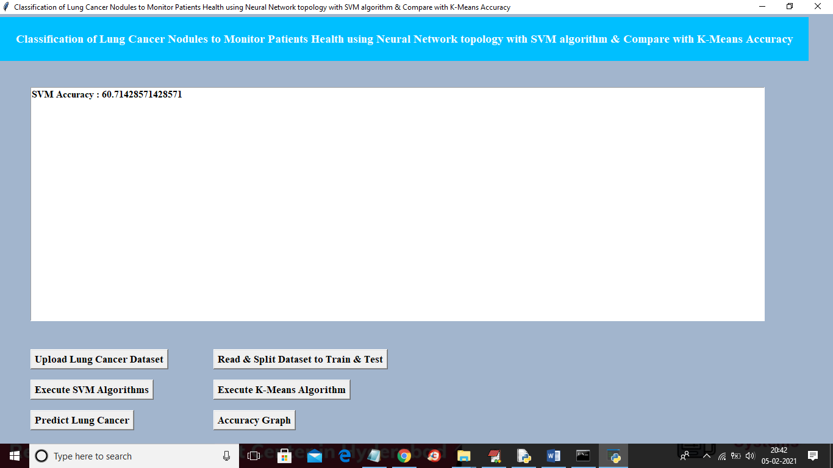

In above screen SVM accuracy is 60% and now click on “Execute K-Means Algorithm” button to run KMEANS algorithm on loaded dataset and to get below screen

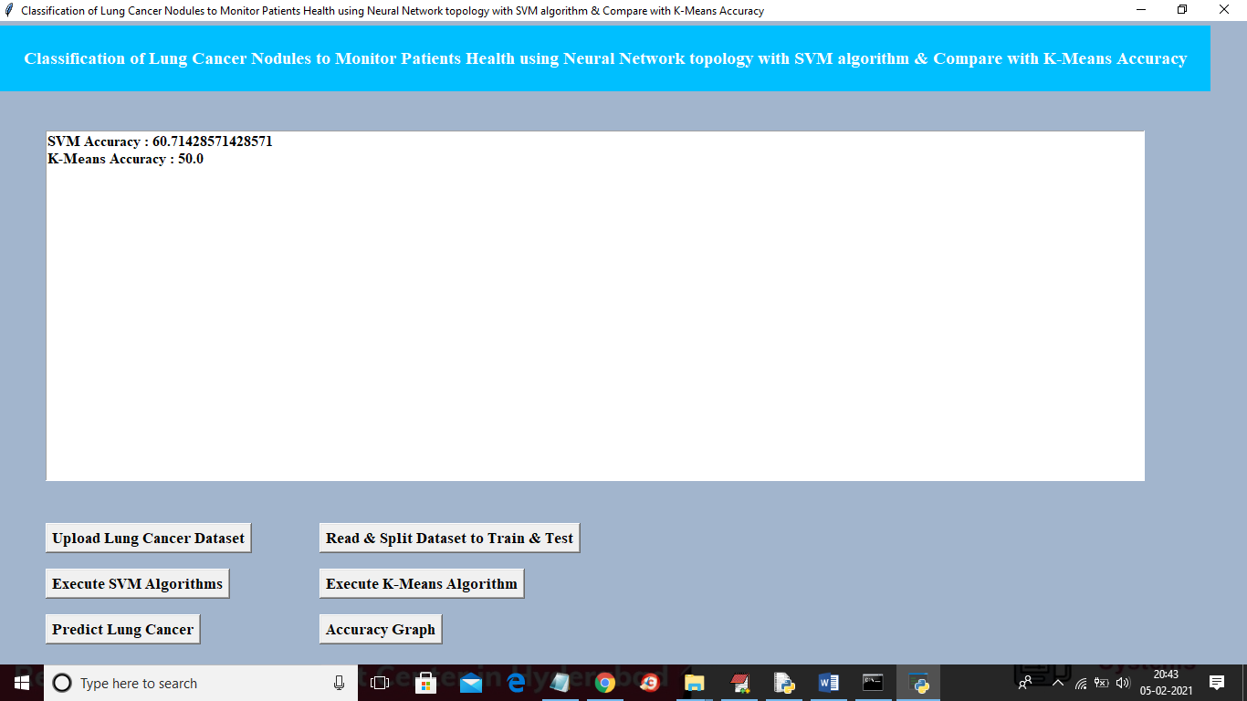

In above screen KMEANS got 50% accuracy and now click on ‘Predict Lung Cancer’ button to upload new test image and then application will give prediction result

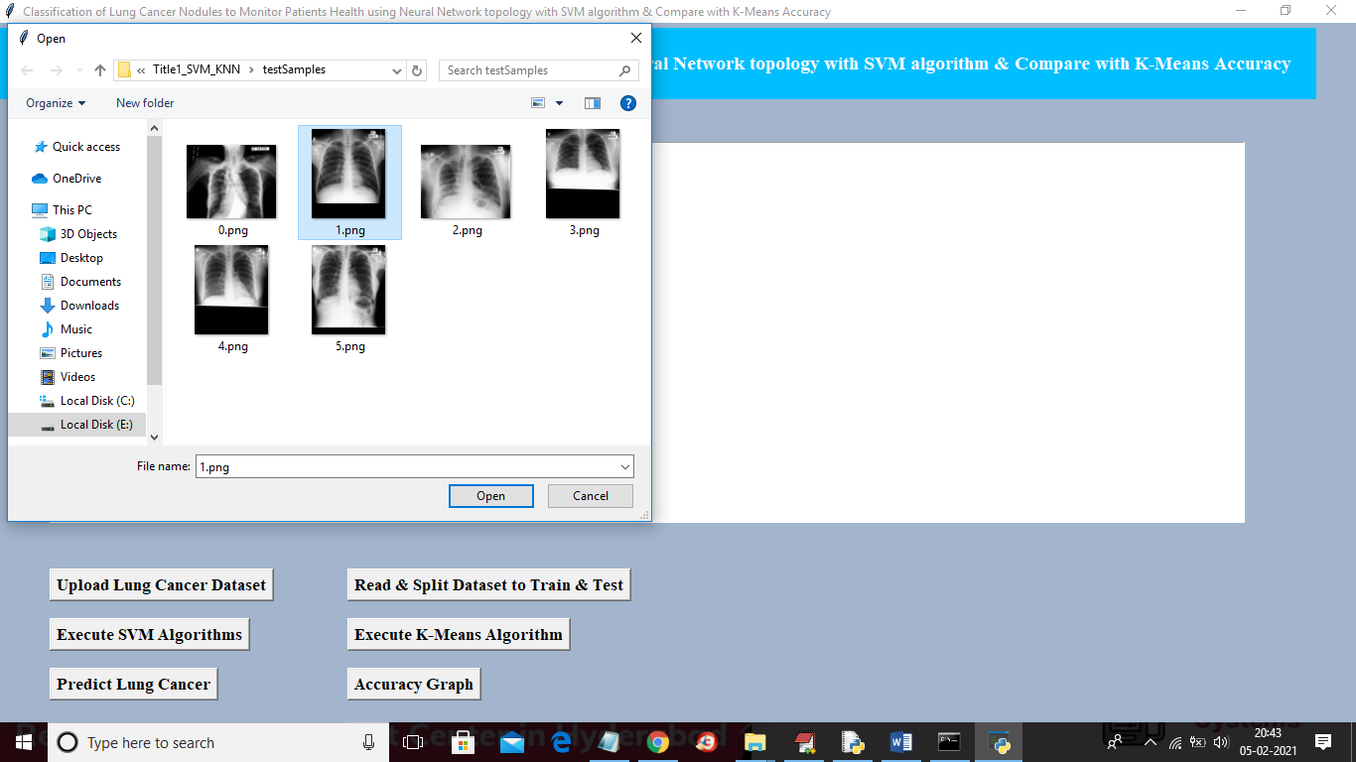

In above screen selecting and uploading ‘1.png’ file and then click on ‘Open’ button to get below result

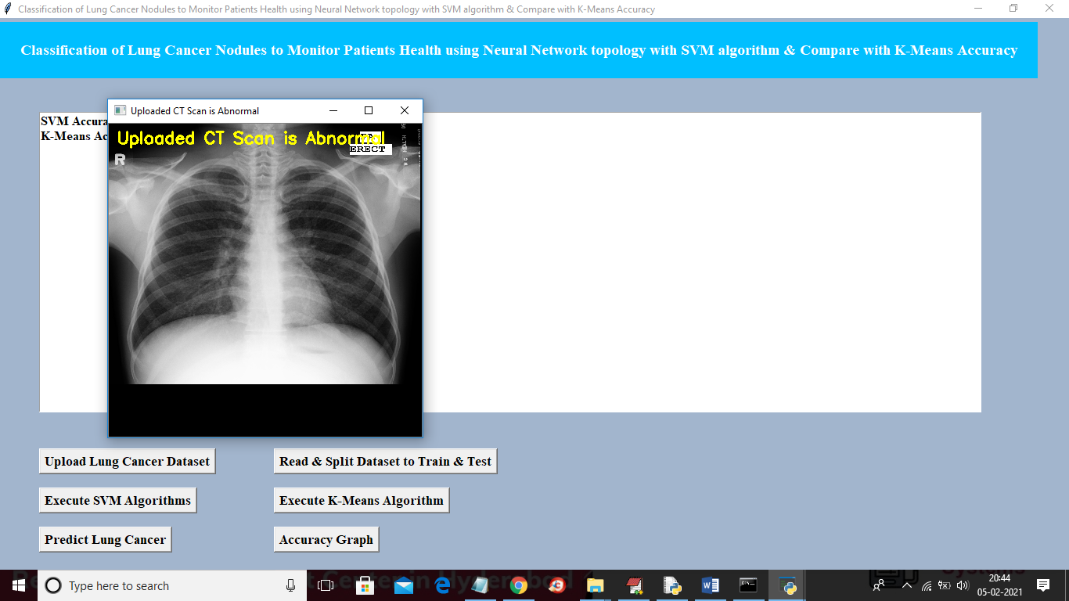

In above screen uploaded image predicted as Abnormal and now test with another image

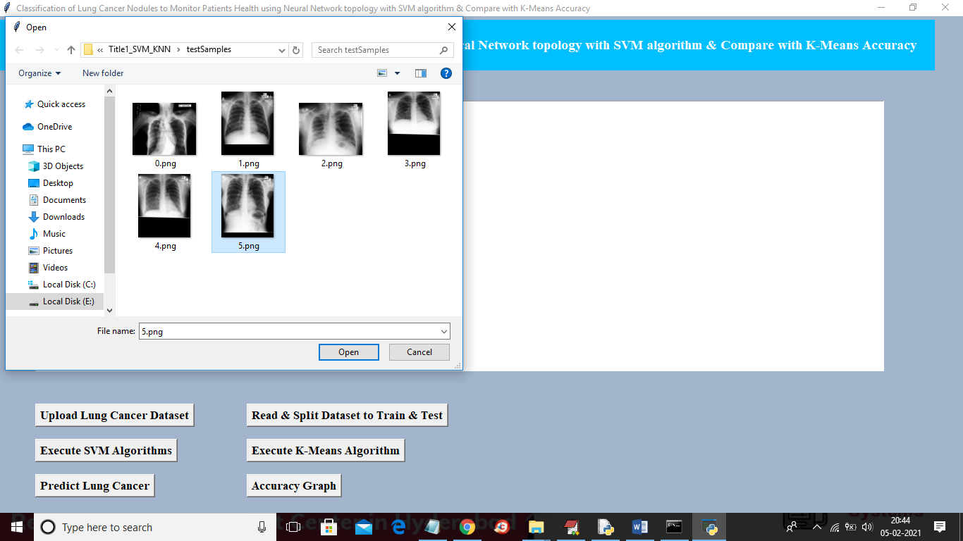

In above screen uploading ‘5.png’ and below is the result

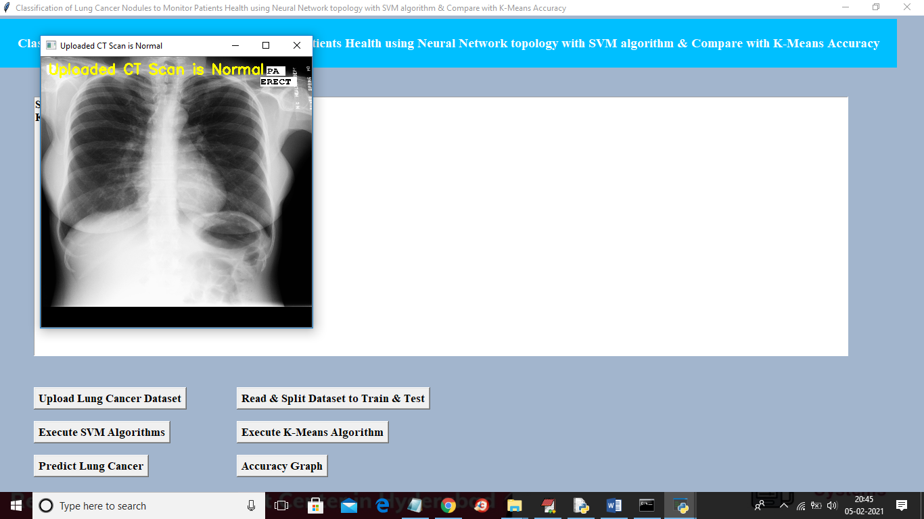

Above image predicted as Normal and similarly you can upload any image and perform prediction and now click on ‘Accuracy Graph’ button to get below graph

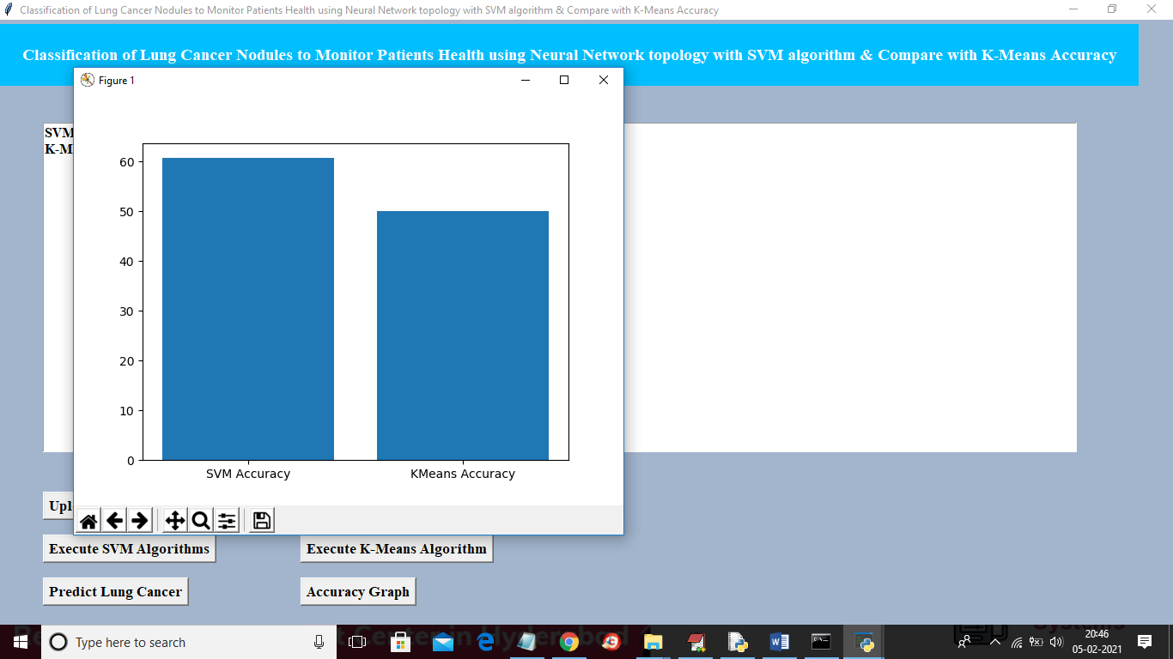

In above screen x-axis represents algorithm name and y-axis represents accuracy of those algorithms and from above graph we can conclude that SVM is better than KMEANS in prediction.

TITLE 2

**A Hybrid model for Classification of Lung Nodules Across Sequential and time variant data to assist doctors to treat the disease over SVM algorithm and compare the error rate with k-Nearest Neighbours**

In this project we are using same above dataset to train SVM and KNN algorithm and then calculating error rate between this 2 algorithms and this error rate refers to wrong classification percentage. For example if application predicted 18 records correctly out of 20 records then error rate will be (1 – (18/20) = 0.1

SCREEN SHOTS

To run project double click on ‘run.bat’ file from ‘Title2_SVM_KNN’ folder to get below screen

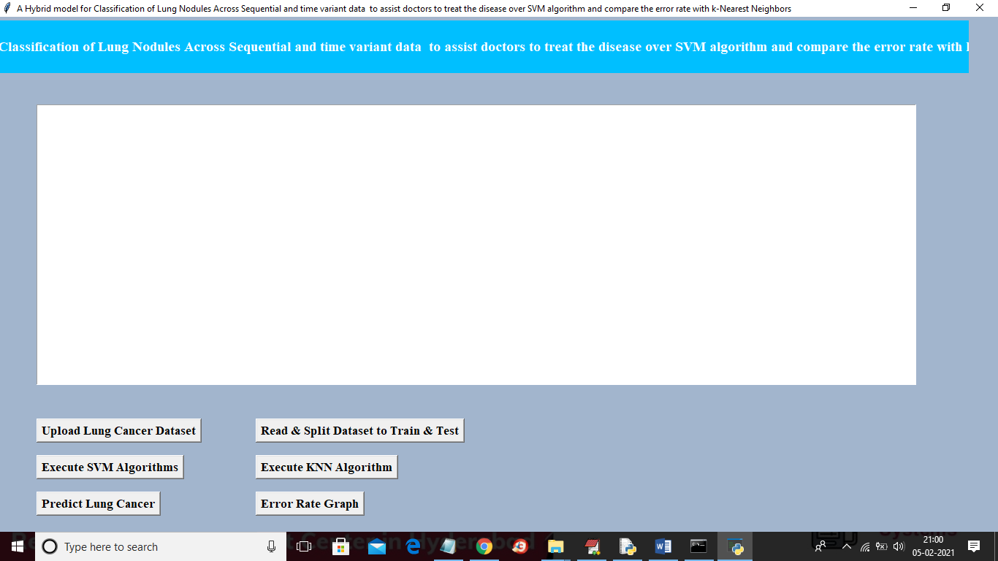

In above screen upload dataset and then read dataset and then execute SVM and KNN and then you can predict and calculate error rate

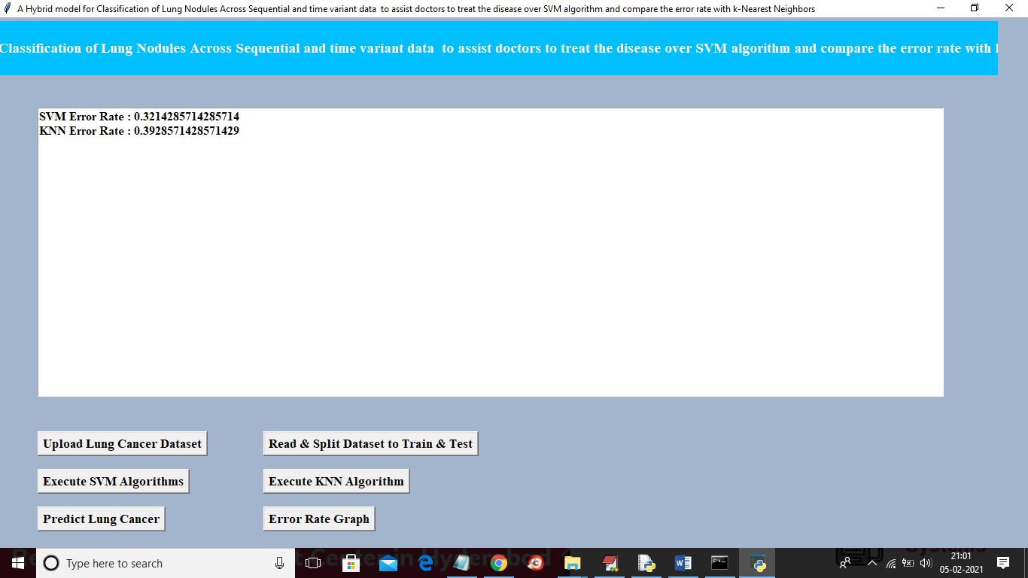

In above screen we can see SVM error rate is 0.32% and KNN error rate is 0.39 and similarly like first project screen shots u can run prediction and graph button. In above screen datasets will be splitted randomly so for every run train and test data may change due to random selection so accuracy or error rate may vary

Title 3

**Detection of Lung cancer from CT image using SVM classification and compare the survival rate of patients using 3D Convolutional neural network(3D CNN)on lung nodules data set**

In this project we are using same above Lungs dataset to train CNN and SVM algorithm and then calculate survival rate of patients by using both algorithms. If algorithm predicted 18 records correctly out of 20 records then survival rate will be (18/20 * 100) = 90%.

SCREEN SHOTS

To run project double click on ‘run.bat’ file from ‘Title3_SVM_CNN’ folder to get below screen

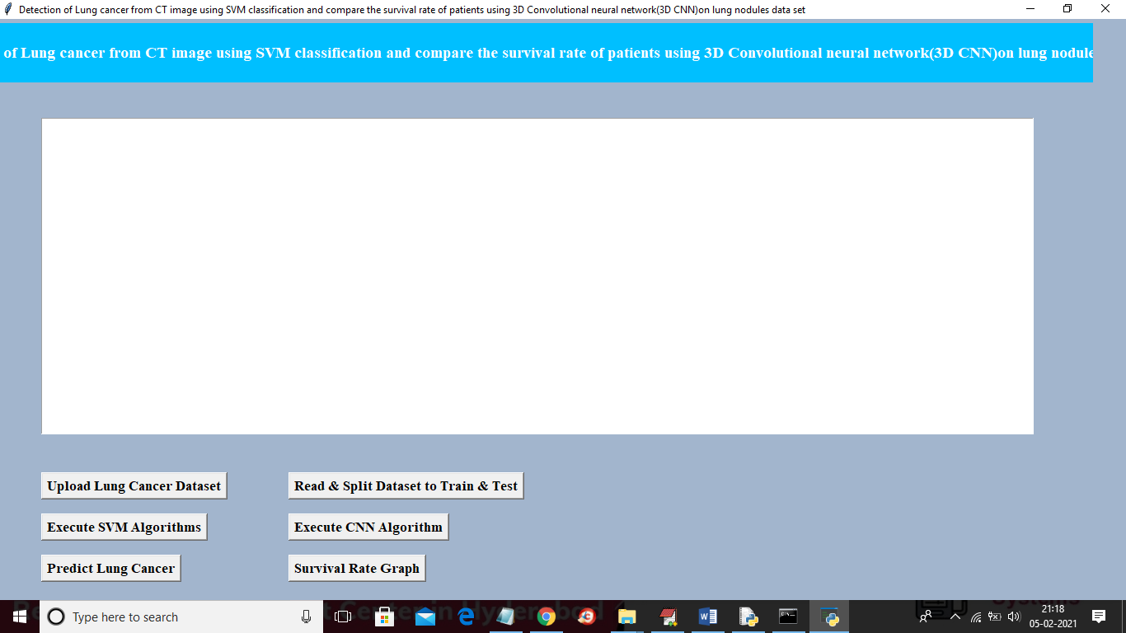

Similar to first two projects here also you upload ‘Dataset’ folder and then click on “read & split” button and then execute SVM and CNN and then predict cancer and go for survival rate graph. For CNN results you can refer to black console below

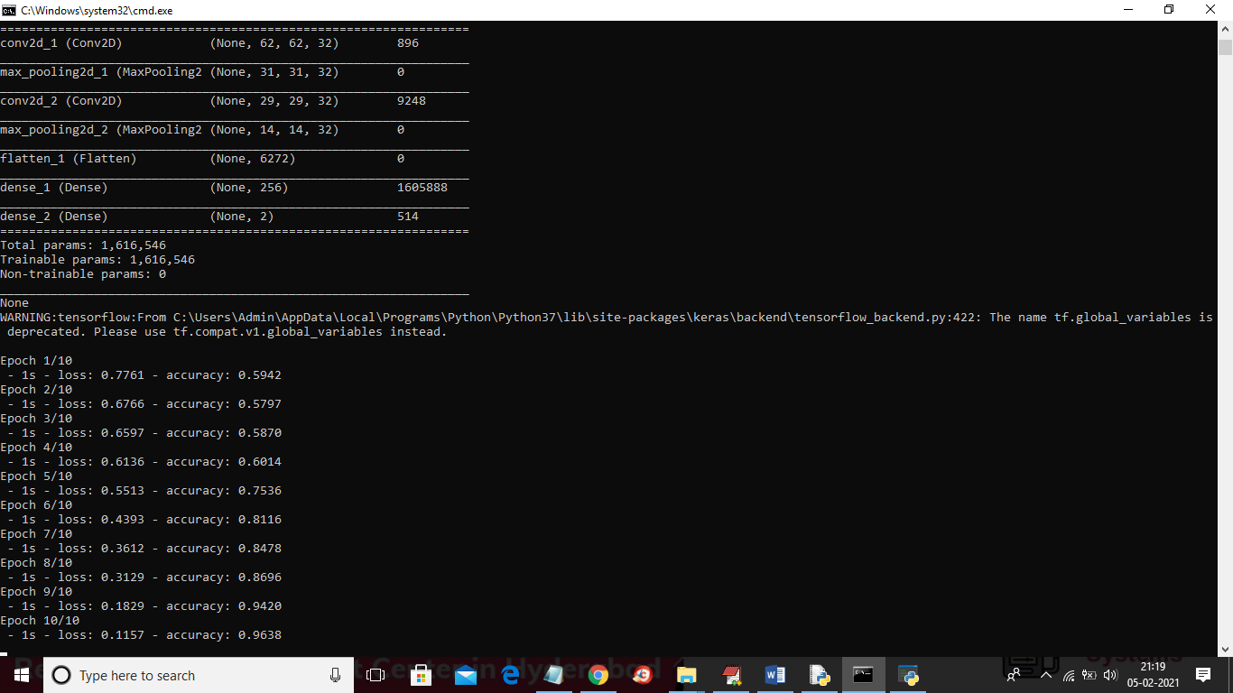

In above screen you can see for CNN we use multiple filters to filter dataset for better prediction result and in above screen in first layer CNN use 62 X 62 image size with 32 filters and in second layer for 31 X 31 image size also it uses 32 filters and for each filter we will have best image features and prediction accuracy will be better. In above screen to run CNN I used 10 epoch/iteration and for each increase iteration accuracy get better and better and for last epoch we got 0.96% accuracy and below is the final accuracy result for both SVM and CNN

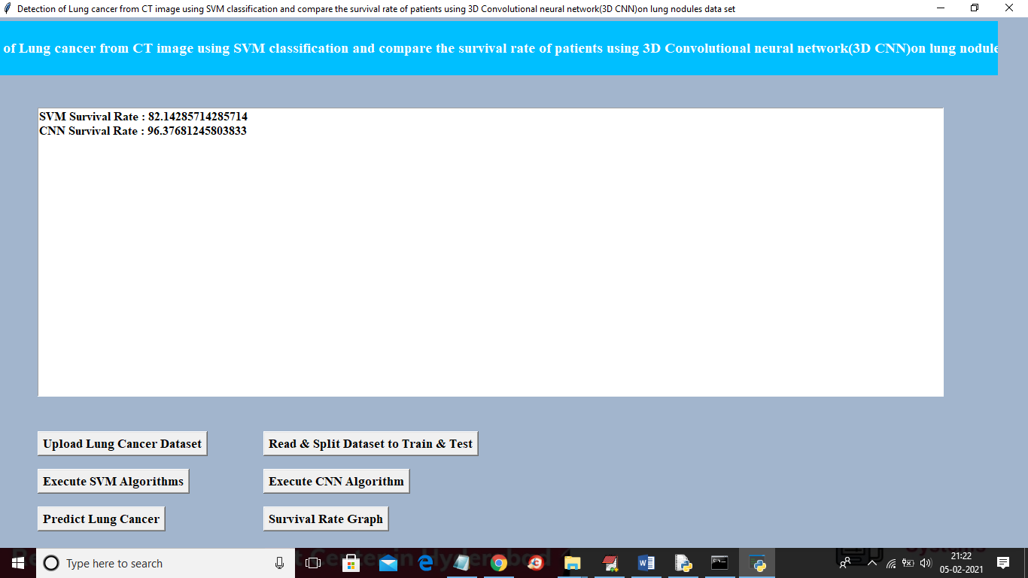

In above screen SVM survival rate is 82% and CNN survival rate is 96% and similarly you can go for predict button and graph button.

Title 4

**Prediction of time-to-event outcomes in diagnosing lung cancer based on SVM and compare the accuracy of predicted outcome with Deep CNN algorithm**

In this project we are training SVM and CNN with same LUNG dataset and then calculating and comparing accuracy of both algorithms

SCREEN SHOT

To run this project double click on ‘run.bat’ file from ‘Title4_SVM_CNN_Accuracy’ folder to get below screen

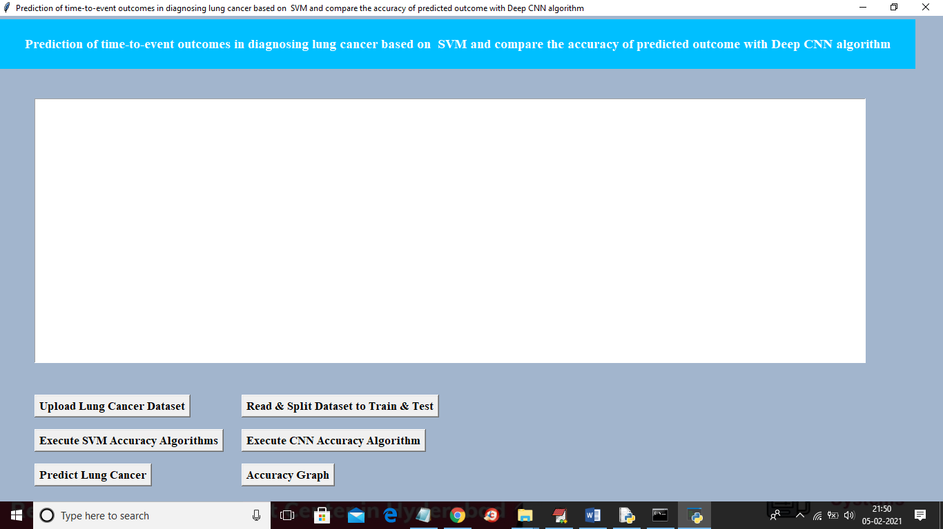

In above screen similar to first two projects upload dataset and then click on ‘read and split dataset’ button and then execute SVM with accuracy and CNN with accuracy and then you can go for predict lung cancer and accuracy graph

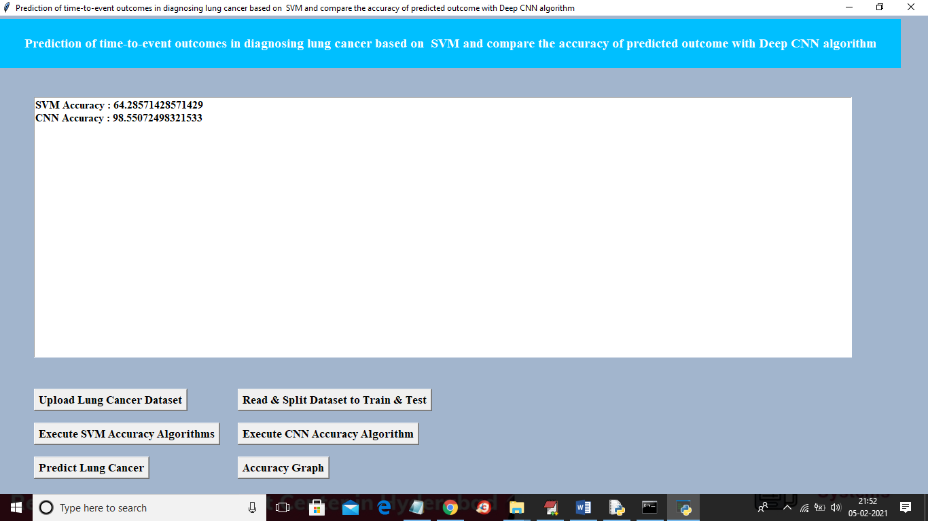

In above screen SVM accuracy is 64% and CNN accuracy is 98% and below is the comparison graph for title 4

