**ASP.NET**

Microsoft® ASP.NET is a set of technologies in the Microsoft .NET Framework for building Web applications and XML Web services. ASP.NET pages execute on the server and generate markup such as HTML, WML, or XML that is sent to a desktop or mobile browser. ASP.NET pages use a compiled, event-driven programming model that improves performance and enables the separation of application logic and user interface. ASP.NET pages and ASP.NET XML Web services files contain server-side logic (as opposed to client-side logic) written in Microsoft® Visual Basic® .NET, Microsoft® Visual C#® .NET, or any Microsoft®.NET Framework-compatible language.

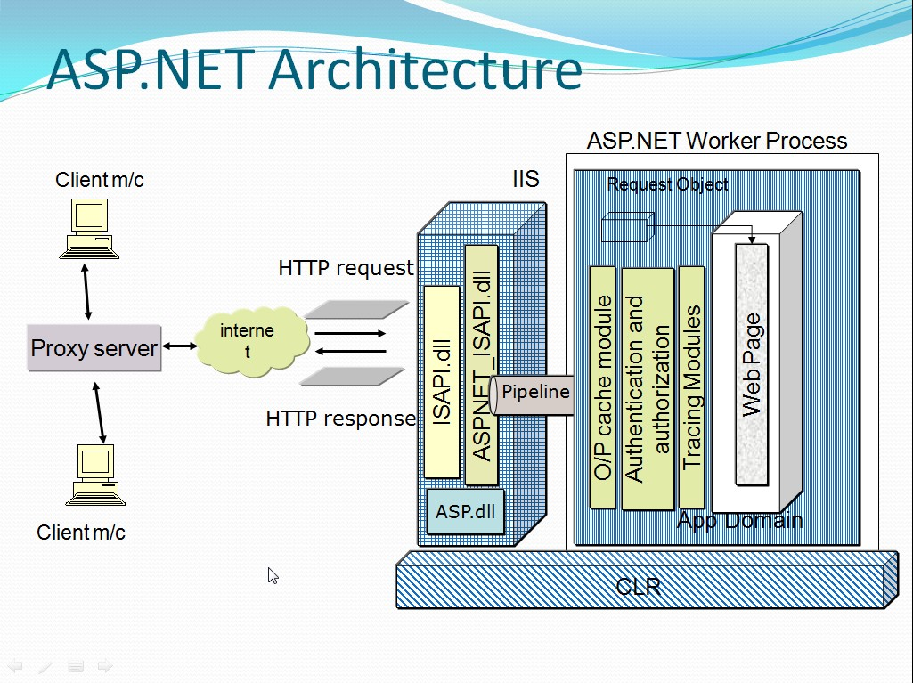

**Difference between ASP and ASP.NET**

|  |  |
| --- | --- |
| **ASP** | **ASP.NET** |
| ASP runs under the ISS(server) process space, hence there is a possibility of application crash. | ASP.NET runs under separate worker process. |
| ASP can run only on Microsoft technology. And not on non Microsoft technology like Apache Web server. | ASP.NET could be run on non Microsoft patform also. |
| Only two languages are available for scripting. VBScript and JavaScript/Jscript. | Any Microsoft .NET compatible languages are available. |
| Pages are interpreted. | Pages are compiled. |

**Introduction to ASP.NET Web Forms**

ASP.NET Web Forms is a part of the ASP.NET web application framework and is included with [Visual Studio](http://www.asp.net/downloads/). It is one of the four programming models you can use to create ASP.NET web applications, the others are ASP.NET MVC, ASP.NET Web Pages, and ASP.NET Single Page Applications.

Web Forms are pages that your users request using their browser. These pages can be written using a combination of HTML, client-script, server controls, and server code. When users request a page, it is compiled and executed on the server by the framework, and then the framework generates the HTML markup that the browser can render. An ASP.NET Web Forms page presents information to the user in any browser or client device.

**ASP.NET Web Forms are:**

* Based on Microsoft ASP.NET technology, in which code that runs on the server dynamically generates Web page output to the browser or client device.
* Compatible with any browser or mobile device. An ASP.NET Web page automatically renders the correct browser-compliant HTML for features such as styles, layout, and so on.
* Compatible with any language supported by the .NET common language runtime, such as Microsoft Visual Basic and Microsoft Visual C#.
* Built on the Microsoft .NET Framework. This provides all the benefits of the framework, including a managed environment, type safety, and inheritance.
* Flexible because you can add user-created and third party controls to them.

**ASP.NET Web Forms offer:**

* Separation of HTML and other UI code from application logic.
* A rich suite of server controls for common tasks, including data access.
* Powerful data binding, with great tool support.
* Support for client-side scripting that executes in the browser.
* Support for a variety of other capabilities, including routing, security, performance, internationalization, testing, debugging, error handling and state management.

## Features of ASP.NET Web Forms

* **Server Controls**- ASP.NET Web server controls are objects on ASP.NET Web pages that run when the page is requested and that render markup to the browser. Many Web server controls are similar to familiar HTML elements, such as buttons and text boxes. Other controls encompass complex behavior, such as a calendar controls, and controls that you can use to connect to data sources and display data.
* **Master Pages**- ASP.NET master pages allow you to create a consistent layout for the pages in your application. A single master page defines the look and feel and standard behavior that you want for all of the pages (or a group of pages) in your application. You can then create individual content pages that contain the content you want to display. When users request the content pages, they merge with the master page to produce output that combines the layout of the master page with the content from the content page.
* **Working with Data**- ASP.NET provides many options for storing, retrieving, and displaying data. In an ASP.NET Web Forms application, you use data-bound controls to automate the presentation or input of data in web page UI elements such as tables and text boxes and drop-down lists
* **State Management**- ASP.NET Web Forms includes several options that help you preserve data on both a per-page basis and an application-wide basis.
* **Security**- An important part of developing a more secure application is to understand the threats to it. Microsoft has developed a way to categorize threats: Spoofing, Tampering, Repudiation, Information disclosure, Denial of service, Elevation of privilege (STRIDE). In ASP.NET Web Forms, you can add extensibility points and configuration options that enable you to customize various security behaviors in ASP.NET Web Forms.
* **Performance**- Performance can be a key factor in a successful Web site or project. ASP.NET Web Forms allows you to modify performance related to page and server control processing, state management, data access, application configuration and loading, and efficient coding practices
* **Debugging and Error Handling**- ASP.NET includes features to help you diagnose problems that might arise in your Web Forms application. Debugging and error handling are well supported  within ASP.NET Web Forms so that your applications compile and run effectively.
* **Deployment and Hosting**- Visual Studio, ASP.NET, Azure, and IIS provide tools that help you with the process of deploying and hosting your Web Forms application.

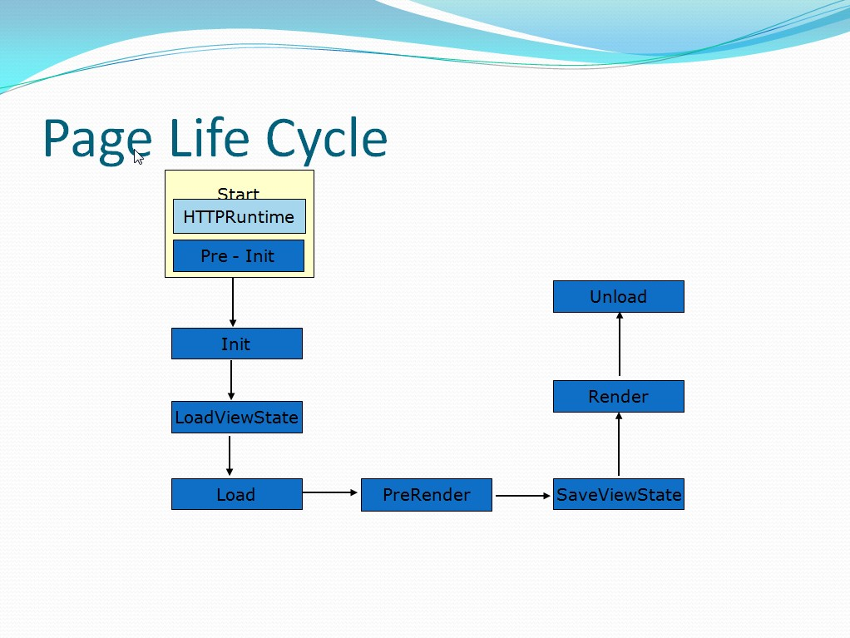

**Application and page Frame works:**

Refer pdf file given below:

Structure of Asp.net page(slide 1 to 36 )