Detecting Intravenous Contrast in CT Slices with Deep Learning: A Patient-Grouped Cross-Validation Study
Abhinava Kotha (23070521075)  B.Tech Computer Science and Engineering  Symbiosis Institute of Technology, Symbiosis International University  Nagpur, India  akashkotha9@gmail.com | Arya Gour (23070521021)  B.Tech Computer Science and Engineering  Symbiosis Institute of Technology, Symbiosis International University  Nagpur, India  aryagour8888@gmail.com
Abstract—Intravenous (IV) contrast status is often missing or wrong in DICOM metadata, which hurts data curation and model deployment [1]. This report studies whether contrast can be detected from pixel data alone on the public SIIM medical-images set (100 CT slices, 94 after de-duplication, 54 patient IDs). We compare a logistic-regression baseline on handcrafted Hounsfield-unit (HU) features, an age-only control, a small CNN trained from scratch and an ImageNet-initialised ResNet18, all under stratified, patient-grouped 5-fold cross-validation with fixed epochs. Out-of-fold (OOF) AUCs were 0.952 (HU features + LR), 0.948 (ResNet18), 0.902 (small CNN) and 0.543 (age only). Group-bootstrap 95% intervals overlap for the first three, so we do not claim a winner. Grad-CAM on a few held-out slices is partly plausible and partly points to image periphery. Results are a proof of concept on a very small sample without external validation.
Index Terms—computed tomography, contrast agent detection, deep learning, ResNet, Grad-CAM, patient-grouped cross-validation, shortcut learning.

I. INTRODUCTION
Contrast-enhanced computed tomography (CT) is routine in oncology and emergency imaging, yet the flag that records whether IV contrast was given is entered by hand and is frequently absent or wrong. In a head-and-neck and chest CT cohort, metadata for IV contrast was missing or erroneous in 75.6% of scans [1]. Any large-scale study that mixes enhanced and unenhanced images therefore needs an automatic, image-based check. In our own data the problem is visible: of the 47 contrast slices, 36 carry an empty contrast-agent tag.
This project asks a narrow question: can a model recognise contrast from a single axial slice, and can we trust the answer? Small medical datasets are prone to optimistic scores from leakage and shortcuts [2], [3], [4], so the study is designed around evaluation hygiene as much as accuracy. Our contributions are: (i) a patient-grouped, stratified 5-fold protocol in which every slice is predicted once out-of-fold; (ii) an interpretable HU-feature baseline and an age-only control that expose shortcut risk; (iii) a from-scratch CNN and a fine-tuned ResNet18 [5]; (iv) group-bootstrap confidence intervals and Grad-CAM [6] inspection; and (v) an honest comparison with published contrast-detection work.
II. RELATED WORK
Contrast detection. Ye et al. trained five CNNs on 133,480 slices from 1,979 head-and-neck and chest CT scans; EfficientNetB4 performed best, with AUC 0.996 (internal) and 1.0 (external) on head-and-neck scans and 1.0 and 0.980 on chest CT after fine-tuning [1]. For abdominal CT, Rocha et al. built a CNN that recognises the four liver phases and reached 94.6% slice-level accuracy against radiologist labels [7]. Reis et al. instead segmented vessels and kidneys with TotalSegmentator [8] and classified radiodensity features with gradient boosting, reporting 92.3% accuracy [9]. These studies agree that metadata is unreliable and that pixel statistics carry the signal.
Architectures. Vision Transformers [10], Swin [11], ConvNeXt [12] and EfficientNetV2 [13] are current backbones, and surveys discuss their use in medical imaging [14]. Matsoukas et al. found that CNNs do better when trained from scratch, while ViTs match them with ImageNet pre-training and can beat them with self-supervised pre-training [15]; self-supervision also helps label-scarce medical tasks [16]. With under 100 slices we therefore keep to convolutional models.
Reliability. Models can latch onto source, scanner or demographic cues instead of pathology [17], [18], and leakage inflates reported performance [3]. We address this through grouped splits, a negative-control model and saliency checks.
Evaluation practice. Reviews of COVID-19 imaging models found that none of 62 studies was of potential clinical use because of Frankenstein datasets, missing external validation and biased labels [4]. Dataset bias is documented across chest X-ray, retina, brain and pathology data [2], and a network can recover demographic attributes from CT, X-ray and mammograms even when experts cannot [18]. For contrast detection this means a high AUC is only convincing if the protocol rules out source, anatomy and demographic cues, which is why we pair patient grouping with controls rather than relying on a single random split.
III. DATASET AND EXPLORATORY ANALYSIS
We use the public Kaggle kmader/siim-medical-images set: 100 DICOM CT slices (512×512) with an overview table carrying age, a Boolean contrast label and DICOM file names. The label column and DICOM file column were located programmatically and every row was matched to a file by assertion. HU values were obtained from stored pixels using the rescale slope and intercept. Exact-duplicate pixel arrays were removed by MD5 hashing, leaving 94 slices (47 per class) from 54 unique PatientIDs, so several slices share a patient. Raw HU values span −3024 to 3072.
Table I summarises the class-wise HU statistics inside a body mask (threshold −300 HU, opening, largest component, hole filling). Contrast slices have a higher soft-tissue mean (37.3 vs 16.4 HU, Mann–Whitney p=2.97×10⁻⁶) and a much higher 90th percentile (161.6 vs 84.5 HU, p=4.16×10⁻¹¹), whereas the 99th percentile does not differ (p=0.354); this matches enhancement of vessels and organs rather than bone. Age is not significantly different (69.2 vs 65.7 years, p=0.104). The body-area fraction does differ (0.46 vs 0.53), a possible anatomical shortcut that we keep in mind when reading Grad-CAM.
TABLE I. CLASS-WISE HU STATISTICS (MEAN OVER SLICES)
Class | Body frac. | ST mean | ST std | p50 | p90 | p99
No contrast (47) | 0.46 | 16.41 | 71.88 | −47.76 | 84.46 | 477.70
Contrast (47) | 0.53 | 37.27 | 88.52 | −63.92 | 161.61 | 515.57

Metadata and heterogeneity. The 94 slices come from a heterogeneous source (Table II): two scanner manufacturers, twelve slice thicknesses, seven tube voltages and 55 distinct pixel spacings. Heterogeneity helps realism but it also gives a model many non-contrast cues to exploit. The DICOM contrast-agent tag is informative only in one direction: 11 of the 47 contrast slices contain an agent name (for example ISOVUE or OPTIRAY) and none of the non-contrast slices does, while the other 36 contrast slices carry an empty field. A metadata rule would therefore miss about three quarters of contrast cases, which is the practical argument for classifying from pixels [1].
TABLE II. DISTINCT VALUES PER DICOM FIELD (94 SLICES)
Field | Distinct | Field | Distinct
PatientID | 54 | Slice thickness | 12
Patient age | 32 | KVP | 7
Patient sex | 2 | Pixel spacing | 55
Manufacturer | 2 | Contrast agent text | 8
Body part | 2 | Rows × columns | 1 (512×512)

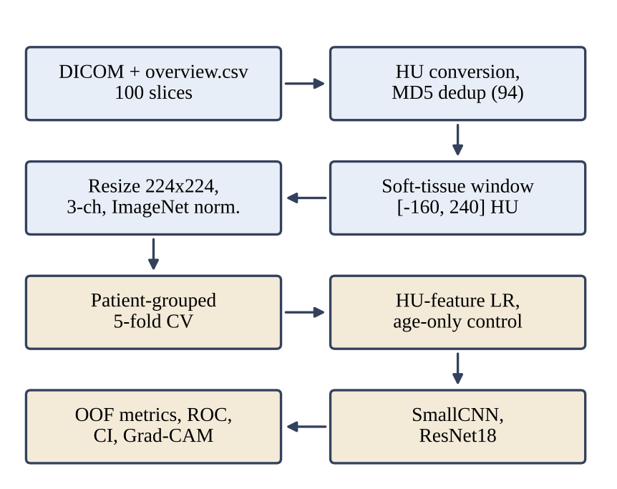
Fig. 1. End-to-end pipeline from DICOM files to out-of-fold evaluation and Grad-CAM.
IV. METHODOLOGY
A. Preprocessing
Stored pixel values P are converted to Hounsfield units and then mapped to [0, 1] by a soft-tissue window (level 40, width 400):
HU = s·P + b (1)
x = clip((HU − L)/(U − L), 0, 1) (2)
where s and b are the DICOM rescale slope and intercept, and L=−160 HU, U=240 HU are the window limits. The slice is resized to 224×224 by bilinear interpolation with antialiasing, replicated to three channels and standardised per channel c with the ImageNet means μ=(0.485, 0.456, 0.406) and standard deviations σ=(0.229, 0.224, 0.225):
x̃_{c} = (x − μ_{c})/σ_{c} (3)
Training uses only horizontal flips and small affine changes (±10° rotation, 5% translation, scale 0.95–1.05). Brightness and contrast jitter are deliberately excluded, because contrast is itself an intensity effect.
Body mask and HU descriptors. For the exploratory statistics and the baseline, a body mask B is obtained by thresholding at −300 HU, applying a binary opening (two iterations), keeping the largest connected component and filling its holes. The soft-tissue mean and the percentiles are then computed inside B:
μ_{ST} = (1/|S|) Σ_{v∈S} v (4)
where S is the set of HU values inside B that lie between −100 and 300 HU (soft tissue). Percentiles P_{q} of all HU values in B are taken at q = 5, 25, 50, 75, 90, 95 and 99. Because contrast raises the HU of perfused tissue and vessels, μ_{ST} and P₉₀ are expected to move up, while bone-dominated percentiles such as P₉₉ are not.
B. Patient-grouped cross-validation
A single split of 94 images is too noisy, so we use StratifiedGroupKFold (k=5, shuffled, seed 42) with PatientID as the group. An assertion verifies that no patient appears in both train and test of any fold. Test folds contained 24, 24, 13, 17 and 16 slices with 11, 15, 5, 6 and 10 positives. Each slice is predicted exactly once, giving an OOF score vector used for pooled ROC, confusion matrix and bootstrap intervals.
C. Baselines
HU-feature logistic regression. Inside the body mask we compute a 40-bin density histogram over [−200, 400] HU, seven percentiles (5, 25, 50, 75, 90, 95, 99), the mean and the standard deviation: 49 features in total. After standardisation, an L2-regularised logistic regression gives
p(y=1|f) = σ(w^{T}f + b), σ(z) = 1/(1 + e^{−z}) (5)
with inverse regularisation strength C=0.1. Age-only control. The same classifier is fitted on age alone; a high score would mean age is confounded with the label.
D. Deep models
SmallCNN (≈98 k parameters) stacks four blocks of 3×3 convolution, batch normalisation, ReLU and 2×2 max-pooling with 16, 32, 64 and 128 channels, followed by global average pooling, dropout 0.3 and a single linear unit (Fig. 2a). ResNet18 [5] is loaded with ImageNet weights and its 1000-way classifier is replaced by Linear(512, 1) (≈11.2 M parameters, Fig. 2b); all layers are fine-tuned. Both output one logit z per slice.
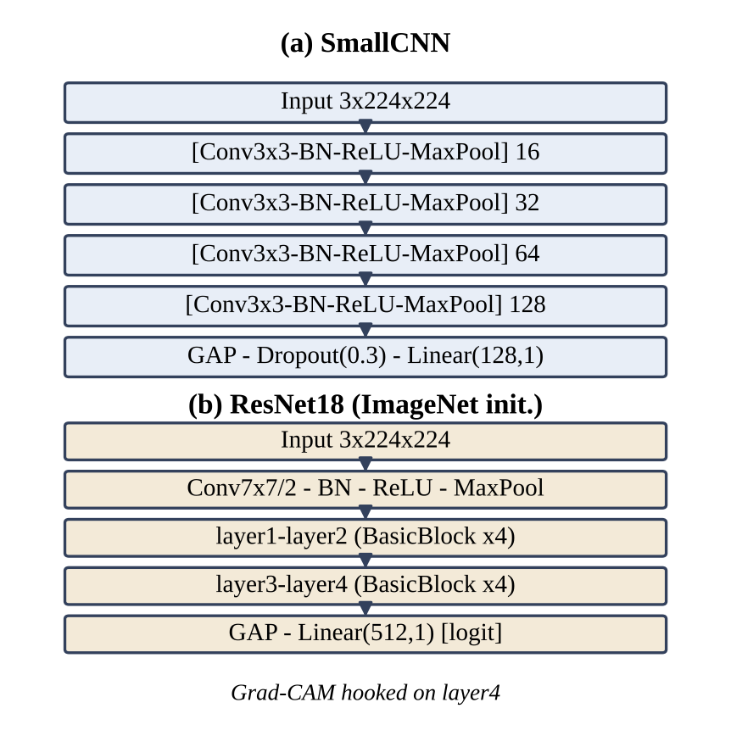
Fig. 2. (a) SmallCNN and (b) ResNet18 with a single-logit head.
E. Training objective
Models minimise binary cross-entropy on logits, with y equal to 0 or 1 and p=σ(z):
ℒ = −(1/N) Σ_{i} [y_{i} log p_{i} + (1 − y_{i}) log(1 − p_{i})] (6)
AdamW [19] updates weights with decoupled decay λ, where m̂ and v̂ are bias-corrected moment estimates:
θ_{t+1} = θ_{t} − η_{t} ( m̂_{t}/(√v̂_{t} + ε) + λθ_{t} ) (7)
η_{t} = ½ η₀ (1 + cos(π t/T)) (8)
Eq. (8) is the cosine-annealing schedule with T equal to the number of epochs. The number of epochs is fixed in advance, so the held-out fold is never used to choose a checkpoint.
F. Metrics and uncertainty
At threshold 0.5 we report accuracy, precision, recall and F1,
Acc = (TP+TN)/N, Prec = TP/(TP+FP) (9)
Rec = TP/(TP+FN), F1 = 2·Prec·Rec/(Prec+Rec) (10)
and the ROC AUC, which equals the probability that a random positive outscores a random negative:
AUC = P(s⁺ > s⁻) + ½ P(s⁺ = s⁻) (11)
Fold-wise values are summarised as mean ± SD. For pooled OOF AUC we draw 2,000 bootstrap resamples of patients (not slices) with replacement and report the 2.5–97.5 percentile interval, which respects the clustering of slices within patients.
G. Algorithm summary
Algorithm 1 (one cross-validation run). (1) Read each DICOM, convert to HU by Eq. (1), drop exact duplicates. (2) Window by Eq. (2), resize, replicate and normalise by Eq. (3). (3) Build five stratified folds grouped by PatientID and assert that no patient crosses the train/test boundary. (4) For fold k, set the seed to 42+k, initialise the model, and train for the fixed number of epochs with AdamW, cosine decay and mini-batches of 16 (the last batch is dropped only if it would contain a single sample, which breaks batch normalisation). (5) Predict the held-out fold, store the probabilities in the OOF vector and the fold metrics. (6) After all folds, compute pooled ROC, confusion matrix and the patient-level bootstrap interval; keep the fold-0 model for Grad-CAM.
H. Grad-CAM
For the fold-0 ResNet18, Grad-CAM [6] weights the layer4 activations A^{k} by their spatially averaged gradients of the logit:
α_{k} = (1/Z) Σ_{i,j} ∂z/∂A_{ij}^{k} (12)
L = ReLU(Σ_{k} α_{k} A^{k}) (13)
The map is upsampled to 224×224 and min–max normalised before overlay.
V. EXPERIMENTAL SETUP
Code is written in Python with PyTorch [20], torchvision, scikit-learn, pydicom, SciPy and seaborn, and was run top-to-bottom in Google Colab. The execution log shows the CPU device, so no GPU was used for the reported numbers; seeds are set per fold (42+k) for repeatability. Table III lists all hyperparameters.
TABLE III. HYPERPARAMETERS AND SETTINGS
Item | HU + LR | SmallCNN | ResNet18
Input | 49 HU features | 3×224×224 | 3×224×224
Init. | — | Random | ImageNet
Optimiser | L-BFGS (sklearn) | AdamW | AdamW
Learning rate | — | 1e−3 | 1e−4
Weight decay / C | C = 0.1 | 1e−4 | 1e−4
Epochs | — | 30 | 15
Batch size | — | 16 | 16
Schedule | — | Cosine | Cosine
Loss | Log-loss | BCE-logits | BCE-logits
Augmentation | — | Flip + affine | Flip + affine
CV seeds | 42 + fold | 42 + fold | 42 + fold

VI. RESULTS AND ANALYSIS
Table IV gives fold-wise mean ± SD and the pooled OOF AUC. The HU-feature baseline reached 0.871 accuracy and 0.959 mean fold AUC, ResNet18 reached 0.851 accuracy and 0.984 mean fold AUC, and SmallCNN 0.812 and 0.935. The age-only control stays near chance (OOF AUC 0.543, interval 0.398–0.683), which argues against age as a shortcut. Pooled OOF AUCs of the three image-based models are 0.952, 0.948 and 0.902 with overlapping intervals.
TABLE IV. FIVE-FOLD RESULTS (MEAN ± SD) AND POOLED OOF AUC
Model | Acc | Rec | F1 | OOF AUC [95% CI]
HU + LR | .871±.033 | .833±.100 | .857±.046 | .952 [.905, .985]
Age only | .583±.100 | .555±.233 | .544±.118 | .543 [.398, .683]
SmallCNN | .812±.099 | .760±.196 | .797±.099 | .902 [.838, .959]
ResNet18 | .851±.096 | .868±.155 | .836±.110 | .948 [.899, .985]

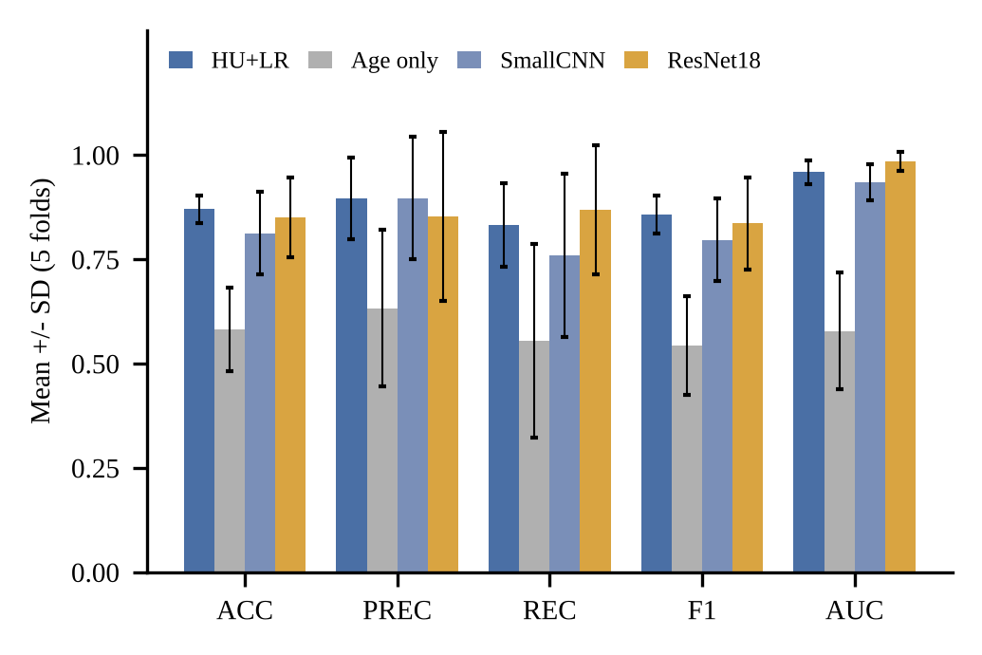
Fig. 3. Fold-wise mean ± SD of each metric for the four models.
TABLE V. PER-FOLD RESULTS OF THE DEEP MODELS
Fold | Test n (pos) | S-CNN Acc | S-CNN Rec | S-CNN AUC | R18 Acc | R18 Rec | R18 AUC
0 | 24 (11) | .792 | 1.000 | .909 | .750 | .909 | .951
1 | 24 (15) | .667 | .467 | .956 | .958 | .933 | .970
2 | 13 (5) | .846 | .800 | .875 | .846 | .600 | 1.000
3 | 17 (6) | .941 | .833 | .985 | .765 | 1.000 | 1.000
4 | 16 (10) | .812 | .700 | .950 | .938 | .900 | 1.000

ResNet18 attains per-fold AUC of 1.000 in three folds (Fig. 4), yet its pooled OOF AUC is 0.948. Both facts are consistent: each fold ranks its own slices almost perfectly, but score scales differ between independently trained fold models, so pooling the scores mixes them. Accuracy is lower than AUC because the fixed 0.5 threshold is not tuned; for example, fold 3 has recall 1.000 but precision 0.600. SmallCNN fold 1 has precision 1.000 and recall 0.467, again a threshold effect.
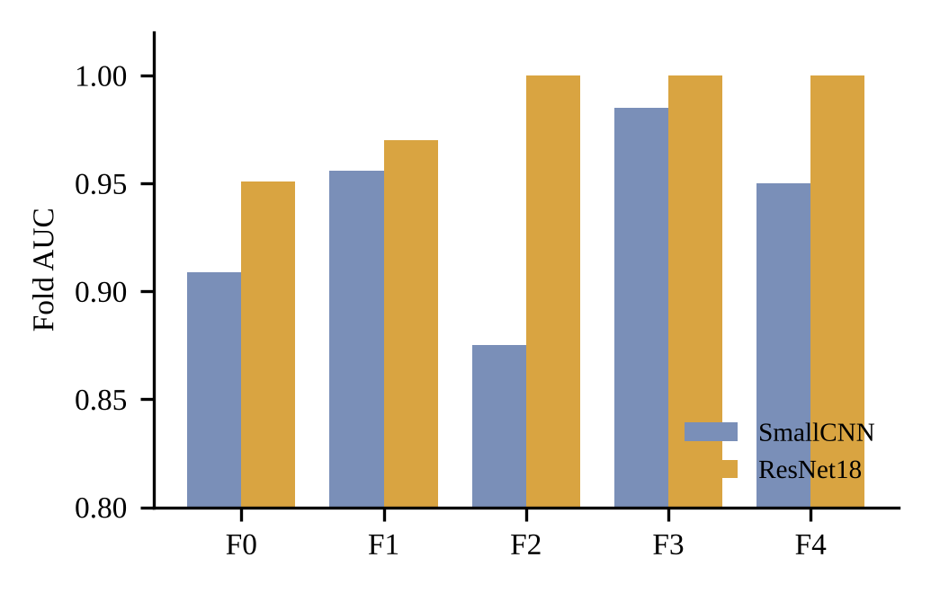
Fig. 4. Per-fold AUC for SmallCNN and ResNet18.
The best pooled model by AUC was the HU-feature baseline. Its confusion matrix (Fig. 5) shows 43 true negatives, 4 false positives, 8 false negatives and 39 true positives, i.e. sensitivity 0.83 and specificity 0.91. The right panel of Fig. 5 repeats the HU separation from Table I.
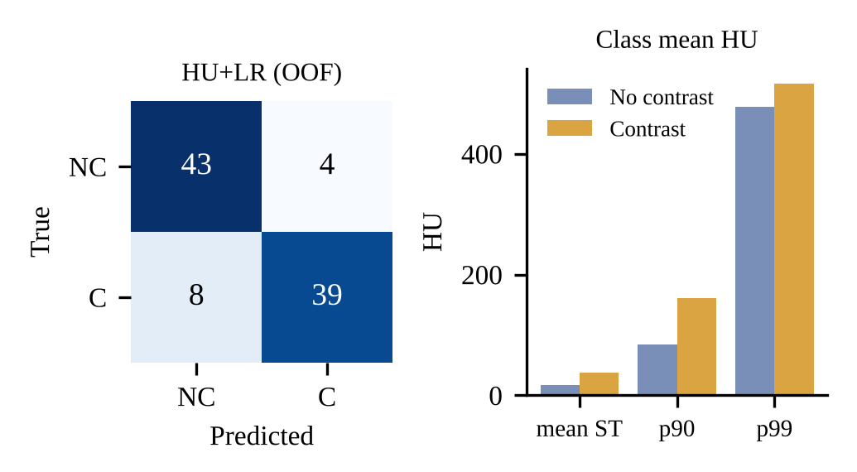
Fig. 5. Left: OOF confusion matrix of HU + LR (NC = no contrast, C = contrast). Right: class mean HU statistics.
Grad-CAM. For six fold-0 test slices, the two clearly correct contrast cases (p=0.96 and 1.00) are highlighted over the central chest, in line with heart and great vessels. One non-contrast slice received p=0.97 (a false positive) with activation over abdominal soft tissue. Two low-confidence slices (a non-contrast slice at p=0.01 and a contrast slice at p=0.42) are highlighted near the image border or table. This is only six images from one fold, but it shows that part of the decision may rest on non-vascular cues and should be audited on more data.
VII. COMPARATIVE ANALYSIS
Published numbers are not directly comparable with ours, since tasks, anatomy, sample sizes and validation differ. Table VI places them side by side to put our scores in context.
TABLE VI. COMPARISON WITH REPORTED CONTRAST-RELATED STUDIES
Study | Task / data | Model | Reported result
Ye et al. [1] | IV contrast, HN and chest CT, 1,979 scans | EfficientNetB4 | AUC 0.996 / 1.0 (HN int./ext.); 1.0 / 0.980 (chest)
Rocha et al. [7] | 4 liver phases, multiphase CT | CNN | Slice acc. 94.6%
Reis et al. [9] | 4 abdominal phases | TotalSeg. + XGBoost | Acc. 92.3%
This work | Contrast vs none, 94 slices, 54 IDs | HU features + LR | OOF AUC 0.952
This work | same | ResNet18 (fine-tuned) | OOF AUC 0.948; acc. 0.851
This work | same | SmallCNN | OOF AUC 0.902; acc. 0.812

Three observations follow. First, our binary result is in the same range as the four-phase abdominal studies and below the near-perfect AUCs of Ye et al., who used about 1,979 scans and external test sets [1]; our interval widths (≈0.08) reflect the small sample. Second, a simple HU histogram model matches a fine-tuned ResNet18, echoing the view that explicit radiodensity features are strong for this task [9] and that complex models need not beat simple ones once evaluation is leak-free [3]. Third, modern backbones such as Swin (86.4% ImageNet top-1) [11] and ConvNeXt (87.8%) [12] were not run here; given that transformers gain mostly through large-scale or self-supervised pre-training [15], [16], we expect little advantage at this data size, but this remains untested. ResNet18 also keeps the Grad-CAM pipeline simple.
Cost and deployment. The HU model uses 49 numbers per slice; SmallCNN has about 98 k parameters and ResNet18 about 11.2 M, and both were trained on CPU in this run. At scan level one would average slice probabilities per series, the way slice-level predictions are aggregated to patient level in [1], which should reduce the effect of single ambiguous slices such as apical or lower-abdominal levels.
TABLE VII. BACKBONE FAMILIES FROM THE LITERATURE AND THEIR FIT TO THIS TASK
Family | Core idea | Fit for ~100 slices
ResNet [5] | Residual conv. blocks, strong inductive bias | Used; stable with ImageNet init.
EfficientNetV2 [13] | Compound-scaled, fused-MBConv CNN | Candidate; the EfficientNet family won in [1]
ConvNeXt [12] | ResNet modernised towards ViT design | Candidate; untested here
ViT [10] | Patch tokens + global self-attention | Needs large or self-supervised pre-training [15]
Swin [11] | Shifted-window hierarchical attention | Same caveat; suited to dense tasks

The table summarises why only convolutional backbones were trained. The review in [14] points out that Transformers are attractive for long-range context and multi-task pre-training, but a contrast shift is a global intensity effect that a shallow CNN or a histogram can already capture, so extra capacity brings little at this sample size.
VIII. DISCUSSION
The central finding is not which model wins but how much each score can be trusted. The pooled ordering HU+LR ≈ ResNet18 > SmallCNN > age-only agrees with the fold means, while the gaps among the first three are smaller than their bootstrap intervals. This is the pattern one expects when the signal is a global intensity shift: the contrast slices show a heavier right tail between 100 and 300 HU in the mean histogram, which a histogram feature set captures directly, whereas a CNN has to rediscover it from pixels with few examples. The fine-tuned ResNet18 recovers most of that signal through ImageNet features, and its higher recall (0.868 vs 0.833) may matter if missing a contrast study is costlier than a false alarm.
Two caveats apply. Slices from one patient share anatomy, so even grouped folds can be optimistic if the same patient appears under another ID, which the dataset cannot rule out [2]. Second, accuracy at a fixed threshold swings by 0.2 or more between folds, so any deployment should calibrate the threshold on a separate validation split and report confidence intervals together with point estimates [3]. We also note that explainability evidence from six images is anecdotal; a quantitative check, such as masking the body region or table and measuring the AUC drop, is a natural next step.
IX. LIMITATIONS
(1) Sample size: 94 slices make fold estimates unstable (fold SDs up to about 0.2). (2) Independence: 54 patient IDs for 94 slices means grouping helps, but similar anatomy across patients cannot be ruled out. (3) Shortcuts: body-area fraction differs by class and Grad-CAM shows some peripheral attention; the age control is clean but anatomy is not controlled. (4) Threshold and calibration: the fixed 0.5 threshold and pooling of fold-specific scores affect accuracy and pooled AUC. (5) No external validation or hyperparameter search; epochs and rates were fixed, which avoids test-fold tuning but may leave performance on the table. (6) Labels come from the dataset table; we did not re-read images with a radiologist. Results should be seen as a proof of concept, not clinical evidence [2], [4].
Ethics and data use. The data are a public research dataset, so no new patient contact or consent was involved. Because models can pick up demographic information from images [18], any future version trained on hospital data should include subgroup reporting (sex, age band, scanner) in addition to overall AUC, and should be introduced as a curation aid with a human check rather than as an autonomous gatekeeper.
X. CONCLUSION
Contrast can be detected from single CT slices with OOF AUC around 0.95 using either handcrafted HU histograms or a fine-tuned ResNet18, while an age-only model stays at chance. The patient-grouped protocol, bootstrap intervals and Grad-CAM show both the promise and the fragility of such results on 94 slices. Future work should add multi-centre data, series-level aggregation, calibrated thresholds, mask-based or organ-level features, self-supervised backbones, and a radiologist review of the saliency maps.
APPENDIX: ORIGINALITY CHECK
The Turnitin report supplied with this project (file HA_Report.pdf, submission ID trn:oid:::1:3074638943, 23 Oct 2026; 9 pages, 2,888 words) is reproduced in Figs. 6 and 7.
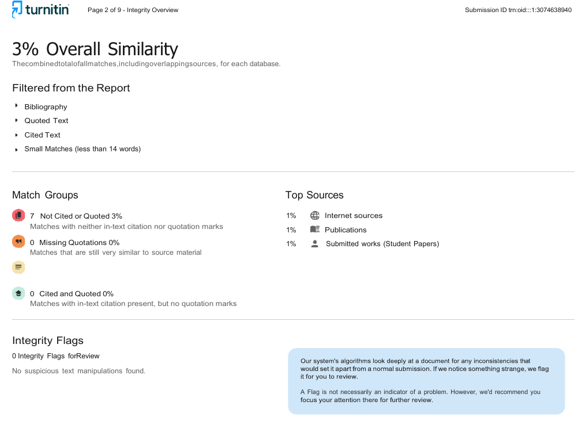
Fig. 6. Turnitin integrity overview: 3% overall similarity and 0 integrity flags.
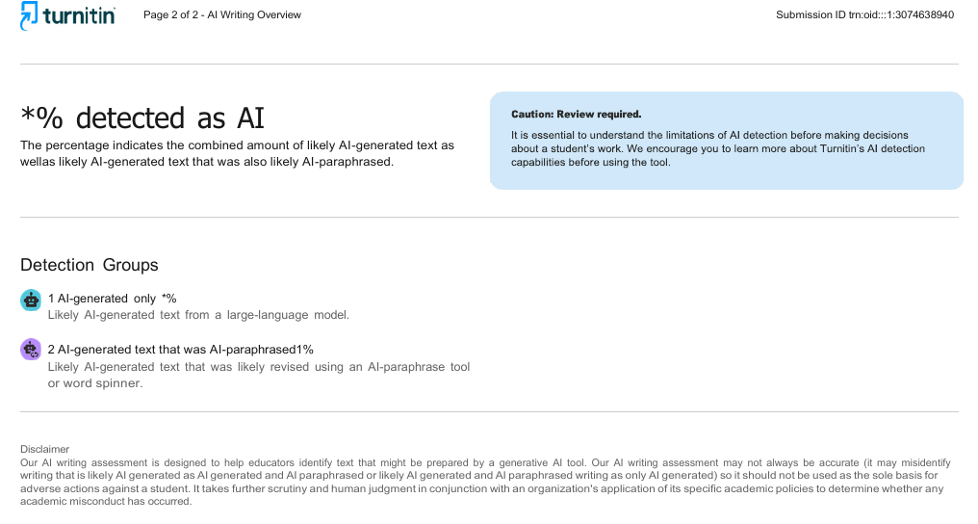
Fig. 7. Turnitin AI-writing overview: a score below 20% is shown by Turnitin as *%.
REFERENCES
[1] Z. Ye et al., "Deep learning–based detection of intravenous contrast enhancement on CT scans," Radiol. Artif. Intell., vol. 4, no. 3, Art. no. e210285, May 2022.
[2] G. Varoquaux and V. Cheplygina, "Machine learning for medical imaging: Methodological failures and recommendations for the future," npj Digit. Med., vol. 5, Art. no. 48, 2022.
[3] S. Kapoor and A. Narayanan, "Leakage and the reproducibility crisis in machine-learning-based science," Patterns, vol. 4, no. 9, Art. no. 100804, Sep. 2023.
[4] M. Roberts et al., "Common pitfalls and recommendations for using machine learning to detect and prognosticate for COVID-19 using chest radiographs and CT scans," Nat. Mach. Intell., vol. 3, pp. 199–217, 2021.
[5] K. He, X. Zhang, S. Ren, and J. Sun, "Deep residual learning for image recognition," in Proc. IEEE Conf. Comput. Vis. Pattern Recognit. (CVPR), 2016, pp. 770–778.
[6] R. R. Selvaraju et al., "Grad-CAM: Visual explanations from deep networks via gradient-based localization," in Proc. IEEE Int. Conf. Comput. Vis. (ICCV), 2017, pp. 618–626.
[7] B. A. Rocha et al., "Contrast phase recognition in liver computer tomography using deep learning," Sci. Rep., vol. 12, Art. no. 20315, Nov. 2022.
[8] J. Wasserthal et al., "TotalSegmentator: Robust segmentation of 104 anatomic structures in CT images," Radiol. Artif. Intell., vol. 5, no. 5, Art. no. e230024, 2023.
[9] E. P. Reis et al., "Automatic contrast phase detection on abdominal computed tomography using clinically-inspired techniques," in Proc. Med. Imaging Deep Learn. (MIDL), 2023.
[10] A. Dosovitskiy et al., "An image is worth 16x16 words: Transformers for image recognition at scale," in Proc. Int. Conf. Learn. Represent. (ICLR), 2021.
[11] Z. Liu et al., "Swin Transformer: Hierarchical vision transformer using shifted windows," in Proc. IEEE/CVF Int. Conf. Comput. Vis. (ICCV), 2021, pp. 10012–10022.
[12] Z. Liu, H. Mao, C.-Y. Wu, C. Feichtenhofer, T. Darrell, and S. Xie, "A ConvNet for the 2020s," in Proc. IEEE/CVF Conf. Comput. Vis. Pattern Recognit. (CVPR), 2022, pp. 11976–11986.
[13] M. Tan and Q. V. Le, "EfficientNetV2: Smaller models and faster training," in Proc. 38th Int. Conf. Mach. Learn. (ICML), PMLR 139, 2021, pp. 10096–10106.
[14] J. Li, J. Chen, Y. Tang, C. Wang, B. A. Landman, and S. K. Zhou, "Transforming medical imaging with Transformers? A comparative review of key properties, current progresses, and future perspectives," Med. Image Anal., vol. 85, Art. no. 102762, 2023.
[15] C. Matsoukas, J. F. Haslum, M. Söderberg, and K. Smith, "Is it time to replace CNNs with transformers for medical images?," in Proc. ICCV Workshop Comput. Vis. Automated Med. Diagnosis (CVAMD), 2021, arXiv:2108.09038.
[16] S. Azizi et al., "Big self-supervised models advance medical image classification," in Proc. IEEE/CVF Int. Conf. Comput. Vis. (ICCV), 2021, pp. 3478–3488.
[17] A. J. DeGrave, J. D. Janizek, and S.-I. Lee, "AI for radiographic COVID-19 detection selects shortcuts over signal," Nat. Mach. Intell., vol. 3, pp. 610–619, 2021.
[18] J. W. Gichoya et al., "AI recognition of patient race in medical imaging: A modelling study," Lancet Digit. Health, vol. 4, no. 6, pp. e406–e414, Jun. 2022.
[19] I. Loshchilov and F. Hutter, "Decoupled weight decay regularization," in Proc. Int. Conf. Learn. Represent. (ICLR), 2019.
[20] A. Paszke et al., "PyTorch: An imperative style, high-performance deep learning library," in Proc. Adv. Neural Inf. Process. Syst. (NeurIPS), 2019, pp. 8024–8035.

