Symbiosis Institute of Technology, Nagpur
B.Tech Computer Science (Honours in AI/ML)
PROJECT REPORT
on
HOUSEHOLD ELECTRICITY CONSUMPTION FORECASTING USING MACHINE LEARNING
Dataset: Individual Household Electric Power Consumption, UCI Machine Learning Repository
Course: Predictive Analytics
Semester 7
Submitted by
Abhinava Akash Kotha
Roll No. 23070521075
October 2026

CHAPTER 1: INTRODUCTION

1.1 Background and Motivation
Electricity is used in almost every part of daily life, and homes are an important part of total demand. Forecasting how much electricity a household will use in the near future helps suppliers plan generation and distribution, supports demand-response programmes and allows smart-home systems to schedule appliances. Households can also use such forecasts to manage their own energy use.
Smart meters now record electricity use at fine time intervals, which produces large amounts of data. Predictive analytics, and machine learning in particular, offers a practical way to learn usage patterns from this history. However, the electricity use of a single household is difficult to predict. It depends on a few appliances and on the habits of the people living there, so it changes quickly and contains many sudden peaks (Kong et al., 2019).
This project uses a public dataset of one household, collected by Hebrail and Berard (2006) and hosted by the UCI Machine Learning Repository. The data are recorded every minute from December 2006 to November 2010. The project builds a complete workflow, from raw data to a forecasting model, following the Knowledge Discovery in Databases (KDD) process (Fayyad et al., 1996).

1.2 Problem Statement
The problem is to predict the household's mean active power consumption (in kW) for the next hour, using historical electricity measurements and time-based features. The raw minute-level data are first aggregated to hourly observations. The model uses features known at the forecast origin t (calendar information, lagged hourly values and rolling statistics of past values) to estimate the target y(t+1). This is a supervised regression problem on a time series, and it must be evaluated without using future data to predict the past.

1.3 Project Objectives
The objectives of the project are:
- To obtain the UCI household power dataset, understand its structure and check its quality, including missing values and duplicates.
- To aggregate the minute-level data into hourly observations suitable for one-hour-ahead forecasting.
- To explore daily and weekly consumption patterns through exploratory data analysis (EDA).
- To create calendar, lag and rolling features that use only past information.
- To split the data chronologically into training, validation and test sets, and to compare a baseline, linear models, tree ensembles and gradient boosting.
- To evaluate the selected model on a held-out test period using MAE, RMSE, MAPE and R², and to interpret it using permutation feature importance.
- To report the results honestly, including the limitations of the model.

1.4 Scope and Significance
The scope of the project is limited to one household and one forecasting horizon (the next hour). The predictors are calendar features and features derived from past values of the target. Six model configurations are compared: a training-mean baseline, Linear Regression, Ridge Regression, Random Forest, Extra Trees and Histogram Gradient Boosting. Deep learning models, weather data and other external information are outside the scope. The final forecast shown in the notebook is an offline demonstration using the last available record and is not a live forecast.
The significance of the work is mainly educational and methodological. It shows a full predictive-analytics workflow with a leakage-safe chronological evaluation, and it reports the results as obtained, without exaggeration. Because the data come from a single household, the findings must not be generalised to all households.

CHAPTER 2: LITERATURE REVIEW

2.1 Household Electricity Load Forecasting
Load forecasting is a long-established topic in power-systems research. Hong and Fan (2016) give a tutorial review of electric load forecasting and show why forecasts are central to planning and operating power systems. Many studies deal with aggregated loads, such as city or substation level, where the random behaviour of individual customers averages out. A single household is different: Kong et al. (2019) note that household-level load is much more volatile and uncertain than aggregated load. Moderate accuracy at household level is therefore not surprising, and results should be judged against simple baselines.

2.2 Statistical Time-Series Approaches
Classical methods model a series using its own past values and errors. The ARIMA family described by Box et al. (2015) and the exponential-smoothing methods explained by Hyndman and Athanasopoulos (2021) are standard examples. They work well for regular series and have a clear statistical interpretation. Household electricity use, however, combines a daily cycle, a weekly cycle, calendar effects and irregular spikes, which makes a single classical model less convenient. This is one reason why machine learning regression on engineered features is widely used.

2.3 Machine Learning Approaches
A common way to apply machine learning to a time series is to convert it into a table. Each row describes the situation at the forecast origin through calendar variables, lagged values and rolling statistics, and the target is the future value. Linear regression is the simplest choice, and Ridge regression adds a penalty on large coefficients to reduce over-fitting (Hoerl & Kennard, 1970).
Tree-based ensembles can learn non-linear relationships and interactions, such as the combined effect of hour and weekday, without manual specification. Random Forests average many decision trees trained on random samples of the data (Breiman, 2001). Extremely Randomised Trees, or Extra Trees, make the split thresholds more random to further reduce variance (Geurts et al., 2006). Gradient boosting builds trees one after another, each correcting the errors of the previous ones (Friedman, 2001). Histogram-based implementations, such as LightGBM (Ke et al., 2017), group feature values into bins to make training faster, and scikit-learn provides a histogram-based gradient boosting regressor of this kind (Pedregosa et al., 2011).

2.4 Deep Learning Approaches
Recurrent neural networks, especially Long Short-Term Memory (LSTM) networks (Hochreiter & Schmidhuber, 1997), are designed to learn dependencies over long sequences. Kong et al. (2019) applied an LSTM-based framework to short-term load forecasting for individual residential households. Such models can capture complex behaviour, but they usually need more tuning and computing resources and are harder to interpret. They are not implemented in this project and are listed as future work.

2.5 Evaluation of Forecasts
The choice of error measure matters. Hyndman and Koehler (2006) discuss measures of forecast accuracy and point out that percentage errors such as MAPE become unreliable when actual values are close to zero. For this reason, the notebook reports MAPE only for actual values above 0.05 kW. The way the data are split is equally important. Bergmeir and Benitez (2012) and Cerqueira et al. (2020) study how performance should be estimated for time-series models, and the idea that evaluation should respect time order is widely accepted. A chronological split, as used here, trains on the past and tests on the future, so no future information leaks into training.

2.6 The KDD Process and Relevance of the Selected Approach
Fayyad et al. (1996) describe KDD as the overall process of finding useful knowledge in data, in which data mining is one step. The usual phases are selection, pre-processing, transformation, data mining, and interpretation or evaluation. This project follows these phases, as shown in Chapter 3.
The selected approach, which uses lag, rolling and calendar features with linear models, tree ensembles and boosting, suits the data for three reasons. The hourly dataset has about 34,000 records, a comfortable size for these methods on ordinary hardware; tree models can capture non-linear daily and weekly patterns; and permutation importance can explain what the model has learned. The project does not claim to outperform published methods, because those studies use different data, horizons and evaluation settings.

CHAPTER 3: WORKFLOW / PREDICTIVE MODELLING PROCESS
The project follows the KDD process (Fayyad et al., 1996). The ten stages implemented in the notebook are grouped under the five KDD phases in Figure 3.1. The workflow was run in a Google Colab notebook with a fixed random seed (42).
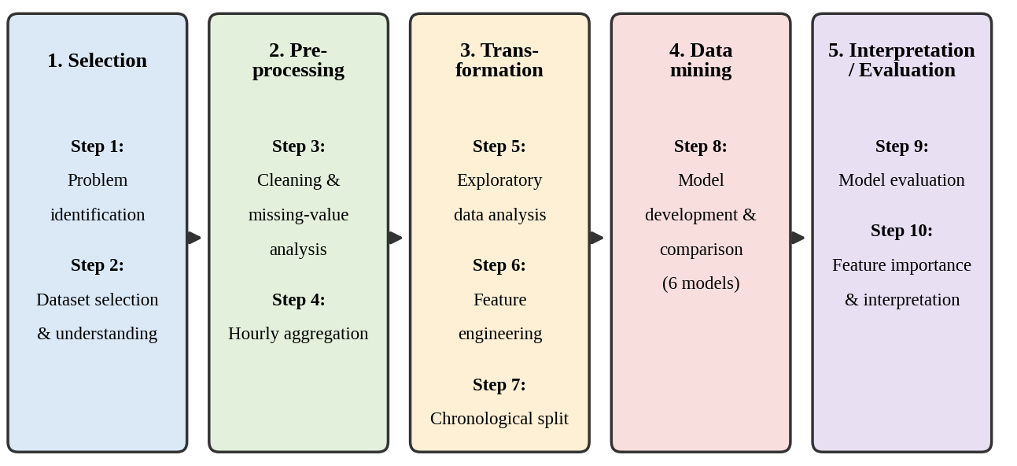
Figure 3.1: KDD workflow followed in the project (ten stages grouped under five KDD phases)

3.1 Problem Identification
The first stage defines what is to be predicted: the mean Global_active_power (kW) in the next hour. This is a regression task on a time series. Fixing the target and horizon first decides how data are aggregated, how features are built and how the model is tested, and it helps prevent data leakage.

3.2 Dataset Selection and Understanding
The UCI Individual Household Electric Power Consumption dataset (Hebrail & Berard, 2006) was chosen because it is public, covers almost four years and is recorded every minute. The notebook downloads the official ZIP file and reads the semicolon-separated text file, treating the symbol "?" as a missing value. The raw data contain 2,075,259 rows and 9 columns: Date, Time and seven measurements (Global_active_power, Global_reactive_power, Voltage, Global_intensity and Sub_metering_1, 2 and 3).

3.3 Data Preprocessing and Missing-Value Analysis
Date and Time were combined into a single datetime using the format day/month/year, rows with invalid timestamps were dropped, the data were sorted in time order, and duplicate timestamps were removed. The check showed no duplicate rows. Infinite values, if any, were converted to missing values. Each of the seven measurement columns has 25,979 missing values, which is about 1.25% of the rows. The counts are identical across columns, which suggests that whole records were missing at the same time.
Outliers were not removed, because unusually high usage may be real. Missing values are not filled at the minute level; they are ignored when averaging into hourly values, and an hour is dropped only if the target has no valid reading in it.

3.4 Hourly Aggregation
The minute-level data were resampled to hourly mean values for all numeric columns, and Global_active_power was renamed target_power_kw. After dropping hours with no valid target, 34,168 hourly records remained. Hourly aggregation reduces noise and data size and matches the one-hour forecasting horizon. The first and last hours are partial, because recording started at 17:24 on 16 December 2006 and ended at 21:02 on 26 November 2010.

3.5 Exploratory Data Analysis
EDA used plots of the full hourly series, of a two-month window (January–February 2007) and of average power by hour of day and day of week, together with descriptive statistics of the hourly target. Its purpose is to find patterns a model can use; the strong daily cycle motivated the hour-of-day feature and the 24-hour and 168-hour (one week) lags. The findings are given in Chapter 4.

3.6 Feature Engineering
Fourteen features were created in three groups, as listed in Table 3.1. The target y_next_hour is the target series shifted by one row backwards, so each row is linked to the value of the following hour. Lag and rolling features were built from past values only; the rolling statistics are calculated on the series shifted by one row, so they never include the target. Rows with a missing feature or target were removed, which leaves 33,999 rows (the first 168 hours cannot have a one-week lag, and the last hour has no next-hour value).
Table 3.1: Features used by the models
Group | Features
Calendar (5) | hour, day_of_week, day_of_month, month, is_weekend
Lag (6) | lag_1h, lag_2h, lag_3h, lag_24h, lag_48h, lag_168h
Rolling (3) | rolling_mean_3h, rolling_mean_24h, rolling_std_24h

Two details should be noted. First, the feature set contains only calendar variables and values derived from the target; the other measurements were aggregated but are not used as predictors. Second, lag_1h is the value of the row before the forecast origin, so the origin row's own hourly value is not a feature. Calendar features come from the origin row's timestamp.

3.7 Chronological Training, Validation and Test Split
The 33,999 rows were split by position without shuffling: the first 70% for training (23,799 rows, 2006-12-23 17:00 to 2009-09-15 17:00), the next 15% for validation (5,100 rows, 2009-09-15 18:00 to 2010-04-19 18:00) and the last 15% for testing (5,100 rows, 2010-04-19 19:00 to 2010-11-26 20:00). This imitates real use, where a model is trained on the past and applied to the future. The validation set is used to compare and select models, and the test set is used once at the end.

3.8 Model Development and Comparison
Six models were trained on the training set and scored on the validation set (Table 3.2). The settings were fixed by hand, and no hyperparameter search was performed. The baseline always predicts the training mean, so it shows how much the other models add beyond a constant guess.
Table 3.2: Models and settings used in the notebook
Model | Settings
Baseline | DummyRegressor, strategy = mean
Linear Regression | Default settings
Ridge Regression | alpha = 1.0
Random Forest | 150 trees, min_samples_leaf = 2, max_features = 0.9
Extra Trees | 150 trees, min_samples_leaf = 2, max_features = 0.9
Hist Gradient Boosting | max_iter = 150, learning_rate = 0.08, l2_regularization = 0.1

3.9 Model Evaluation
Four metrics were used. MAE is the average absolute error and is easy to interpret in kW. RMSE squares the errors before averaging, so large errors are penalised more. MAPE gives the error as a percentage of the actual value, and it is calculated only where the actual value is above 0.05 kW. R² shows the share of the variance in the target that the model explains.
MAE = (1/n) Σ |y − ŷ| RMSE = √[(1/n) Σ (y − ŷ)²]
MAPE = (100/m) Σ |y − ŷ| / y (only y > 0.05) R² = 1 − Σ (y − ŷ)² / Σ (y − ȳ)²
The model with the lowest validation RMSE was selected and evaluated once on the test set.

3.10 Feature Importance and Interpretation
Permutation importance was computed for the selected model on the first 5,000 rows of the validation set, with three repeats and negative RMSE as the scoring rule. The importance of a feature is the increase in RMSE when its values are shuffled. Finally, the notebook uses the last feature row (20:00 on 26 November 2010) to demonstrate a next-hour estimate of 1.939 kW for 21:00; this is an offline demonstration on historical data.

CHAPTER 4: RESULTS AND DISCUSSION

4.1 Dataset Statistics
The raw data contain 2,075,259 minute-level records from 2006-12-16 17:24:00 to 2010-11-26 21:02:00, with 2,049,280 valid values in each measurement column (Table 4.1). The median of Global_active_power (0.602 kW) is well below its mean (1.092 kW) and its maximum is 11.122 kW, so the distribution is right-skewed with occasional high peaks. Voltage stays in a narrow range around 240.8 V, and Sub_metering_1 and Sub_metering_2 have a median of zero, so these circuits are idle most of the time.
Table 4.1: Descriptive statistics of the minute-level data (n = 2,049,280 valid values)
Variable | Mean | Std | Min | 25% | 50% | 75% | Max
Global_active_power | 1.0916 | 1.0573 | 0.076 | 0.308 | 0.602 | 1.528 | 11.122
Global_reactive_power | 0.1237 | 0.1127 | 0.000 | 0.048 | 0.100 | 0.194 | 1.390
Voltage | 240.840 | 3.240 | 223.20 | 238.99 | 241.01 | 242.89 | 254.15
Global_intensity | 4.6278 | 4.4444 | 0.200 | 1.400 | 2.600 | 6.400 | 48.400
Sub_metering_1 | 1.1219 | 6.1530 | 0 | 0 | 0 | 0 | 88
Sub_metering_2 | 1.2985 | 5.8220 | 0 | 0 | 0 | 1 | 80
Sub_metering_3 | 6.4584 | 8.4372 | 0 | 0 | 1 | 17 | 31

After hourly aggregation, 34,168 records remain, with a target mean of 1.0917 kW, standard deviation 0.8976 kW, median 0.8029 kW, minimum 0.124 kW and maximum 6.5605 kW. Averaging smooths the extremes (the maximum falls from 11.122 to 6.561 kW). The engineered dataset has 33,999 rows and 14 features.

4.2 Exploratory Data Analysis Findings
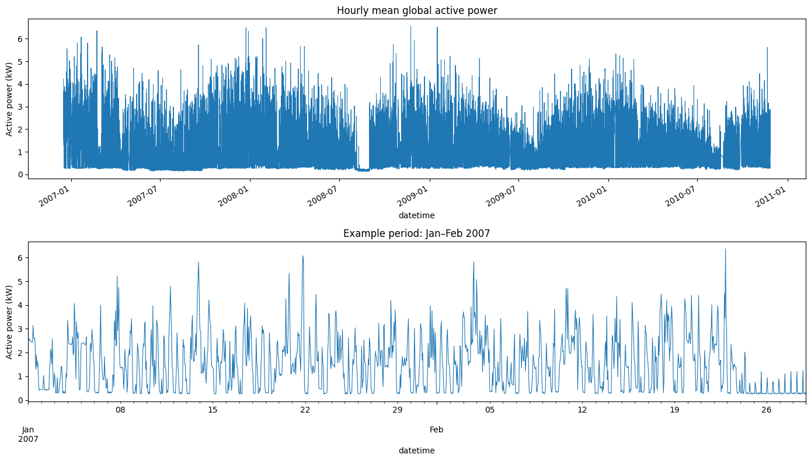
Figure 4.1: Hourly mean global active power for the full period (top) and for January–February 2007 (bottom)
Figure 4.1 shows a strongly repeating daily pattern with frequent spikes of up to about 6 kW. Consumption stays close to its minimum for a stretch around mid-2008, and the January–February 2007 window ends with several days at a low, flat level. The notebook does not explain these stretches, so no cause is claimed. They show that the series contains irregular periods that calendar and lag features cannot anticipate.
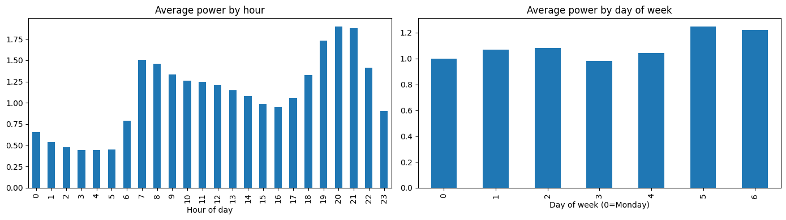
Figure 4.2: Average power by hour of day (left) and by day of week (right; 0 = Monday)
Figure 4.2 shows a clear daily profile: consumption is lowest between about 03:00 and 05:00 (around 0.45 kW), rises sharply at 07:00 (about 1.5 kW), falls slowly during the day and peaks at 20:00–21:00 (about 1.9 kW). The weekday effect is smaller: Saturday and Sunday are highest (about 1.25 and 1.22 kW) and Thursday is lowest (about 0.98 kW). These values are read from the chart and are approximate.

4.3 Model Comparison on the Validation Set
Table 4.2: Validation results of all models (sorted by RMSE)
Model | MAE | RMSE | MAPE (%) | R²
Hist Gradient Boosting | 0.4460 | 0.6181 | 52.1165 | 0.5194
Random Forest | 0.4441 | 0.6242 | 51.9365 | 0.5099
Extra Trees | 0.4467 | 0.6243 | 52.9586 | 0.5097
Ridge Regression | 0.5652 | 0.7507 | 72.4061 | 0.2910
Linear Regression | 0.5652 | 0.7507 | 72.4063 | 0.2910
Baseline (training mean) | 0.7324 | 0.9077 | 94.9199 | -0.0365

Hist Gradient Boosting had the lowest validation RMSE (0.6181) and the highest R² (0.5194), so it was selected. The three tree-based models are very close (RMSE 0.6181–0.6243), and Random Forest has a slightly lower MAE and MAPE, so the choice rests on RMSE alone. Compared with the baseline, Hist Gradient Boosting reduces validation RMSE by about 31.9% (0.9077 to 0.6181), and compared with Ridge Regression by about 17.7%. The baseline R² is slightly negative (−0.0365), so it is a little worse than predicting the validation mean. The gap between linear and tree models suggests that non-linear effects, such as the interaction of hour and day, matter.

4.4 Held-Out Test Results
Table 4.3: Selected model (Hist Gradient Boosting) on validation and held-out test data
Data | MAE | RMSE | MAPE (%) | R²
Validation | 0.4460 | 0.6181 | 52.1165 | 0.5194
Held-out test | 0.3958 | 0.5455 | 57.1879 | 0.4088

On the test period the average absolute error is 0.3958 kW, about 36% of the overall hourly mean of 1.09 kW. RMSE (0.5455 kW) is larger than MAE, so some large errors exist. The MAPE of 57.19% means that the forecast differs from the actual value by more than half of the actual value on average. This is high, and it is partly caused by low night-time values, where a small absolute error becomes a large percentage. The 0.05 kW threshold removes no hourly observation, because the smallest hourly value in the whole dataset is 0.124 kW. The R² of 0.4088 means the model explains about 41% of the variance of the test target and leaves about 59% unexplained. The model is therefore moderately useful, not highly accurate.
Test RMSE and MAE are lower than the validation values, but R² is also lower and MAPE higher. The reported numbers imply that the test target has a smaller variance than the validation target (about 0.50 against 0.79 kW², calculated from RMSE and R²), so absolute errors are smaller while relative measures are worse. The baseline was not evaluated on the test set, so the improvement over the baseline is shown on validation data only.

4.5 Actual versus Predicted Values
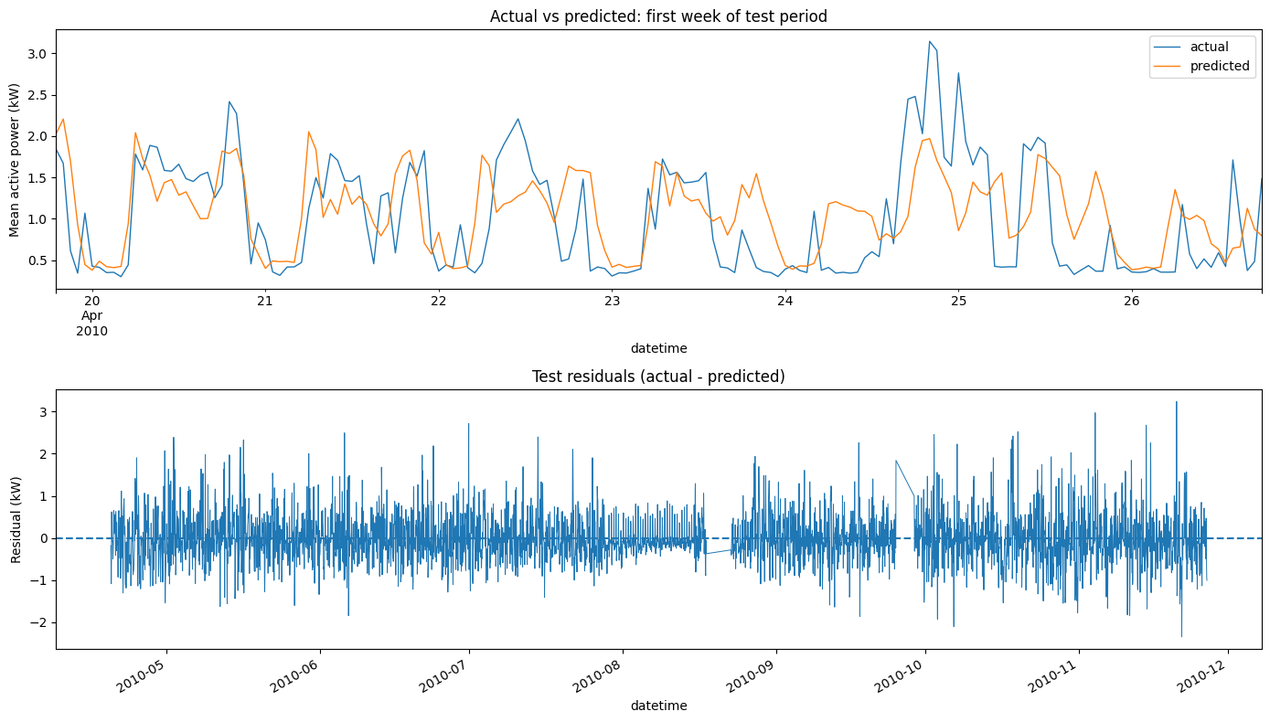
Figure 4.4: Actual versus predicted values for the first week of the test period (top) and test residuals (bottom)
The top panel of Figure 4.4 shows that the predictions follow the daily rhythm, with rises in the morning and evening and low values at night. The predicted curve is smoother than the actual one and often misses the height of peaks; for example, an actual peak above 3 kW on 24–25 April is predicted at about 2 kW. Figure 4.5 shows the same for the whole test set: points are concentrated at low values, the spread around the diagonal is wide, and high actual values are mostly under-predicted.
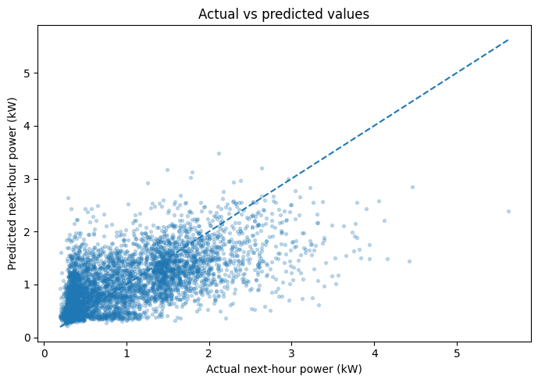
Figure 4.5: Actual versus predicted next-hour power on the test set

4.6 Residual Analysis
The residuals (actual minus predicted) in the lower panel of Figure 4.4 are centred near zero, so there is no obvious overall bias, but they are large in both directions, from about −2 kW to spikes of about 3 kW. The positive spikes are larger, which agrees with the under-prediction of sudden peaks. The spread is not constant: it is very small around August 2010, which appears to be a period of low, flat consumption, and larger when the household is active.

4.7 Feature Importance Findings
Table 4.4: Permutation importance (increase in RMSE, validation sample)
Feature | Mean | Std | Feature | Mean | Std
hour | 0.250971 | 0.012712 | lag_3h | 0.005473 | 0.000270
lag_1h | 0.149968 | 0.003147 | lag_2h | 0.003577 | 0.000385
day_of_week | 0.038340 | 0.002477 | day_of_month | 0.002587 | 0.000643
lag_168h | 0.008424 | 0.000414 | rolling_mean_3h | 0.001284 | 0.000203
month | 0.007992 | 0.002148 | lag_48h | 0.000962 | 0.000201
lag_24h | 0.007084 | 0.000350 | is_weekend | 0.000000 | 0.000000
rolling_mean_24h | 0.006442 | 0.000427
rolling_std_24h | 0.006171 | 0.000438

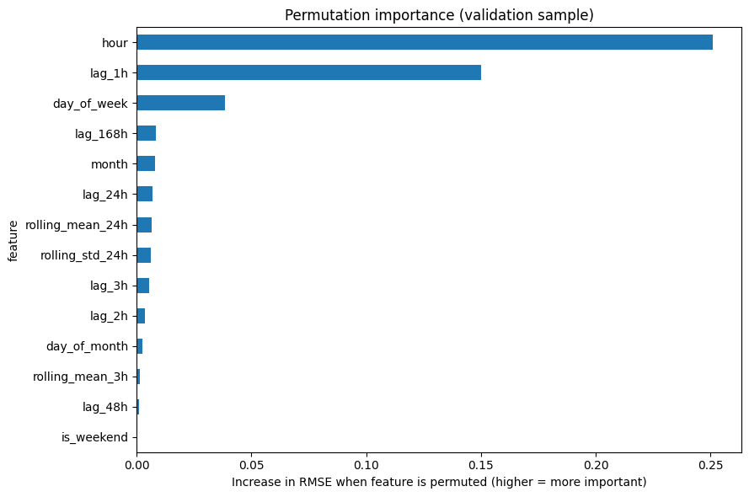
Figure 4.6: Permutation importance of the 14 features
Hour of day is the most important feature (0.2510), followed by lag_1h (0.1500) and day_of_week (0.0383). All other features are below 0.01. lag_168h is slightly more important than lag_24h, and is_weekend has zero importance because day_of_week already holds the same information. The model therefore mainly learns the typical daily profile and adjusts it using the most recent value. Permutation importance can understate features that share information, such as lag_1h and rolling_mean_3h.

4.8 Strengths and Limitations
Strengths. The workflow avoids data leakage through a chronological split and past-only features, compares the model with a baseline and several model types, uses the test set once, and is reproducible through a fixed random seed and saved outputs. All results are reported as obtained, including the weak ones.
Limitations. The main limitations are:
- The data come from one household in 2006–2010, so the results cannot be generalised.
- Performance is moderate (test R² 0.4088, MAPE 57.19%); only calendar and target-derived features are used.
- The hourly value of the forecast-origin row is not a feature; the newest lag is lag_1h, one row earlier.
- Lags and rolling windows are computed by row position after hours with no valid reading were dropped, so near missing stretches a lag may not match its clock time.
- The models were not tuned, a single split was used, only the selected model was tested, and forecasts are point estimates without intervals.
- The training-mean baseline is weak; a seasonal baseline (the value 24 or 168 hours earlier) was not tested.

CHAPTER 5: CONCLUSION

5.1 Summary of Completed Work
This project built an end-to-end workflow for household electricity forecasting using the UCI dataset. The 2,075,259 minute-level records were cleaned and aggregated into 34,168 hourly observations, and 14 calendar, lag and rolling features produced 33,999 modelling rows. After a chronological split, six models were compared on the validation set. Hist Gradient Boosting had the lowest validation RMSE (0.6181) and was evaluated once on the test period: MAE 0.3958, RMSE 0.5455, MAPE 57.1879% and R² 0.4088. Permutation importance was used to explain the model.

5.2 Achievement of Objectives
All seven objectives were met. The data were obtained, checked (25,979 missing values per measurement column and no duplicates) and aggregated to hourly form. EDA revealed a clear daily profile and a smaller weekend effect. Fourteen past-only features were built, the data were split chronologically and six models were compared. The selected model was evaluated on the test set and interpreted, and the results were reported honestly with their limitations; the forecasting accuracy itself is moderate.

5.3 Main Findings
- Tree-based models and gradient boosting clearly outperformed linear models and the baseline on validation data.
- Hour of day and the previous hour's value are the strongest predictors.
- Test accuracy is moderate: the model follows the daily rhythm but under-predicts sudden peaks.

5.4 Limitations
The study covers one household, uses only calendar and target-derived features, was not tuned and has no seasonal baseline or prediction intervals (see Section 4.8). The results therefore describe this workflow on this dataset and are not general accuracy claims.

5.5 Possible Future Improvements
- Add the origin-hour value and other measurements (voltage, sub-metering) as features.
- Rebuild the series on a complete time index so that lags match exact clock times.
- Add a seasonal naive baseline and use rolling-origin evaluation instead of a single split.
- Tune the hyperparameters, add weather and holiday information, test sequence models such as LSTM, produce prediction intervals and repeat the study on several households.

REFERENCES
Bergmeir, C., & Benitez, J. M. (2012). On the use of cross-validation for time series predictor evaluation. Information Sciences, 191, 192–213.
Box, G. E. P., Jenkins, G. M., Reinsel, G. C., & Ljung, G. M. (2015). Time series analysis: Forecasting and control (5th ed.). Wiley.
Breiman, L. (2001). Random forests. Machine Learning, 45(1), 5–32.
Cerqueira, V., Torgo, L., & Mozetic, I. (2020). Evaluating time series forecasting models: An empirical study on performance estimation methods. Machine Learning, 109(11), 1997–2028.
Fayyad, U., Piatetsky-Shapiro, G., & Smyth, P. (1996). From data mining to knowledge discovery in databases. AI Magazine, 17(3), 37–54.
Friedman, J. H. (2001). Greedy function approximation: A gradient boosting machine. The Annals of Statistics, 29(5), 1189–1232.
Geurts, P., Ernst, D., & Wehenkel, L. (2006). Extremely randomized trees. Machine Learning, 63(1), 3–42.
Hebrail, G., & Berard, A. (2006). Individual household electric power consumption [Data set]. UCI Machine Learning Repository. https://doi.org/10.24432/C58K54
Hochreiter, S., & Schmidhuber, J. (1997). Long short-term memory. Neural Computation, 9(8), 1735–1780.
Hoerl, A. E., & Kennard, R. W. (1970). Ridge regression: Biased estimation for nonorthogonal problems. Technometrics, 12(1), 55–67.
Hong, T., & Fan, S. (2016). Probabilistic electric load forecasting: A tutorial review. International Journal of Forecasting, 32(3), 914–938.
Hyndman, R. J., & Athanasopoulos, G. (2021). Forecasting: Principles and practice (3rd ed.). OTexts. https://otexts.com/fpp3/
Hyndman, R. J., & Koehler, A. B. (2006). Another look at measures of forecast accuracy. International Journal of Forecasting, 22(4), 679–688.
Ke, G., Meng, Q., Finley, T., Wang, T., Chen, W., Ma, W., Ye, Q., & Liu, T.-Y. (2017). LightGBM: A highly efficient gradient boosting decision tree. Advances in Neural Information Processing Systems, 30, 3146–3154.
Kong, W., Dong, Z. Y., Jia, Y., Hill, D. J., Xu, Y., & Zhang, Y. (2019). Short-term residential load forecasting based on LSTM recurrent neural network. IEEE Transactions on Smart Grid, 10(1), 841–851.
Pedregosa, F., Varoquaux, G., Gramfort, A., Michel, V., Thirion, B., Grisel, O., et al. (2011). Scikit-learn: Machine learning in Python. Journal of Machine Learning Research, 12, 2825–2830.

