PCB Manufacturing ERP/MES Implementation Plan
Generated on 2025-10-11 13:32
Scope: End-to-end process from RFQ (Gerber+BOM intake) through CAM, PCB fabrication, SMT/assembly, testing, shipping. Separate login per phase and a quality-control gate after every phase.
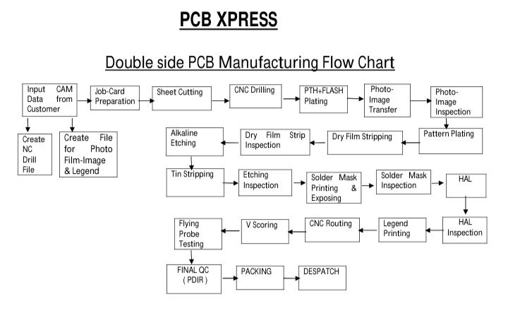

1. End-to-End Workflow
- Customer RFQ via portal → Upload Gerber & BOM → automatic DFM/DRC → Review Dashboard for corrections/approval.
- Sales quotation → customer acceptance & payment/PO → Sales Order.
- Production Approval (capacity + materials) → auto-generate Work Order with traveler & fixed revision.
- CAM release: NC drill, phototools/legend, panelization, testpoints, IPC class/tolerances, fixtures.
- PCB fabrication routing per traveler with QC after each step and NCR/rework loop on failure.
- SMT/Assembly/Box-build: screen print → P&P → reflow → touch-up → ICT → FT → firmware flash → wiring → labelling → pack → despatch.

2. ERP/MES Modules
- CRM/RFQ & Customer Portal
- DFM/CAM control & e-sign release
- Item/BOM/AVL with revisions
- Costing & Quoting
- Production Planning & Scheduling
- MES/Shop-floor (station dashboards, traveler scan)
- Quality (inspection plans, FAI/PDIR, NCR/CAPA, SPC)
- Inventory/Procurement/Stores with lot traceability
- Maintenance (PM schedules)
- Test Data Capture (ICT/Flying-probe/FT)
- Shipping/Logistics & labeling
- Finance (invoices, receipts)
- Document Control (SOPs, ECNs)
- Analytics (OTD, FPY, yields, cost)

3. Roles & Logins
Total distinct station/role logins planned: 53

3.1 Business / Control Roles
- Sales Executive
- Sales Manager / Approver
- Costing / Estimation
- CAM / DFM Engineer
- Production Planner / Scheduler
- Materials / Stores
- Purchasing
- QA Manager
- Finance / Accounts
- Shipping & Logistics Coordinator
- System Admin / IT

3.2 PCB Fabrication Stations
Count: 27
Step / Station | QC Gate after Step
Review Dashboard / Document control | Yes
Job-card preparation | Yes
Sheet cutting | Yes
CNC drilling | Yes
Create NC drill (CAM) / Tooling | Yes
Create photo films & legend (CAM) | Yes
PTH + flash plating | Yes
Photo-image transfer | Yes
Photo-image inspection (QC) | Yes
Alkaline etching | Yes
Dry-film inspection (QC) | Yes
Resist strip | Yes
Dry-film stripping | Yes
Pattern plating | Yes
Tin stripping | Yes
Etching inspection (QC) | Yes
Solder mask printing & exposing | Yes
Solder mask inspection (QC) | Yes
HAL | Yes
HAL inspection (QC) | Yes
Legend printing | Yes
CNC routing | Yes
V scoring | Yes
Flying-probe testing (QC) | Yes
Final QC (PDIR) | Yes
Packing | Yes
Despatch | Yes

3.3 SMT/Assembly/Wiring Stations
Count: 15
Station | QC Gate after Step
Solder-paste screen printing | Yes
Pick & place | Yes
Reflow oven | Yes
Manual soldering / touch-up | Yes
ICT testing | Yes
Functional testing | Yes
Software / firmware flashing | Yes
Wire cutting | Yes
Wire crimping | Yes
Wire connector insertion | Yes
Wire load testing | Yes
Wire electrical connection testing | Yes
Labelling | Yes
Packing | Yes
Despatch | Yes

4. Quality & Control Points
- Barcode traveler scan and operator login at each station; machine ID and start/stop time recorded.
- Mandatory inspection checklist with photos/measurements; SPC where applicable.
- Automatic hold on QC fail; NCR created; rework routing enforced; re-QC before proceeding.
- Engineering revision lock; only CAM can change revision; WO bound to specific revision.
- Materials lot/feeder traceability; MSD baking logs.
- Firmware images under ENG control; checksum recorded during flashing.

5. Dashboards
- Review: incoming RFQs, DFM status, corrections outstanding
- Planning: capacity, bottlenecks, WO Gantt, material shortages
- Shop-floor: per-station queue, WIP aging, rework queue
- Quality: FPY, yields by step, NCR cycle time, Pareto
- Commercial: quote hit-rate, OTD, AR/AP
- Compliance: calibration due, ESD audits, operator training

6. Implementation Phases
- Phase 0 – Master data & RBAC (items, work centers, routing library).
- Phase 1 – RFQ→Quote→SO + file intake & review dashboard.
- Phase 2 – CAM release & Materials/MRP.
- Phase 3 – PCB Fabrication MES (all stations + QC).
- Phase 4 – SMT/Assembly/Test/Wiring MES.
- Phase 5 – Quality (NCR/CAPA), Shipping, Finance connections.
- Phase 6 – Analytics, SPC, maintenance, advanced test data capture.

7. Verification: Flow Steps ↔ Logins ↔ QC
Mapped directly from the PCB XPRESS flow chart; Stage-QC required after every step.
Flow Step | Mapped Login / Role | Explicit QC Node in Chart | Stage QC after Step (Requirement) | Verification
Input Data from Customer | Customer Portal (External) | No | Yes | PASS
CAM from Customer Data | CAM Engineer (Intake) | No | Yes | PASS
Create NC Drill File | CAM – NC Drill | No | Yes | PASS
Create File for Photo Film‑Image & Legend | CAM – Phototools/Legend | No | Yes | PASS
Job-Card Preparation | Production Control / Job Card | No | Yes | PASS
Sheet Cutting | Sheet Cutting Operator | No | Yes | PASS
CNC Drilling | CNC Drilling Operator | No | Yes | PASS
PTH + Flash Plating | PTH Line Operator | No | Yes | PASS
Photo‑Image Transfer | Photo Imaging Operator | No | Yes | PASS
Photo‑Image Inspection | QA – Photo Imaging Inspection | Yes | Yes | PASS
Alkaline Etching | Etching Line Operator | No | Yes | PASS
Tin Stripping | Tin Strip Operator | No | Yes | PASS
Etching Inspection | QA – Etch Inspection | Yes | Yes | PASS
Dry Film Inspection | QA – Dry Film Inspection | Yes | Yes | PASS
Strip (Resist Strip) | Resist Strip Operator | No | Yes | PASS
Dry Film Stripping | Dry Film Strip Operator | No | Yes | PASS
Pattern Plating | Pattern Plating Operator | No | Yes | PASS
Solder Mask Printing & Exposing | Solder Mask Operator | No | Yes | PASS
Solder Mask Inspection | QA – Solder Mask Inspection | Yes | Yes | PASS
HAL | HAL Operator | No | Yes | PASS
HAL Inspection | QA – HAL Inspection | Yes | Yes | PASS
Legend Printing | Legend Printer Operator | No | Yes | PASS
CNC Routing | CNC Routing Operator | No | Yes | PASS
V Scoring | V‑Score Operator | No | Yes | PASS
Flying Probe Testing | Test – Flying Probe | Yes | Yes | PASS
FINAL QC (PDIR) | QA – Final Inspection / PDIR | Yes | Yes | PASS
PACKING | Packing Operator | No | Yes | PASS
DESPATCH | Dispatch / Shipping | No | Yes | PASS

Appendix: Source Flow & Notes
Double-side PCB Manufacturing Flow Chart
Handwritten QA/Stage inspection notes
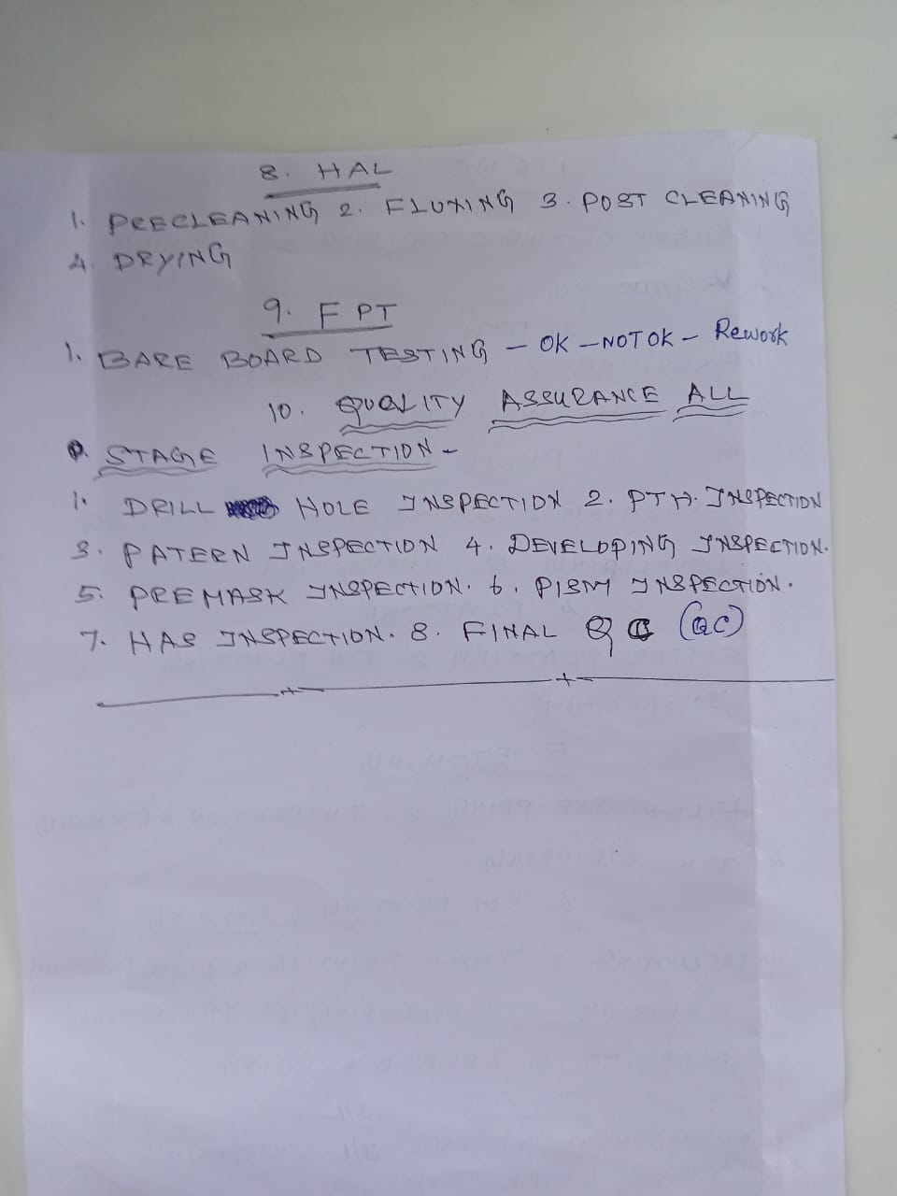
Handwritten process steps (CNC, PTH, Photo, Plating, Etching, SM, AOI)
