MLOps Assignment 01 — Heart Disease Risk Classifier
AIMLCZG523 — Machine Learning Operations, BITS Pilani WILP
Submitted by: Akash Kumar (2024AC05843)

1. Problem Statement
For this assignment, I built a classifier that predicts heart disease risk from patient health data and took it through to a deployed, containerized API running on Kubernetes. The dataset used is the Heart Disease (Cleveland) dataset from the UCI Machine Learning Repository — 303 patient records, 13 clinical features (age, sex, chest pain type, blood pressure, cholesterol, and others), and a target indicating whether disease is present.

2. Setup / Install Instructions
The following steps set up the project on a clean machine:
git clone <repo-url>
cd heart-disease-mlops
Note on Python version: this project is pinned to Python 3.11.9 using pyenv (see .python-version in the repository). Python 3.14 was tried initially, but numpy did not have a prebuilt wheel available for it and failed to build from source. Switching to 3.11 resolved this, and it is the recommended version for reproducing this setup.
pyenv install 3.11.9
pyenv local 3.11.9
python3 -m venv venv
source venv/bin/activate
pip install -r requirements.txt
To reproduce the dataset download, cleaning, and training end-to-end:
python3 -m src.preprocess
python3 -m src.train
This regenerates data/heart_disease_cleaned.csv, logs a run to MLflow, and saves the final model to model/heart_disease_pipeline.pkl.
To run the unit tests:
python3 -m pytest tests/ -v
To build and run the API in Docker:
docker build -t heart-disease-api:v2 ./app
docker run -d -p 5001:5001 heart-disease-api:v2
To deploy on Kubernetes (Docker Desktop's built-in cluster was used here, though this should work on any cluster with kubectl configured):
kubectl apply -f deployment/k8s-manifest.yaml
kubectl get pods
kubectl get services
The full EDA and model-selection work is documented in notebooks/eda_and_training.ipynb. The final logic was subsequently moved into standalone scripts under src/ for testing and automation.

3. EDA and Modelling Choices

3.1 Data cleaning
The raw target column from UCI (num) is a severity score from 0 to 4, not a binary label. It was converted to a binary target: 0 for no disease, 1 for any value above 0. Two columns, ca and thal, had a small number of missing values (4 and 2 respectively, out of 303 rows). Since both are essentially categorical rather than continuous — ca is a count of blocked vessels, thal is a coded category — the missing values were filled using the column mode rather than the mean. Rows were not dropped, given the already limited size of the dataset.

3.2 Class balance
164 patients have no disease and 139 do, roughly a 54/46 split. This is not a severe imbalance, but it was still treated as a reason not to rely on accuracy alone when comparing models — ROC-AUC and recall were given equal or greater weight in the final decision.
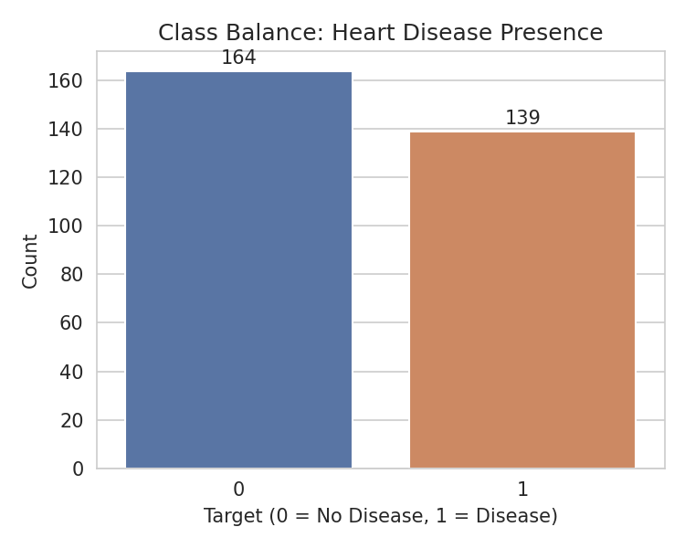

3.3 Distributions and correlations
oldpeak (ST depression) is right-skewed, with most patients near zero and a long tail. chol is approximately bell-shaped. The features most strongly correlated with heart disease presence are thal, ca, oldpeak, exang, cp, sex, and age (all positive), and thalach — maximum heart rate achieved — which is negatively correlated. This is consistent with clinical expectation: more blocked vessels, greater ST depression, and exercise-induced angina are all associated with higher risk, while a higher achievable heart rate typically indicates better cardiovascular fitness.
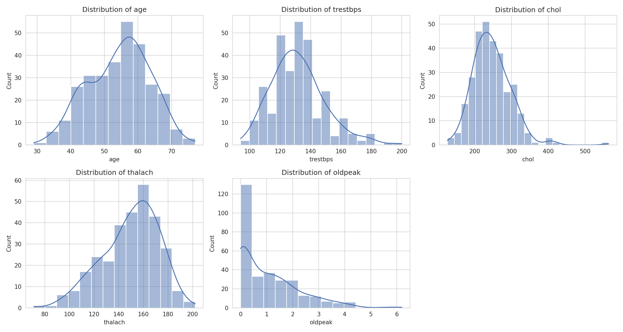
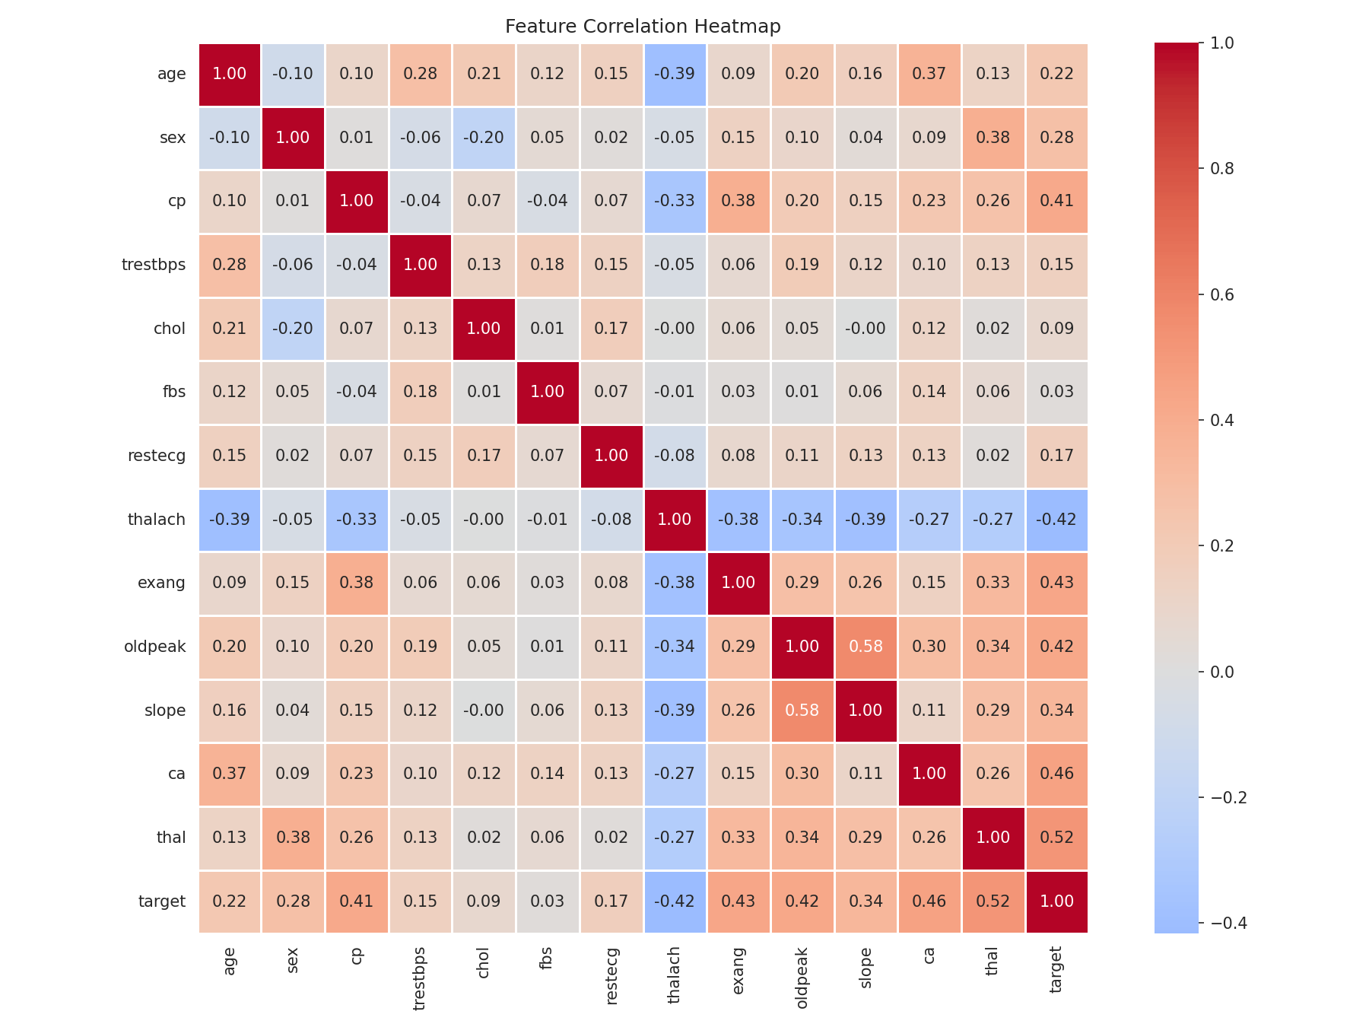
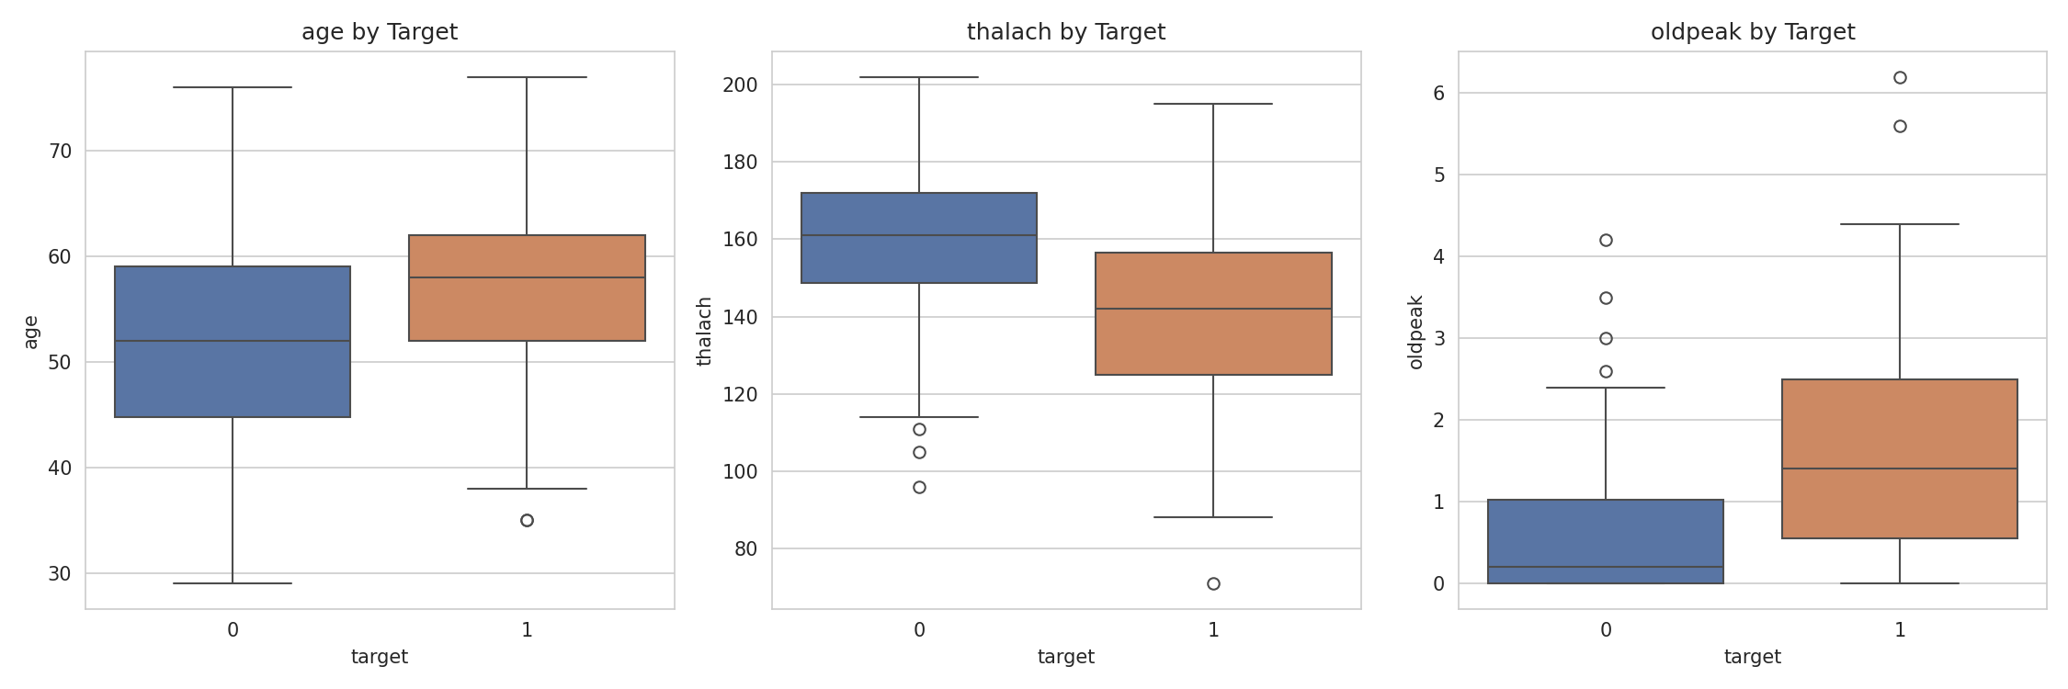

3.4 Feature engineering
Features were grouped into three categories and handled through a single ColumnTransformer (in src/preprocess.py), keeping preprocessing and the model bundled together as one pipeline object:
- Numeric (age, trestbps, chol, thalach, oldpeak) — standard-scaled
- Categorical, more than two levels (cp, restecg, slope, thal) — one-hot encoded, dropping the first level to avoid multicollinearity
- Binary or ordinal-like (sex, fbs, exang, ca) — passed through unchanged
Bundling preprocessing and the classifier into a single sklearn Pipeline meant there was only one object to save, reload, and serve, with no separate scaler to track or reapply at inference time.

3.5 Model selection
Two models were trained and compared: Logistic Regression and Random Forest, both evaluated with 5-fold cross-validation and tuned using GridSearchCV, scored on ROC-AUC.
Model | CV Accuracy | CV Precision | CV Recall | CV ROC-AUC
Logistic Regression (default) | 0.839 | 0.855 | 0.783 | 0.902
Random Forest (default) | 0.793 | 0.796 | 0.738 | 0.885
Random Forest (tuned) | — | — | — | 0.898
Logistic Regression (tuned, C=1) | — | — | — | 0.902
Logistic Regression achieved a marginally better score even after tuning Random Forest. This is a reasonable outcome given the size and nature of the dataset — 303 rows is limited, and the features are largely well-behaved and clinical, leaving little non-linear structure for Random Forest's added complexity to exploit. Logistic Regression was selected as the final model on the basis of its slightly higher CV score and its relative simplicity and interpretability, which is a meaningful consideration for a clinically adjacent use case.
On the held-out test set — 61 patients not used during cross-validation or tuning — the final Logistic Regression model achieved:
Metric | Value
Accuracy | 0.852
Precision | 0.806
Recall | 0.893
ROC-AUC | 0.957
Recall exceeding precision is a favourable outcome for this use case, as the model is more effective at identifying disease cases than at avoiding false positives, which is the safer error to make for a screening tool. One caveat worth noting: the test ROC-AUC (0.957) is somewhat higher than the CV estimate (0.902). With only 61 rows in the test set, this is most likely attributable to sample variance rather than genuinely superior generalization, and the CV estimate should be treated as the more reliable indicator of performance.
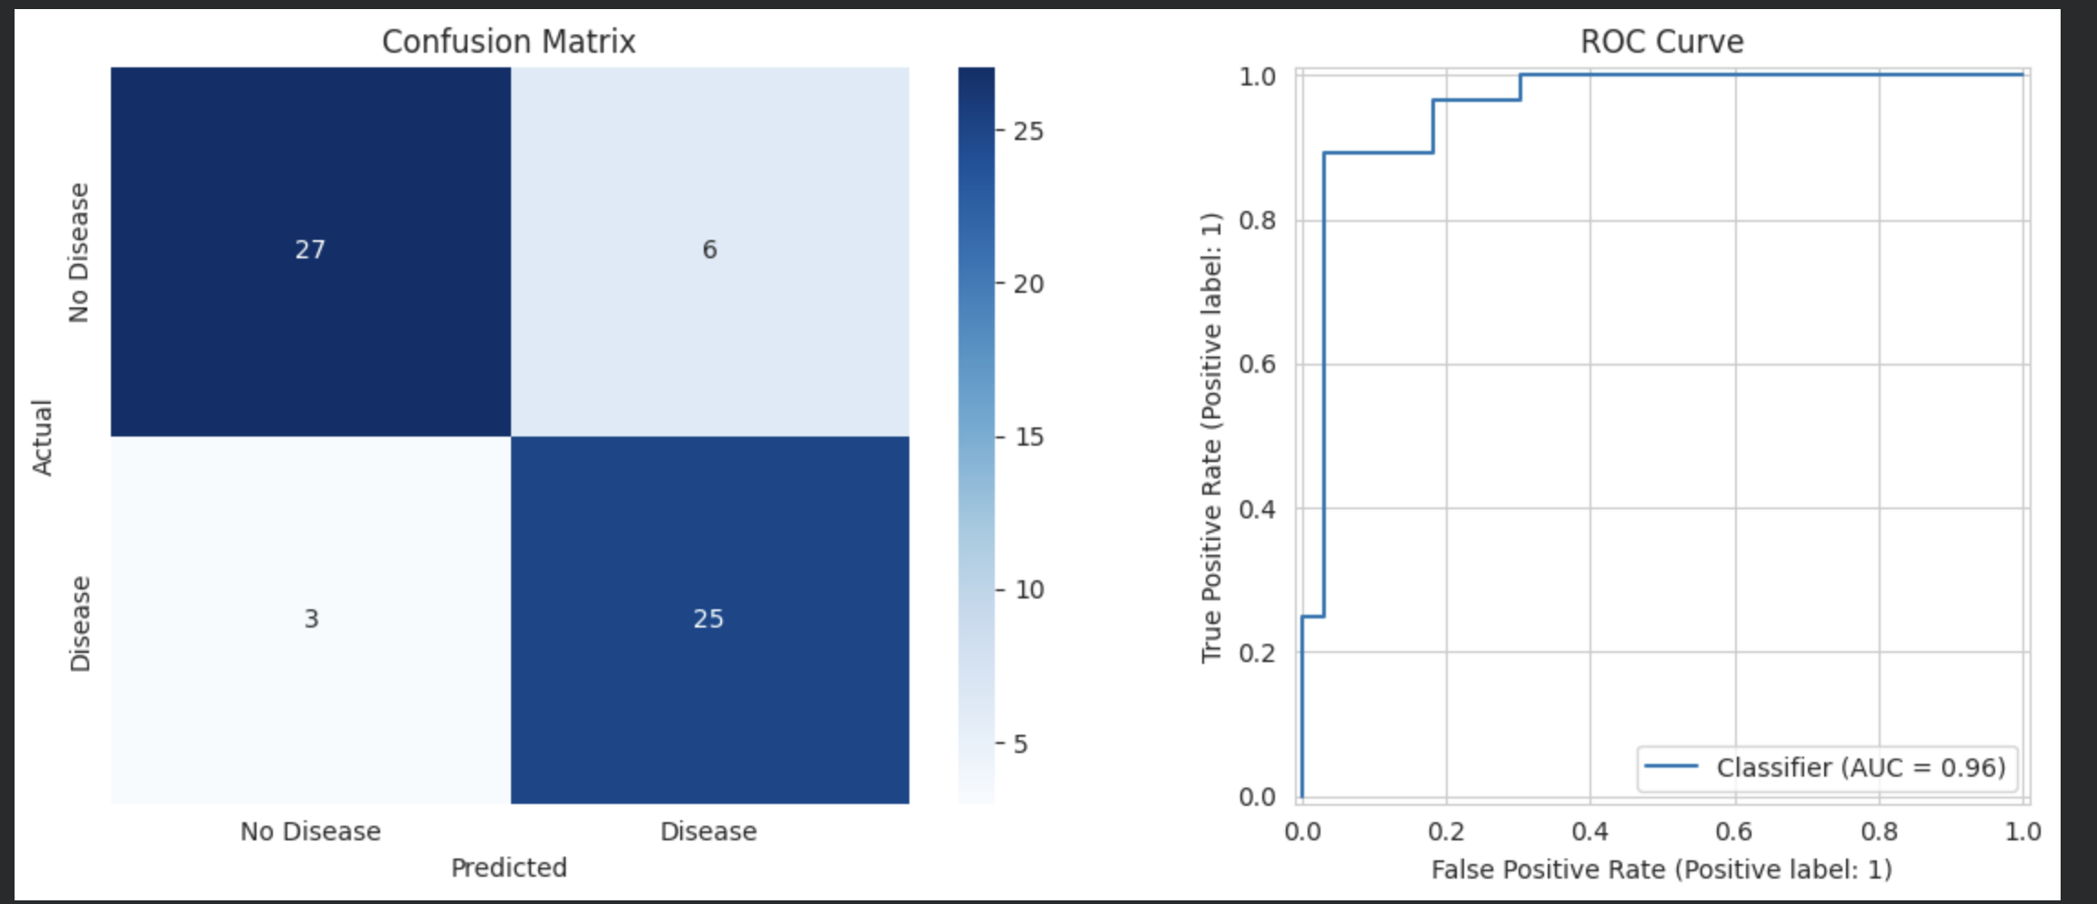

4. Experiment Tracking (MLflow)
All four runs — Logistic Regression and Random Forest, default and tuned versions — were logged to MLflow with their parameters, metrics, and the trained model as an artifact. The final selected run is tagged final_model=true for easy identification.
One issue encountered during this process: MLflow's default model-saving format (skops) rejected the pipeline due to an internal sklearn type, _RemainderColsList, created as a result of using 'passthrough' on certain columns, which was not on its list of trusted types. This was resolved by saving with serialization_format="pickle" instead of the default. Pickle carries a known limitation — it can execute arbitrary code on load — which MLflow explicitly warns about, but this is a reasonable tradeoff for an assignment context. In a production setting, unpickling a model file from an untrusted source would not be advisable.
A second issue arose from MLflow's local tracking store (the mlruns/ folder and mlflow.db), which stores absolute file paths and is therefore machine-specific. This had been committed to Git, and when GitHub Actions attempted to run training on Ubuntu, it failed with a PermissionError while trying to resolve a path that only existed locally. This was resolved by removing that folder from version control and allowing each environment to build its own local tracking store. The table and screenshot below serve as the retained record for this report.
Run | Model type | Accuracy | Precision | Recall | ROC-AUC
logistic_regression_default | LogisticRegression | 0.852 | 0.806 | 0.893 | 0.957
random_forest_default | RandomForest | 0.902 | 0.844 | 0.964 | 0.955
logistic_regression_tuned_FINAL | LogisticRegression | 0.852 | 0.806 | 0.893 | 0.957
random_forest_tuned | RandomForest | 0.918 | 0.897 | 0.929 | 0.970
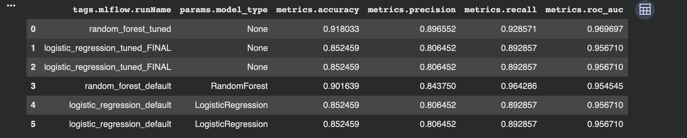
Worth noting: on this particular test split, random_forest_tuned achieved a higher accuracy and ROC-AUC (0.970) than the final selected Logistic Regression model (0.957). This does not contradict the earlier decision, which was based on the 5-fold cross-validated ROC-AUC obtained during tuning (0.902 for Logistic Regression versus 0.898 for Random Forest), rather than this single test-set result. It serves as a concrete illustration of the point made in Section 3.5 — with only 61 rows in the test set, either model can appear stronger by chance, which is precisely why the CV score, rather than the test score, was used as the actual selection criterion.

5. Model Packaging & Reproducibility
The final pipeline — preprocessing and the Logistic Regression model combined as a single object — is pickled to model/heart_disease_pipeline.pkl. Reproducibility was verified directly rather than assumed: the pickled model was reloaded in a fresh session, the same test sample was passed through it, and the resulting prediction was compared against the original in-memory model's output. The two matched exactly, to nine decimal places.
Dependencies are pinned to exact versions in requirements.txt (scikit-learn, pandas, numpy, mlflow, flask, along with ucimlrepo, pytest, and flake8, added as they became necessary). A useful lesson from this section: the exact versions that worked in Google Colab did not install cleanly on a local machine running Python 3.14, where numpy failed to build. Switching to 3.11.9 via pyenv resolved this. This illustrates that pinning package versions alone is not sufficient for reproducibility — the underlying OS and Python version matter as well, which is why .python-version has also been retained in the repository.

6. CI/CD Pipeline & Automated Testing
The notebook logic was split into two standalone modules: src/preprocess.py (loading, cleaning, and the preprocessing pipeline) and src/train.py (training, tuning, and MLflow logging). This separation is what makes automated testing and CI possible, since notebook cells cannot be imported or unit tested directly.
Seven unit tests were written using pytest, covering both data processing and model code:
- Target binarization produces only {0, 1}
- Target values map correctly from the original severity score
- Missing values in ca/thal are fully imputed
- clean_data() does not mutate the caller's original DataFrame
- build_preprocessor() returns a properly structured ColumnTransformer
- The full pipeline fits and predicts correctly on synthetic data with the expected schema
- evaluate_model() returns all four expected metrics, each within the range [0, 1]
The GitHub Actions workflow (.github/workflows/ci.yml) runs on every push to main: it installs dependencies, lints with flake8, runs the pytest suite, and then runs the training script end-to-end, uploading the test results and trained model as workflow artifacts.
The lint step caught genuine issues on the first run — two unused imports and two files missing a trailing newline — and correctly failed the build until they were addressed. This confirmed that the "pipeline must fail on code errors" requirement was functioning as intended, not merely satisfied on paper.
[ Insert screenshot: GitHub Actions run — all jobs green ]

7. Model Containerization
The model is served through a Flask application (app/main.py) with three routes: /predict (accepts the 13 input features as JSON and returns a prediction with confidence), /health (used for container and Kubernetes health checks), and /metrics (discussed in Section 9).
The Dockerfile uses python:3.11-slim as the base image, matching the local development Python version, and runs the application through gunicorn rather than Flask's built-in development server, which explicitly warns against use in production.
docker build -t heart-disease-api:v2 ./app
docker run -d -p 5001:5001 heart-disease-api:v2
curl -X POST http://localhost:5001/predict -H "Content-Type: application/json" -d '{"age": 63, "sex": 1, ...}'
Sample response: {"prediction": 0, "prediction_label": "No Disease", "confidence": 0.828} — identical to the model's behaviour outside the container, confirming the containerization was successful.
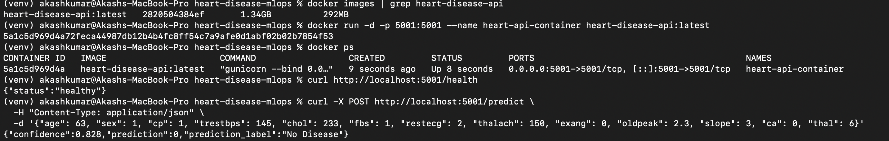

8. Production Deployment (Kubernetes)
The container is deployed to a local Kubernetes cluster — Docker Desktop's built-in single-node cluster — using a Deployment with 2 replicas and a LoadBalancer Service (deployment/k8s-manifest.yaml). Both liveness and readiness probes target /health, so Kubernetes only routes traffic to a pod once it is confirmed healthy, and restarts it automatically if it stops responding.
kubectl apply -f deployment/k8s-manifest.yaml
kubectl get pods
kubectl get services
curl http://localhost/predict ...
A notable issue encountered during this stage is documented here in detail, as it illustrates a common Kubernetes pitfall. After adding logging and the /metrics endpoint and rebuilding the Docker image, Kubernetes continued to serve the previous version of the code, with no /metrics route available. The image digest had in fact changed on rebuild, but because the pods used imagePullPolicy: IfNotPresent together with the latest tag, Kubernetes never re-checked whether "latest" pointed to something new — it simply reused the image already cached under that tag, dating back to the original image built in Section 6. This was confirmed by comparing the image digest inside the running pod (via kubectl describe pod) against the local docker images output, which did not match. The issue was resolved by moving away from the latest tag and using explicit version tags instead (heart-disease-api:v2), which forced Kubernetes to recognize that the manifest had changed and pull the new image. This is a well-documented limitation of the :latest tag in Kubernetes, and the manifest now uses versioned tags going forward.
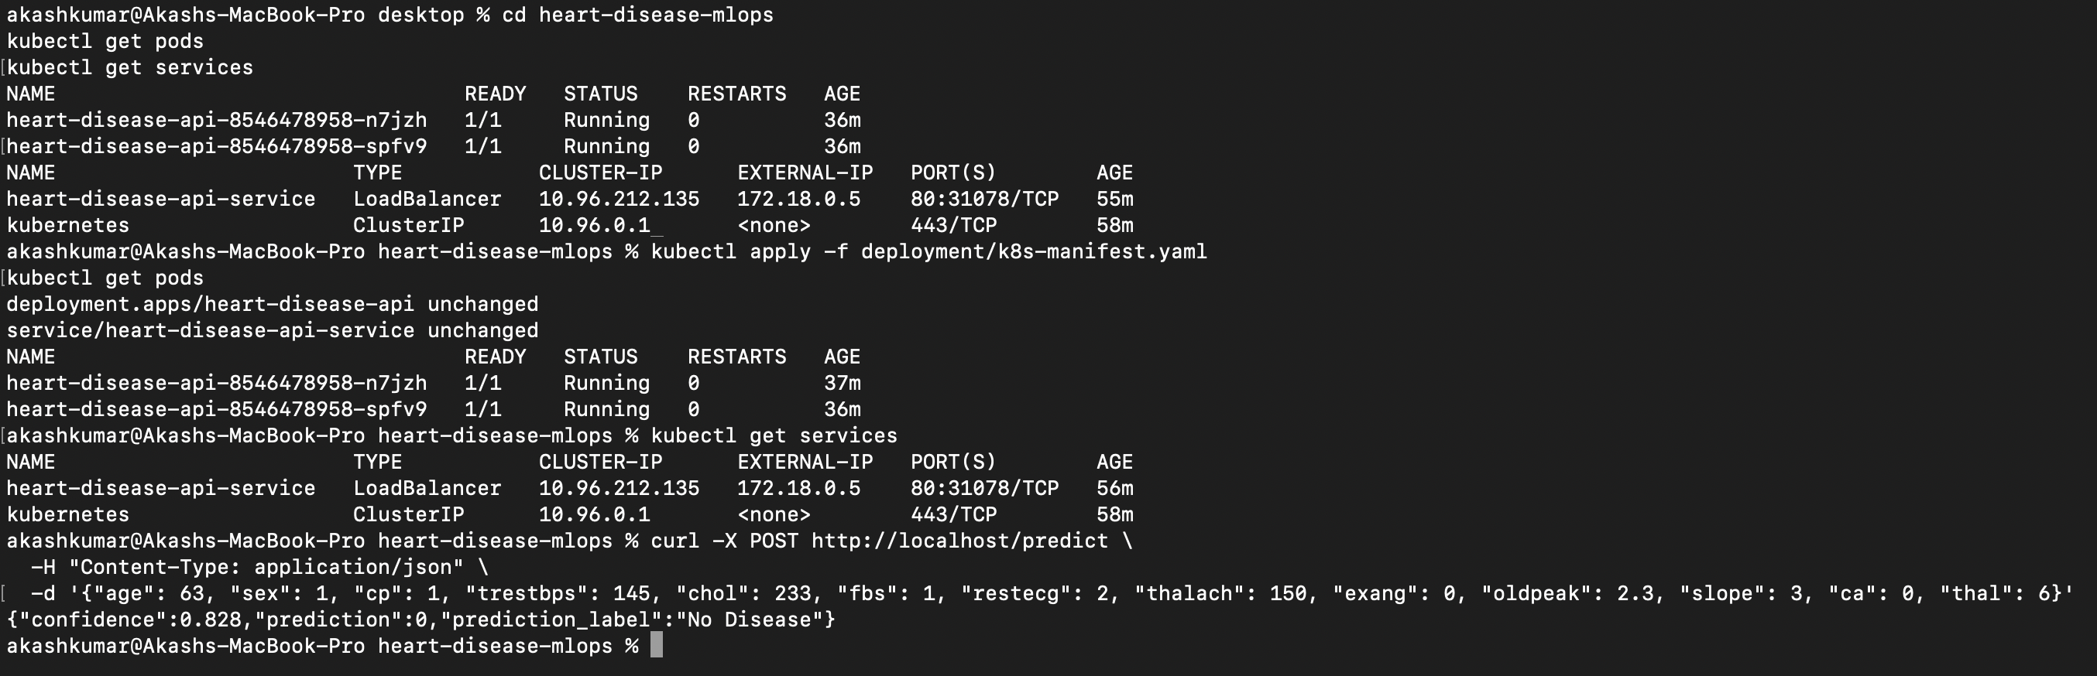

9. Monitoring & Logging
Rather than deploying a full Prometheus and Grafana stack, a lighter approach was used given the scope of this assignment: structured request logging combined with a small /metrics endpoint built directly into the Flask application.
Every /predict call is logged, both to a log file and to stdout — stdout is significant here because it is what kubectl logs <pod> displays, providing visibility without additional setup. Each log entry records the key inputs, the prediction, the confidence, and the response time. /metrics reports total requests, an error count, the distribution of predictions across classes, and the average response time.
This revealed a genuine limitation rather than a defect, which is documented here rather than concealed. The deployment runs 2 replicas, and each pod maintains its own in-memory metrics dictionary. Since the Service load-balances across both pods, a request to /metrics can land on a different pod than the one that most recently handled a /predict call — meaning /metrics may still show zero requests immediately after a successful prediction, simply because the request was routed elsewhere. This was confirmed, rather than assumed, by port-forwarding directly to a single pod and repeating the same test, which correctly showed total_requests: 1. The appropriate production solution would be a centralized metrics store — for example, Prometheus scraping every pod, or a shared Redis or database-backed counter — rather than maintaining state within each pod individually. This was not built out given the scope of the assignment, but the underlying logging and metrics instrumentation is structured in a way that would support this extension.

10. Architecture
The end-to-end flow is as follows: data is retrieved from UCI, cleaned and split by preprocess.py, then trained and tuned by train.py, with all runs logged to MLflow. The final pipeline is pickled and loaded by a Flask API, which is containerized with Docker and deployed to Kubernetes as 2 replicas behind a LoadBalancer Service. Separately, GitHub Actions runs linting, testing, and training on every push to main.
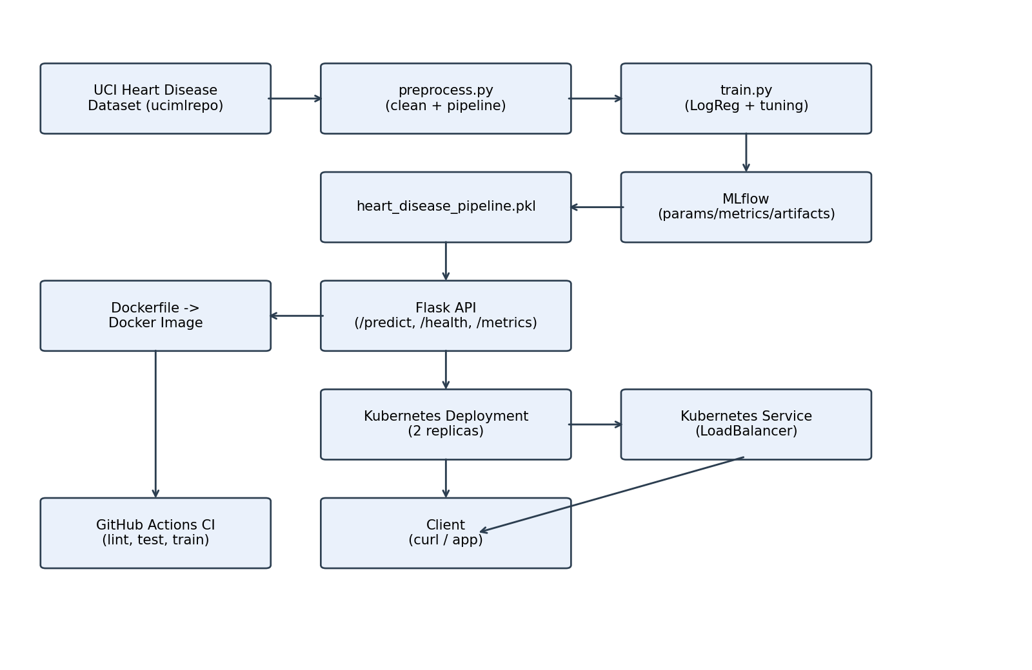

11. Repository
The complete code, tests, Dockerfile, CI workflow, and Kubernetes manifest are available at:
https://github.com/akashkt09/heart-disease-mlops

12. Limitations & Potential Improvements
- The test set is small (61 rows) — CV metrics should be treated as more reliable than the single test-set numbers
- Metrics are per-pod and in-memory, and do not scale correctly beyond a single replica without a shared store
- The model is not retrained automatically on new data — the CI pipeline retrains on every push, but there is no scheduled or drift-triggered retraining
- Deployment was tested only on a local single-node cluster (Docker Desktop), not on a cloud cluster such as GKE, EKS, or AKS
- There is no authentication on the /predict endpoint, which is acceptable for a local demonstration but would need to be addressed before any public exposure

